Context
Founded by benefactors in 1516, Gillingham School is proud and privileged to offer a quality and enjoyable educational experience that is open to all young people from the town of Gillingham, its surrounding villages and indeed, to young people further afield in Dorset, Wiltshire and Somerset.
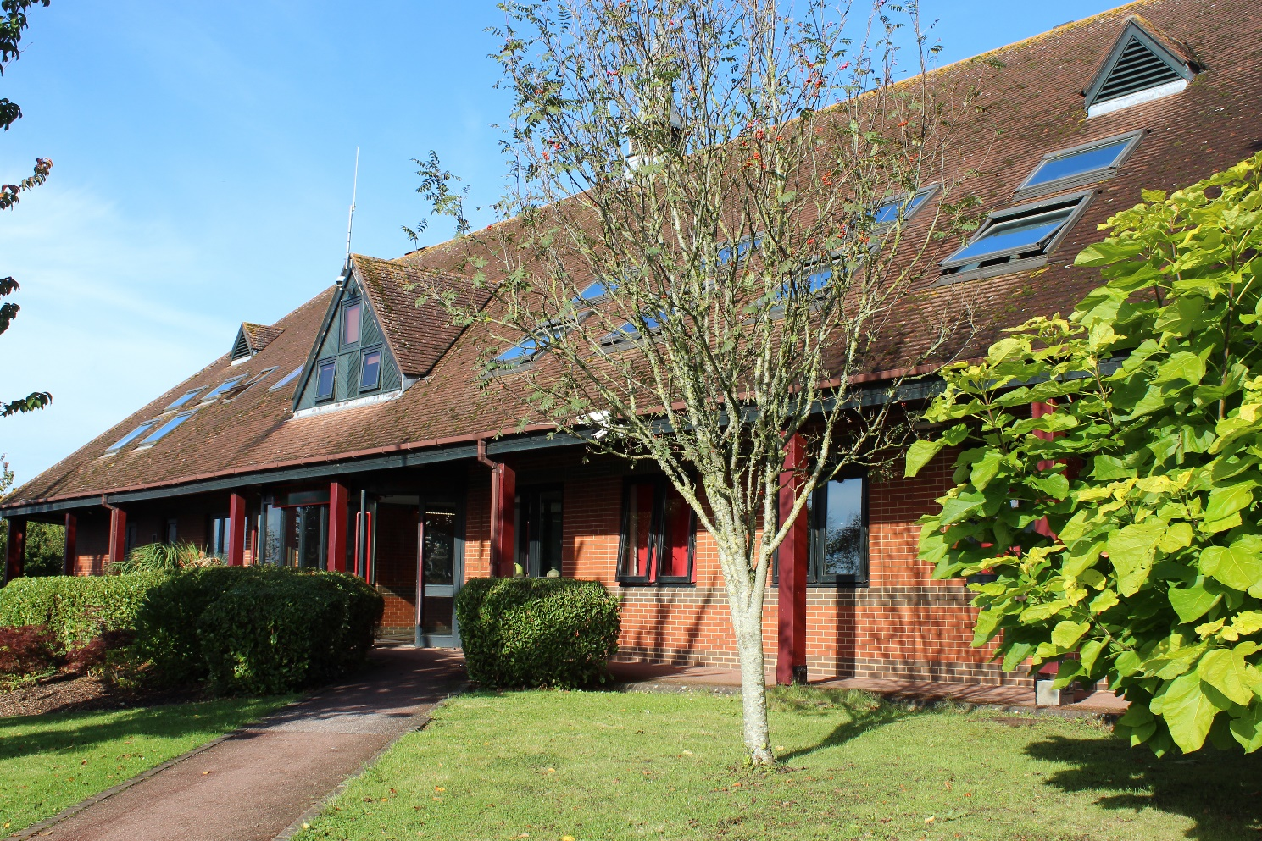
At Gillingham School, we recognise that children have many abilities, talents and personalities. Knowing that each student is different and that they learn in many ways, we aim to develop their abilities, raise their expectations and to provide the support that is necessary for success. By offering a wide range of experiences to our students both in and out of the classroom, students will receive a broad spectrum of learning.
Gillingham School, furthermore, is a friendly, welcoming and inspiring school. Characterised by good behaviour, respect towards other and enthusiasm for new experiences, the positive ethos of Gillingham School has been a feature here for years and underpins our three School Values:
- We are ambitious, take pride in our school and our learning is never disrupted.
- We treat everyone with kindness and dignity.
- We have the right to feel safe and happy.
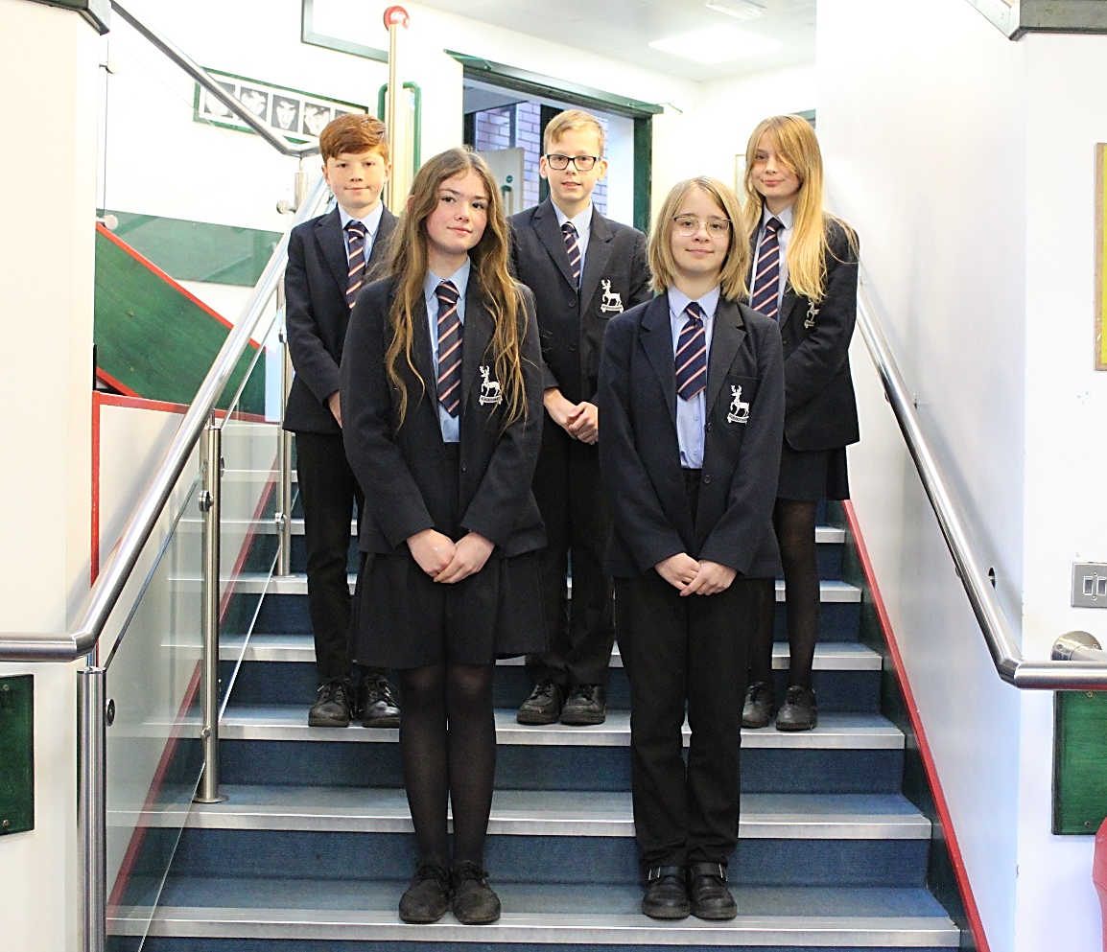
It is our privilege as teachers to welcome children into our school and to watch them learn, grow, develop and mature into the young adults who will eventually leave us and become the next generation of our community and our country. It is a delight when we meet former students some years later and hear how they have progressed, how far they have come and how Gillingham School helped them to achieve their goals.

The role - Head of Mathematics
We are seeking to recruit an outstanding and motivated Head of Maths who is able to provide the vision and strategic leadership for our Maths Department. You will join an ambitious team who are committed to providing an outstanding learning experience for all our students.

The responsibilities of this position are significant; you will lead a department of 17 (13 FTE) talented and experienced teachers, including a Maths Leadership Team currently comprised of two Assistant Subject Leaders and one colleague leading the department’s development of Mastery. You will also be well supported by your SLT Line Manager and the wider leadership team. As part of your role, you will work collaboratively with the other Heads of Department to develop a shared and coordinated approach to supporting student progress.
This is a pivotal time for the Maths department who have been working collaboratively to foster mixed attainment teaching in Key Stage 3, developing a consistent understanding of and approach to pedagogy. As a school we have invested in the development of the department, appointing additional staff to create a greater number of classes in Key Stage 4, alongside providing designated collaborative planning time and CPD focused on a Mastery approach to teaching Mathematics.

Improvement in Maths is a key driver of our school improvement agenda. Whilst we are proud of the significant improvement in Maths provision in recent years, the progress made by students is yet to match that seen in other areas of the school. The successful candidate will require the necessary ambition and determination to take the department to the next stage of its development. The leaders in the department work closely together and, under your direction, they will strategically direct the curriculum to improve the attainment and progress of all students.
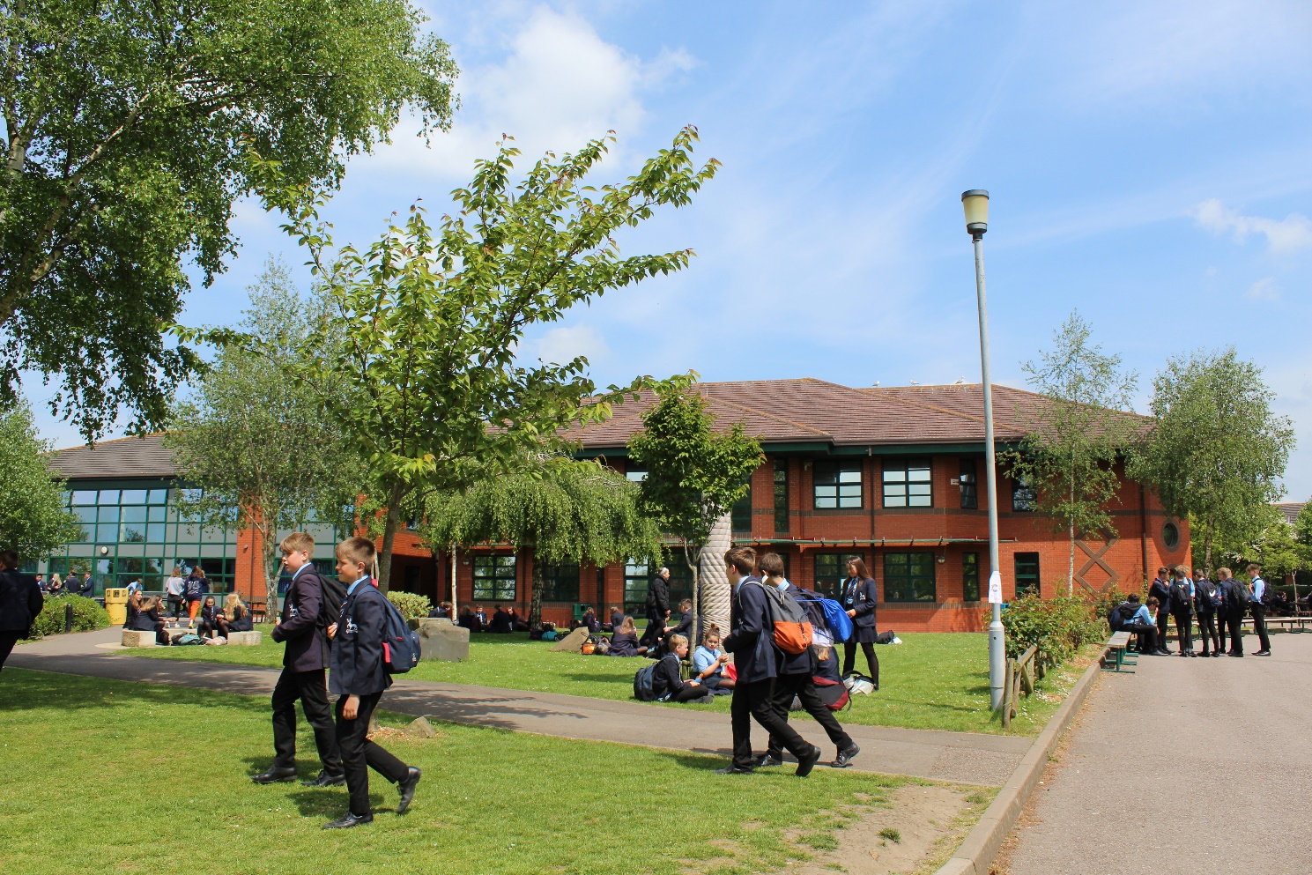

An introduction to the Maths Department
The Maths team is both friendly and supportive. We are committed to professional development, learning from each other and sharing good practice. As such, we work together to create a purposeful learning environment and provide a positive learning experience for our students who work hard and want to do well. ECTs, PGCE and School Direct trainees have excellent support from their department mentors. The leadership of the department is made up of the Head of Maths, two Assistant Subject Leaders and a temporary Mastery in Mathematics Leader.

Curriculum
Gillingham is a ten-form entry school. The department offers a five year curriculum from Years 7 to 11. We enter all of our students in Year 11 for the Edexcel Maths GCSE. Currently, students in Years 7 and 8 are taught in ten mixed attainment groups. In Years 9 to 11 there are 12 classes, which are gradually refined into groups based on tier of entry. Students have the opportunity to take an additional GCSEs in Statistics and Further Maths at the end of Year 11 which is delivered as part of our rich extra-curricular programme.

We have a large number of students continuing to study Maths and Further Maths in the Sixth Form, with a large number continuing to study Mathematics or related subjects in Higher Education. In addition, Core Maths is offered to students studying other Level 3 courses which contain significant mathematical content.

Facilities and Enrichment
We make use of a wide variety of resources so that lessons are active and students are engaged. Home learning is delivered via the platform Hegarty Maths. Students are well supported with intervention programmes of small group mentoring in the lower school delivered by trained Year 12 Maths students. In the Sixth Form students benefit from additional 1:1 support when required from their teachers. We offer a programme of visits, activities and competitions to enthuse, inspire and engage the students further.
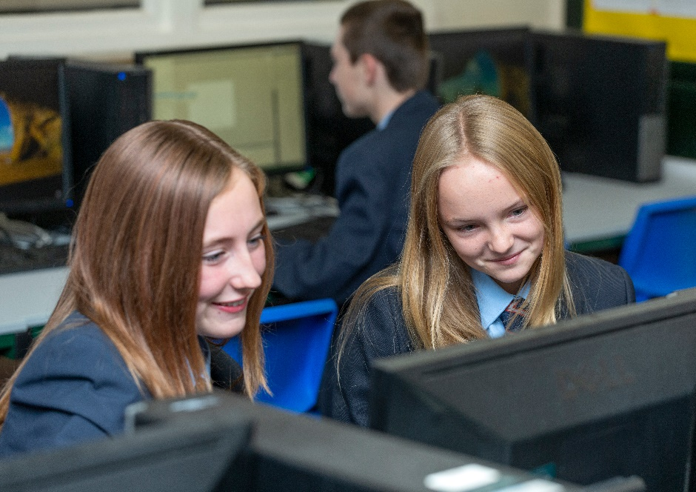

Staffing
A team of 17 staff presently teaches in the Maths Department. All teach across the full ability range and most across the full age range from 11-18 years. Most of the teachers are subject specialists and are involved in a continuing programme of rich professional learning. A considerable amount of support is given and derived from other individuals within the department.

