WISDOM  
HOPE  
COMMUNITY  
DIGNITY  
EQUALITY



Information pack for candidates

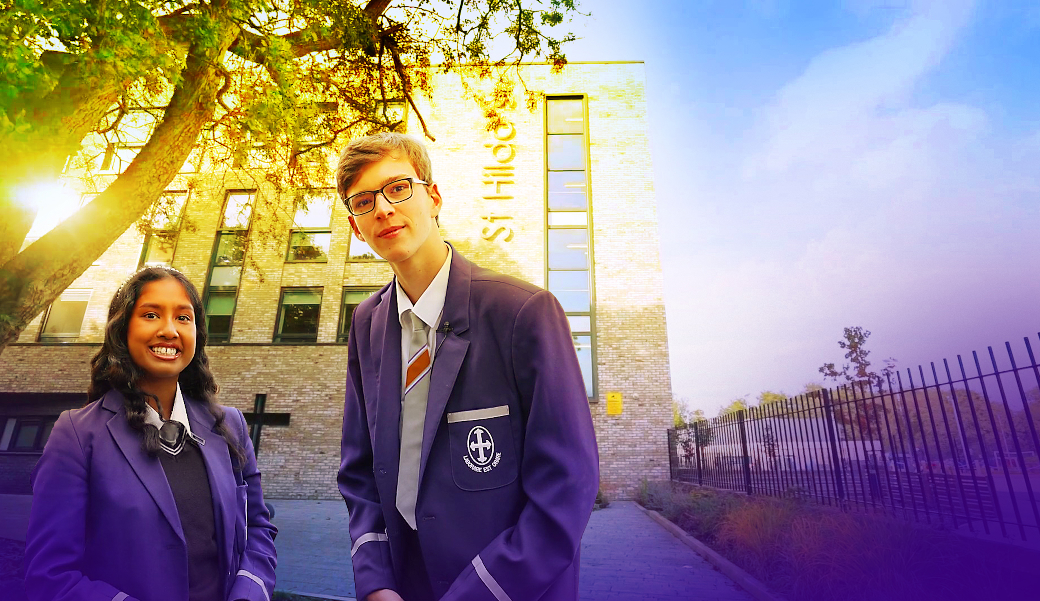

Welcome



Dear Candidate

Many thanks for your interest in St Hilda's and the post of Head of Mathematics.

St Hilda's is unique. St Hilda’s is a family. We are the only co-educational Church of England school in Liverpool in key stages 3 and 4. We welcome students and their family from a Christian background, from other faiths and those who have no faith. Each individual is precious.

Although our reputation in the community is excellent, this does not mean that we do not look for opportunities to improve who we are and what we do. We live by our values and are educating for 'wisdom, hope, community, dignity and equality'. Students helped to choose our 5th value of equality. We changed to a house system to promote a sense of belonging in each of our students and members of staff. Our smaller House families come together to form the larger St Hilda’s family. We chose our 5 Houses very carefully. Each one of these inspirational people embody our values and have helped to shape Liverpool. We speak in more detail about Margaret Aspinall, Gee Walker, Kitty Wilkinson, John Brodie and William Roscoe on our website.

We believe in student voice, in student leadership and in high expectations. Our behaviour systems focus on a Chance to Change and we work hard in ensuring we support our students in making the right decisions, ready to take their place in our society. Our SlAMS Report in March 2017 graded us as outstanding across all areas, and our more recent Keeping on Track report in December 2019 states’ *The strong, vibrant and inspirational vision, which proudly celebrates Christ as the cornerstone of this nurturing, inclusive and flourishing school, genuinely lies at the heart of this Christian community.’* We are unashamedly a Christian school. Our most recent Ofsted report graded us as Good in 2021.

We are heavily oversubscribed, but this does not mean that we do not recognise that we can become even better. We are looking for someone who will join the St Hilda's family in the key position as Head of Mathematics who champions all of our students, challenges where necessary and celebrates at every opportunity. You will support and develop the people in your team, ensuring all opportunities are taken to lead and share excellent practice and teaching and learning and strategies to support those students who need additional support. Your vision to lead St Hilda's Mathematics department to the next level is paramount.

Academically, St Hilda's intake above is national average. However, our aspiration is that every single one of our students achieves or exceeds their potential, has exceptional pastoral support and has a wealth of opportunities to support their development. In this role, we are looking for a very special person with the vision and experience to help our vision become a reality. Is this you?

We welcome visits from prospective candidates, but this will not form part of the selection process. Please contact Tracey Cain by email should you wish to arrange a visit [tcain@st-hildas.co.uk](mailto:tcain@st-hildas.co.uk)

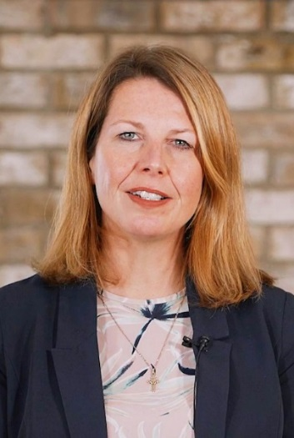I look forward to receiving your application if you believe that St Hilda's suits your career aspirations and you meet our criteria for selection. We are looking for a very special Head of Mathematics whose vision can take the department to the next level.

Thank you for your time,

**Mrs Jo Code**, Headteacher

St Hilda’s CE High School

St Hilda’s CE School is an 11-18 co-educational Church of England school that sits on the fringe of Sefton Park in Liverpool. The school currently has 1100 Students. Due to parental demand for places at the school, from September 2018 we increased our Year 7 PAN from 150 to 170. We pride ourselves in being a fully inclusive school that serves our Diocese and beyond. Our vision encapsulates who we are as a school:

We are the St Hilda’s family, with Jesus Christ as our cornerstone.   
Building on foundations of **wisdom**, **hope**, **community**, **dignity** and **equality**, we nurture and support each other to be or very best. We rejoice in our diversity and celebrate our many achievements.

St Hilda’s also has a sixth form. St Hilda’s College is an integral part of the school and last year, over 88% of Year 11 chose to continue their education at St Hilda’s. The College is growing year on year.

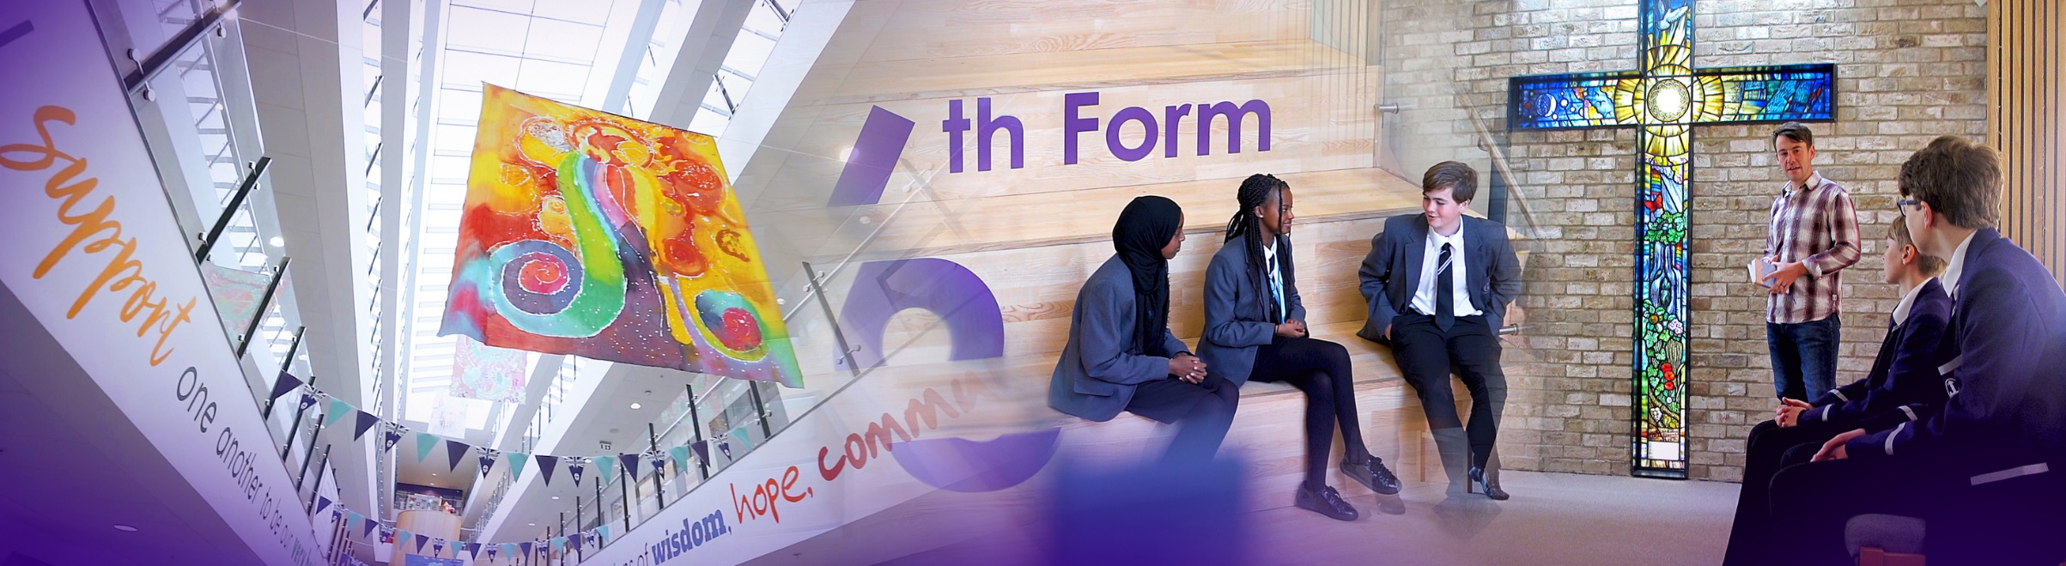

The new school buildings were opened in September 2015. We are incredibly proud of the excellent facilities we have, including excellent sports facilities. St Hilda’s College have dedicated areas in the school, including their own study rooms and café.

Our greatest asset at the school is our staff. St Hilda’s staff are incredibly generous with their time and support of each student. We have an incredibly low turnover of staff and we retain many of our NQTs and former students return to work here.

This is an exciting time to join the school and become part of a hard-working and committed team who embody our vision and values.

_________________________________________________________________________________

Senior Leadership Team

**Jo Code,** Headteacher   
Vision and values, curriculum, data, SEP, SIP, admissions, monitoring and tracking, QA systems policies.

**Lynne Noon,** School Business Manager  
Strategic Finance, Premises; Maintenance, Development and staffing, Health & Safety, School Calendar, Service Contracts and performance, Catering, Lettings.

**Roy Bellmon,** Deputy Headteacher  
DSL, St Hilda’s College, post-16 learning and standards, IT strategy, HAP programme, enrichment, Year 11 transition.

**Suzanne Harrison,** Deputy Headteacher  
Behaviour and Inclusion. Deputy DSL, Attendance, PP and Catch-up, Director of STEM, Head of Science

**John Martin,** Assistant Headteacher  
Deputy DSL, Behaviour support, Student Welfare, House System, Rewards and celebration, Student Leadership, Friends of St Hilda’s, parent engagement, transition.

**Liz Cowdell,** Assistant Headteacher  
Head of mathematics, Teaching and Learning. Staff Appraisal; Teacher Targets; Mentoring/Support; T & L innovation and development, CPD, Development Thursdays.

**Andrea Howard,** Assistant Headteacher  
Teaching and Learning, Data, ARR, Examinations and Options.

**Katie Pritchard,** Assistant Headteacher  
SENCo, SEND, Looked after Children.

**Carina Bird,** Academic Catch-up and T&L

**_______________________________________________________________________________**

Liverpool

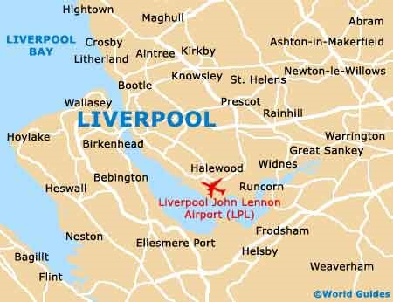Liverpool is a city with unique attractions, exciting events, world class sport offerings, unrivalled musical heritage and a famously warm welcome!  
  
  
**Location and Transport Links**  
Liverpool enjoys superb communication links.   
St Hilda’s CE School is located close to the M62 and other major roads. There are train and bus links to   
St Hilda’s. Liverpool Lime Street train station is the main station serving the city of Liverpool. Liverpool Airport is less than 30 minutes away.

©Marketing Liverpool, Liverpool Docks 2

**Facilities and Amenities**St Hilda’s CE School is close to the 3 universities in Liverpool. We are also close to Liverpool One;   
a range of shops, bars, restaurants, cafes and a cinema. Speke Retail Park and Edge Lane Retail Park are also close by.

Liverpool has the largest collection of museums and galleries anywhere outside London. The city also has several hospitals, theatres, cinemas and numerous other cultural and leisure facilities. St Hilda’s CE School lies in South Liverpool, overlooking Sefton Park.

**Housing and Accommodation**  
A range of accommodation options are available in the local area and there is a thriving rental market. The excellent transport links allow many staff at the school to live in outside of Liverpool. Help and advice can be given by the school if accommodation is required.

_________________________________________________________________________________

Job Description

Whilst every effort has been made to explain the main responsibilities and duties of the post, each individual task to be undertaken will not be identified. Employees will be expected to comply with any reasonable request from a manager to undertake work of a similar level that is not specified in this job description. The job description is current to the date shown but, in consultation with you, it may be changed by the Headteacher to reflect or anticipate changes in the job commensurate with the grade and job title.

|  |  |
| --- | --- |
| Working time: | Full time, permanent |
| Grade: | MPS/UPS TLR 1b £10,201 |
| Disclosure level: | Post is subject to a current enhanced disclosure |
| Reporting to: | Headteacher  SLT Line Manager |
| Working with: | Senior Leadership Team  Middle Leaders  Data Analyst  Data Officer  Exams Officer |

PURPOSE OF POST

1. To be a member of the Middle Leadership Team of St Hilda’s Church of England School, with a specific responsibility for the Mathematics department.

2. To lead and be responsible for the quality of Teaching and Learning: including pedagogy,

student progress and outcomes in the Mathematics department.

3. To contribute to St Hilda’s role as a high-achieving school, informed by research and best practice, in the Mathematics department.

4. To bring knowledge, expertise and high-order skills to the work of the school through your role as Head of Mathematics.

5. To actively model and promote the values and ethos of the school.

6. To be accountable for the line-management of staff within the Mathematics department.

7. To actively support the efficient and effective running of the school and good order, welfare, and safety of students and staff.

GENERIC RESPONSIBILITIES

*Shaping the future: Strategic direction*

1. To ensure outstanding provision in own department.

2. To keep abreast of local, national and global developments in pedagogy.

3. To contribute actively to building, communicating and implementing a shared vision of the school’s future.

4. To contribute actively to the strategic planning process.

5. To work with new technologies and help develop their use to promote teaching, learning, the experience of students and the effectiveness of the school.

6. To be accountable for leading and managing change.

7. To demonstrate a commitment to –

1. the collaborative school vision of excellence and equity – high standards / expectations for all

students.

b) helping to set and achieve challenging and ambitious targets.

c) inclusion.

8. To demonstrate the ability to –

a) think strategically.

b) inspire, challenge, motivate and empower others.

c) model the values and vision of the school and actively promote our Christian ethos.

9. To show commitment to:

1. Raising standards in pursuit of excellence.
2. Equipping students with the necessary mindset for success; building resilience, ambition, determination and problem-solving.
3. The entitlement of all students to the best possible teaching and learning.
4. Personalised and cooperative learning.
5. Coaching and mentoring students to ensure maximum commitment and effort.

10. To demonstrate the ability to:

1. Demonstrate personal enthusiasm for learning.
2. Demonstrate the principles and practice of the best teaching and learning.
3. Challenge poor performance.
4. Develop relevant strategies for improved performance.

SPECIFIC RESPONSIBILITIES

Leadership and Management

Improving Teaching and Learning

1. To lead and have responsibility for Mathematics at the school; for the quality of Mathematics teaching, for results of assessments and standard of marking, recording and reporting of students’ work.
2. To provide regular information to members of SLT in relation to Mathematics.
3. To monitor, evaluate and act upon students’ progress, achievement and attainment in all Mathematics key stages.
4. To liaise with other Mathematics members of staff to identify under performance by students and ensure appropriate intervention strategies and plans are implemented.
5. To liaise with other Mathematics members of staff to ensure continuity and progression of achievement and attainment.
6. To develop assessments and marking which promote student progress and support teacher workload and work-life balance.
7. To co-ordinate and oversee the work of other teachers in relation to the development and delivery of Mathematics and other subjects within the department.
8. To conduct observations and use the knowledge gained to improve the quality of Teaching and Learning within the department, learning from each other.
9. To ensure the professional development of all members in the Mathematics, helping them to set relevant targets to support the department and school improvement plans.
10. To model appropriate teaching strategies and lessons for others to observe, using department time to share the most effective practice.
11. To teach Good or better Mathematics lessons at all key stages 3, 4, and 5.
12. To have the highest standards within the Mathematics department, using the school’s behaviour and rewards systems to develop good relationships.
13. To ensure that home learning is effective and underpins the schemes of learning and student progress.
14. To use current research to impact the effectiveness of the department and to produce the best results and life-long learning for all
15. To actively lead the promotion of Mathematics careers, working collaboratively with key departments involved in STEAM School.

WIDER PROFESSIONAL RESPONSIBILITIES

As a member of the St Hilda’s family, you will be expected to:

* support our 5 values of Wisdom, Hope, Community, Dignity and Equality.
* be sympathetic to the teachings of the Church of England.
* operate at all times within the stated policies and practices of the school.
* establish effective working relationships and set a good example through their presentation and personal and professional conduct.
* co-operate with other staff to ensure a sharing and effective usage of resources to the benefit of the school, department and students.
* contribute to the corporate life of the school through effective participation in meetings.
* take part in marketing and liaison activities such as parents evenings, review days and other appropriate school events.
* recognise health and safety is a responsibility of every employee, to take reasonable care of self and others and to comply with the school’s Health and Safety policy.
* promote the welfare of children and to support the school in safeguarding children though relevant policies and procedures. Establish a purposeful and safe learning environment which complies with current legal requirements, national policies and guidance on the safeguarding and well-being of children and young people so that learners feel secure and sufficiently confident to make an active contribution to learning and to the school.

Whilst every effort has been made to set out the main duties and responsibilities of the post, each individual task undertaken may not be identified. All staff may be required to undertake other such reasonable duties as may be required in line with the grade of this post.

**This job description is a guide to the duties and should be read in conjunction with the accompanying person specification.**

**This role involves contact with children and will be engaging in regulated activity relevant to children. This post is subject to an enhanced DBS disclosure check through the Disclosure & Barring Service.**

__________________________________________________________________________________

Person Specification

**In your letter of application, please  *demonstrate* how you meet these criteria.**

**Do not include a curriculum vitae.**

**Candidates failing to meet any of the essential criteria will automatically be excluded.**

**[A]**

|  |  |  |  |
| --- | --- | --- | --- |
| **Qualification requirements** | **Essential** | **Desirable** | **Source** |
| Qualified teacher status | **E** |  | **A** |
| Recognised degree or equivalent in Mathematics or related subject | **E** |  | **A** |
| Further professional development: post-entry qualification |  | **D** | **A** |

1. **Experience**

|  |  |  |  |
| --- | --- | --- | --- |
|  | **Essential** | **Desirable** | **Source** |
| At least four years’ teaching experience | **E** |  | **A/I/R** |
| Teaching experience in more than one secondary school |  | **D** | **A/I** |
| Track record of successful team leadership which has improved outcomes for students | **E** |  | **A/I/R** |
| Middle Leader Responsibility |  | **D** | **A/I/R** |
| Whole-school development responsibility |  | **D** | **A/I/R** |
| Evidence of successful student achievement | **E** |  | **A/I/R** |
| Experience of Experience of having designed, implemented and evaluated effective, imaginative and stimulating schemes of work and of leading successful enrichment programmes including establishing a high achieving department within a large school | **E** |  | **A/I/R** |

1. **Knowledge/Understanding**

|  |  |  |  |
| --- | --- | --- | --- |
|  | **Essential** | **Desirable** | **Source** |
| Outstanding practitioner in own subject area, as evidence by student progress/outcomes/performance feedback. | **E** |  | **A/I/R** |
| Ability to teach Mathematics to A-Level | **E** |  | **A/I/R** |
| Knowledgeable about best practice in Teaching and Learning, pedagogy, and developing staff. | **E** |  | **A/I** |
| Data-smart with the ability to use data analysis to improve progress and outcomes for students across all 3 key stages | **E** |  | **A/I** |
| Mastery of and enthusiasm for mathematics | **E** |  | **A/I/R** |
| Recent professional development/INSETrelevant to the post | **E** |  | **A/I** |
| Knowledge of the primary/secondary education system, examinations and curriculm | **E** |  | **A/I** |
| Leadership and Management training |  | **D** | **A/I** |
| Knowledge of supporting staff and championing their professional development | **E** |  | **A/I** |

1. **Personal Qualities and Skills**

|  |  |  |  |
| --- | --- | --- | --- |
|  | **Essential** | **Desirable** | **Source** |
| Outstanding communicator | **E** |  | **A/I** |
| Outstanding interpersonal skills | **E** |  | **A/I** |
| An excellent networker – receptive, flexible and persuasive | **E** |  | **A/I** |
| Team player – empathetic to the needs of the department, able to challenge and support | **E** |  | **A/I** |
| Strategic, able to balance long-term and short-term goals | **E** |  | **A/I** |
| Ability to motivate | **E** |  | **A/I** |
| Ability to meet deadlines/manage time | **E** |  | **A/I** |
| Resilient | **E** |  | **A/I** |
| ICT literate | **E** |  | **A/I** |
| Commitment to the school Christian values and vision | **E** |  | **A/I** |

1. **Pre-Employment Checks**

|  |  |  |  |
| --- | --- | --- | --- |
|  | **Essential** | **Desirable** | **Source** |
| Positive recommendation from all referees, including current employer | **E** |  | **R** |
| DBS Clearance post appointment | **E** |  | **N/A** |

*(Source: A=Application (form+letter); I=Interview; R=Reference)*

1. **Application Form and Supporting Statement**

The form must be fully completed and legible.

The supporting statement should be clear, concise and related to the specific post. No more than 2 sides of A4, font size 12.

There should be no unexplained gaps in career history.

_________________________________________________________________________________

How to apply and the Selection Process

**Application Window: 17th November – 1st December 2021**

Visits to the school are available on Tuesday 23rd November and Tuesday 30th November. Please contact [recruitment@st-hildas.co.uk](mailto:recruitment@st-hildas.co.uk) if you would like to arrange a visit.

**Deadline for applications: 9am Wednesday 1st December 2021**

Applications should be sent to: [recruitment@st-hildas.co.uk](mailto:recruitment@st-hildas.co.uk)

Candidates who are shortlisted will be contacted by email. Details of the date and time of interviews and any other assessments will be given.

**Formal interview at the school: TBC**

Candidates will be asked to demonstrate and outline, in a variety of ways, their ability to successfully lead change at St Hilda’s CE School.

Details of this will be sent out in advance. All candidates will be contacted following the interviews.

__________________________________________________________________________________

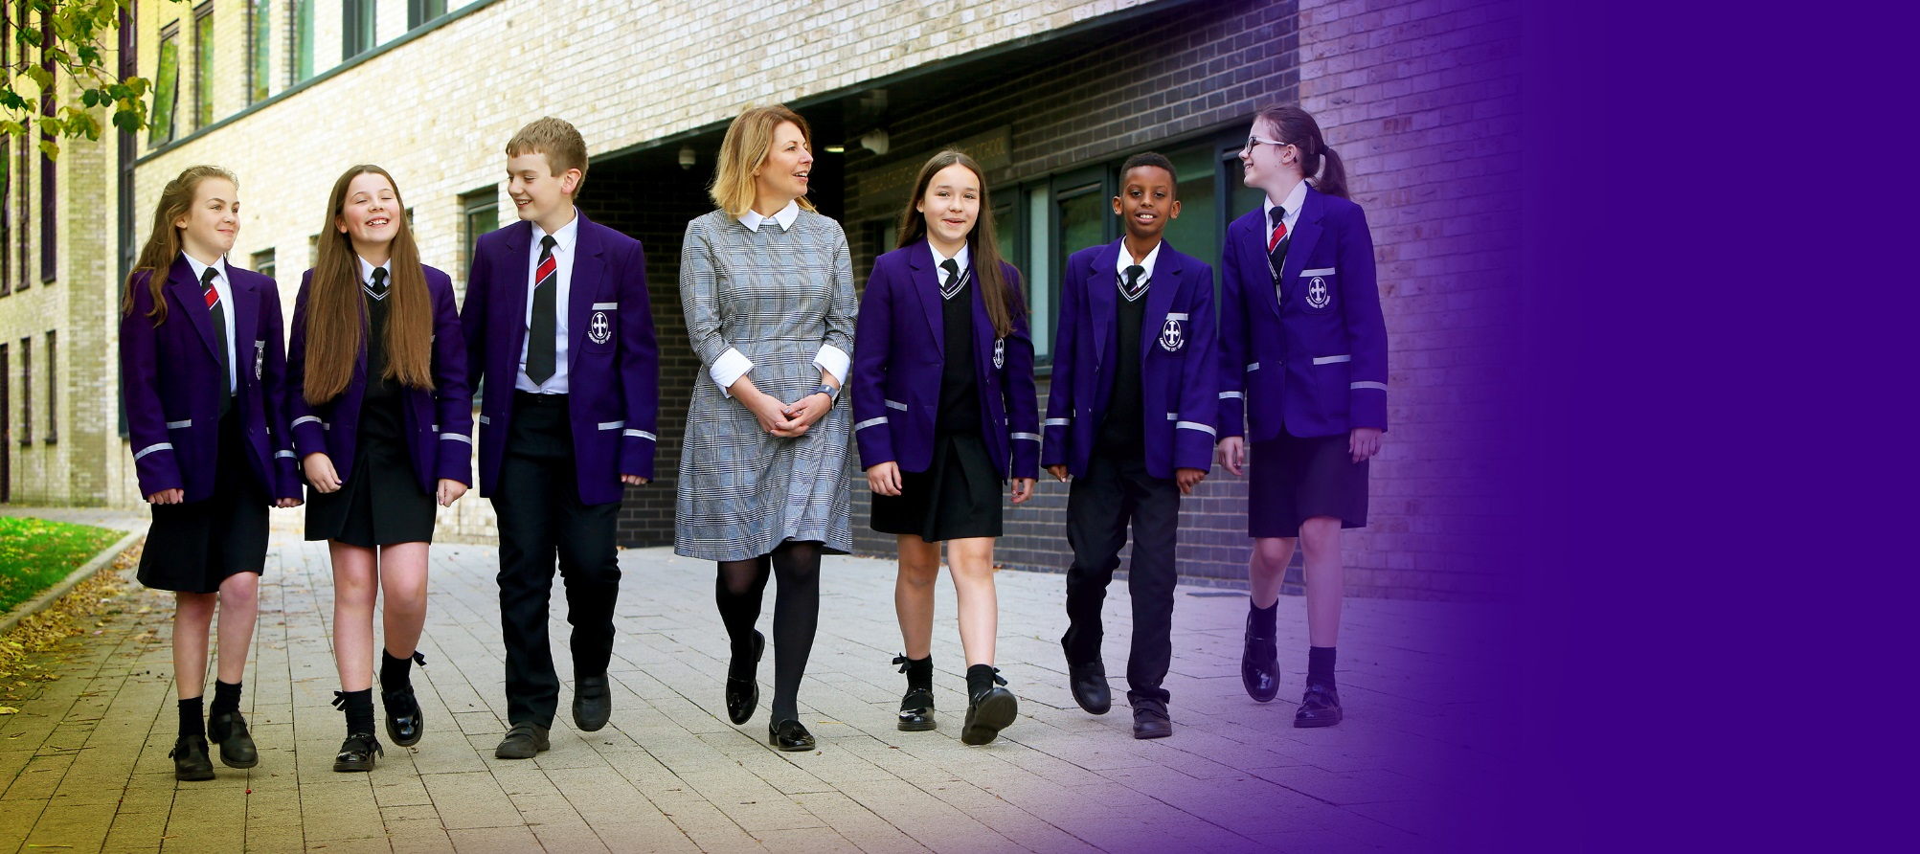

**St Hilda’s CE High School**

Croxteth Drive, Sefton Park, Liverpool L17 3AL

T: 0151 733 2709 E: info@st-hildas.co.uk I: www.st-hildas.co.uk

**Mrs J Code**  
BA (Hons), NPQH, FCCT

Headteacher

WISDOM  
HOPE  
COMMUNITY  
DIGNITY  
EQUALITY

