March 2021

Dear Applicant,

**ALFRISTON SCHOOL**

**Role:** Head of Mathematics

**Salary:** Leadership Pay Range 1–6 (£43,356 - £48,901)

**Hours:** Full Time / Permanent

**Required to Start:** As Soon As Possible

Are you an outstanding Mathematics Teacher who is looking for a new challenge and would Head of Mathematics in an outstanding special school be of interest to you?

If you are looking for a Head of Mathematics post and think that you have the skills and aptitude to inspire and motivate children with special needs then why not come and join us and lead our department to new heights.

Our school is an outstanding Special School Academy, and we are committed to ensure that all our pupils become the best that they can be and they can enjoy and achieve in all that they do. Our teachers have a strong sense of commitment and use their excellent subject knowledge to provide interesting and creative lessons in which all pupils learn well. They have high expectations of their pupils and develop good supportive relationships and a positive learning atmosphere where the girls can thrive. We cater for a wide range of abilities up to and including lower level GCSE standard.

We are currently seeking a successful, inspirational and highly motivated Mathematics Teacher to lead this vital department. The successful applicant will be an outstanding Mathematics Teacher, with strong leadership skills and a desire to innovate and further develop the department. You will be leading a small team of teachers and support staff and working with motivated students who love learning.

A strong desire to develop skills for living in preparation for adulthood within the context of the practical application of mathematics in everyday life would be an advantage.

**To Apply:** Please visit our website [www.alfristonschool.com](http://www.alfristonschool.com) to download and complete the application form, please send a supporting cover letter with your application. All applications are to be sent via email to [recruit@alfristonschool.com](mailto:office@alfristonschool.com) for the attention of Mrs Ellie Davison.

**Closing Date for Applications:** Monday 19th April 2021 at Midday

**Interview Date:** Thursday 22nd April 2021

Yours sincerely

Jinna Male

Headteacher

**ABOUT THE SCHOOL AND STAFF**

Alfriston is an outstanding Special School with Academy status for girls aged 11-19 with moderate learning difficulties and speech and language and communication difficulties. We currently have 150 girls on roll. All the pupils have an Education Health Care Plan and are taught in small groups and with additional support. Our staff are specialist subject teachers and are experienced in working with a range of special needs and abilities.

Pupils attend Alfriston from all over Buckinghamshire and some neighbouring counties. We also have weekly boarding provision for 20 pupils.

We consider the staff team as our most valuable resource. Training and development is a high priority in the school. There is also personal support given to staff to manage the diverse and challenging work needed to support pupils with significant special needs. At present there are 60 staff employed at the school working in the teaching, support, residential and administrative teams. We are proud of the excellent standard of education provided at Alfriston.

Our website is [www.alfristonschool.com](http://www.alfristonschool.com)

This school is committed to safeguarding and promoting the welfare of children which will be reflected throughout recruitment. The selected candidate will be required to provide suitable references and undergo an enhanced Disclosure and Barring Service (DBS) check before taking up the post.

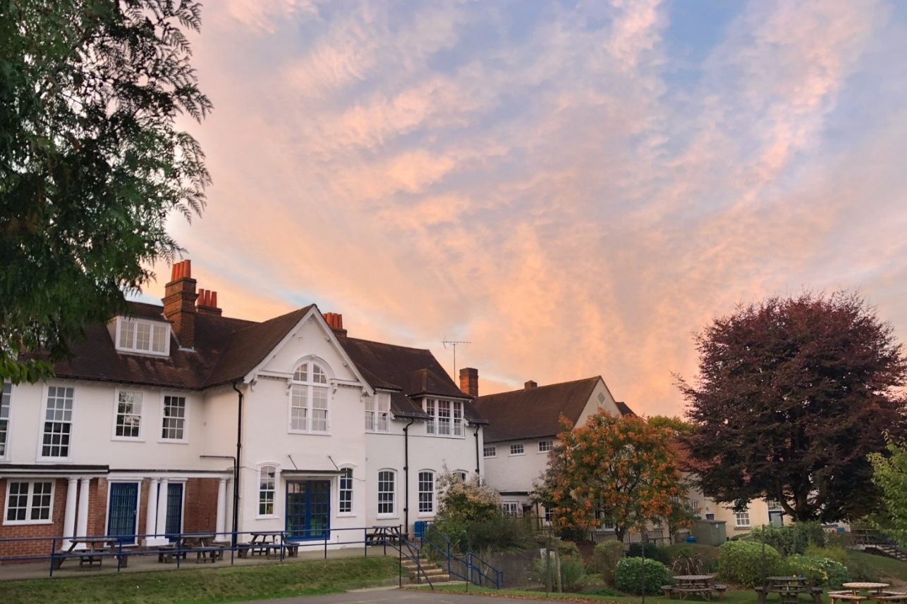

**JOB DESCRIPTION**

**JOB ROLE**: **HEAD OF MATHS**

**LINE MANAGER:** Headteacher

**JOB PURPOSE:** Leading and managing a departmental area (Mathematics)

This job description is provided to assist in the understanding and appreciation of the work content of this post and the role it plays in school. The post holder is required to undertake the professional duties and responsibilities of a member of the Leadership Group, as set out in the current School Teachers’ Pay and Conditions document.

**ROLE AND RESPONSIBILITIES**

**Core Duties**

* To promote the vision, mission and aims of the school, in line with school policies
* To provide professional leadership which secures the success and improvement of the school, ensuring high quality education and care for the pupils so that they are safe and happy at school, enabled to be successful learners and achieving high standards

**Responsibilities**

**Strategic Direction & Development of the School**

* To help embed the vision, values, ethos and ambitions of the school
* To keep up to date with and share knowledge of current issues in education
* To contribute to effective school self-evaluation and improvement planning

**Leadership & Management**

* To lead and manage the department team.
* To be responsible, with the Headteacher and Senior Leadership Team, for improving the quality of teaching and learning throughout the department, leading to all lessons being judged good or outstanding.
* To participate fully in the school improvement planning process, taking account of agreed whole school priorities and how these link with national and local initiatives.
* To work to a high standard in implementing agreed policies, priorities and expectations.
* To promote a culture of team work, in which the views of all members of the school community are valued and taken into account.
* To contribute to the self-evaluation of the school.
* To act as performance management leader for a group of teachers and support staff

**Curriculum & Development**

* To be responsible for the collection and analysis of student progress data in the department
* To contribute to the whole school cycles of assessment, recording and reporting including Annual Reviews; Academic Reviews and Parents Evenings.
* To promote a wide range of teaching and learning styles to enable students of all abilities to be appropriately challenged.
* To work with the Leadership Team in curriculum planning and design.
* To ensure that students work in a positive, stimulating environment where work is displayed and achievements rewarded.
* To ensure all courses provide equality of opportunity to all students whilst meeting their needs.
* To keep up to date with the requirements of examination syllabi and to attend relevant training courses.
* To organise appropriate educational or extra-curricular visits as appropriate to your department.
* To advise the examination co-ordinator in making arrangements for externally validated exams.
* To oversee the allocated budget and resources for your department
* To ensure that equipment is stored safely and that school Health and Safety policies are observed.

**Teaching & Learning**

* To provide a consistently outstanding role model and play a major role in the development of high quality teaching and learning throughout the school
* To co-ordinate and manage a curriculum subject across the school with a timetabled teaching commitment
* To promote the effective management of pupil behaviour and safeguard the welfare of pupils and staff

**Pastoral & Community**

* To communicate to students the values, standards and expectations of the school.
* To contribute to the life of the community according to individual talents and skills, including a willingness to undertake the organisation of extra-curricular activities.
* To participate in the arrangements made for the supervision and safety of the students between lessons and during unstructured times.
* To attend scheduled meetings with colleagues and parents and carers.
* To promote the department and the achievements of the students within the wider community.
* To ensure that student progress targets inform curriculum planning.
* To assist with a Pastoral Tutor group programme.

**Other Duties**

* To support pupils by ensuring that the needs and priorities for individuals are widely disseminated
* To create and maintain an effective partnership with parents to support and improve pupils’ personal development and achievement
* To build effective links with other special schools, mainstream partners and the local community and to develop outreach, in-reach and inclusion opportunities
* To undertake other such duties as may be reasonably required.

**PERSON SPECIFICATION**

**FACULTY LEADER, MATHEMATICS**

|  |  |  |
| --- | --- | --- |
| **Criteria** | **Desirable** | **Essential** |
| **Qualifications** | | |
| Qualified Teacher status |  | **🗸** |
| **Experience** | | |
| Able to demonstrate successful teaching experience with evidence of exemplary practice. |  | **🗸** |
| Evidence of taking the lead in preparing, implementing, monitoring and reviewing a whole school policy or a major change in school |  | **🗸** |
| Experience of successfully overseeing the planning, implementation and review of a significant curriculum development initiative |  | **🗸** |
| Experience of Data analysis and tracking pupil progress |  | **🗸** |
| Recent successful experience of a leadership role, including experience in leading teams | **🗸** |  |
| Proven experience in performance management of staff | **🗸** |  |
| Experience of working with partners including school Governors | **🗸** |  |
| Experience of teaching in a special school | **🗸** |  |
| Experience of working with and developing links with the community | **🗸** |  |
| **Knowledge & Understanding** | | |
| Knowledge of national educational standards and expectations for Mathematics |  |  |
| Substantial knowledge and understanding of teaching and learning at KS3/KS4 |  | **🗸** |
| Knowledge of special educational needs | **🗸** |  |
| Knowledge and understanding of data analysis, ability to use data to set targets for improvement and evaluate an action plan in relation to those targets | **🗸** |  |
| Confident in department or curriculum self-evaluation | **🗸** |  |
| Up to date knowledge & understanding of the current national education agenda |  |  |
| Understanding of the contribution of the school to the community | **🗸** |  |
| Understanding of how children with MLD/SLCN learn and effectively apply their learning |  | **🗸** |
| Knowledge and understanding of teaching and learning at Post 16 | **🗸** |  |
| **Leadership Skills** | | |
| Evidence of highly effective teaching |  |  |
| Be capable of setting and achieving ambitious goals for students and staff |  |  |
| Demonstrate strategic thinking and leadership, a commitment to creativity, innovation and the use of new technologies |  |  |
| Have the ability to build relationships with colleagues and parents |  |  |
| The ability and skills to mentor, challenge, influence and motivate others to attain high goals |  |  |
| Experience of observing and feeding back to staff on teaching and learning in order to ensure continuous improvement of the teaching and learning across the academy |  |  |
| Ensure health and safety of self and others |  | **🗸** |
| Experience of overseeing the delivery and development of part of the school curriculum |  | **🗸** |
| Experience of leading CPD including staff meetings and when appropriate providing support to colleagues who are required to organise staff meetings |  | **🗸** |
| **Decision-making Skills** | | |
| Ability to investigate, resolve problems and make decisions |  | **🗸** |
| Collect and weigh evidence, make judgements and take decisions in line with good educational practice |  | **🗸** |
| Think creatively and imaginatively to solve problems and identify opportunities |  | **🗸** |
| **Communication Skills** | | |
| Personal quality: The ability to communicate clearly and take into account, where appropriate, the views of others |  | **🗸** |
| Professional quality: Effectively communicate orally and in writing to a range of audiences |  | **🗸** |
| **Self-Management Skills** | | |
| Ability to plan time and organise work effectively. This will include an ability to: |  | **🗸** |
| * Prioritise and manage time |  | **🗸** |
| * Work under pressure and meet deadlines |  | **🗸** |
| * Be self-motivating and set personal goals |  | **🗸** |
| **School Ethos** | | |
| Be able to demonstrate an understanding of the Headteacher’s responsibility for child protection and Safeguarding. |  | **🗸** |
| Capacity to influence others |  | **🗸** |
| Ability to support and help develop a vision for high quality education which promotes spiritual, moral and cultural development |  | **🗸** |
| Ability to ensure that the school atmosphere is welcoming and that parents are encouraged to take an active part in the life of the school and their child’s education |  | **🗸** |
| **Personal Attributes** | | |
| Adaptability to changing circumstances & ideas |  | **🗸** |
| Energy and enthusiasm |  | **🗸** |
| Reliability and integrity |  | **🗸** |

This school is committed to safeguarding and promoting the welfare of children which will be reflected throughout recruitment. The selected candidate will be required to provide suitable references and undergo an enhanced Disclosure and Barring Service (DBS) check before taking up the post.