**Head of MFL**

**Central Lancaster High School**

Dear applicant

Thank you for your interest in joining the community at Central Lancaster High School. Central Lancaster is part of The Bay Learning Trust, a community of like-minded schools. We serve our community to enable pupils to flourish and achieve excellence. The Trust was established by Ripley St Thomas Church of England Academy in 2017. You can find out more about our Trust by visiting our website:[The Bay Learning Trust](https://www.baylearningtrust.com/)

We are a small and friendly secondary school at the heart of our community. Our core values are Commitment, Creativity and Community. We are looking to recruit a Head of MFL. The role is a pivotal one in supporting the key functions of our school in order to support the effective delivery of the curriculum to our pupils.

We were judged ‘good’ in all areas by Ofsted in September 2023. A copy of the report can be read here: <https://reports.ofsted.gov.uk/provider/23/147260>

We have also completed work our £8 million new build which houses five science labs, technology workshops and a catering room alongside a suite of English and maths classrooms.

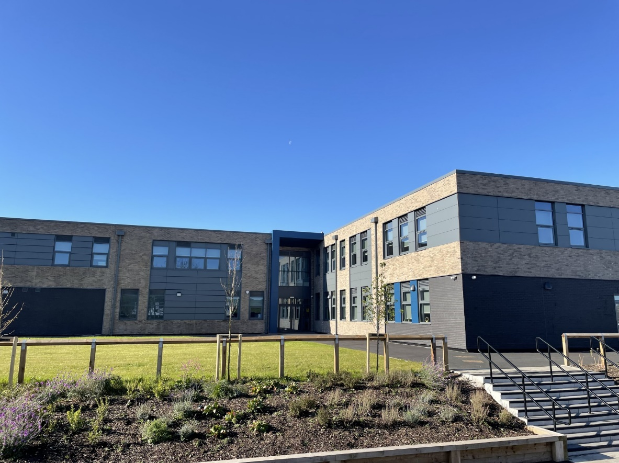

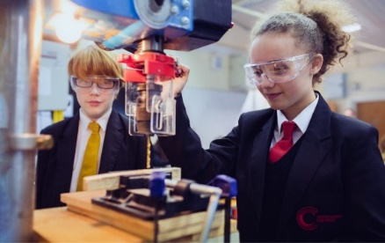

You will be a classroom practitioner with a record of excellent outcomes for pupils in your care and you will be able to articulate a strong understanding of the MFL curriculum and its effective implementation. The ideal candidate will be an aspirational middle/senior leader who has a passion for supporting **all** learners in fulfilling their potential.

In return we can offer you excellent training and development opportunities across the Trust and a friendly and welcoming staff. If you would like to have an informal, confidential conversation about the role, or to visit our school and speak with our pupils and staff, please contact us on [recruitment@lancasterhigh.lancs.sch.uk](mailto:recruitment@lancasterhigh.lancs.sch.uk)

Yours faithfully



Victoria Crossman

Acting Headteacher

Central Lancaster High School