HOLY TRINITY
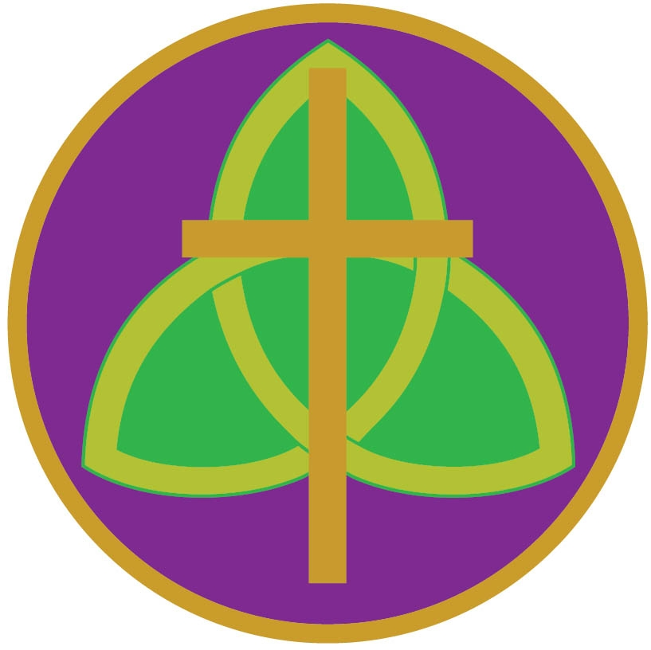
A learning community providing Catholic and Church of England education for all
Headteacher: Mrs L. Oldcorn
Carlton Road, Barnsley, S71 2LF
Tel: 01226 704550 / Fax: 01226 286798
Email: info@holytrinitybarnsley.org
Website: www.holytrinitybarnsley.org

The Governors seek to appoint:

HEAD OF MFL (MPS/UPS + TLR2B)
To commence April 2022

At Holy Trinity, the leadership team, staff and governors are completely focused on nurturing each individual in order that they reach their full potential. We are determined to raise standards for our pupils and to develop independent, aspiring and caring young people.
You will be joining a school at a time of innovation, development and rapid improvement, building on our strong foundation of care, commitment and challenge. Staff are valued and supported to grow as professionals and students to aspire to achieve at the highest level. Outstanding relationships underpin our cohesive and forward looking community. Staff and pupils are proud to be part of our school.
Holy Trinity is a 3 – 16 Catholic and Church of England through school which opened in September 2012 in a purpose-built, state of the art building. We have a 470-place primary phase and a 700-place secondary phase. Our 3 – 16 through-school status offers exciting and innovative learning opportunities which enhance progress and create a seamless transition between Key Stages 2 & 3. Our Catholic and Church of England values form our distinctive Christian ethos, and this guides and supports everything we do in school.

We are seeking an enthusiastic, experienced teacher; passionate about teaching and learning with the determination to drive our school forward. As Head of MFL, you will lead the MFL team to develop outstanding provision from Y4-Y11. You will lead the intent, implementation and drive standards up further to impact the outcomes of our learners positively in MFL. You will enthuse pupils and staff and enrich the experience pupils receive both inside and outside the classroom. Your vision will raise standards and create outstanding life chances for our pupils.

You will be joining a supportive, forward thinking MFL department which is committed to working as a team, to continuous professional development and to high levels of progress for our pupils. In 2019, our school Progress 8 score was positive and the MFL VA above National. Disadvantaged VA was above like-for-like. Last year, 61% of pupils achieved grade 4+ in French.

- Are you interested in working in an innovative and forward-thinking environment?
- Are you a child-centred person who wants to harness the enthusiasm of our young people?
- Are you a hard-working, positive and resilient individual who is passionate about driving the development of our young people?

If so, we want to hear from you.

Closing date: Friday 11th February 2022, 9am
Interviews: W/C 14th February 2022

An enhanced DBS check is required for this post. The successful candidate will be required to complete a Disclosure & Barring Services form in line with Section 115 of The Police Act 1997.

Further information and application forms are available online at www.holytrinitybarnsley.org. All CES application forms should be returned to Holy Trinity School marked for the attention of Mrs L Bristow-Wogan, PA to the Headteacher.

