Primary, Secondary & Sixth Form

“A SCHOOL FOR EVERYONE…” Ofsted 2020
Head of Modern Foreign Languages with responsibility for Leading Teaching and Learning in Languages

An Introduction to Washwood Heath Academy
Washwood Heath Academy is a large All-Through Academy with over 1700 learners, ranging from Reception age children right up to Sixth Form students.
We are extremely proud of the ambitious, broad and balanced curriculum we offer to all of our learners. We are committed to providing children with the best life chances possible, irrespective of their background or starting point. We deliver the most powerful knowledge-rich curriculum to our learners with the view to their development as global citizens able to make a positive contribution in the local and wider communities of the future.

Our pastoral system is at the heart of everything we do at Washwood, with students being assigned to one of seven houses within school – each with its own designated colour and name. We have one House dedicated to Year 11 students, so that the pastoral team, supported by Academic Mentors, can target support and guidance specifically towards the needs of these students as they reach this critical time in their education. In the Primary Phase, our learners experience the different Houses before joining a House permanently in Year 7.

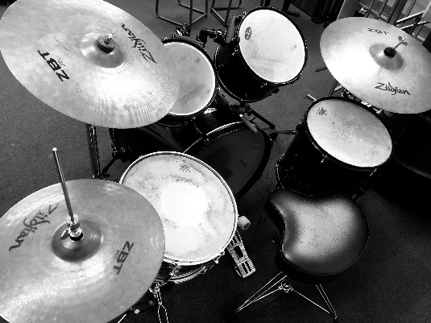
At Washwood Heath Academy, we believe in creating and sustaining a positive and uplifting culture for all of our children and we also do this for each other as well. There is a caring and nurturing environment which aims to develop all of our core HEARTS values: Happiness, Excellence, Achievement, Respect, Resilience, Tolerance and Self-Belief. We go above and beyond to ensure that everybody within our school community feels respected, challenged, supported and safe. We believe in being: Ready, Respectful and Safe and we expect all visitors to our school to uphold our three rules. We aim to equip our learners with the right tools for them to achieve and we aim to provide them with the most effective environment that ignites curiosity and wonder throughout our their journey with us. We have been developing the links between our Primary and Secondary phases, with a particular focus on utilising the expertise of subject specialists in Secondary and the extensive facilities in the school. Primary children have access to music rooms, Science Labs, Language teachers, PE facilities, Drama studio, Art rooms and outside space – a real benefit to the all-through school.
We support our families in ensuring that they too, can provide the right environment for our children to learn effectively and to grow securely both emotionally and mentally. Together as one school, Washwood Heath Academy provides a safe and caring environment for our learners led by highly-effective staff whose main aim is to ensure a continuing ethos of resilience and respect in learning.
In March 2020, Washwood Heath Academy experienced its first Ofsted inspection as an All-through Academy and was graded ‘Good’ in all categories. Ofsted reported that ‘Leaders have a clear and ambitious view of what pupils should learn. They have reviewed the curriculum, and made changes in short and longer term’.
In September 2019, Washwood Heath Academy embarked on its journey to develop and implement a knowledge-rich curriculum across all phases of the Academy. To date, we have embedded a knowledge-rich curriculum into Key Stage 3 and Key 4 subject areas and work is still very developmental in Primary and Key Stage 5. In addition, we have embedded Direct Instruction into Key Stage 3 and we are keen to introduce it into the Primary phase as a catch-up strategy. Staff at Washwood Heath Academy use research to help improve teaching and learning, curriculum and pastoral care.
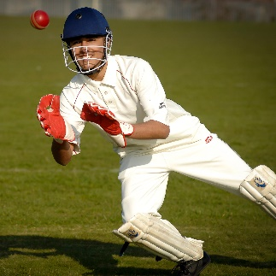
Washwood Heath Academy really is ‘a school for everyone’ and a significant number of staff have remained at Washwood for many years because they enjoy being part of a family and working in a caring and supportive community that wants the best for all of its young people and staff.
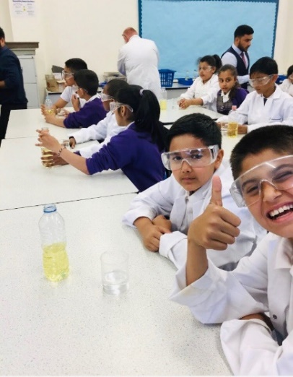
JOB DESCRIPTION
Job Title: Head of Modern Foreign Language – All Through School and Modern Foreign Languages Teaching and Learning Lead.

Salary Scale: Main Scale + TLR 1b (£11,811)

Reports to: Head of Academy and Deputy Head of Academy

Core Purpose:
To lead, develop and manage a team of staff in delivering high quality teaching and learning and high standards of achievement and attainment for all learners studying languages, across all key stages. To oversee the development of teaching practice within the Modern Foreign Language Department and support with whole Academy teaching and learning CPD. Promote and maintain good behaviour and positive learning across Modern Foreign Language lessons.

Job Description

The duties outlined in this job description are in addition to those covered by the latest ‘School Teachers Pay and Conditions’ document. The job description will be reviewed regularly to reflect or anticipate changes on the job, commensurate with the salary and areas of responsibility

The post holder will:
- Help to deliver the Academy’s vision and translate into practice
- Ensure that all the Academy policies are implemented
- Foster a learning culture with high expectations in a safe and secure learning environment
- Be responsible for the self-evaluation of their subject and produce and lead on the subject development plan taking responsibility for all aspects within it and sharing with members of the Department

SPECIFIC RESPONSIBILITES
Lead Strategic Direction by:
- Delivering their vision for the subject and ensure all teachers within their subject buy into it
- Lead on standards and student outcomes within the Department and Language lessons taught in other phases
- Work with Subject Lead in Primary to ensure good delivery of Languages curriculum and effective teaching and learning
- Develop and sustain high quality teaching and learning throughout the Department/Phases
- Create and own the curriculum Intent for Department and phases, working with the team to ensure effective Implementation which produces clear Impact
- To ensure that the curriculum offer within Languages meets the needs of the learners
- To lead on all aspects of Languages, keeping up to date with new and relevant information
- To ensure an effective Languages enrichment offer is available for all learners across the Academy
- To lead good pedagogy practice within Languages and sharing where appropriate with other subject areas
- To develop and support staff within the subject to ensure they are effective in the classroom
- To attend Middle Leaders meetings and participate in developing strategies for improvement and sharing
- To ensure Languages learning outcomes and vision are shared across the Academy
- To coordinate the Modern Foreign Languages subject CPD programme to ensure all teachers have appropriate training and support
- To lead on sharing good practice developed within the Modern Foreign Languages Department
- Work closely and effectively with outside agencies providing creative learning experiences across the Academy
- Communicate the impact of working with outside agencies with the academy, staff and parents/ carers
- Ensure all teachers implement the use of Show My Homework online resource in line with the Academy Homework Policy
- To lead on any Languages Curriculum Days including the organisation and delivery
- To ensure an engaging and varied curriculum is offered at all key stages to ensure all learners have a quality education experience
- To continuingly assess the Modern Foreign Languages curriculum offered at all key stages and adjust it to suit the needs of the learners
- To provide a rich extra-curricular provision that is accessible to all learners in the Academy
- To manage the Department budget and possible funding opportunities.

Teaching and Learning (Head of Department)
- To monitor standards of achievement through regular monitoring, review and evaluation
- To monitor the progress of all learners and classes in Languages – including those able and talented, with special educational needs and to ensure the right support is put in place
- To ensure that learners in Languages are set challenging targets and that they are shared with learners and reviewed on a regular basis
- To ensure that the quality of lesson plans, the use of assessment and homework set are of the highest quality
- To develop positive approaches to teaching and learning so that learners have every opportunity to become confident and positive learners, enthusiastic about their own progress and place in society
- To support colleagues within Languages so that appropriate standards of behaviour are established and maintained
- To develop, implement, monitor and review schemes of work regularly to ensure that they are up to date and consistent with the Academy’s framework
- To develop, implement, monitor and review the use of new technologies within Languages
- To analyse learner data and work with staff within the subject to ensure learners achieve their potential
- With the Assistant Head responsible for Raising Standards, identify learners who are underachieving and where necessary create and implement effective plans to close the gap.

Teaching and Learning – Leading Teaching and Learning in Languages (LTL)
- To contribute to raising standards of student attainment by developing and improving the quality of teaching and learning within the designated curriculum area (faculty) including strategies to improve links between curriculum areas.
- To research and promote innovative and creative approaches to teaching and learning, including in enrichment activities, which secure student engagement and progress
- To support the other Middle Leaders with ongoing development of a Knowledge-rich Curriculum. To include contributing to; schemes of work, resources, knowledge books, knowledge organisers, assessment materials, model answers and any other strategies which promote high quality learning in the designated curriculum area (faculty) and sharing models of these.
- To provide support to colleagues through producing and disseminating high quality teaching materials
- To support the induction and where appropriate mentoring of new staff, ITT students, NQTs as required within the faculty and any colleagues who require or request support
- Collaborate with the Assistant Head (T&L), Head of Faculty/post-holders to organise, carry out and review all aspects of the monitoring of teaching and learning.
- To be a member of the relevant working group within the school and to liaise with colleagues in the WHMAT and other partnerships as appropriate and any other external partners
- To have extensive knowledge and understanding of the subject areas within their faculty and related pedagogy gained through whole school or wider professional networks associated with the subjects in their faculties e.g. examination boards
- Attend after school team meetings with Assistant Head & Lead Practitioners
- Deliver fortnightly Faculty T&L briefings as directed by Lead Practitioner for CPD
- Deliver subject specific pedagogy/ knowledge CPD (dates on calendar)
- Support as required with whole school T&L CPD
- Keep up to date with current research relating to Teaching & Learning and their subject area. Share relevant professional reading with T&L team and their Faculty
- Proactively seek out CPD opportunities (ResearchEd, T&L blogs, TES Ed and so on).

To develop an effective team by:
- Creating a climate which enables all staff to develop positive attitudes towards the subject and confidence in teaching it
- Establishing clear expectations and constructive working relationships with all staff
- Helping staff to achieve constructive working relationships with students by implementing the school behaviour policy
- Coaching staff through Professional Growth and using the process to develop staff effectiveness
- Ensuring that trainee and newly qualified teachers are appropriately trained, monitored, supported and assessed
- Chairing departmental meetings, setting agendas and ensuring the effective dissemination of outcomes
- Attending calendared meetings, contributing to discussions and implementing agreed actions.

Achievement
- To lead on data analysis of external and internal data to provide exam data analysis and reports
- Drive the department Improvement Plan for Modern Foreign Languages by indicating and including current trends and continuous assessment; share the strategic overview; identify priorities
- Anticipate and respond to National Agenda, e.g. curriculum and performance measures.
- Keep up to date on national trends and monitor progress against national expectations.
- Develop report to be shared with line managers, on half-termly basis, after each data collection with overview of KS3 and KS4 achievement.
- Ensure all underachieving students, after each data collection and external result publication, are identified and receive appropriate, high quality intervention

Management of the Academy
- To undertake any professional duties delegated by the Head of Academy
- To apply best value for money principles to secure resources for Languages and ensure they manage the budget effectively
- To ensure that the accommodation provides a positive and safe environment which promotes wellbeing and high achievement for all in the Academy
- To use every opportunity to create a positive and memorable learning environment within Languages
- To support the Senior Team in any performance management needs within their subject area

Community and Partnerships
- To work closely and in partnership with the Senior Leadership Team to ensure the successful ongoing development of the Academy
- To assist in the appointment of staff following the Safer Recruitment Policy
- To create and maintain good working relationships among all members of the Academy community
- To work with the SENCO to ensure that Individual Education Plans, behaviour and other contracts are implemented to match students’ needs within Languages
- To line manage teachers within Languages
- To line manage non-teachers such as Curriculum Assistants and Teaching Assistants within Languages

VARIATION IN THE ROLE
Given the dynamic nature of the role and structure of Washwood Heath Academy, it must be accepted that as the Academy’s work develops and changes, there will be a need for adjustments to the role and responsibilities of the post. The duties specified above are therefore not to be regarded as either exclusive or exhaustive. They may change from time to time commensurate with the grading level of the post and following consultation with the post holder.

Education/ Qualifications  PERSON SPECIFICATION | Essential | Desirable
QTS status | √
Degree/post graduate study (specialising in French or Urdu). | √
High Academic achievement (Further degree/qualification) |  | √
Evidence of continuous INSET and commitment to further professional development. |  | √
Good knowledge of current research relating to teaching and learning | √
Experience, Knowledge and Understanding
Specialist subject knowledge of KS3, 4 and 5 Art curriculum and experience teaching it. | √
Experience MFL students aged 11-16. | √
Specialist subject knowledge and experience teaching GCSE Languages with evidence of sustained performance over time improving results. | √
ICT Competence and interest using ICT in the classroom. | √
Experience of successful, varied, creative and specialist teaching. | √
Experience of managing a budget. | √
Experience of leading on whole school initiatives |  | √
Experience and a willingness to contribute to the whole school enrichment programme. | √
Specialist subject knowledge of Primary Language Curriculum |  | √
Recent, relevant in-service training in current educational practice, including management. |  | √
Experience of teaching Higher ability pupils |  | √
Experience of teaching SEN and EAL pupils. |  | √
Experience of organising and developing the MFL curriculum in KS3, 4. | √
Leadership experience within a MFL department. |  | √
Experience of delivering MFL at primary school level. |  | √
Know how to use data, together with information about students’ prior attainment to set targets for improvement. |  | √
Skills and Abilities
The ability to plan, monitor, evaluate, review and lead by example across the MFL subject area. | √
Ability to manage raising achievement and intervention strategies in MFL | √
Ability to lead a team of MFL teachers and technicians. | √
Ability to take responsibility for continuous professional self- development | √
The ability to solve problems and make decisions. | √
The ability to inspire students and staff. | √
The ability to work under pressure and meet deadlines. | √
The ability to use ICT appropriately | √
The ability to analyse, understand and interpret relevant information and data | √
Communicate a clear vision for MFL in the future. |  | √
Experience of GCSE marking for an Exam Board. |  | √
Experience of holding other post holders to account. |  | √
Attributes/ Other
Self-confidence and initiative. | √
Reliability, resilience and integrity. | √
Energy, enthusiasm and imagination. | √
Intellectual ability. | √
Awareness, understanding and commitment to equal opportunities. | √
Personal impact and presence. | √
Willing to contribute to the wider life of the school. |  | √
Interests and experiences outside of teaching. |  | √

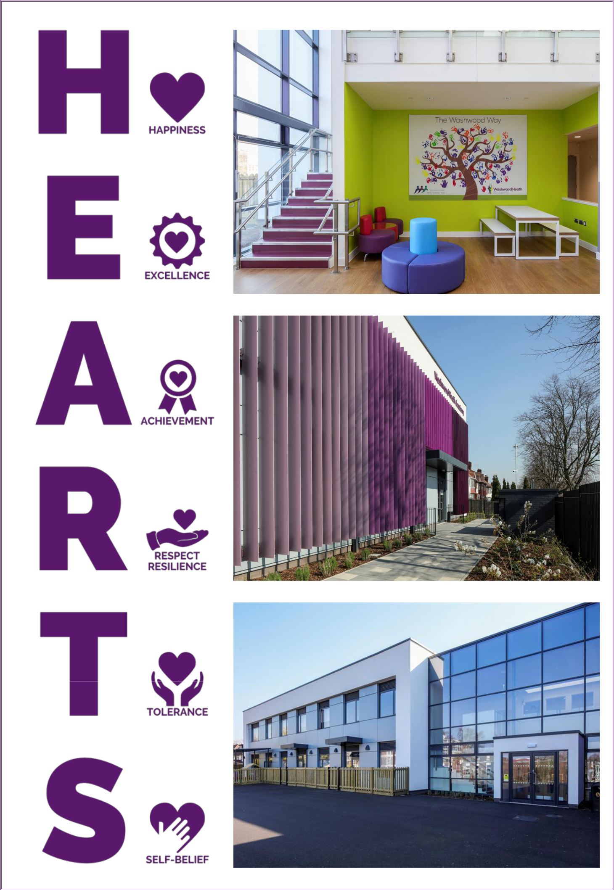

Primary, Secondary & Sixth Form

