Application Pack
Head of Music

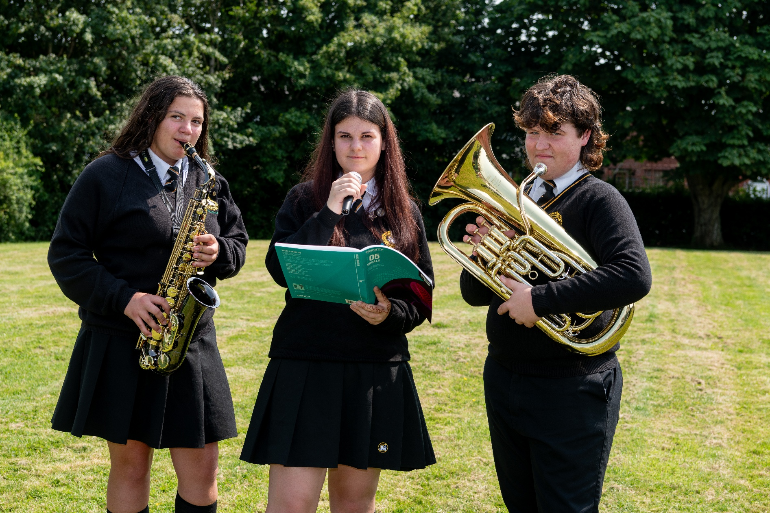

Contents

 | Page
Headteacher | 3
Our Vision | 4
Our Values | 5
How to apply | 6
About the role | 7
Job description | 9
Person specification | 13

Mrs J Hoyle
Headteacher
At Ashton, we are incredibly proud of our school and its successes. We make no secret of striving for excellence in every aspect of school life for all our students. Our school motto declares that we are “A School to be Proud of” and this underpins our ethos.
We provide a unique way to give students the opportunities to learn they deserve from 11 to 16, and to equip them with the attitudes, skills and knowledge that they will need to lead successful lives. We want our students to have ambition and aspirations, to stretch themselves and to reach further than they ever thought possible, we have a student-centred approach to all that we do, which ensures that students are placed at the very heart of the decisions we make and the actions we take.
We expect all our students to succeed both academically and socially and we support them in this journey so that they can take their place in adult life well prepared.

We place particular emphasis on members of the school community being part of the school family. With over 800 students on roll, we are relatively small, which allows us to get to know our students very well, to focus on their individual needs and work in real partnership with parents and carers.

Our Vision
At Ashton, we are resolute in wanting the best for every child. We hold high standards and expectations for all, from all, underpinned by a no-excuses mindset. We believe that every student deserves to feel valued, supported, and inspired to attend school and engage with what is offered every day.
We aim to create a supportive and challenging environment where every individual can aspire, enjoy, and achieve. We are committed to fostering a culture where students want to be present—where attendance is not only expected but encouraged through meaningful relationships, engaging learning experiences, and recognition of effort and success.
Our staff lead by example, demonstrating passion for their subjects and dedication to the school community. We support this with high-quality professional development which ensures all our staff stay at the forefront of research informed practice.
We are a “School to be proud of,” and our ethos—built around creating an acronym from the word PROUD—reflects our belief that every member of our school family plays a vital role in our collective success. We work closely with parents, carers, and families to ensure that the interests of the child are at the heart of everything we do. PROUD gives us a strong set of values and lays a solid foundation for life as well as school.

P- Punctual
R-Responsible
O-Organised
U-Uniform
D-Determined

Our Values
We are developing students who understand their responsibilities within the school, local, and wider communities, and who are motivated to make a positive contribution. Our PROUD ethos provides a moral compass for both students and staff:
To help this we have developed the following guiding principles to achieve our vision-
- Our environment must be inclusive. Students must feel safe, supported and motivated to attend. This is our number one priority.
- We work in close partnership with parents, carers, and families.
- We insist on mutual respect and the highest standards of behaviour.
- We have a relentless pursuit of excellence in teaching and learning.
- We offer a rich curriculum and a wide range of extra-curricular opportunities.
- We celebrate attendance, effort, and achievement to build confidence and pride.
- We believe in continuous improvement for both staff and students.
- We value examination performance and personal growth equally.
- We promote collaboration and teamwork at every level.
- We believe raising capability is the key to future success.


How to apply
To apply for the position at Ashton Community Science College, you would:
Go to our “Job Vacancies” page and download the appropriate application form (there are separate forms for teaching and non-teaching (support) roles.)
Complete the form carefully, following any guidance notes included, and make sure any required background-checks documentation (e.g. DBS, right-to-work) is prepared.
Submit your completed application electronically, (via an email address provided in the vacancy posting). If included, attach any additional documents requested (such as a cover letter, references or evidence of qualifications).
POINTS TO BEAR IN MIND BEFORE YOU START
• Look carefully at the job description and application form. Ask yourself why you are interested in the job. Don’t copy the same application for a series of jobs.
• Read the Person Specification carefully. This outlines the type and range of skills/experience etc. that we would like the candidate to possess or have the potential to develop.
• Try to complete the form in a concise, well organised and positive way.
• Please use the application form provided, continuing on a separate sheet if necessary. Please do not send standard details of your own, i.e. in the form of a curriculum vitae, unless specified in the advertisement.
• Please remember to complete the Monitoring Job Applicants Form as this is essential for the County Council to determine whether its Equal Opportunities Policy is working with regards to employment.

About the role
“Ashton Community Science College is a Good School”. (Ofsted 2023)
Due to the promotion of the current postholder, the Governors wish to appoint a committed, enthusiastic and well-qualified Head of Music to lead our music department as it moves into the next stage of its development. Ashton Community Science College is an 11-16 mixed school and was rated as Good by Ofsted in the last inspection in 2023.
Our goal is to be an outstanding High School and we are seeking to appoint an enthusiastic, well qualified teacher to teach across the full ability and age range, who is committed to raising standards by inspiring learners. If you believe that young people deserve nothing less than the best and have the passion, drive and ambition to make a difference as a leader in a creative subject area, you would be a welcome addition to our school family.
The successful candidate will:
· Be an excellent classroom practitioner with a proven track record of exam performance
· Have a strong commitment to engaging students of all abilities
· Be innovative and inspirational in their classroom delivery
· Have a strong desire to contribute to the extra-curricular life of the school
We welcome applications from experienced teachers who are ready for the next stage in their career development. They should have an enthusiasm for their subject and for working with young people, with a real interest in a wide range of teaching and learning approaches and enjoy working in, as well as leading, a team. A full programme of support is available as part of our commitment to investing in high-quality staff
ACSC is committed to safeguarding and promoting the welfare of children. The successful applicant will be required to provide a disclosure from Disclosure Barring Service before any appointment is confirmed.
Application documents are available to download in the vacancies section of the school website http://www.ashtoncsc.lancs.sch.uk/job-vacancies
Applications should be submitted electronically by 9am Monday 16th November.
Interviews will take place on Wednesday 25th November.
Covering letters should be no longer than 2 sides of A4, 12 point font using Century Gothic.
Please note we regret we are unable to contact individual applicants who may be unsuccessful at this time.

Job Description
Post: | Head of Music
Reporting to: | Line Manager as designated by the Headteacher
Responsible for: | The provision of a full learning experience and support for students
Working Hours: | 195 days per year – Full time
Salary/Grade: | Teachers pay scale plus TLR 2.1
Overview of Role
- To plan, implement and deliver an appropriately broad, balanced, relevant and differentiated curriculum for students.
- To monitor and support the overall progress and development of students as a teacher/Form Tutor.
- To facilitate and encourage a learning experience which provides students with the opportunity to achieve their individual potential.
- To contribute to raising standards of student attainment.
- To share and support the school’s responsibility to provide and monitor opportunities for personal and academic growth.
Main Core Duties – Teaching/Curriculum Development
Operational/strategic/planning
- To develop appropriate syllabuses, resources, schemes of work, marking policies and teaching strategies in the curriculum area and department.
- To lead the curriculum area and department’s development plan and its implementation.
- To plan and prepare courses and lessons.
- To contribute to the whole school’s planning activities.
- To deliver high-quality teaching and learning experiences.
Curriculum provision
- Ensure that the curriculum area provides a range of teaching which complements the school’s strategic objectives.
Curriculum development
- To carry out curriculum development and implement changes to ensure the continued relevance to the needs of students, examining awarding bodies and the school’s aims and strategic objectives.
Staff
- To take part in the school’s staff development programme by participating in arrangements for further training and professional development.
- To continue personal development in the relevant areas including subject knowledge and teaching methods.
- To engage actively in the appraisal process.
- To ensure the effective/efficient deployment of classroom support.
- To lead a designated team and contribute positively to effective working relations within the school.
Quality Assurance
- To help to implement school quality procedures and to adhere to those.
- To contribute to the process of monitoring and evaluation of the curriculum area/department in line with agreed school procedures, including evaluation against quality standards and performance criteria. To seek/implement modification and improvement where required.
- To review appropriately, methods of teaching and programmes of work.
- To take part, as may be required, in the review, development and management of activities relating to the curriculum, organisation and pastoral functions of the school.
Management Information
- To maintain appropriate records and to provide relevant, accurate and up-to-date information for SIMS, Synergy, on-line reporting etc.
- To complete the relevant documentation to assist in the tracking of students.
- To track student progress and use information to inform teaching and learning.
Communication and Marketing
- To communicate effectively with the parents of students as appropriate.
- Where appropriate, to communicate and co-operate with persons or bodies outside the school.
- To follow agreed policies for communications in the school.
- To take part in publicity and liaison activities such as Open Evenings, Parents Evenings, Celebration events and liaison events with partner schools.
- To contribute to the development of effective subject links with external agencies.
Management of resources
- To order and allocate equipment and materials.
- To identify resource needs and contribute to the efficient/effective use of physical resources.
- To co-operate with other staff to ensure a sharing and effective usage of resources to the benefit of the School, department and the students.
Students
- To be a Form Tutor to an assigned group of students.
- To promote the general progress and well-being of individual students and of the Form Tutor Group as a whole.
- To ensure the implementation of the school’s Pastoral System.
- To register students, accompany them to assemblies, encourage their full attendance at all lessons and their participation in other aspects of school life.
- To evaluate and monitor the progress of students and keep up-to-date student records as may be required.
- To contribute to the preparation of Action Plans and other reports.
- To alert the appropriate staff to problems experienced by students and to make recommendations as to how these may be resolved.
- To communicate as appropriate, with the parents of students and with persons or bodies outside the school concerned with the welfare of individual students, after consultation with the appropriate staff.
- To apply the behaviour management and rewards systems so that effective learning can take place.
Teaching
- To teach students according to their educational needs, including the setting and marking of work to be carried out by the student in school and elsewhere.
- To assess, record and report on the attendance, progress, development and attainment of students and to keep such records as are required.
- To provide, or contribute to, oral and written assessments, reports and references relating to individual students and groups of students.
- To ensure that ICT, Literacy, Numeracy and the school’s specialism are reflected in the teaching/learning experience of students.
- To undertake a designated programme of teaching as directed by the Headteacher.
- To ensure a high-quality learning experience for students which meets internal and external quality standards.
- To prepare and update subject materials.
- To use a variety of delivery methods which will stimulate learning appropriate to student needs and demands of the syllabus.
- To maintain discipline in accordance with the school’s procedures, and to encourage good practice with regard to punctuality, behaviour, standards of work and homework.
- To undertake assessment of students as requested by external examination bodies, departmental and school procedures.
- To mark, grade and give written/verbal and diagnostic feedback as required.

Other Specific Duties
- To play a full part in the life of the school community, to support its distinctive mission and ethos and to encourage staff and students to follow this example.
- To support the school in meeting its legal requirements for worship.
- To promote actively the school’s corporate policies.
- To continue personal development as agreed.
- Commitment to safeguarding and protecting the welfare of children and young people.
- To comply with the school’s Health and Safety Policy and undertake risk assessments as appropriate.
- To undertake any other duty as specified by STPCB not mentioned in the above.
- To maintain the highest level of professionalism at all times.
While every effort has been made to explain the main duties and responsibilities of the post, each individual task undertaken may not be identified.
Employees will be expected to comply with any reasonable request from a Leader or Manager to undertake work of a similar level that is not specified in this Job Description.
Employees are expected to be courteous to colleagues and provide a welcoming environment to visitors and telephone callers.
The School will endeavour to make any necessary reasonable adjustments to the job and the working environment to enable access to employment opportunities for disabled job applicants or continued employment for any employee who develops a disabling condition.
This job description is current at the date below, but following consultation with you, may be amended by the Headteacher to reflect or anticipate changes in the job or needs of the school.
Date: 23/10/2026

Personal Specification
Personal Attributes required (on the basis of the job description) | Essential (E) or Desirable (D) | To be identified by: (eg application form, interview, reference etc)
Qualifications  - Qualified Teacher Status  - Relevant Degree  - Further leadership qualifications | E  E  D | A  A  A
Leadership  - Evidence of successful leadership that led to positive outcomes  - Strong leader with a clear vision for faculty development and the passion and ability to drive that vision forwards  - Strong commitment to school improvement and raising achievement for all  - Evidence of use of data for self-evaluation and improvement strategies  - Ability to assess the strengths and weaknesses of music programmes of study  - High expectations for pupils learning and attainment  - Demonstrate an awareness of managing underperformance  - Evidence of use of quality assurance procedures including lesson observation, work scrutiny and student voice to ensure high-quality implementation of the curriculum  - Evidence of leading events within the music department  - Other whole school leading experience  - Understanding of finance and resource management | E  E  E  E  E  E  E  E  E  D  D | A/I  A/I  A/I  A/I  A/I  A/I  A/I  A/I  A/I  A/I  A/I
Teaching and Learning  - Proven track record of good examination outcomes sustained over a period of time  - Excellent classroom practitioner with an in-depth understanding of the relevant teaching and learning approaches that will maximise the progress of all pupils  - Ability to plan engaging and purposeful long-term and short-term units of study  - A working knowledge of assessment and target setting  - Ability to use assessment in a meaningful way to close gaps in learning, inform future retrieval and ensure all pupils make good progress  - Ability to use a range of different behaviour management techniques to create excellent climates for learning within classrooms  - A commitment to pastoral care as a positive support to learning  - Experience of leading sessions to develop knowledge of staff | D  E  E  E  E  E  E  D | A/I/R  A/I/R  A/I/R  A/I  A/I  A/I  A/I  A/I
Philosophy and Commitment  - Vision aligned with ACSC of high aspirations and high expectations of self and others  - An understanding of the strategies needed to establish consistently high aspirations and standards of results and behaviour and a commitment to relentlessly implementing these strategies  - A commitment to the responsibility to safeguard and promote the welfare of all students  - Evidence of continuing professional development  - Evidence of leading INSET or training  - Evidence of school-to-school support  - Ability to demonstrate an impact of CPD across the music department | E  E  E  E  D  D  D | A/I  A/I  A/I  A/I  A/I  A/I  A/I
Personal Qualities  - Excellent communicator – strong interpersonal, written and oral skills  - The ability to establish successful relationships at all levels and work as part of a team  - Drive, determination and self-motivation  - Commitment to contribute to the wider life of the school and the community  - Successful evidence of motivating staff and pupils  - Sense of humour  - Resilience  - Ambition  - Integrity | E  E  E  E  E  E  E  E  E | A/I/R  A/I/R  A/I/R  A/I/R  A/I/R  A/I/R  A/I/R  A/I/R  A/I/R

