
WALTHAMSTOW SCHOOL FOR GIRLS
CANDIDATE INFORMATION PACK

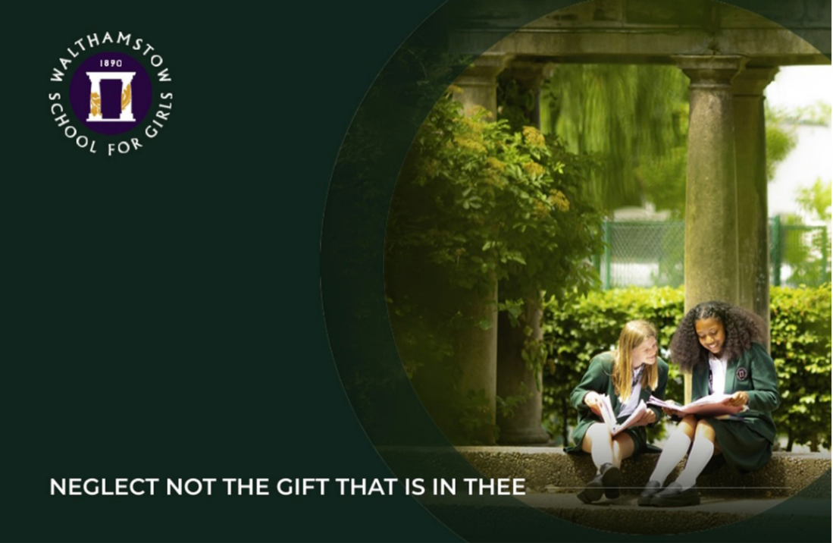

Walthamstow School for Girls
Church Hill, Walthamstow, London, E17 9RZ
0208 509 9446
www.wsfg.waltham.sch.uk

School Prospectus
https://www.wsfg.waltham.sch.uk/prospectus
School Improvement Plan
https://sway.office.com/8kD9HWBkxtkwJZUC?ref=Link

Candidates are encouraged to visit the school website for additional information:
https://www.wsfg.waltham.sch.uk/



Thank you for your interest in applying to Walthamstow School for Girls.
WSFG is an oversubscribed, highly successful state comprehensive, with a proud history of educating girls since 1890. We are passionate about education being a vehicle for promoting equality and our mission is to empower young women to become leaders of the future. Although we are an Outstanding School, achieve exceptional outcomes and have consistently been in the top 10% of schools nationally for progress, our focus is on developing exceptional young women, not just on academic achievement. We want to recruit staff who actively embrace diversity and inclusion and who are committed to social justice as part of the state comprehensive system.
We actively value staff and students: we are committed to their development and the contribution they make to shaping the future direction of the school. Our vision and values, created with a range of staff, students, parents and governors, along with our School Improvement Plan, demonstrates our commitment to staff and student wellbeing, distributed leadership and creating robust systems, founded on evidence-informed practice. I have included a summary in this pack so that you have a ‘flavour’ of our key priorities.
As you read through our prospectus and this information pack, you will see what a unique school we are: characterised by a commitment to developing lifelong learning, a strong sense of ‘family’ and community and our values of courage, compassion, aspiration and integrity.
Making the right choice of school is important at any stage in your career. We hope that this applicant pack provides you with an insight into our school which goes beyond reports and statistics. We are looking for someone who shares our values, is ambitious for young people and who is passionate about both their subject and the transformational power of education. If you are energetic, hardworking and want to inspire our students, we would love to hear from you.
We look forward to welcoming you.
Helen Marriott
Headteacher


OUR VISION AND VALUES:
WHAT DO WE STAND FOR?



Our school motto, ‘Neglect not the gift that is in thee’, expresses our desire to nurture the individual talents of every child. We achieve this through inspirational teaching and learning, exciting extra-curricular opportunities and strong partnerships with parents and carers.

Student and staff experiences when learning, working and leading at WSFG are underpinned by the principles of our school vision. Our vision is to:

- Foster a lifelong love of learning
- Look after ourselves and treat others with kindness and respect
- Embrace our diverse community and value our environment
- Empower everyone to make courageous choices
- Celebrate each unique gift

Our school values of courage, compassion, aspiration and integrity were developed by a group of stakeholders, including students. They sum up the character we seek to develop in everyone in our school community.

The logos for our school values were designed by students in year 10. We actively promote our values through the pastoral curriculum and assemblies, through our School Improvement Plan and our rewards system.



We understand that students cannot thrive without strong pastoral support. This begins with highly-skilled form tutors who get to know their tutees, work in partnership with parents and deliver stimulating tutor time activities. Experienced and knowledgeable Heads of Year support form tutors, students and families so that we can ‘bring out the gift’ in all of our girls. Where students need additional support, we have robust systems for meeting their needs, including planned interventions, our Wellbeing Hub, key workers, learning mentors and school counsellor.

WHY TEACH AT WSFG?

Walthamstow School for Girls is a fantastic and fulfilling place to work. This is reflected in our high staff retention rates, with a number of current staff having served over 20 years with us.
Our students are a pleasure to teach: they are keen to learn and grateful for the many opportunities afforded to them. As you walk around the school, you will see that there is a calm and productive atmosphere as students engage with the challenges of learning.
Heads of Faculty have a good deal of freedom to plan the curriculum in their area and teachers are encouraged to experiment with a range of approaches to teaching. Our staff are subject specialists who plan collaboratively and actively develop their subject knowledge, for example through our partnership with the Princes’ Teaching Institute.
Our CPD is structured so that staff have choices about their CPD pathways. Internal CPD is organised around themes which are formulated based on what we know about the needs of students from our lesson observations, reviews and data. Staff then select a course and join a Teaching and Learning community on such themes as Metacognition, Inclusive Practice, Developing Oracy and Developing Assessment practice. For more details, please see our website: https://www.wsfg.waltham.sch.uk/page/?title=Staff+Development&pid=56
Staff also have the opportunity to develop their leadership skills through Masters programmes and the NPQ suite of qualifications, delivered in conjunction with our Teaching School Hub and UCL / IOE. Subject knowledge development is encouraged through our work with the Princes’ Teaching Institute.
All new teaching staff have a comprehensive induction programme and ECTs benefit from support from experienced mentors and links to other schools through our Teaching School Hub.

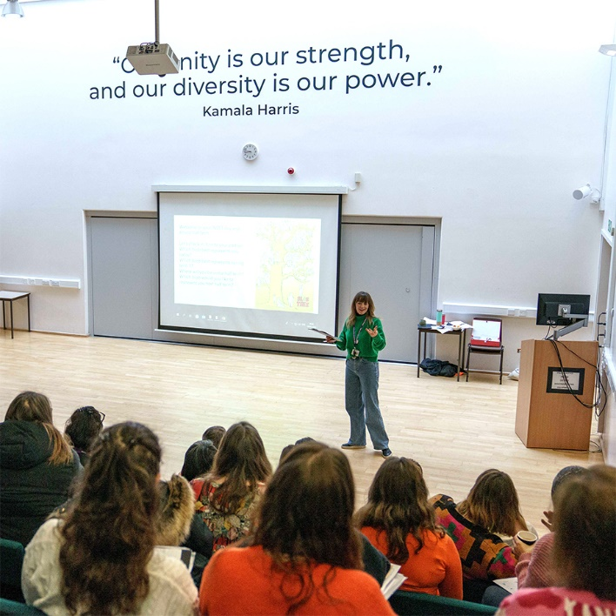 | 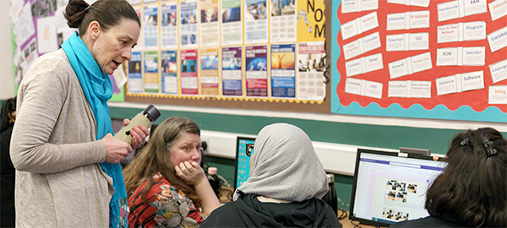
 | 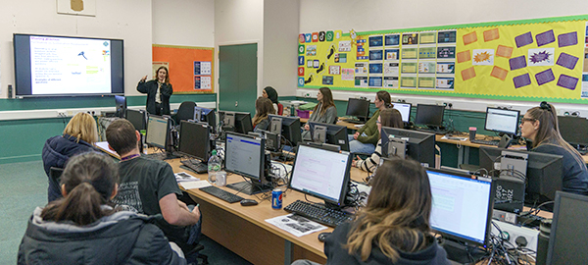
Other benefits of working here:
- One of the lowest teaching time contact ratios in London, demonstrating that we have chosen to invest in our staff
- An understanding that work-life balance is important, including a commitment to staff wellbeing in our School Improvement Plan
- In addition to making allowances for staff to have cover for family events, we are piloting a whole school approach to flexible working which will be rolled out across the school in 2025
- Home and Family weeks: termly non-meeting weeks throughout the year to support with reduced workload and staff wellbeing
- Beautiful school grounds, including staff terrace (in summer!)
- One-hour lunch break
- The possibility of flexible working contracts (37% of our staff are part-time)
- Regular wellbeing surveys and meetings; member of SLT with responsibility for staff wellbeing
- Employee Assistance: free 24-hour confidential counselling, help and information service
- Staff organised activities including a running club, yoga and Boxfit exercise sessions
- Cycle 2 work scheme
- Staff working in schools in Waltham Forest, regularly using computers, are eligible to apply for reimbursement towards some of the costs associated with eye tests and glasses
- Free on-site parking
- Lunch or breakfast provided on INSET days
- Free tea and coffee in the staff room
- Staff benefit from preferential admission criteria for their daughters

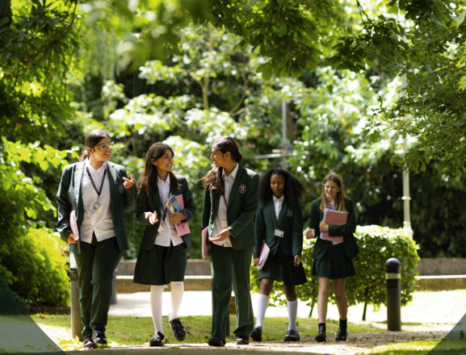

What do our staff say?
“WSFG is a fantastic, exciting and supportive place to work. All staff at WSFG are committed to bringing out the gift in every child, as well as supporting each other to be the best we can possibly be. As a new member of staff I have found settling in extremely easy, in part due to the easy-to-follow policies, and also because of the high level of support I have received from my colleagues. “
"I enjoy working at WSFG. I like the fact that our colleagues are from a diverse community, but we always manage to work as one team. In WSFG there are many activities and I am really lucky to see students' potential and their talent. This is a result of everyone's teamwork!"
"Working at WSFG is a wonderful opportunity: it has enriched my professional and personal development. The atmosphere is unique, the staff are lovely and the children are friendly, curious learners. I have felt incredibly well supported by my work colleagues: support staff, teachers, my faculty leader and SLT.”

What do people say about us?

"My daughters excelled academically, thrived emotionally and developed the confidence to go on and challenge themselves.” Year 11 Parent

“Really happy with my daughters start to year 7 and the school. Thank you!” Year 7 Parent

“You can build a future there, it’s where is all begins.” Ex-student

“WSFG offers a lovely environment. A great ethos and terrific teaching.” Year 11 Parent

“We visited with six of her teachers and every one of them was wonderful to chat with and we greatly appreciated their time that evening and their commitment to our daughter's education. Looking forward to the next few years at WSFG!” Year 7 Parent


PRE-EMPLOYMENT CHECKS
We are committed to Safer Recruitment practices and procedures and shortlisted applicants will be questioned about their commitment to the safeguarding of young people. The successful candidate will be subject to an enhanced DBS clearance.
If you are successful at interview and are offered a post at Walthamstow School for Girls we will be required to carry out a number of pre-employment checks. All offers of employment are conditional on these checks being satisfactorily completed.
The checks completed are:
Identification documents
All staff are required to provide proof of their identity and that they have the right to work in the UK.
EEA Citizens are required to provide evidence of their immigration status in the UK to be eligible to work. You will need to provide the school with this evidence before a provisional offer of employment can be made.

Online / Social Media Checks
As recommended in Keeping Children Safe in Education 2022, online searches are carried out on all shortlisted candidates at Walthamstow School for Girls. The searches are carried out to identify any issues or incidents that have happened, and are publicly available online, which the school might want to explore with the candidate at interview. If you are shortlisted you will receive a link to complete an online check prior to interview.

Criminal Record Checks (DBS)
All offers of employment are subject to a satisfactory Enhanced Disclosure from the Disclosure and Barring Service DBS (formerly the Criminal Records Bureau CRB). Full information relating to this check and the Rehabilitation of Offenders Act 1974 is included in our New Starter Information Pack, issued with offer letters. You will be asked to complete and return a Disclosure of criminal background form prior to interview.
Please note any information provided on your application form in the Disclosure and Criminal Background section will only be viewed by those who need to see it as part of the recruitment process. Any information disclosed will be treated in strictest confidence.

Employment history and references
On your application form it is important that you provide your full employment history including information regarding any gaps in your employment. References will be requested, prior to interview, from the information provided on your application form. We reserve the right to seek further references deemed appropriate and references are verified on receipt.
If you are currently employed in a school we will request a reference from your current Headteacher.

Overseas Checks
If you have worked overseas in the last 10 years or are working on a Tier 2 Sponsorship certificate you will need to provide the school with an overseas criminal record document.
If you are unable to provide an overseas criminal record certificate you must provide a letter which details your attempts to obtain the certificate and confirms why this has not been possible. This information will then be reviewed and a decision made as to whether an offer of employment can be made.

Qualifications
If your role requires you to hold a professional qualification you will be asked to provide evidence in the form of original certificates. Copies of these will be held on your Personnel file.
NCTL Checks (Teaching staff only)
All teachers are checked against the NCTL central register, this includes a Prohibition check.
Pre-Employment Health Check
All staff will be asked to complete a pre-employment health questionnaire. Any information that is disclosed as part of the health check will only be shared with relevant key members of staff and will be treated in the strictest of confidence.

Please follow the links provided below:
Safeguarding:
Safeguarding Policy 2024.docx
Keeping Children Safe in Education:
Keeping_children_safe_in_education_2024_part_one.pdf
LBWF Guide for employing people with criminal records
POLICY STATEMENT ON RECRUITING EX-OFFENDERS AND SAFEKEEPING OF DISCLOSURES.150716714.pdf

LBWF Applicants Guide to Prevention of Illegal Working:
APPENDIX_17_Applicant_guide_to_illegal_working.pdf

LBWF Safer Recruitment Guidance
WF Safer Recruitment Guidance notes (advertising).doc

LBWF Equalities Policy Statement and Equality Act 2010 guidance
WF Equal_Opportunities_Policy_Statement_(advertising).doc

LBWF Equal Opportunities Policy Statement
APPENDIX_21_Equal_Opportunity_Statement v2.pdf

