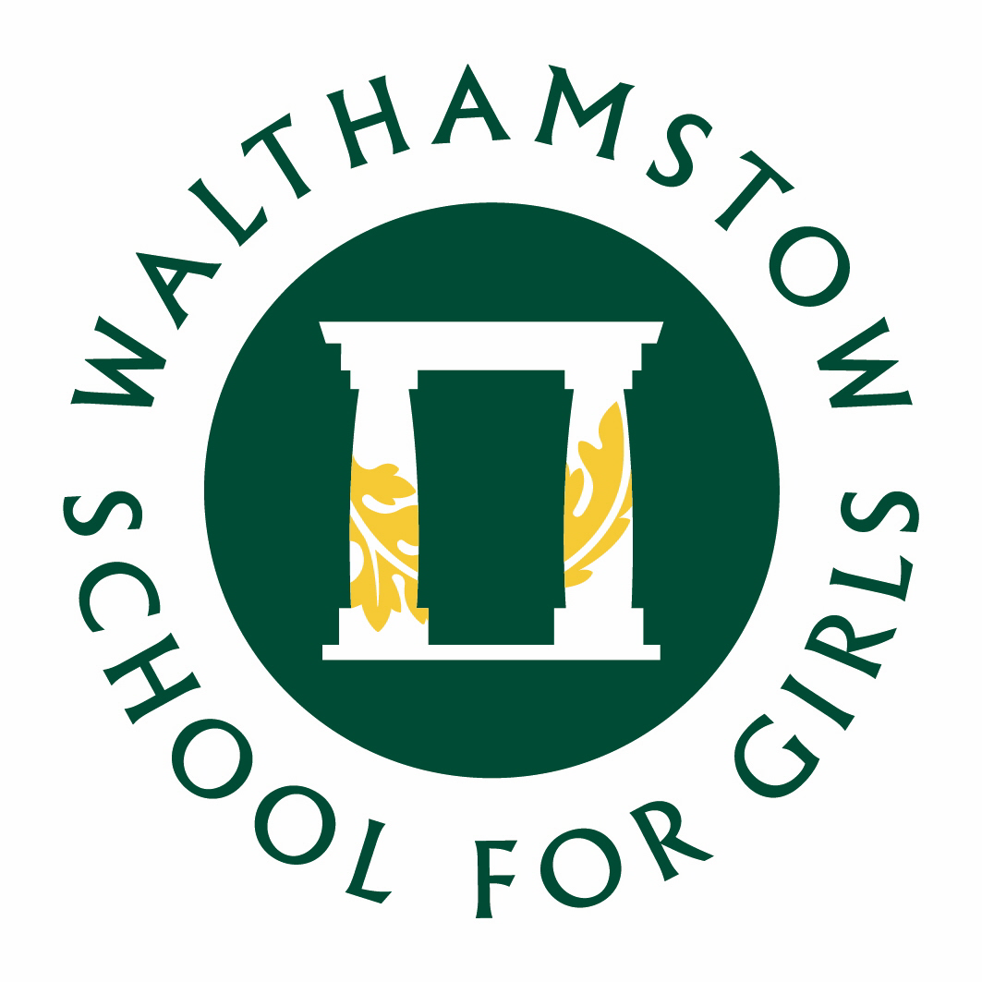
WALTHAMSTOW SCHOOL FOR GIRLS
Performing Arts Faculty Information

The Performing Arts Faculty is made up of a committed, passionate and energetic team of teachers. Music, Drama and Physical Education are taught as discrete subjects at KS3, but we adopt a unified approach and a shared philosophy across the three curriculum areas. At KS4 the academic results are very good and many students go on to study the subjects at ‘A’ level and beyond.
The Faculty enjoys a high profile within the school and the local community, and the extra-curricular programme on offer is a permanent and regular feature of school life, with a high percentage of the student body participating at a number of different levels. Every two years, in addition to the individual departmental activities, we work together on a fully staged Musical. The last few years have seen highly successful productions of ‘Bugsy Malone’, ‘The Wizard of Oz’, ‘Annie’, ‘Mary Poppins’, ‘Sister Act’ and ‘Matilda’.
In Music at Key Stage Three all students follow a Scheme of Learning designed to develop and extend their skills in the key areas of Performing, Composing and Listening and Appraising. This includes whole class vocal work, music from other cultures, instrumental skills and music technology projects on Cubase.
At KS4 students follow the AQA GCSE Music Specification, further developing their Performing, Composing, Listening and Appraising skills. They develop a broad knowledge of key musical features from the Western Classical Tradition from 1650-1910, Popular Music, Traditional Music and Western Classical Music Post 1910. Students also develop their analytical skills through the study of the first movement of Beethoven’s Symphony No 1 and three songs by Queen.
The work of the Music Department is supported by a team of peripatetic teachers who deliver private instrumental lessons during the school day. The department runs a choir, Glee Club a flute ensemble, five steel bands and an orchestra, performing at numerous annual events throughout the school year. We are regular participants in the Festival of Music for Youth. In 2019, our Year 11 Steel Band was invited to perform as part of the Music for Youth Prom at the Royal Albert Hall, an achievement matched by our Year 10 bands in 2022 and 2024. Our Glee Club participates regularly in the Jack Petchey Glee Club Challenge.
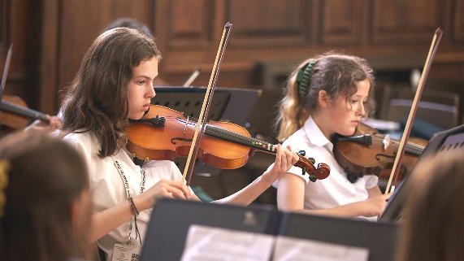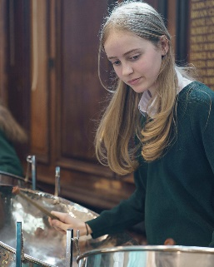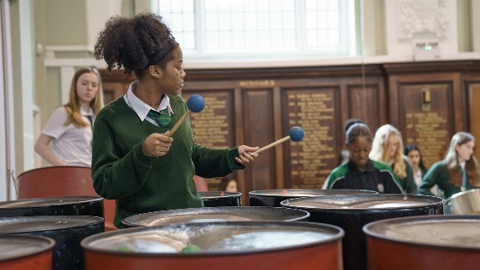

In Drama lessons at KS3, pupils explore the development of theatre, from ancient Greece to Shakespeare to contemporary theatre. Students develop drama skills through the study of practitioners and genres, including Boal, Stanislavski and physical theatre and use these skills to explore topics such as the transition from primary to secondary school. Students are given the opportunity to devise their own drama and work on text throughout Key Stage 3, and logbooks are used to record and support their learning. Within lessons, there is also a strong emphasis on the development of oracy.
At KS4, students follow the Eduqas GCSE Drama course. This involves the in-depth study of practitioners and genres, including the work of Vivian Franzman and Sally Cookson. Devising and text-work are given equal weighting, and experiencing live theatre is an important element of the course.
The provision of cultural enrichment through extra-curricular opportunities is a key element of the Drama Department’s philosophy. In recent years, we have forged partnerships with the Unicorn, Almeida, Donmar Warehouse and Old Vic theatres, giving students in Key Stages 3 and 4 numerous opportunities to experience live performance. Our students have participated in the Donmar’s Take the Stage project, Barbican Box, National Theatre Connections and Shakespeare Schools Festival, performing at the Donmar Warehouse, Barbican, Soho Theatre and Stratford Circus.

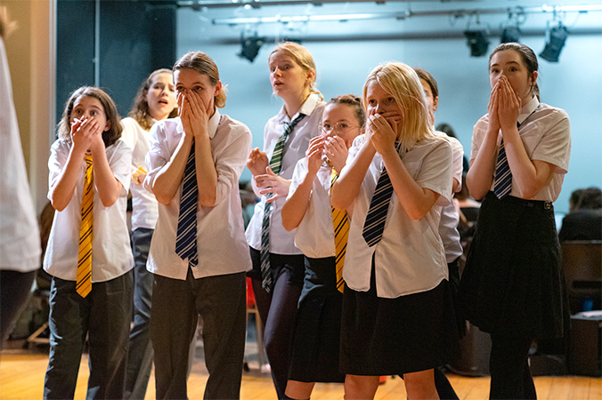
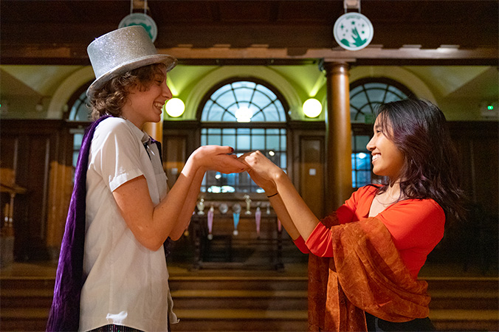

The P.E. Department aims to emphasise the importance of leading a healthy lifestyle and encourages participation in all forms of sporting activities. To this end, the core curriculum at KS4 has a more recreational basis and we offer activities such as boxing, badminton, trampolining and self-defence; many Year 11 students opt into offsite activities such as swimming and use of a local gym.
At GCSE, P.E. follows the AQA specification. The course has a strong scientific element, with the study of anatomy, physiology and sports’ psychology. The practical focus is on netball, handball and trampolining.
At KS3, the students follow a broad curriculum which includes dance, gymnastics, netball, football, basketball, trampolining, handball, tag rugby, fitness and athletics and are assessed at the end of each activity.
In addition to the 4 members of the P.E. department, the school is fortunate in having a number of specialist coaches, who deliver extra-curricular activities in school. The department organises an annual Sports Day in the summer term and Inter-Form competitions spread throughout the year, where every student in the school participates in a sporting activity. A range of extra-curricular clubs and events are run throughout the year, and the school has a reputation for high levels of participation in borough fixtures.
The Faculty firmly believes that education through aesthetic and physical subjects is of vital importance to the development of each individual and that cultural capital is a key element in academic and personal fulfilment. We strive to promote our work as a microcosm of the wider artistic and sporting world.
September 2024

