“Be Brilliant Today” | Head of Philosphy and Ethics  Required ASAP or September 2022.
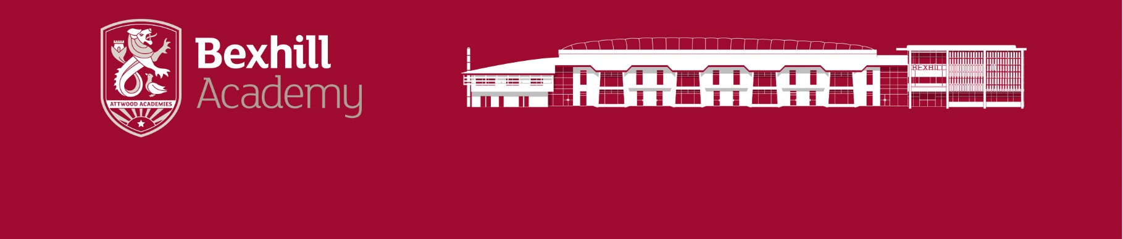
Bexhill Academy is looking for a dynamic and inspiring Head of Philosphy and Ethics who will develop the Philosphy and Ethics department and curriculum at Bexhill Academy. A teacher with excellent subject knowledge including at GCSE level and someone who is excited by the prospect of having a real impact on shaping such vital part of the school curriclum. This post would suit a teacher seeking their first leadership role or an existing leader of Religious Studies or Philosphy and Ethics pursuing a new challenge.
We aim to recruit staff who:
• Are excited by their role and by the prospect of challenging young people to achieve their very best.
• Love the processes of teaching and learning and are keen to continually develop their own skills.
• Recognise that teaching can be a demanding job and react positively to those demands.
• Will subscribe to the ethos of the Academy and be committed to get the very best from our students.
• Take every opportunity, in and out of the classroom, to talk to students, model expected behaviours and build positive relationships with all.
• See themselves as having the potential to become school leaders of the future.

Salary: Teachers Main/UPS Plus a TLR2b currently £4854 per annum
Closing Date: Monday 23rd May 2022
Interviews will be held on: Wednesday 25th May 2022
For a preapplication visit or discussion please contact Ellie Gordon, Vice Principal eleanore.gordon@bexhillacademy.org
Please see our website www.bexhillacademy.org under ‘community’ and then ‘vacancies’ for more details. Please note that we do not accept CVs or approaches from agencies. Please send completed application forms to academyhr@bexhillacademy.org
The Academy is committed to safeguarding and promoting the welfare of children and young people and expects all staff and volunteers to share this commitment.
The successful applicant will be subject to an Enhanced DBS check.

