

**HEAD OF PHYSICS or TEACHER OF PHYSICS**

**Full time**

**Information for Applicants**

**May 2025**

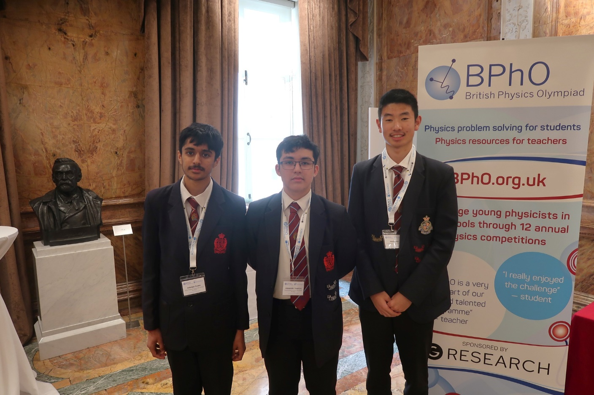

British Physics Olympiad

**GENERAL INFORMATION ABOUT OUR SCHOOL**

King Edward VI Camp Hill School for Boys is a selective state school; it is a member of the King Edward VI Academy Trust Birmingham, which is a group of twelve schools, six of which academically select their pupils. These schools, together with two independent schools, form the King Edward’s Foundation. The school moved from the inner city to its present location on the former Cartland Estate in 1956. Kings Heath is a pleasant suburb in South Birmingham with easy access to the M42, M40, M5 and M6 motorways, to Stratford and to the Warwickshire/Worcestershire countryside. In recent years, we have benefited from a new Sports Hall, Library, laboratories, classrooms and Sixth Form Common Room.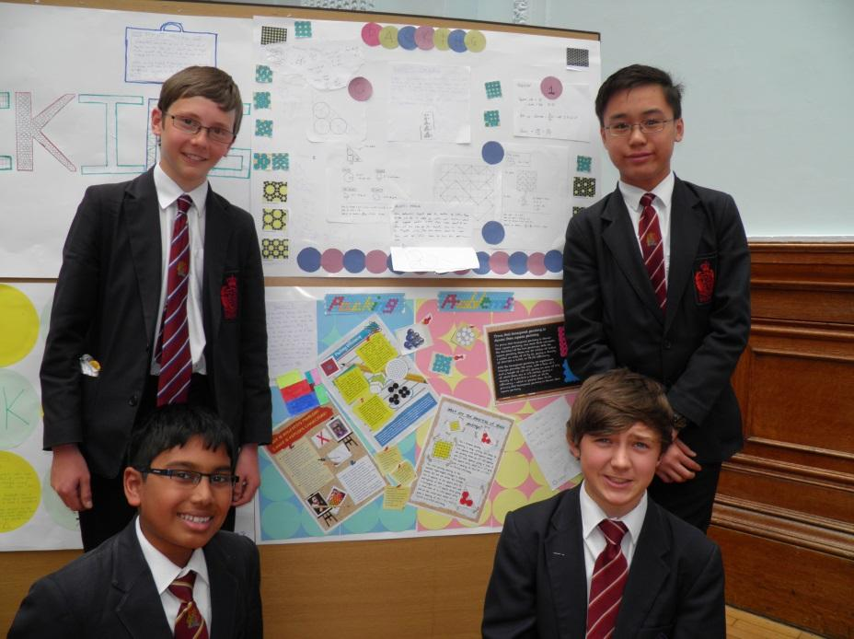

There are 1053 students on roll, of whom 335 are in the Sixth Form. The school admits 150 pupils a year at the age of 11. Nearly all of the students stay on at the school to the age of 18 and proceed into Higher Education. Academic standards are very high – in 2024 the percentage of GCSEs passed at grades 8 and 9 was 74%. At A Level the percentage of exams passed at A*-B was 83%. 20 (9 Cantab, 11 Oxon) Oxbridge hopefuls achieved their places.

**THE PHYSICS DEPARTMENT**

**Staffing**

Mr D Redshaw (current HOD)

Mr J Oggelsby

Dr T Munoz-Britton (Assistant Headteacher)

Mr J White (Part time Physics teacher)

Mrs A Khan (Part time Physics teacher)

Even in the context of this high performing school, the Physics Department has one of the strongest academic records. The school is fortunate to have a team of dedicated, long-serving and talented teachers. The popularity of the subject is indicated by the number of boys taking up A level in Year 12.

**Accommodation**

There are three dedicated Physics Laboratories and another two laboratories which are shared between all the sciences. All specialist teaching rooms are fully equipped with interactive whiteboards, projectors and sound systems. The work of the department is supported by experienced laboratory technicians.

**Curriculum**

* The three sciences are taught separately from Year 7 to Year 9 in Key Stage 3. Lessons are 1 hour long and we have a two week timetable. In Physics there are two hours per fortnight in Years 7 & 8 with 3 hours per fortnight in Year 9. Practical work is an integral part of almost every lesson. The boys are expected to become confident with apparatus by the end of Key Stage 3. The department has designed and produced booklets for each of these years. These outline the work for the year and provide information and practice questions. There is an end of year examination for each year.
* At Key Stage 4 in Years 10 & 11, students have 4 physics lessons per fortnight and we follow the AQA GCSE Physics 8463 specification. The department has designed and produces ‘in-house’ booklets for both years which contain all the specification content, useful notes and practice questions. We believe this course will offer an ideal preparation for A level Physics.
* In Year 12 and Year 13 we study the AQA 7408 specification. Physics is a very popular subject which is testament to the quality of teaching delivered throughout the school. We usually have 60 to 80 students in Year 12 and a similar number of students will carry on studying Physics in Year 13.

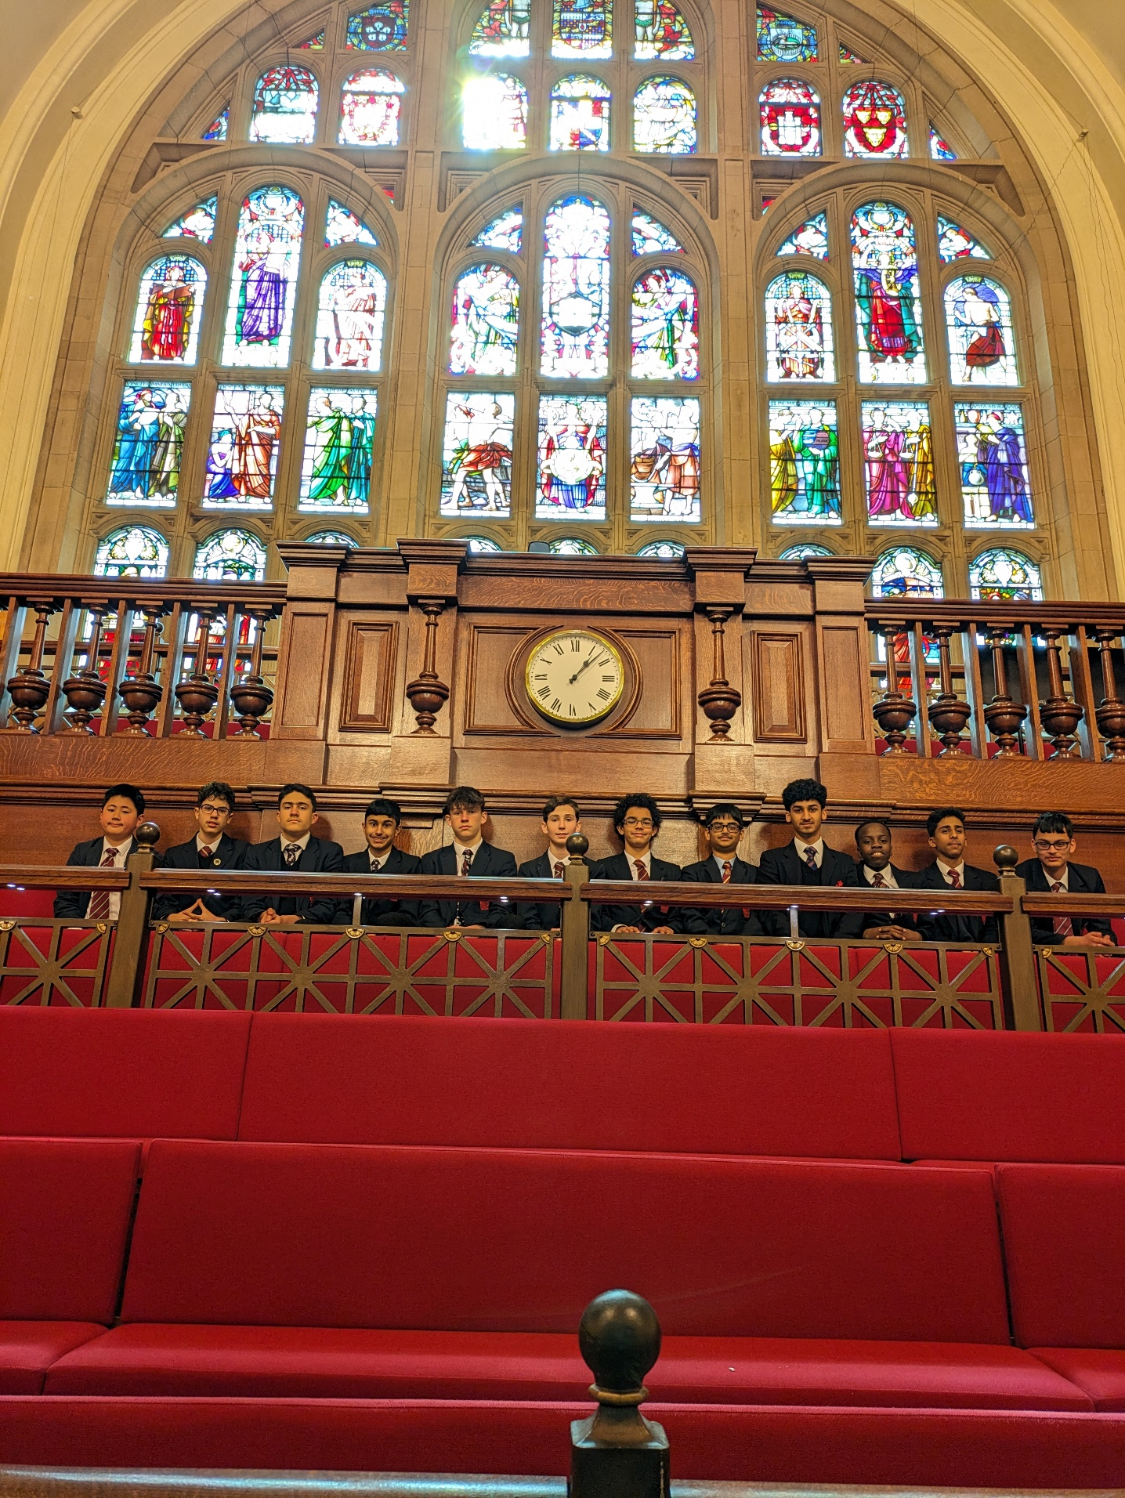The Big Physics Quiz

**Other important issues**

* The department has high expectations of the boys throughout all years in exchange for excellent teaching. Each member of staff has a laptop and they collate weekly marks into an excel spreadsheet enabling effective tracking of the progress of individual pupils. All staff in the Physics department communicate effectively with each other via daily contact in the prep room and via weekly department meetings. This facilitates the exchange and distribution of good practice and ensures everyone is aware of the latest demonstrations, requirements, forthcoming meetings etc.
* As part of the King Edward VI Multi Academy Trust, Camp Hill for Boys had a ‘SIP’ visit from the Academy Trust and the Physics department was one of the two departments which were deep dived. The feedback from this visit was overwhelmingly positive and encouraging. The physics department is a place that is ready for future potential inspections.
* Since physics is one of the popular subjects for A Level study in the school, the department offers the ablest students Astronomy as one of the GCSE option subjects. The Astronomy lessons are taught at lunchtime by one of the members in the department.
* Pupils take part in extra lessons for the Physics Olympiad and the Physics Aptitude tests. The Physics department often offers mock interviews for students who apply to study Physics or Engineering at Oxford or Cambridge.

**Examination Results**

Key Stage 4: In 2024 our GCSE results were 86% of Grade 8/9.

Key Stage 5: In 2024 our A-Level results were 67% of Grade A*/A.

The department is rightly proud of the extremely high standards which are achieved across all Key Stages and results show continuous improvement year on year.

**THE POST**

The post becomes vacant due to the departure of the current Head of Department. We are seeking a suitably qualified and talented classroom practitioner who can bring the best out of our students, and who is able and willing to make a contribution to the wider life of our school.

A generic class teacher job description is available on the website.

**FURTHER INFORMATION**

Candidates are asked to complete the application form and attach a letter of application giving examples of achievements, skills and experience which match those sought in the job description provided by the school. These documents should be sent to me as soon as possible, but by no later than **Wednesday 21st May, 9:00am**. Interviews will follow shortly after.

Please do not hesitate to contact me if you require any further information ([headspa@camphillboys.bham.sch.uk](mailto:headspa@camphillboys.bham.sch.uk)) . Camp Hill Boys is a happy, flourishing and friendly community as well as an outstandingly successful grammar school. I look forward to receiving your application.

**R W Bowen**

**Headmaster**