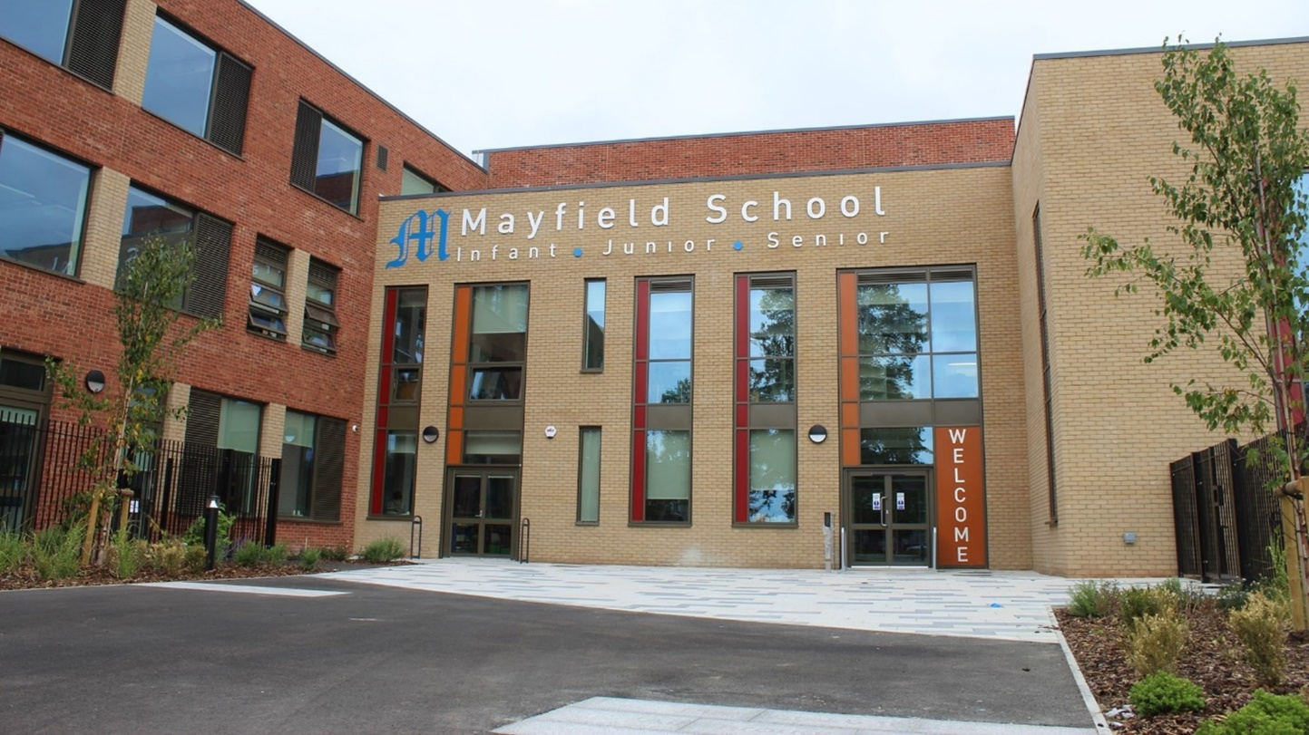

Head of Primary

Recruitment Pack

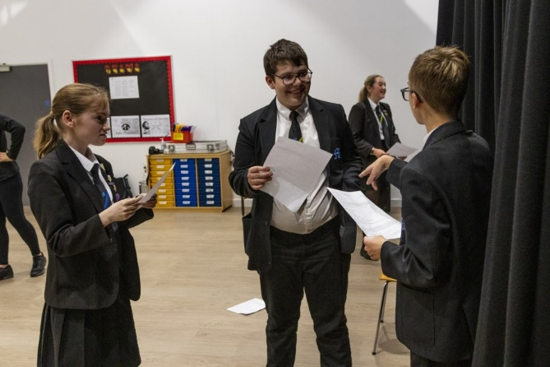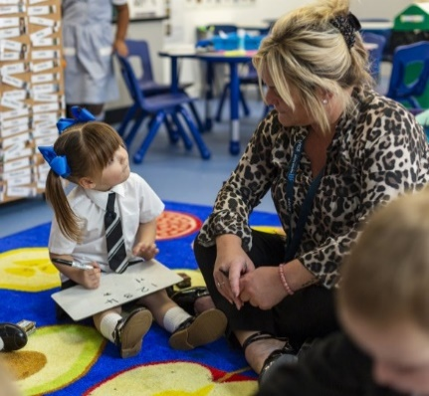

Letter from the Chair of Governors Dear Applicant,
Thank you for your interest in becoming the new Mayfield School Head of Primary.
Firstly, Mayfield School is a fantastic school. A school that does have its challenges, but also a school with huge potential, a school that has made progress in many areas and a school with staff who are committed and dedicated to each and every pupil.
The Governing body is looking for a Head of Primary who has the drive, the leadership skills and the shared vision of the headteacher of the whole school to ensure the primary section of the school continues to progress. I trust the information contained in this pack will assist you in deciding whether you are the right person to meet this challenge.
We believe Mayfield is a supportive, caring and exciting place to learn. It is a school that has a
curriculum to meet the needs of each pupil, an environment that recognises individual learning needs and we expect the new Head of Primary to build on the solid foundations, develop the staff and to work with the leadership team of the whole school. The Governors also recognise the changing face of education, both nationally and locally and would expect the Head of primary to take on these additional new challenges.
As one of the first single-site 'all-through' schools in the country, with a single vision, set of values, staff, and Governing Body we believe that we have a unique opportunity to improve and shape the lives of the
children in our community. In addition, in September 2021 we opened our doors to a brand new purposely built school building designed to make this vision a reality.
Our school vision is to provide our pupils with:
- outstanding academic standards, with a particular focus on acquiring a foreign language, developing competency as a musician and performer, as well as encouraging sporting prowess - all in a timely fashion;
- outstanding pastoral care based on nurturing each individual's self-esteem and ambition to realize their full potential;
- outstanding opportunities to develop the 6Rs (being ready, resilient, responsible, respectful,
resourceful and reflective) and ‘character’ experiences to succeed both at school and prepare them for being a well-equipped member of society and ready for the world of work.
Mayfield is a unique school which offers staff and students great opportunities to develop; a school which truly believes that all pupils can ‘Believe, Achieve, Succeed’.
Whilst Mayfield is currently a Local Authority maintained school, the new Head of Primary would be expected to play an influential role in working with all schools and key partners in the city, irrespective of academy or maintained school status, as part of the work of the Portsmouth Education Partnership and the Primary Heads Conference Meetings.
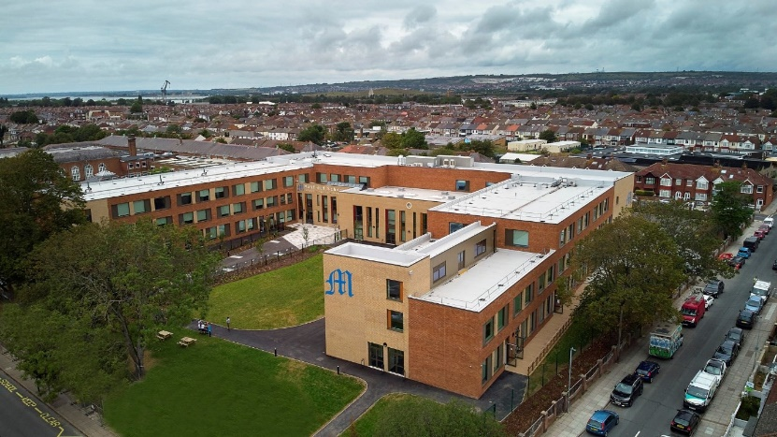
If you feel you have these skills and qualities, then we would very much welcome your application. Kelly Perrett
Chair of Governors
INTERNAL

Job Description
HEAD OF PRIMARY - MAYFIELD SCHOOL

Job Title: Head of Primary
Salary: Leadership Scale 16 - 20
Responsible to: The Headteacher
Responsible for: The headteacher carries out duties in line with the conditions of employment as set out in the current School Teacher’s Pay and Conditions document, the
Headteachers' Standards 2020 and the policies and procedures of the Governing Body.

Ethics and professional conduct
The headteacher will demonstrate consistently high standards of principled and professional conduct upholding the Nolan Seven Principles of Public Life (selflessness, integrity, objectivity, accountability, openness, honesty, leadership).

Function of the post:
As an inspirational innovative leader you will work with the headteacher of the school to drive the vision and strategic direction of the primary section of the school. You will empower and motivate staff and pupils to ensure excellence in learning and teaching and the continued rapid improvement of the primary section. Aligning to the culture and ethos of the school, you will provide a child-centered approach to education, an engaging curriculum and will inspire a sense of collective purpose, with high aspirations for pupils and staff. You will work collaboratively with parents, the head of seniors, the Local Authority and other schools within and beyond Portsmouth developing and delivering a dynamic learning partnership and act as a positive role model and advocate for the school.

Job Purpose
To ensure that within their work and the work of any they might line manage:
- there is a relentless focus and active promotion of all aspects of "safeguarding" including; child protection, child welfare and health and safety;
- the school, team and self, comply with all statutory, Portsmouth City Council or Governing Body requirements;
- all school policies and procedures are understood, followed and positively promoted;
- the school's ethos is understood, followed and positively promoted;
- there is a culture of flexible working, sharing skills and developing the individual.

Key Accountabilities

- To actively promote the school’s equal opportunities policy and observe the standard of conduct which prevents discrimination taking place;
- To maintain awareness of and commitment to the school’s Equal Opportunity policies in relation to both employment and service delivery;
- To fully comply with the Health and Safety at Work Act 1974 etc., the school’s Health and Safety policy and all locally agreed safe methods of work;
- At the discretion of the Headteacher, such other activities as may from time to time be agreed consistent with the nature of the job described above.

Principal Accountabilities:
- Join the Executive Leadership Team consisting of the Headteacher and the head of seniors to provide strategic leadership across the whole school;
- Lead, inspire and promote a positive whole school culture and ethos (with a specific focus on primary) aligned to the values of the school, that supports the school on its journey to continued improvement and secures a strong reputation locally as the school of choice for pupils, parents and teachers;
- Lead the development and delivery of a dynamic, relevant and enriching primary curriculum which motivates and inspires all children to learn and achieve;
- Lead the development and delivery of the school’s improvement plan, to ensure it is child centered and supports exemplary learning and teaching strategies and practice;
- Develop high quality dispersed leadership to manage development and drive improvements in the primary section of the school;
- Develop strong collaboration with all leaders and staff across the school to ensure the transition of pupils from Year 6 to Year 7 is smooth and that the excellent progress that the pupils make is sustained into the senior section.
- Lead the teaching and learning programme of the primary section of the school, work with senior leaders as part of the school’s Teaching and Learning Team, and act as a role model for innovative and engaging evidence based practice;
- Alongside the headteacher of the school, develop and implement a strategy for recruitment, retention and professional development of primary staff that will ensure good or better teaching in an environment staff find challenging, enriching and rewarding;
- Actively and positively participate in school wide systems such as performance management system, annual leave, absence management etc;
- Ensure primary school structures and systems are embedded, secure and supported by robust policies and procedures;
- Ensure quality assurance is robust and the primary section of the school is a safe and effective educational environment for all children;
- Act as a Designated Safeguard Lead, committed to ensuring all practices relating to safeguarding and child protection are effective and children and staff feel safe and are valued;
- Act as a Senior Investigating Officer as required;
- Contribute to the success of the school, building and promoting the engagement with the local authority; community stakeholders and engaging with other schools to enhance learning through school to school support and evidence based practice. This includes working with and reporting to governors.

The duties and responsibilities in this job description are not restrictive and the post-holder may be required to undertake any other duties that may be required from time to time. Any such duties should not however substantially change the general character of the post.

Principal Attributes and Person Specification Essential

Head of Primary – Person Specification
Essential requirements are those, without which, the candidate would not be able to do the job. It is expected that the post holder will have the knowledge and qualifications indicated or equivalent qualifications and experience.

Desirable requirements are those which would be useful for the post holder to possess and will be considered when more than one applicant meets the essential requirements.

Attributes | Essential | Desirable | Evidence
Education, Training, Qualifications | - Qualified Teacher with evidence of continual professional development or relevant accredited study appropriate to the post  - Evidence of current knowledge of the national curriculum and research on strategies to support effective teaching and learning  - Understanding of current trends in education both nationally and internationally  - Good understanding of the local authority and OFSTED, and how to work effectively with these and other such bodies  - Good understanding of the principles of equality and diversity that support a culture that embraces diversity within the classroom and community  - Knowledge of, and training in health and safety and safeguarding legislation within the context of school compliance. | National Professional Qualification for Headteachers or other leadership and management training. | Application  Documentary evidence  Interview
Experience | - Successful experience at Deputy or Headship level in the primary age range, with evidence of leading a successful team to bring about rapid and sustainable whole school improvement that has had a positive impact on pupils achieving their full potential  - Relevant experience of whole school management, including financial, budgetary and resource management such as challenging and supporting staff through managing change, performance management, conflict resolution, staff recruitment and development processes  - Proven track record of monitoring, evaluating and improving quality of learning and teaching, building effective strategies for school self-evaluation and making effective use of ICT in learning  - Evidence of providing the support and resources that enabled a highly effective governing body fulfil their statutory responsibilities for teaching, learning and standards, and act as critical friend for the benefit of the school  - Evidence of managing additional educational needs provision which required collaborating and building effective relationships with parents, carers, multi-agencies and the wider community to enrich teaching and learning for the inclusion and wellbeing of all pupils  - Experience of being inspected by OFSTED at a senior level |  | Application  Interview  References
Skills and Abilities | - Evidence of demonstrable leadership qualities, with the ability to set and achieve challenging goals which achieve improvement  - Evidence of strong emotional intelligence and the ability to work with staff in a way that motivates and engages staff and develops a strong team approach to delivery.  - Organisational, financial, budgetary and management skills relevant to the effective delivery of the duties of the post to achieve the school’s educational goals and priorities  - Excellent people skills to build and lead an effective team; managing issues in a sensitive, supportive but appropriate manner to ensure the effective operation of the school, promoting high aspirations and success for all  - A skillful communicator with strong, interpersonal and presentation skills, both verbal and written, which naturally adapts to a diverse audience, e.g. governors, parents and carers, staff, pupils and the wider community on a wide range of issues to provide clarity of vision, influence and direct or challenge others  - Good ICT and administrative skills to enable effective implementation of tasks required of a Headteacher  - Networking skills that build a professional learning community and enable good practice to be shared for the benefit of the school. | Use of systems such as SIMS, CPOMS, Classcharts etc | Application  Interview  Presentation  References
Personal Attributes | - Desire to work in an ‘all through’ environment  - Attributes that enable and empower individuals and teams to innovate and achieve, where success is celebrated and individuals are motivated to achieve high goals and accept responsibility for outcomes  - Commitment to equality and inclusivity which allows the academic, spiritual, moral, social, emotional and cultural development of pupils, celebrating and recognising the differing needs of pupils and staff in a diverse and multicultural Britain, challenging assumptions and preconceived ideas.  - An ability to foster an open, innovative, equitable culture, dealing with difficult decisions or situations in a timely manner, making reasoned judgements, conveying conclusions clearly, positively and sensitively  - The personal resilience required of a leader, with the ability for self-reflection and a positive approach that enables constructive relationships and feedback to aid continuous improvement.  - A commitment to the mission and values of the whole school community and to collaborative working for the benefit of all pupils personal and academic successes. |  | Interview  Presentation  References

Application and selection procedures:

Your application should relate specifically to the person specification and also include information on:
- your education philosophy;
- your view of the role of the Head of Primary;
- what you feel you could bring to this school.

Completed application forms should be returned no later than 5pm, Tuesday 17th January 2023
to hollis@mayfield.portsmouth.sch.uk or by post to Mayfield School, Mayfield Road, Portsmouth, PO2 0RH.

Interviews will be held during the week commencing 30th January 2023. References will be taken up
immediately after shortlisting. Candidates are asked to ensure that their referees are advised of this.

Safer Recruitment Mayfield School and Portsmouth Local Authority are committed to safeguarding and promoting the welfare of children, and young people, and expect all staff and volunteers to share this commitment. DBS Disclosure at Enhanced level will be required.

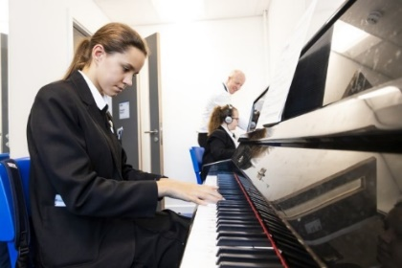
Data Protection Act 1998 You should be aware that the information you have provided will be stored on Portsmouth City Councils secure recruitment database and will only be used to process your application. It will not be passed to any other organisation.

