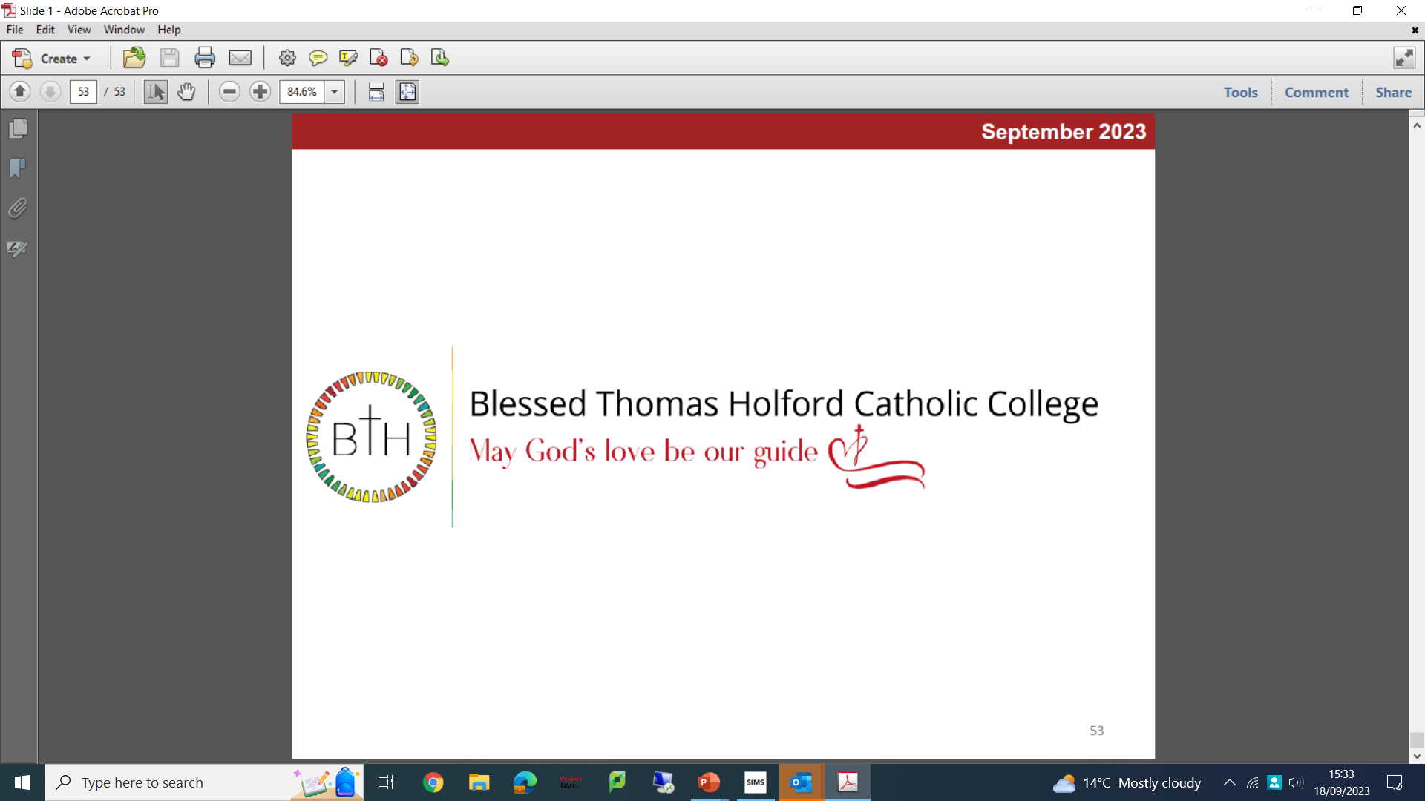

Head of Religious Education
Required for an Easter start
MPR/UPR Plus TLR 1A (£9,272)

Governors at Blessed Thomas Holford Catholic College are looking to appoint an inspirational and ambitious Head of Religious Education to join our college. It is a requirement of the role that the postholder is a practicing Catholic.

We are an 11-18 Catholic college with 1,600 pupils on roll, including 220 in the Sixth Form. GCSE and A level results have been consistently excellent over several years and we are determined to make ourselves an exceptional educational provider. Our college is highly popular with parents/carers, and we are oversubscribed every year.

We are looking for someone with a strong personal faith, who is a committed Catholic with a clear vision on Catholic education. You should be passionate about teaching and results and able to demonstrate the experience and leadership qualities necessary to be Head of Religious Education at our college.

This is an exciting opportunity for a highly motivated and ambitious person to develop their career in a forward-thinking college with high standards of achievement and care.

We offer:
- A supportive and committed college family
- A college with a desire to continuously improve
- Highly motivated and talented staff with a strong team ethic
- Ambitious and hardworking pupils

To Apply:
The job description and application forms are available on the school’s website: https://www.bthcc.org.uk/vacancies

All applications should be made using the CES application form
All applicants are required to follow the guidance for applicants securing a Faith Reference

Completed application forms should be sent to: recruitment@bthcc.org

Closing date for applications is: 9.00 am on Tuesday, 20th February 2024

Our school is committed to safeguarding and promoting the welfare of children and young people and we expect all staff and volunteers to share this commitment. In line with Keeping Children Safe in Education (KCSIE) online/social media checks may be undertaken for shortlisted applicants. An enhanced Disclosure and Barring Service (DBS) disclosure will be sought, along with other relevant pre-employment clearances, for the successful applicant.

