About our School
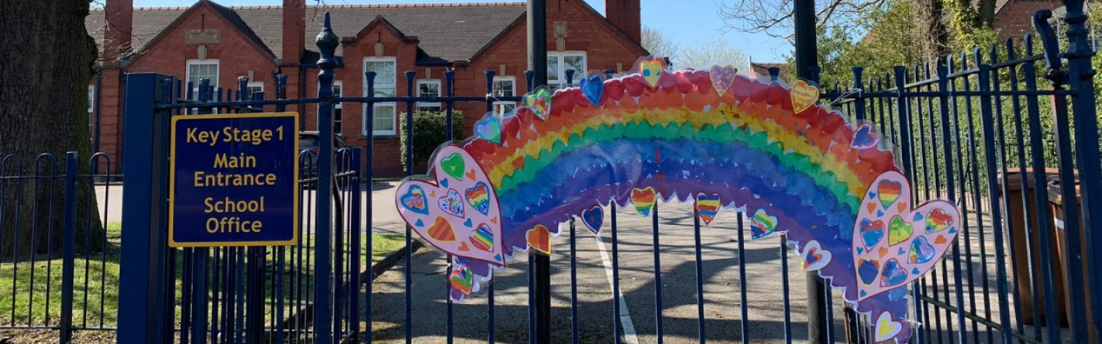
Welcome to our wonderful school here at Haslington. We offer a friendly, vibrant and enriched learning environment where every child matters. Our inclusive ethos nurtures and celebrates the diversity across our school, built around a positive and engaging curriculum.

We converted to Academy status on April 1st 2021 and we are very proud to be a member of the Alexandra Academy Trust. Our school is situated at the heart of the community in the centre of the village of Haslington. We are a one and a half form entry school with a maximum intake number of 45 pupils per year group. We currently have 264 pupils on role and in 2017, we were delighted to be awarded a ‘good’ rating from Ofsted.

Here at Haslington, we focus on the development of the whole child, building life-long skills to move into an ever-changing world. An emphasis is put into teaching the basic skills, through repetition and SMART ways of helping our children build independence and a love of learning. We pride ourselves on recognising individual skills of children such as sporting, practical, musical and artistic talent.

Our Character-Building, Commando Joe curriculum focuses on achievement based around ‘RESPECT’, Resilience, Empathy, Self-awareness, Passion, Excellence, Communication and Teamwork.
We want every child to reach their full potential, measuring the impact of their resilience.

Our school is housed in an attractive, single storey brick building, the oldest part of which was opened in 1913. The school has 10 large, well-equipped classrooms, which are decorated and furnished to a high standard. There are several spacious, airy shared areas, where practical activities and small group work can take place. A resource area, comprising a library area and additional teaching spaces, provides the opportunity for the children to undertake independent study and research. The school has extensive, well-developed outdoor facilities, a large field enabling a wide variety of sporting activities to take place and provides a pleasant area for children to play.

The younger children in Key Stage 1, have their own appealing play area with a pleasant shaded playground and an attractive woodland walk, while Key Stage 2 children can make use of the shaded tables in the quiet playground. We are fortunate to have a beautiful pond and boggy area that allow for scientific and environmental studies.

Haslington Primary Academy recently merged with the Alexandra Academy Trust joining Monks Coppenhall Academy and Day Nursery, a large Primary Academy just a few miles away. The two schools have already established strong bonds after working closely together for the past 12 months.

Letter from Chair

Dear Head of School applicant,
Thank you for your interest in the post of Head of School at Haslington Primary School. I am very pleased that you are considering applying to lead our wonderful school. The vacancy has arisen following a restructure as we joined the Alexandra Academy Trust.
In the application pack we have provided a flavour of the school in order to give you an indication of the scope and range of opportunities and possibilities that the post offers. I hope that you find the information we have provided of sufficient interest that you decide to apply for the post. We want to employ somebody who is able to build on the strengths and achievements of the current team as well as working closely with colleagues across the MAT to improve learning outcomes for all.
Our new Head of School should be a strong, approachable, compassionate and supportive leader who is passionate and knowledgeable about the pursuit of teaching and learning in schools and has a love of working with children. The person specification provides a more comprehensive list of the qualities we are looking for, but in essence, we wish to appoint somebody with the wisdom, experience and confidence to take the school forward. Our new Head of School will be someone who builds on what is currently good and ensures we continue to improve by embracing the opportunities and challenges that are offered in our primary school.
I warmly encourage you to visit the school and meet our wonderful pupils and staff.
Please contact Mrs Zoe Holloway to make an appointment by e-mail (holloway@monkscoppenhall.cheshire.sch.uk).
I look forward to hearing from you and receiving your application by the closing date of Tuesday 27th April at noon. The interviews for this post will be held on 6th and 7th May 2021.

Our Vision and Ethos

Mission Statement

‘Explore, dream, learn, shine.’

Our educational vision is to be a place;
- Of high aspirations, excellence, enjoyment and discovery.
- Where everyone feels valued and achieves to the best of their potential.
- Where self-discipline and very good behaviour is expected.
- Where all learners are treated fairly and given equal opportunities.
- Where learners are able to make positive contributions to society and are prepared for future technologies.
- Where we create motivated, lifelong learners and safely use a range of technologies to enhance and support learning.

Aims
Through our character-building curriculum, we aim to develop:
- Resilience – by providing strategies to enable children to cope and recover quickly from difficulties and setbacks.
- Empathy – by providing opportunities and experiences to place themselves in the ‘eyes, ears and heart’ of others.
- Self-awareness – by developing an understanding of own strengths, weaknesses, thoughts, beliefs, motivation, health, well-being and emotions.
- Passion - by fostering a long-term love, enthusiasm and excitement for learning
- Excellence - by encouraging the growth of individual qualities in order to achieve their maximum potential, so that excellence becomes a habit.
- Communication – by creating an open, inclusive and welcoming learning community where all forms of communication are valued and listened to, enabling children to be expressive, reflective and evaluative learners.
- Team work - by encouraging self-discipline, unity, patience, and co-operation within a safe and secure environment to make responsible decisions to achieve a common goal.

What the children think about our school and would like to see in the Head of School:
‘In this school everything is amazing the equipment is fun and a good thing to play on. Every teacher and helper are all really nice. I also love the COJO curriculum it is great.
In a Headteacher, I would like to see kindness also someone who is a little bit strict but not too strict. Someone who is very professional and fair.

‘In our school, I like learning because it is interesting and I like English because I love reading. I like maths because I can work with my friends and the staff because they are kind.
In a Headteacher, I would like to see someone who is helpful, funny, caring and a positive person who promotes good behaviour.’

‘In our school I get to play and talk to my friends and you learn new things’.
In a Headteacher, I would like it to be someone you can talk to, some one you can trust – a friend.

Recent parent Comments about our school
“Despite the unprecedented times it has been wonderful to watch my daughter thrive at school and I am excited to see how she and her peers flourish as they continue their journey through school together.”

“After a turbulent year, I can confidently say that I am proud of Haslington Primary School and the support it has provided throughout. I cannot thank the staff enough for all the hard work, perseverance and determination in ensuring the children have the right tools to start out in life.”

