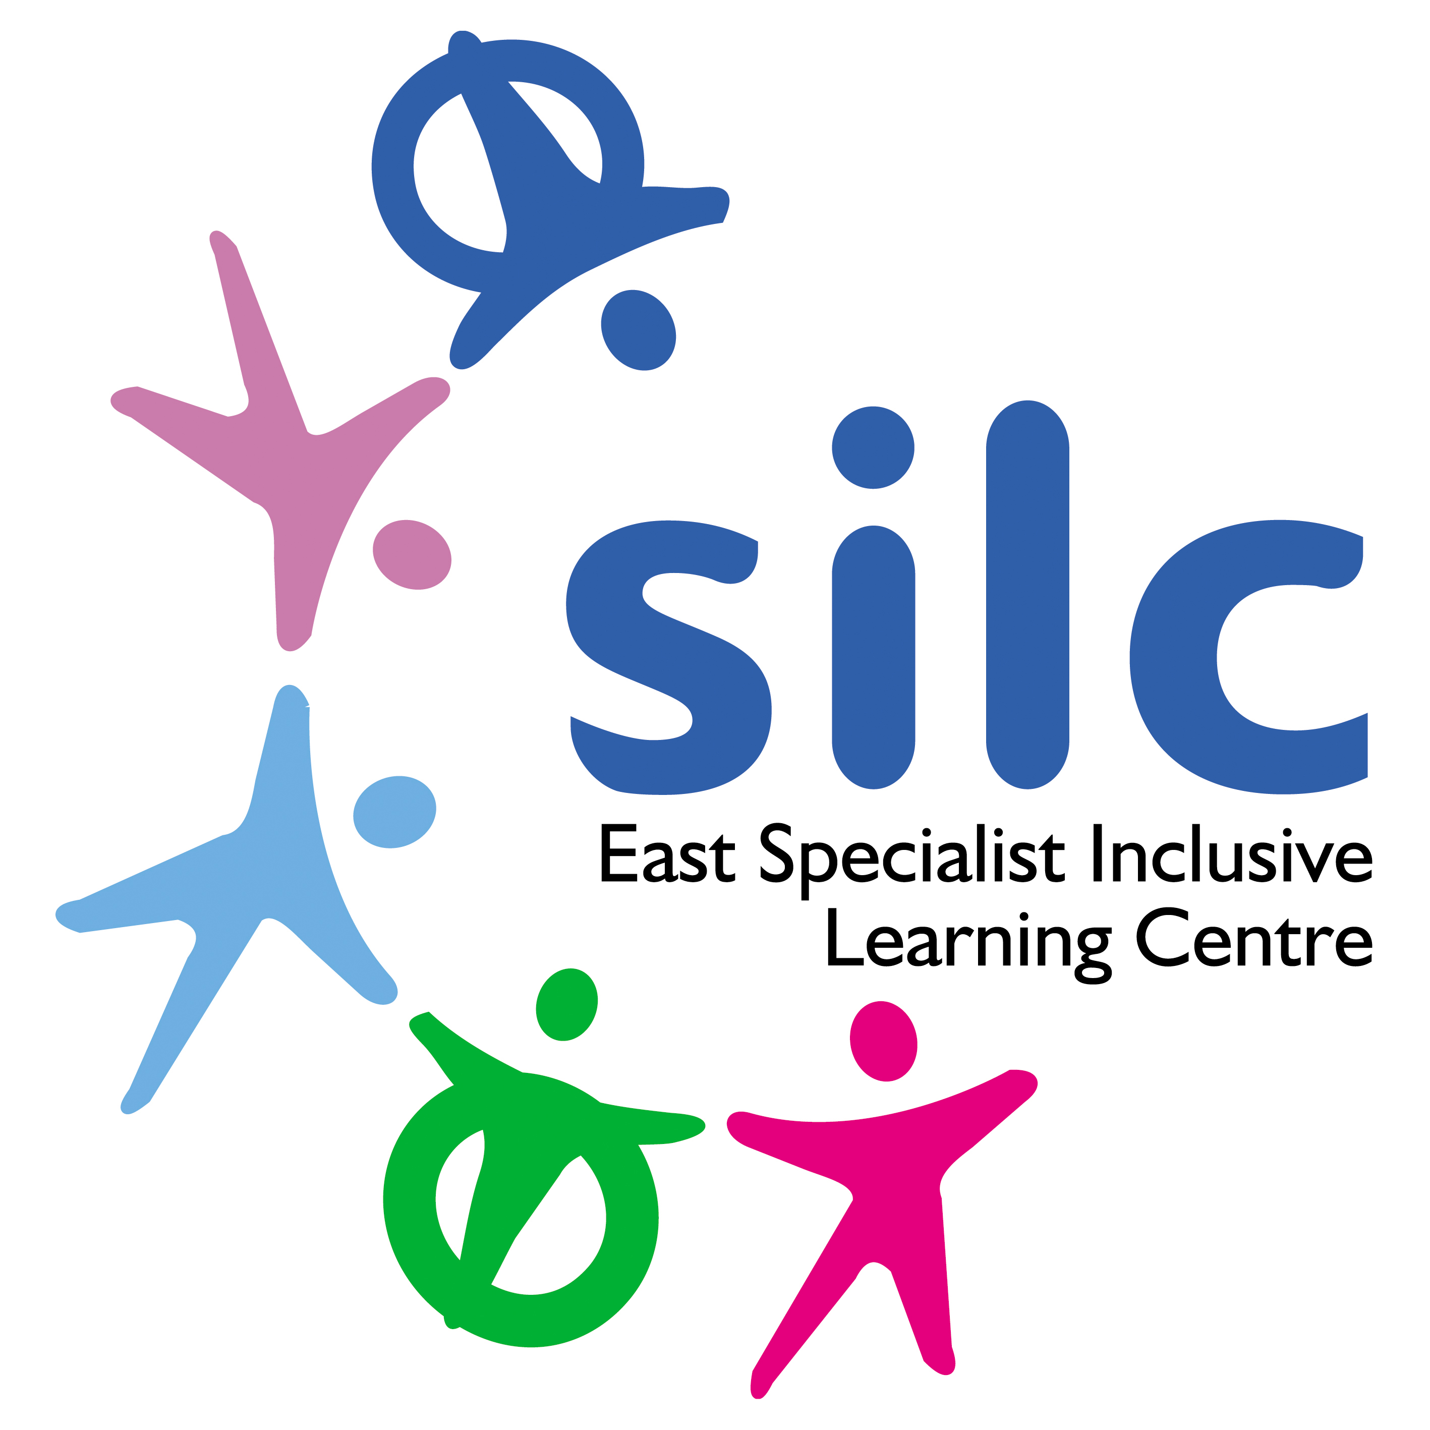
East Specialist Inclusive Learning Centre
John Jamieson School

PERSON SPECIFICATION

JOB TITLE: Head of School

Start date: September 2023 or as soon as possible

Salary Range: Leadership LS18-22

Key to assessment criteria
A = Application Form I = Interview R = References C= Certificates

 | Essential Selection Criteria | Essential Criteria Assessment | Desirable Selection Criteria | Desirable Criteria Assessment
Education and Qualifications | - To be a qualified teacher in England  - Evidence of continuous professional development  - A degree qualification | A / C | Higher degree  NPQSL/NPQH  Additional Ofsted Inspector or a commitment to become an AOI | A /C / I
Experience and Knowledge | - Proven record of outstanding practice as a classroom teacher  - Successful record of having a significant impact on outcomes of all students  - Developing and leading the implementation of strategies to drive whole school improvement  - Successful record of implementing strategies that have a positive impact on student attainment and progress outcomes  - Knowledge of a range of theories of learning and teaching | A / I / R | - Leadership in a specialist setting  - Experience of working in a range of settings including mainstream  - Leadership of an assessment in a school  - Leadership of strategic curriculum developments | A / I / R
Experience and Knowledge | - Evidence of excellent leadership and management skills  - Ability to build good relationships with all stakeholders  - Understanding of whole school resources  - Current involvement in implementing School Improvement Plan | A / I /R
Education & Organisational Leadership | - Initiate, lead and manage change  - Ability to use ICT as a management tool  - Excellent interpersonal and communication skills  - Ability to communicate a clear vision for improving standards  - Tangible evidence of driving performance upwards: staff and students  - Able to demonstrate a pragmatic approach that is focused on delivering objectives, managing diverse priorities and workload  - Deal sensitively with people and resolve conflicts | A / I / R
Personal Qualities | - Reliability, integrity and stamina  - Personal impact and presence  - Work under pressure and to deadlines | A / I
Skills and Abilities | - Ability to teach at nationally accredited level successfully proven by strong progress/results.  - Comprehensive understanding both of national performance measures for schools and the Ofsted framework for inspectors  - Ability to analyse and report on key data documents  - Ability to coach and motivate | A / I / R | - Qualification in coaching | A / I
Philosophy and Ethos | - Commitment to high standards and continuing improvement  - An understanding and commitment to equality and inclusion principles and practice  - High expectations of student progress, personal development and conduct  - Relentless personal drive and ambition anchored in success | A / I / R
Community | - Ability to work and gain the support of external agencies  - Commitment to working closely with governors  - Ability to promote the school within a diverse community. | A / I / R | - Experience in building wider relationships in a diverse community | A / I / R

