Information about our Trust

Working together towards success for all!

Dear Colleague,
Thank you for considering working with us within the Attain Academy Partnership! Hopefully this information will help you to understand what it would be like to work within our close, committed and collaborative team of school leaders. Our Headteachers work together to create the conditions in which leadership can flourish and each child can better achieve their potential. Whilst maintaining their autonomy, our Headteachers very much value and benefit form being part of a dynamic network who are constantly working to achieve a shared vision for all of our children. As members of the Trust, they also enjoy additional support, resources and funding to enable their schools to succeed and all their pupils to thrive.
The true strength of Attain lies in its people. Our schools employ talented, caring and committed staff and support happy pupils who are proud to be there. Our Local Governing Bodies and our Trustees are both ambitious and supportive and we have developed strong relationships with our parent community This partnership approach involves all members of the school and trust community, achieving significant levels of mutual support which support the successful outcomes of all our children. This document will give an overview of some of the people and processes within Attain which ensure our Headteachers / Heads of School can access the established strength and expertise within the existing team to inform and advise when necessary.
Additionally, any new member of our team brings fresh ideas and strengthens the development of our educational journey and as such I am very keen to welcome any questions or queries which challenge our existing practice and offer innovative changes.
“If your actions inspire others to dream more, learn more, do more and become more, you are a leader” John Quincy Adams
Susannah Edom-Baker, CEO Attain Academy Trust

A Perspective on Headship in Attain "Coming together is a beginning. Keeping together is progress. Working together is success." Henry Ford

Gosfield Community Primary School is a small school with mixed age classes and a total of 140 pupils. We converted to academy status with Attain in January 2019. Our journey with Attain has been fantastic and there are so many elements that we’ve benefited from; professional development, collaborative working, staff CPD, inhouse training plus many more!

Since joining we have had the opportunity to take part in a wide range of school development opportunities which have spurred on our school improvement mission. We have access to experienced and dedicated practitioners and the Headteachers / Heads of School work together in close collaboration to share the improvement goals for all. The support and collaboration of our MAT is an element of the group that I value greatly. In the world of education, where our job is tough enough, it is wonderful to be working for a MAT who places the children and its staff’s best interest at the heart of all they do. As a member of the Attain family we have had access to high quality support at all levels of school organisation, from classroom support, leadership development, through to site support. Being a part of the group has opened up a wide range of support networks and greater access to school development opportunities than we had capacity for alone.

Through CPD, collaborative working and peer to peer support we have been able to upskill our middle leaders, focus tightly on developing and implementing new pedagogical research in the classrooms and also open up new learning opportunities for our pupils. This support in professional development has also seen staff confident and eager to tackle new subject leader roles, it has supported classroom teachers to think about wider educational developments in their career and it has even supported some classroom teachers to take the leap into school leadership roles. The up and coming Attaining Excellence pathways will further secure the wide range of development opportunities available to staff at all points in their educational career. Moving to academy status with Attain Academy Partnership was one of the best choices we could have made for our school, it has helped us to secure the foundations of our school and encouraged us to build even higher, aspirational goals for our pupils, ourselves and our community. Jo Morgan: Gosfield Community Primary School
Our Vision: Working together towards success for all

Attain Academy Partnership aims to provide an outstanding education for all children in all schools, relevant to the world in which they live. We would like all members of Attain to become:
- Ambitious, capable learners who are resilient and independent
- Enterprising, creative contributors who have a real love of learning
- Ethical, informed citizens who value differences and inclusivity
- Healthy, confident individuals who contribute to a mutually supportive environment
We want to create a community of outstanding schools with the highest aspiration and dedication to achieving the best outcomes for all our learners:

- An unshakeable belief in the intrinsic value of every individual within our community
- Exciting and creative climates for learning within a safe and supportive environment
- Sustainable collaboration and sharing of best practice
- Personal and professional development for all members of staff
- Accountability based on honesty and responsibility in all our relationships

We believe:
  - That every pupil deserves a good education that enables them to be the best they can possibly be
  - That every individual in our community of schools (our pupils, staff, families and friends) is important and has something to contribute
  - In building an exciting and creative climate for learning within a safe and supportive environment
  - In working together and sharing best practice
  - In ensuring the personal and professional development for all members of staff so that they have a rewarding and a fulfilling career within our community of schools
  - In accountability based on honesty and responsibility in all our relationships

Who’s Who in Attain?
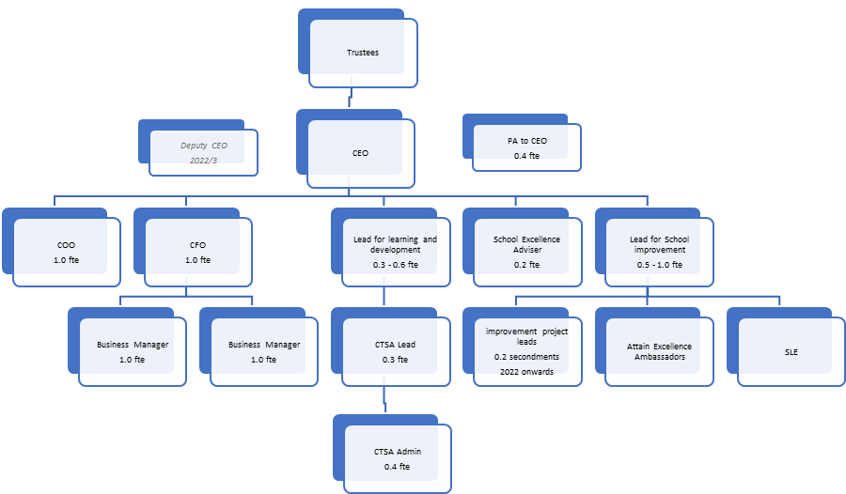

Central Management Team
CEO – Susannah Edom- Baker
Chair of the Board of Trustees – Bruce Doy
CFO – Sarah Orley
COO – Karoline Ellwood
Business Managers - Melanie Maul and Nathan Martin
Lead for School Improvement – TBC
CEO PA / CTSA Coordinator – Lisa Weatherhead
Governance Professional – Heather Hasmujajj

Headteachers / Heads of School
Jo Morgan – Gosfield Primary School
Natalie Hawkes – Newlands Spring primary School
Mike Wood – Elm Hall Primary School
Michelle Keeling – Rayne Primary School
Debra – Bocking Primary School
Shelley Jones – de Vere Primary School
Stewart Caplen – Cressing Primary School

School Improvement Adviser Associates
Keith Pullen (Attain School Excellence Adviser)
Tracy Goodway (Lead for Learning and Development - also CTSA Lead)

Senior HR Consultant
Tula Smith, Juniper Education
Governance

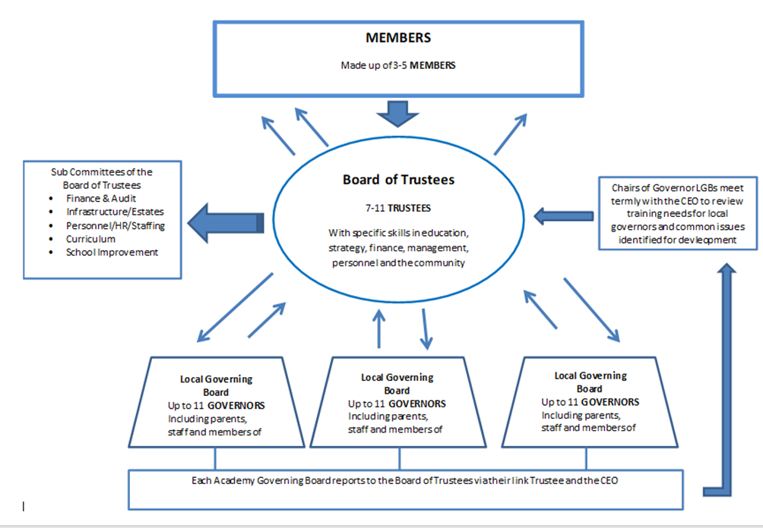

Governance is underpinned by the Academy Articles of Association and the Scheme of Delegation.

How we work

United by our core values, aims and ethos core values, all academies work together to create one learning community. Each academy, however, retains its local distinctiveness and appropriateness in order to serve its community.

Strategic planning

The Trust’s work is underpinned by our 3 year Business Plan which sets out our key priorities year by year. This plan is developed and monitored by the CEO and Trustees, in consultation with the Headteachers / Heads of School.

Support from the central team

To enable Headteachers / Heads of School and their schools to focus on their core purpose of providing the highest quality teaching and learning, the Trust provides centralized systems and support in relation to
- Finance
- HR
- ICT infrastructure
- Health and Safety
- Safeguarding
- GDPR
- Operations

DB Primary is used as a collaborative portal where policies, planning and other documentation is shared.

Support structures and meetings

Headteachers / Heads of School and staff have access to a wide range of support structures, both formal and informal. There are regular meetings of Headteachers / Heads of School, leaders of specific subjects, SENDCos, finance assistants and other staff groups.

All Trust schools also set common annual closure days. The November closure day is used as a whole Trust development day with an agenda set by the CEO and Headteachers / Heads of School.

Attaining Excellence

Every school in Attain is on a journey of continual improvement, aspiring for excellence year on year, for pupils and staff. We have already taken many valuable steps on that journey.

To achieve the next stage of our aspirational evolution, we believe the keys to unlock the full potential of our schools lie in:
- a shared understanding of excellence,
- a commitment to continuous, coherent staff and leadership development and
- enabling meaningful collaboration, at all levels.

To achieve this vision, we have developed the Attaining Excellence staff development framework.

It is underpinned by a Professional Standards Framework which describes aspirational standards of excellence for all leaders and staff, including support staff.

Alongside this sits the Staff Development Statement which outlines the Trust’s commitment to providing development for its staff, its expectation of their active role in this, and a description of the range of opportunities the Trust provides. It also includes a career progression map, reflecting the Trust’s commitment to identifying and nurturing potential.

Every member of staff will also have a Personal Professional Portfolio to record their professional learning journey.

Research and Development
In Attain, we believe passionately in the central role of research in ensuring our pupils have access to the highest quality education. Via the Attaining Excellence Framework (see page X) we enable staff to access and apply the latest research and also to carry out collaborative school based enquiry, for the benefit of all Trust schools.
We also seek opportunities to work on regional and national research programmes. We are extremely fortunate at the current time to be working with the Paul Hamlyn Foundation who have funded research into School Readiness and Musicianship in the Early Years, 3 Trust schools are currently engaged in this work, with publication of the outcomes scheduled for 2022.

Our partners
Essex Primary SCITT

Ofsted ‘Outstanding’ in all areas, 2017 https://www.essexprimaryscitt.co.uk/

Accredited through Attain Academy Partnership and lead by Newlands Spring Primary and Nursery School, The Essex Primary SCITT programme runs across 2 cohort’s one in Braintree and one in Chelmsford.
The EYTS programme runs across Essex, Cambridgeshire, Suffolk and Norfolk.

Each year around 50 new primary phase teachers are trained to a very high standard, and most gain their first teaching post locally, including in Attain schools. More than 30 Early Years practitioners also gain Early Years Teacher Status through the EYITT programme.

Chelmsford Teaching Schools Alliance (CTSA) http://www.chelmsfordteachingschoolsalliance.co.uk/
The Chelmsford Teaching Schools Alliance (CTSA) was established in March 2013 when Newlands Spring Primary and Nursery School became a National Teaching School. The Alliance currently have a partnership of 45 primary, 8 secondary and 2 special schools based in and around Chelmsford.
The Alliance offers a wide ranging programme of professional development and school to school support opportunities which form an integral part of the Trust’s school improvement and staff development strategy.
Saffron Teaching School Hub
The DfE is replacing the current Teaching School strategy with a new ‘Teaching School Hub’ model. This programme is creating a national network of 87 ‘centres of excellence’ for professional development and teacher training.
As part of this realignment, the current Chelmsford Teaching Schools Alliance has become strategic partner of the Saffron Teaching School Hub. This opens up collaborative, cross region opportunities whilst still allowing the Alliance to maintain independent local activity.
Via the Hub, Trust schools have access to an increasing range of partnerships and professional development opportunities across a large area of Essex.

