INFORMATION PACK
head of school south shore academy

Contents of this pack
Bright Futures Educational Trust | Page 2
South Shore Academy | Pages 3 -5
Why work for us and terms and conditions of the post | Page 6
Further information and a tour of the school | Page 6
How to Apply | Page 6
South Shore Head of School Job Description | Pages 7-9
South Shore Head of School Person Specification | Pages 10-12

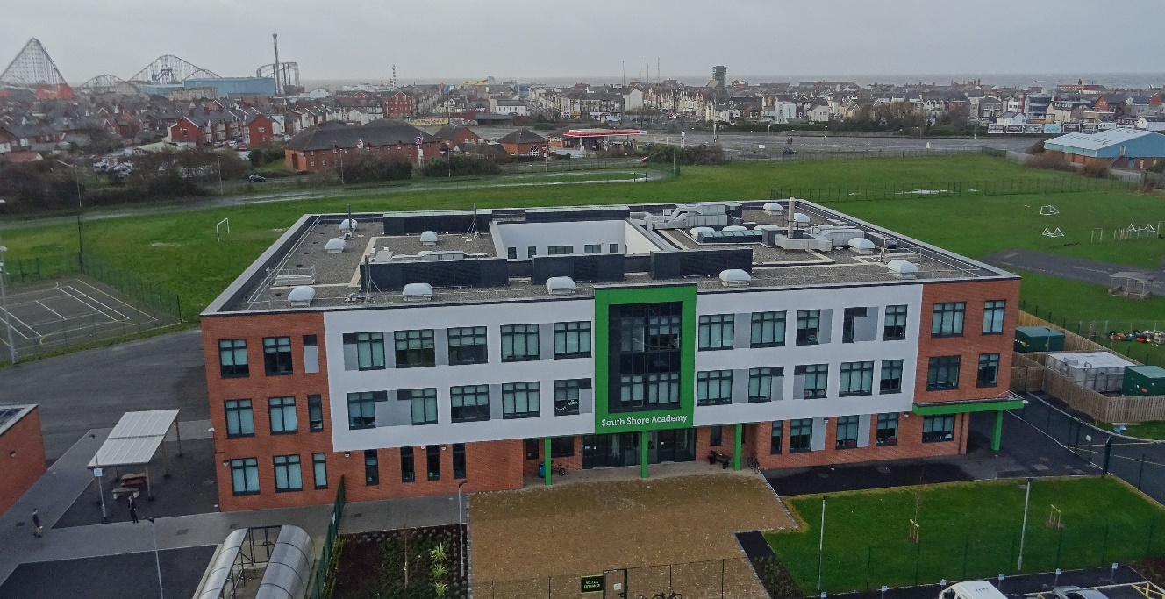

South Shore Academy
St Annes Road, Blackpool,
Lancashire
FY4 2AR

Bright Futures Educational Trust
Bright Futures Educational Trust (The Trust) is a multi-academy trust set up in 2011. The Trust is made up of a richly diverse group of schools in Greater Manchester and Blackpool. We are passionate about working together within and beyond the Trust to achieve our aspirational vision: the best for everyone, the best from everyone. We are an organisation that is underpinned by values of: community, integrity, and passion. In everything we do, we remember that we are accountable to the children, families, and communities that we serve.
Our schools have their own identities, form one organisation and have one employer, Bright Futures Educational Trust. Bright Futures’ Board of Trustees maintains strategic oversight of the Trust and delegates some of its responsibilities to the Executive Team, Principals, and local governing bodies. We place a high value on integrity and probity and take seriously our accountabilities for making the best use of public money. How decisions are made is described in our delegation framework. You can find out more about the Trustees and the Executive Team on our website: http://bfet.co.uk/about-us/.

The central team includes the Executive: John Stephens, CEO; Edward Vitalis, Chief Operating Officer; Gary Handforth, Director of Education; Lisa Fathers, Director of Development, Partnerships and Teaching School Hubs and Lynette Beckett, Director of HR & Strategy. The focus of these roles is to work with schools, providing high quality and timely guidance, leadership, challenge, and support. In addition to the executive team, we have central operations for finance, communications and marketing, HR, educational psychology, and digital technologies. Please see our website brochure which explains our central operations: Working together for a Bright Future.
Bright Futures Development Network is another important outward facing component of our organisation. Underneath this umbrella we have 5 network hubs. ‘The Alliance for Learning’ (AFL) which provides school improvement services and CPD to over 700 schools (http://allianceforlearning.co.uk/), a North West Maths’ hub providing mathematics training and coaching to 500 schools and a SCITT (School Centered Initial Teacher Training) which is the largest in the North West. After significant national reforms to the teaching school policy, Bright Futures was designated with two new large-scale Teaching School Hubs in 2021. The areas we serve are Manchester, Stockport, Salford, and Trafford. Our two Blackpool schools benefit significantly from the Trust’s wide range of strategic partnerships, having priority access to high quality CPD, professional expertise and bespoke learning opportunities.

Collaboration and strong relationships form one of the ‘commitments’ in our Strategy and all components of the Bright Futures’ family work closely together. Our Strategy was developed collaboratively and can be found
on our website: Our Strategy.
South Shore Academy
South Shore Academy was one of the first schools to join Bright Futures’ Blackpool cluster. The school works closely with others within and beyond the Trust to help every student and member of staff to succeed. Leaders from South Shore are involved in collaboration and support with other Bright Futures’ schools, and we both contribute to and benefit from the extensive experience and expertise that exist in the Trust.

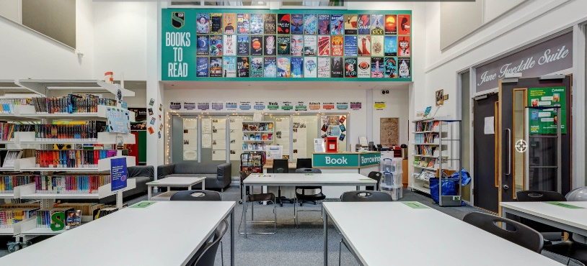

We are proud of the excellent relationships that exist between staff and students. Within our culturally diverse student body, tolerance, respect, and understanding are cornerstones of our strong relationships. Parents/carers and governors work in partnership with the school to ensure that the young people of our community enjoy the highest standard of education. The traditional values of courtesy, discipline and respect are important to us, and we believe that upholding them will help us continue to improve and achieve great outcomes for all at South Shore.

South Shore moved into a new building in 2017 and enjoys great outdoor facilities. The new building and site have been further developed since its opening and now is well resourced to support the implementation of a broad, ambitious curriculum for all.

Pupil Information
Type: Mainstream School
Phase: Secondary
Funding status: Publicly funded Academy
Gender: Mixed
Age Range: 11 - 16 years
No of students on roll: 755 and increasing
PAN: 985
SEND Students: 25% typically
EAL Students: 10% typically
Free school meals/PP: 57% FSM and 70% PP typically
Address: South Shore Academy
St Annes Road, Blackpool
Lancashire. FY4 2AR

South Shore Academy is located in the south shore area of Blackpool with great links to the M55 motorway and also has good transport links.

2021 GCSE results
English and Maths
G4-9 38.8%
G5-9 18.8%
G7-9 5.6%

There were some excellent results in: Computer Science G4-9 65.4% and Physics G4-9 100% Geography, History, Chemistry and Physics all show a strong improving trend. The school have also posted some excellent BTEC outcomes. There is much still to be done, but the school is enjoying a period of positive improvement, has a committed, friendly, and enthusiastic staff and a real drive to provide the very best for students.

South Shore Academy serves people who experience very high levels of socio-economic disadvantage. Numbers of children with special educational needs and/or disabilities are high. There is a high level of social care involvement with families and pupil mobility is also high. These indicators highlight the vulnerability of many families who have also been impacted badly by Covid 19. Equally, the students, families, and communities that we serve at South Shore are bright, ambitious, resilient, friendly, and kind. We owe it to them to maintain the highest expectations and to work positively and creatively to realise the Bright Futures vision: ‘the best for everyone, the best from everyone’. As Head of South Shore, the successful candidate will need to be uncompromising in their ambition for the people of Blackpool.

Blackpool Opportunity Area and Education Improvement Board
Blackpool was designated as one of the government’s ‘Opportunity Areas’ four years ago. The town has received significant additional resources from the DfE during that time and this has impacted positively on work at South Shore. The work of the OA has increased the scale and depth of collaboration between schools in Blackpool. The secondary sector works well together to take responsibility for all children and young people in Blackpool. Blackpool’s Research School, English Hub and Teaching School Hub each make a valuable contribution to the work of schools in the area. The MATs responsible for mainstream and special secondary schools in Blackpool work closely together. There is a secondary headteacher group and the MAT Chief Officers also meet regularly.

The local authority is very supportive of schools and has been a valuable partner, especially during the Covid pandemic. Through the Opportunity Area resources, South Shore has reduced permanent exclusions to zero and has a good programme of family support/early help in place. Through the Education Improvement Board – a collaborative structure focusing all partners on improvement – the town has developed an ambitious ten-year strategy for education.

Ofsted
South Shore was last inspected in September 2019 under the ‘new’ Education Inspection Framework. The school was judged to ‘require improvement’ but inspectors noted many significant improvements, not least in the improved consistency and quality of teaching, learning and the curriculum. The report can be accessed here:
Ofsted 2019.

Staff Information
Snr Leadership: In addition to the post of Head of School, South Shore has six other Leadership roles; two Deputy Head posts and four Assistant Head posts.
Teachers: The academy has 46 teaching posts and 20 of these role holders have a range of teaching and learning responsibilities (TLRs) such as team leader, deputy team leader (department heads/deputies), SENDCo, reading leader, heads of year and for leading careers, EAL and Duke of Edinburgh award.
Associate Staff: In addition, there are 46 associate staff posts e.g., pastoral leads, data, HR, IT, technicians, keyworkers, facilities, administrator posts
Staff engagement: A summary of the results of the Spring 2020 staff engagement survey is included below. Over the last few years, the new leadership team have made significant improvements in the culture at the academy. This is also seen in the voluntary turnover which in 2019/20 was 7.87% (lower than the national and the Trust’s average) and sickness absence in term two 2020/21 was 1.34%, again lower than the national and Trust’s average.
Governance: Accountability for the school rests ultimately with the Bright Futures Board of Trustees. However, the Board delegates some of its responsibilities to a local governing body (LGB) of staff, parents/carers, community, and co-opted representatives. The LGB is chaired by Jill Baker. Jill worked at the most senior levels in education and children’s service in local authorities and with DfE and bring significant experience and expertise to the role.
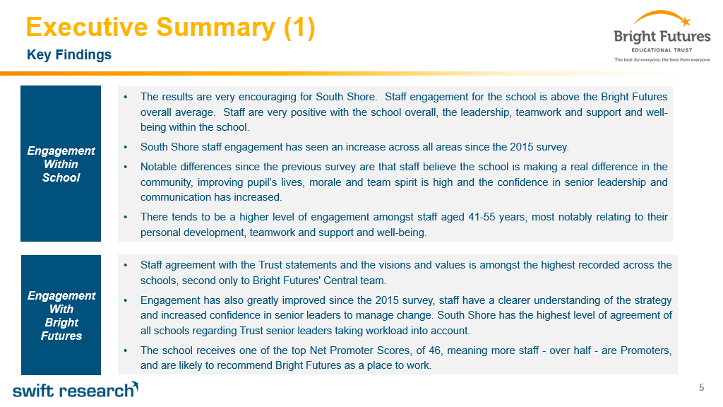

Why work for us?

We offer a great opportunity to join an organisation which really lives its values. Our working environment is very inclusive and whilst you can expect to be challenged in your role, you will be supported through professional learning, treated fairly and with dignity and respect. Please see the Equality, Diversity, and Inclusion statement on our website: http://bfet.co.uk/vacancies/.

Terms and Conditions
Salary: L25-L29 on Bright Futures Leadership scales
Pension: Teachers Pension Scheme: https://www.teacherspensions.co.uk/

Other: We offer salary sacrifice schemes for purchasing bikes used for travel to work and technology for personal use, through monthly interest free salary deductions.
Start Date: January 2022 or earlier
For a full explanation of our employment offer please see the booklet on our website:
Great-Place-booklet.pdf (bfet.co.uk)

Further Information and a tour of the school
We want candidates to learn as much as possible about South Shore and Bright Futures before deciding to apply. We’d love to hear from you and are happy to answer questions you might have to help you decide about applying for this important and exciting role. Our Chief Executive Officer, John Stephens, is available to have an informal phone conversation with prospective applicants. If you would like a call, please email admin@bfet.uk and let us know your availability and a number to call and we will be in touch.

For prospective candidates wishing a look around the school, our Executive Principal will be available to show people around the site. Please contact admin@bfet.uk, if you would like to come along.
How to Apply
We can only accept completed application forms, rather than CVs. This is because the regulatory guidelines of Keeping Children Safe in Education (2021), require us to check various details of job applicants and an identical application format for each candidate enables us to do this. We use a process that does not identify personal characteristics to the shortlisting panel. This is part of our commitment to equalities and diversity.
NO AGENCIES PLEASE.
Our new portal contains the application form and disclosure of criminal background form. The portal link is: Head of School Application Form - South Shore Academy. Please complete the application by 5pm on Wednesday 29 September 2021.

The selection will take place on 6th and 7th of October 2021 at South Shore Academy.

Keeping Children Safe in Education
Bright Futures Educational Trust is committed to safeguarding and promoting the welfare of children and young people and we expect all staff and volunteers to share this commitment. This post is exempt from the Rehabilitation of Offenders Act 1974; pre-employment checks will be carried out and references will be sought for shortlisted candidates and successful candidates will be subject to an enhanced DBS check and other relevant checks with statutory bodies.

Data Privacy
You can the details of how we use the personal data that you provide us with in our Job Applicants’ privacy notice on our website: http://bfet.co.uk/wp-content/uploads/2018/07/BFET-Applicant-privacy-notice-002.pdf

HEAD OF SCHOOL SOUTH SHORE
JOB DESCRIPTION

Job summary
The role of Head of School is to provide strategic and operational leadership and management to the school. You will develop and nurture a shared vision, clear leadership, and robust management for the school. We are looking for candidates who seek collaboration as a means to strive for excellence in both their own professional development and for high quality provision for all of our children. Our Head of School will have the energy, experience, and passion to help us realise our ambitions.

The Head of School will be a highly successful and experienced Senior Leader, who is able to enthuse, motivate and inspire colleagues, pupils, families, and communities. The successful candidate will be ready to take on more responsibility having already performed successfully as part of a senior leadership team. Good teamwork, high standards and a capacity for hard work will be at the core of his/her success. They will be a creative thinker with the ability, determination, and commitment to continue to develop the school and to ensure that our pupils receive a consistently high quality, inclusive education.

Key focus areas:
The detail of the role description is contained below. They should be considered within the context of the high standards of the Headteachers' standards 2020 - GOV.UK (www.gov.uk):

Ethics and professional conduct
Culture and Ethos
Curriculum and Teaching
Organisation Effectiveness
Governance and Accountability

Key responsibilities:

The Head of School, with the support of the Executive Principal, will:

Lead on good progress, participation, and achievement for all pupils through a rich and diverse curriculum.

- Ensure that the school improves at an ambitious pace and has the capacity for sustainable continuous improvement in all aspects of the curriculum and wider offers.
- Secure and sustain effective teaching and learning through structured data gathering, analysis and strategic review processes, working with the leadership team.
- Ensure that high quality staff training and development successfully impacts on raising standards in teaching and learning.
- Ensure the continuous development and effective implementation of a rich, relevant, inclusive, and impactful curriculum and enrichment programme.
- Ensure the effective use of appropriate data and research evidence to inform teaching and learning, planning and support/intervention strategies to raise attainment, maintain progress and address any under-performance of groups and individual pupils.
- Ensure the school holds ambitious expectations for all pupils including those with additional and special educational needs, those for whom English is not the first language and for pupils with disabilities
- Forge collaborative networks within the school, local area, and other Trust schools, in a climate of honest mutual challenge and support.
- Establish effective relationships with other schools, Bright Futures Development Network, and external partners such as the local authority and agencies to identify and maximise opportunities.
- Ensure that ambitious targets for improvement in key areas are set, understood by all, good progress made, and improvement secured.
- Ensure high quality staff training and development successfully impacts on raising standards in teaching and learning.
- Ensure the school works effectively in partnership with parents, carers, and partner professionals both generally and specifically to identify additional and special educational needs and disabilities of pupils, providing support and reasonable adjustment where appropriate.
- Secure exemplary behaviour and attendance for all students and staff.
- Secure good progress to further education and/or employment with training for all students.

Provide an environment where our people are valued
Ensure that all staff are positively engaged, enjoy equitable treatment, are held to account, supported, and challenged. To nurture an environment where people’s wellbeing and development are evident through compassionate behaviours, strategies and decision making.

- Ensure an effective staffing structure, where accountabilities are clear and people are listened to, held to account, supported, and developed.
- Staff training and continuous professional development is provided for ALL staff and targeted to needs and measured to ensure that it positively impacts on teaching and learning standards.
- Implement the trust’s people policies to ensure that people are recruited, managed, supported, and developed appropriately and in accordance with our vision, mission, values, and commitments.
- Lead on health, wellbeing, workload, safeguarding and general safety across the academy for pupils and staff, ensuring that a safe environment is experienced by all.
- Ensure an environment that embraces equality, diversity, inclusion, and social justice.
- To ensure that there are open and transparent verbal and written communication strategies are implemented with staff, pupils, parents/carers, and the local community.
- Maximise opportunities for staff afforded by being part of Bright Futures Educational Trust.
- Be a visible presence for pupils, parents/carers and the local community and sustain effective and positive relationships.
- Contribute to support programmes for students and staff that may include weekends and holiday periods.

Ensure financial viability
Plan for sustained financial viability enabling flexible investment in school improvement.

- Contribute to the production of annual school budgets, for approval by the Trust Board, which enable robust teaching and learning and value for money.
- Work closely with the central finance team to monitor budgets throughout the year and hold budget holders to account for their expenditure.
- Ensure all financial transactions undertaken by academy staff, are in accordance with the Trust’s finance handbook and financial control environment.

Robust governance through effective systems and processes

- Demonstrate understanding of the Trust’s delegation framework, act in accordance with its parameters and unite behind all decisions.
- Provide transparent and thorough materials and updates to the school local governing body in order for them to challenge and hold the school to account and/or to make decisions.
- Lead on the establishment of robust systems and processes across all areas of the academy, ensuring that the impact can always be measured.
- Ensure the protection and safety of pupils and staff through effective approaches to safeguarding, as part of the duty of care.
- Identify, manage, and mitigate against risks using the Trust’s risk management framework.

Other general Senior Leadership responsibilities, behaviours, and expectations

- Develop and maintain a culture of high expectations for self and others.
- Contribute to improvements across the whole Trust.
- Lead by example in all aspects of leadership consistently promoting the Trust’s vision, values, and commitments.
- Commitment to the development of all staff as well as challenging underperformance at all levels and ensuring effective action and follow up at an appropriate pace.
- Work to the ‘Nolan Principles’ of public life: Selflessness, Integrity Objectivity, Accountability, Openness, Honesty, Leadership.
- A commitment to maintaining confidentiality and always acting with discretion.
- Operate within the requirements of the Trust’s delegation framework.
- A positive approach to challenges, which seeks solutions to problems and addresses difficulties with positivity and good humor.
- Work closely with the Executive Principal and the Trust’s executive team to bring about sustainable school improvement.
- Work effectively with the Local Governing Body and the Chair to secure progress in the school.
- Sustain highly effective, positive relationships with all staff, pupils, parents/carers, governors, partners, the local community.
- Maintain clear expectations and high standards of professionalism.
- Support the development and maintenance of school policies and practices to ensure consistent application, ensuring that Trust wide policies are implemented in a timely manner.
- Keep the Senior Leadership Team up to date with local and national developments specific to their post and area of responsibility.
- Oversee the management of budget(s) in line with areas of responsibility.
- In conjunction with the Senior Leadership Team, oversee the development of the school environment/building developments to meet the needs of students and staff and to ensure a safe environment.
- Contribute to support programmes for students and staff that may include weekends and holiday periods.
- Take appropriate initiatives, working positively and creatively with the new opportunities offered by the Trust.

HEAD OF SCHOOL SOUTH SHORE
PERSON SPECIFICATION
Category | Essential | Desirable | Method of assessment
Qualifications,  Educational,  Training | Degree and teaching qualification.  Q.T.S.  Evidence of continuing professional development or further professional study. | Post-graduate qualification.  Professional qualification e.g., NPQH. | - Application form  - Certificates
Relevant Experience | Successful leadership within a substantive senior role or roles.  Experience in developing whole-school policies and strategies.  A deep understanding of successful classroom practice.  Experience of having led, or made a significant contribution to, the success of a school through its leadership, pupil outcomes and ethos.  Experience of leading and training staff to be successful practitioners.  Experience of supporting staff to optimise attainment and progress of pupils.  Extensive experience of working with children with significant barriers to learning. | Evidence of a contribution to wider educational issues.  Leadership experience in a Primary School. | - Application form  - Interview  - Tasks
Leadership & Management  behaviours | Communicate compellingly the School’s and Trust’s vision and drive the strategic leadership, empowering all pupils and staff to excel.  Highly reflective leader who strives for high self- awareness and understanding of the impact on others.  Demand ambitious standards for all pupils and staff.  Create an ethos where staff are motivated and supported to develop their own skills and subject knowledge and to support each other.  Hold staff to account for their professional conduct and practice, through fair and transparent processes.  Deep commitment to a collegiate approach and to working with others as a means of securing best outcomes for children.  Ability to work well under pressure and meet deadlines.  Ability to formulate, monitor, evaluate and review plans and policies.  Ability to confront and resolve problems.  Ability to innovate and manage change.  Ability to take difficult and courageous decisions and to follow them through.  Ability to formulate, monitor, evaluate and review plans and policies.  Ability to be a conceptual thinker with a practical application.  Ability to take on new challenges and to be a leader in the field of education.  Ability to develop effective partnerships with parents and other stakeholders in order to improve pupil outcomes. |  | - Interview  - Tasks
Our Values | A leader with authentic commitment to the Trust’s values of community, integrity, and passion. |  | - Interview  - Tasks
Safeguarding | Commitment to demonstrating responsibility for safeguarding and promoting the welfare of young people. |  | - Application form  - Interview  - Tasks
Dispositions and Attitudes | Hold and articulate clear positive and inclusive values and moral purpose.  Have vision and values aligned with the academy’s high aspirations and high expectations for children, staff, and families.  A relentless focus on improvements through a deep understanding of issues and insisting on high academic standards.  Understands how to set high aspirations and lead effective strategies across all aspects of the school.  Promotes equality, diversity, and inclusion, including championing the vulnerable.  Clear understanding of the ethos and strategies to establish consistently high standards of outcomes and attitudes and behaviour in an area of socio-economic challenge and commitment to relentlessly securing those standards. |  | - Application form  - Interview  - Tasks
Pre-employment screening | - Enhanced DBS check  - 2 satisfactory employment references, from the last two employers  - Evidence of the right to work in the UK
Bright Futures Educational Trust is committed to safeguarding and promoting the welfare of children and young people and expects all staff and volunteers to share this commitment. Any successful applicant will be required to undertake an Enhanced Disclosure by the Criminal Records Bureau. The post is exempt from the Rehabilitation of Offenders Act 1974.

