



Head of School

L6 – L9
£53380 - £57482

Swineshead St. Mary’s CE Primary School

Application Pack

September 2024

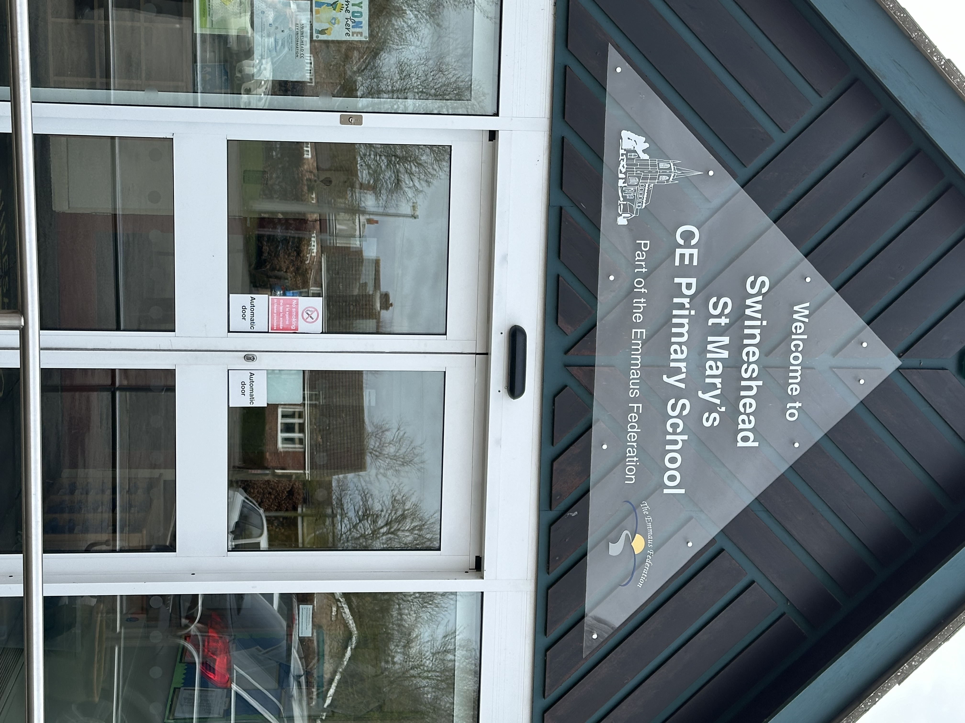

The Emmaus Federation

Our Federation is made up of two schools:

St Mary’s CE Primary School, Abbey Road, Swineshead, Boston, Lincolnshire, PE20 3EN
Tel 01205 820356

Fourfields CE Primary School, Park Avenue, Sutterton, Boston,
Lincolnshire, PE20 2JN
Tel 01205 460547

enquiries@suttertonswinesheadfederation.co.uk
www.suttertonswinesheadfederation.co.uk

What do we value?

Everyone in school is committed to doing their best, as educational and pastoral professionals, for each and every child. To do this we try to ensure that our school is colourful, exciting and welcoming to all who enter it where children and adults feel secure and confident enough to experiment and take risks, whilst always striving for excellence.

We know that each of our children comes to school with different experiences, knowledge and skills and that each has different learning needs and preferred ways of learning. We therefore aim to match our provision to the needs of each child.

We seek to not only provide an environment which promotes achievement in learning but also one of warmth, security and care, valuing each member of the school community and working to encourage the realisation of each individual’s potential.

We celebrate all achievement whether big or small and challenge our children (and ourselves) to improve even more. We encourage a ‘can do’ culture, a thirst for life-long learning and a pride in each other's skills and attributes

All children need to be cherished, protected and nurtured. Our mission is to help them to be the best that they can be in a safe and caring learning environment where respect, responsibility and co-operation are valued.

Contents

Foreword from the Executive Head Teacher

How to apply for the post of Head of School and SENCO

Job Description

Person specification

Application Form (separate attachment)



Reception children making pancakes for Shrove Tuesday

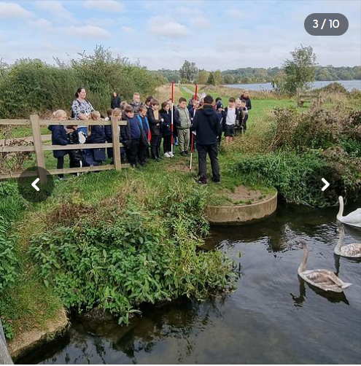
We believe strongly in enhancing our curriculum with educational visits – here children are visiting wetland areas to learn about rivers as part of their topic


We have large outdoor areas which are well resourced for PE lessons


Year 6 children dissecting pig hearts as part of their Science lesson
Foreword from the Executive Headteacher
Dear Applicant,

I would like to send you a warm welcome and thank you for taking an interest in the post of Head of School at Swineshead St Mary’s. The school is a popular school on the outskirts of Boston with good transport links to the Boston, Spalding and Sleaford areas. We currently have 245 children on roll.

We are part of a Federation – I am the Executive Headteacher and there is a Head of School at each site. Our partner school is Sutterton Fourfields CE Primary School. Both teams work well together in sharing ideas and best practice, as well as providing support.

We are currently in a period of consultation to join Lincoln Anglican Academy Trust and we expect that most of the due diligence checks and the work involved will be almost complete by September 2024.

Our schools are church schools and we value our links with our families, our local churches and the wider communities in the villages our schools are in. We are proud of our children, they work hard, are a pleasure to teach and are well behaved.

We are lucky to have lovely school grounds. We are well resourced with teaching assistants, who work hard to support our teachers. We are looking for a dynamic Head of School & SENCO with high expectations to drive our school forward, who is friendly, has good sense of humour and who will work well in our team.

If you need further information, please do not hesitate to contact us. I would strongly encourage you to come and have a look around our school – please contact the school office to arrange this.

Yours faithfully,

Mrs Claire Collett
Executive Headteacher

How to apply for the post of Head of School

- Please ensure that your application form is completed in full before returning it

- Your application form should be accompanied by a supporting personal statement.

- Please ensure that your supporting statement provides information detailing your experience, skills, knowledge and aptitude in relation to the criteria found on the person specification.

- Deadline for receipt of applications is
.
- Interviews will be held on 23rd May 2024

- Candidates are encouraged to visit the school.

Please return your completed application form to:

Mrs E Woods
School Business Manager
Swineshead St Mary’s CE Primary School
Abbey Road
Swineshead
Boston
Lincolnshire
PE20 3EN
01205 820356

Applications by email will be accepted. We advise that you request a confirmation email. If you don’t receive this email please ring us to confirm receipt of your application.

emma.woods@suttertonswinesheadfederation.co.uk

Job Description
The post holder will report to the Executive Head teacher. Apart from other colleagues, the main contacts of the job are the Executive Head teacher, Governors, SBM, teaching staff, other support staff, children, parents, governors, LA and outside agencies

Main Purpose of the job
The Head of School (& possible SENCO) will support the Executive Head teacher by:
- Working within the federation to articulate and promote the vision and values of Swineshead St Mary’s Primary School which take account of the federation’s vision and of the diversity, values and experiences of the school and the communities it serves.
- Managing the day to day running of Swineshead St Mary’s Primary School and support the Executive Head teacher in leading the school.
- Motivating and working with others to create a shared culture and a positive climate consistent with the agreed educational vision and values of the School.
Qualities
The Head of School will:
- Uphold public trust in school leadership and maintain high standards of ethics, behaviour and professional conduct
- Build positive and respectful relationships across the school community
- Serve in the best interests of the school’s children
- Duties and responsibilities
- Leading Learning and Teaching
Under the direction of the Executive Head teacher the Head of School will:
- Demonstrate the principles and practice of effective teaching and learning.
- Ensure a consistent and continuous school wide focus on children’ achievement which
reflects the agreed vision and values, using data and benchmarks to monitor progress in
every child’s learning.
- Lead in accessing, analysing and interpreting information to inform planning for
improvement.
- Initiate and support research and debate about effective teaching and learning.
- Develop relevant strategies for improvement.
- Ensure that learning is at the centre of strategic planning and resource management.
- Demonstrate and articulate high expectations, promoting individual and community
aspirations by establishing challenging targets for the whole community.
- Implement strategies which secure high standards of behaviour and attendance and
which reflect the school’s agreed values in their response to the needs of vulnerable individuals.
- Determine, organise and implement a diverse and flexible curriculum which takes
account of the needs and aspirations of all children.
- Implement an effective assessment framework.
- Monitor, evaluate and review classroom practice and promote improvement strategies.
- Challenge underperformance at all levels and ensure effective corrective action and
follow-up.
Developing Self and Working with Others
Under the direction of the Executive Head teacher the Head of School will:
- Treat all people fairly, equitably and with dignity and respect to create and maintain a positive culture in line with the School’s agreed vision and values.
- Manage conflict effectively, seeking positive outcomes.
- Build a collaborative learning culture based on self-improvement within the school community and actively engage with other schools, especially the federated schools, to build effective learning communities.
- Maintain effective strategies and procedures for staff induction, professional development and performance review.
- Ensure effective planning, allocation, support and evaluation of work undertaken by teams and individuals, including clear delegation of tasks and devolution of responsibilities.
- Develop and maintain a culture of high expectations and aspirations for him/herself and for others, taking appropriate action when performance is unsatisfactory and giving and receiving effective feedback.
- Regularly review his/her own practice, set personal targets and take responsibility for his/her own personal development.
- Give and accept support from colleagues, governors and the Local Authority.
- Have regard for the well-being of him/herself and others, managing his/her workload to promote a healthy work-life balance and encouraging and enabling others to do likewise.
Leading and Managing the Organisation
Under the direction of the Executive Head teacher the Head of School will:
- Be responsible for the day to day running of the school.
- In partnership with the Executive Head teacher, create an organisational structure which reflects the school’s values, and enables the management systems, structures and processes to work effectively in line with legal requirements.
- In partnership with the Executive Head teacher, produce and implement clear, evidence based improvement plans and policies for the development of the school and its facilities.
- In partnership with the Executive Head teacher, ensure that policies and practices take account of national and local circumstances, policies and initiatives and of Local Authority priorities.
- In partnership with the Executive Head teacher manage the school’s financial and human resources effectively and efficiently to achieve the school’s educational goals and priorities.
- Recruit, retain and deploy staff appropriately, managing their workload to enable achievement of the vision and goals of the school.
- Implement successful performance management processes with all staff.
- Ensure that the range, quality and use of all available resources is monitored, evaluated and reviewed to improve the quality of education for all children and provide value for money.
Securing Accountability
Under the direction of the Executive Head teacher the Head of School will:
- Work with the governing body, enabling it to meet statutory responsibilities by giving objective professional advice and regular accounts of the school’s progress.
- Develop systematic and rigorous procedures for school self-evaluation which are appropriate and enable everyone to work collaboratively, share knowledge and understanding, celebrate success, accept responsibility for outcomes and use the outcomes of evaluation to further improve the school.
- Ensure that all available data are used to identify strengths and weaknesses of the school and to inform planning for improvement.
- Ensure that individual staff accountabilities are clearly defined, understood and agreed and are subject to rigorous review and evaluation.
- Develop and present a coherent, understandable and accurate account of the school’s performance to a range of audiences including governors, parents and carers.
- Participate in arrangements for review of his/her performance, reflecting on his/her personal contribution to school achievements and taking account of feedback from others.
Strengthening Community
Under the direction of the Executive Head teacher the Head of School will:
- Ensure that effective strategies, systems and support are in place to ensure the safeguarding of children and young people in the school and co-operate and work with relevant agencies for the protection of children.
- Act as the public face and main advocate of the school, representing effectively its interests and those of the children.
- Build a school culture which takes account of the richness and diversity of the communities served by the school and of the global community.
- Enable children to develop an understanding of their responsibility to others and provide the means for them to respond positively to this.
- Create and implement positive strategies for promoting understanding that everyone is equal, and in particular for challenging racial and other prejudices and for dealing with racial harassment.
- Ensure the provision of learning experiences for children which are linked into and integrated with the wider community, including community based learning.
- Collaborate with other agencies in providing for the academic, spiritual, moral, social, emotional and cultural well-being of children and their families.
- Create and maintain an effective partnership with parents and carers to support and improve children’ achievement and personal development.
- Seek opportunities to invite stakeholders (parents and carers, community figures, businesses and other organisations) into the school to enhance and enrich the school and its children and their value to the wider community.
- Engage in dialogue with all stakeholders to build partnership and understanding of shared values, beliefs and responsibilities, reflecting on and taking account of their views.
- Contribute to the development of the education system by sharing effective practice, working in partnership with other schools and promoting innovative initiatives, especially with other schools.
- The Head of School will be required to safeguard and promote the welfare of children and
- young people, and follow policies and the staff code of conduct.

Please note that this is illustrative of the general nature and level of responsibility of the role. It is not a comprehensive list of all tasks that the Head of School will carry out. The post holder may be required to do other duties appropriate to the level of the role, as directed by the Executive Head teacher including the position of SENDCo if appropriate and possible.
Person Specification - Head of School & SENCO
Criteria | Qualities
Qualifications and training | Essential:  - Evidence of successful leadership experience in the primary sector  - Evidence of driving improvements at a whole-school level  - Successful high quality teaching experience within the EYFS/Primary age range  Desirable  NPQH or further professional qualification  SENDCo qualification
Experience | Essential:  - Evidence of successful leadership experience in the primary sector  - Evidence of driving improvements at a whole-school level  - Successful high quality teaching experience within the EYFS/Primary age range
Leadership | Essential:  - Ability to provide clear educational vision and direction  - Ability to inspire and motivate all stakeholders Evidence of developing effective strategies for school improvement  - High level of involvement with school improvement planning  - High level involvement in monitoring and evaluation procedures leading to clear impact  - Ability to work in partnership with senior leaders and governors  - Ability to set challenging targets for children and staff  - Ability to analyse and use pupil data on attainment and progress to raise standards  - Understand the principles of effective teaching and learning
Leading Learning and Teaching | Essential:  - Successful experience of monitoring, evaluating and improving the quality of teaching and learning  - Understanding the role and impact of assessment in children’s learning Secure knowledge of statutory requirements relating to curriculum and assessment  - Experience of leading curriculum innovation  - Successful experience of developing effective learning behaviours
Leading and Managing Change | Essential:  - Ability to lead, manage and motivate across the school community  - Ability to establish positive working relationships  - Ability to plan, allocate, delegate, support and evaluate work undertaken by individuals and teams Successful experience of identifying the need for, and leading, in-service training  - Significant experience of taking a lead role in performance management of staff  - Experience of dealing with staff when performance gives cause for concern  - Successful experience of managing budgets Ability to manage, monitor and review available resources, ensuring value for money  Desirable:  - Experience of working with Governors  - Budgetary management at whole school level  - Experience of recruiting and deploying staff
Personal Qualities | Essential:  - Strong commitment to raising standards High expectations of self and others  - Ability to establish and maintain positive relationships, including with parents  - Ability to remain positive and enthusiastic, including when under pressure  - Good communication skills  - Empathy with children

