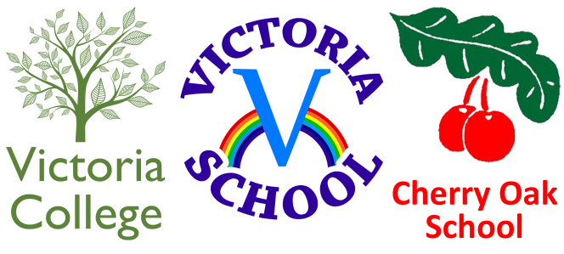

Federation of Cherry Oak School, Victoria School and Victoria College

Head of School – Victoria School

Full Time

Based at Victoria School, Bell Hill, Northfield, Birmingham, B311LD

Dates:

Applications close: Monday 17th January 2022 at 12:00 Midday.

Interviews: Tuesday 1st and Wednesday 2nd February 2022

Job starts: Anticipated April 2022

Salary: L18 – L22 (£64,143 - £70,745)

Location: Victoria School, Bell Hill, Northfield, Birmingham, B31 1LD

Contract type: Full Time

Contract term: Permanent

The Federation comprises two special schools and one 19-25 specialist College in Birmingham. The schools are LA maintained, whilst the College is an Independent Specialist Provider, with its own Board of Trustees. The College is in a soft Federation with the two schools.

Victoria School
Victoria School is an all age 2-19 special school based in Northfield; supporting pupils with cognition and learning needs, profound and multiple learning disabilities (PMLD), physical disabilities and complex medical health and learning needs. We cater for 228 pupils and are extremely proud of our provision and whole school community.

Victoria College
Victoria College is based on the same site in Northfield. We support young people with PMLD and complex medical and health needs. The college opened in 2013 and we have 31 learners on roll.

Cherry Oak School
Cherry Oak is a Primary Special School for children aged 4-11 years and is based in Selly Oak. There are currently 112 pupils on roll. Our pupils have Speech, Language and Communication Difficulties and/or Cognition and Learning Difficulties. Approximately half of our pupils are diagnosed as being on the Autism Spectrum.

The Federation’s vision is ‘working together for success’. Our aim is to increase every individual pupil’s knowledge and understanding of the world so that their full potential may be achieved.’

The Board of Governors is seeking to appoint an inspirational and dynamic Head of School to support us in our continuous journey of self-improvement and to work in collaboration with the Executive Headteacher and Senior Leadership Team.

We are rightly proud of our Federation. This is an exciting opportunity for the right person to lead a vibrant, highly committed and caring community where children and young people are at the very heart of all that we do.

The successful candidate will:

- Promote outstanding classroom practice for students with severe cognition and learning difficulties and speech, language and communication difficulties
- Provide inspirational and supportive leadership to the team of teachers and support staff
- Have an in-depth understanding of SEND, relevant curriculum and safeguarding
- Demonstrate excellent communication and interpersonal skills
- Have a track record of leading whole school initiatives
- Motivate and support colleagues and work collaboratively across the Federation and with other professionals
- The ability to lead with clear direction, building on the success of the Federation
- The strategic innovation and drive to help build on the exciting plans that have been established and are in place for the Federation’s future development
- A commitment to ensure that all children and young people achieve the very best outcomes
- Implement a clear vision, combined with highly effective communication skills that will inspire, motivate and lead the community forward for further success.

Our school offers:

- An opportunity to work with our fantastic students and staff team!
- A happy and caring community that always puts our young people first
- A highly motivated staff team who are committed to getting the very best outcomes for our students
- Excellent opportunities to further develop your leadership skills and career pathway
- A commitment to continuing professional development
- A strong and supportive Governing Body
- A culture of promoting positive mental health and wellbeing through a well-planned strategy

This is an exciting opportunity for the right person to lead teaching and learning and manage the day to day operation of Victoria School. If you are ready for a new and exciting challenge, you are encouraged to visit prior to submitting your application.

If you wish to discover more details about this exciting opportunity, please request an information pack and application form by email
recruitment@victoria.bham.sch.uk or downloaded from the Victoria School website https://www.victoria.bham.sch.uk/vacancies/

This post is covered by Part 7 of the Immigration Act (2016) and therefore the ability to speak fluent spoken English is an essential requirement for this role.

This post is exempt from the Rehabilitation of Offenders Act 1974 and the amendments to the Exceptions Order 1975, 2013 and 2020. Which means that when applying for certain jobs and activities certain spent convictions and cautions are ‘protected’, so they do not need to be disclosed to employers, and if they are disclosed, employers cannot take them into account. Further information about filtering offences can be found in the DBS filtering guide.

This school is committed to safeguarding and promoting the welfare of children and expect all staff and to share this commitment. The successful candidate will be subject to all necessary pre-employment checks, including: an enhanced DBS; medical fitness; teacher prohibition check, identity checks and right to work.

All applicants will be required to provide two suitable references.

