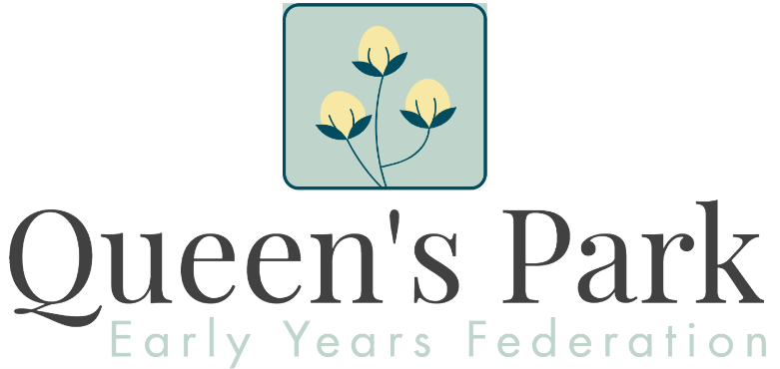

Federation Head of Schools
Application Pack

Contents
Letter to candidates | P-2
Vision for teaching and learning | P-3
Staffing structure | P-4
Job description | P-5
Person Specification | P-7
How to apply | P-8
Location | P-9
Westminster – The place to live and work | P-10

Letter to candidates
Dear Colleague,
Thank you for your interest in our vacancy for Federation Head of Schools. I would like to take this opportunity to tell you about our federation.
We are three unique Early Years’ settings that make up the Queen’s Park Early Years Federation;
- Mary Paterson Nursery School
- Dorothy Gardner Nursey School
- Queen’s Park Family Hub
The federation’s vision ensures that high quality early years provision, resources and services are used for the youngest children so they get the best possible start in rich settings that are welcoming and secure. Every child is supported in uniquely creative environments in order to thrive as part of family and key worker groups. ​

Excellent outdoor learning experiences and opportunities provided on a daily basis within the school grounds but also as part of the forest school experience underpin all that the children do; ‘learning from the feet up’ is the approach used by the school. Ofsted 2017
​
We have high aspirations for all the children we educate, where there is no cap on any child’s potential linked to a bold vision for our early years federation. With your support and help we work together to achieve our aim of high outcomes for every child.

It is very evident that children are at the heart of every conversation in this nursery. Ofsted 2017

Our staff team are extremely dedicated and demonstrate high levels of passion, energy and resilience. Our pupils are highly motivated, determined and curious. Everyone in the school community has a passion for learning.
​​
As the child’s first educator we will always make sure that views and thoughts about children’s progress and next learning steps are part of their bespoke learning journey. I look forward to meeting you as we go forward together.

The richness of the curriculum and how children’s interests lead and shape their learning are powerful motivators and ensure that they are enthused by their learning. It is hard to remember that these are only two-, three- and four-year-olds when you see what they are experiencing and learning. ‘Making everything out of anything’ is an expression you use to explain the role of the educator within this school. Ofsted 2017

I hope this information pack encourages you to make an application. If you have any questions about the position or the federation, please do not hesitate to contact me. Applicants are encouraged to call or email the federation and arrange a visit to the school.

Please contact the federation on:
Email: office@dorothygardner.co.uk
Tel: 020 8969 5835

I look forward to hearing from you.

Kind regards

Ben Commins
Executive Headteacher

Vision for teaching and learning
We are three unique Early Years’ settings that make up the Queen’s Park Early Years Federation; our unity and expertise strengthens our offer to the local community to provide young children and parents the best opportunities in order to flourish.
​
Both Nursery Schools and Children’s Centre are culturally diverse, inclusive settings within the London borough of Westminster. All staff work in partnership with parents and other professionals to build a culture of trust, collaboration and development beyond both schools and children’s centre, irrespective of social or economic background. We are keen to share our staff and our practice.
​
We believe that children learn best through active exploring, engagement and creativity which includes the natural world though our Forest School’s approach.
​
We follow children’s lead with their interests and make them the centre of every thought and conversation so that limits on expectations and outcomes are never set within a safe and secure environment.
​
Children are appropriately challenged and supported through open and reflective practice. This includes parents and carers so that each child’s unique identity and take on the world develops their creativity, intent, feelings, ability to innovate and think critically. The insights that we gain enables us to discuss and plan our environments to support and shape future learning.
​
We are a federation where children and adults learn from each other, where childhood achievements, free play and open ended learning are honoured and celebrated.

Staffing Structure

Key

Dorothy Gardner staff

Mary Paterson Staff

Queen’s Park Children’s Centre Staff

Federation (Multi-site) Staff

Head of Schools for Dorothy Gardner and Mary Paterson Nursery Schools
Job description
Job title: Head of Schools
Pay range: L9 to L13
Reports to Executive Headteacher
Five Direct reports: Business Manager, two Senior Teachers, Deputy Head of Children’s Centre, Sendco
Job Purpose
- Provide effective leadership of Dorothy Gardner and Mary Paterson Nursery Schools, which form part of the Queen’s Park Early Years Federation
- Day-to-day management of children, staff, resources and buildings
- Create and maintain a culture of improvement and success
- Form and develop effective partnerships within and beyond the Federation
- Work with the Executive Headteacher, providing high quality professional leadership
- Contribute to the Federation’s success through membership of the Senior Leadership Team

Key Responsibilities
- Work with the Executive Headteacher and Governing Body to develop and communicate a clear strategic vision for the Federation
- Motivate and empower others to carry this vision forward
- Develop, with the Executive Headteacher and Business Manager, a costed, annual strategic plan

Leadership of Teaching, Learning and Assessment
- Ensure the quality of teaching and learning is at the centre of strategic planning
- Ensure a planned annual cycle of assessment, monitoring and evaluation
- Ensure a consistent and continuous approach to monitoring children’s progress, using data and benchmarks to identify individual and group achievement
- Ensure the implementation of effective intervention and support programmes, the impacts of which, are regularly reviewed and evaluated
- Implement strategies that promote high standards of behaviour and attendance
- Monitor, evaluate, and review classroom practice

Managing the two nursery schools
- Work with the Executive Headteacher to develop and sustain an organisational structure, which raises standards and ensures that two nursery schools function effectively
- Manage the nursery school’s financial and human resources
- Manage the nursery schools on a day-to-day basis ensuring that policies, including those relating to safeguarding and health & safety, are fully adhered to
- Advise the Executive Headteacher and Governing Body on the performance, competence, and capacity of staff
- Undertake responsibilities as defined in health and safety policies and ensure that appropriate risk assessments are undertaken
- Manage, monitor, and review the range, quality, quantity and use of all resources to improve the quality of education, improve pupils’ achievements, ensure efficiency, and secure value for money
- Undertake responsibility for promoting and safeguarding the welfare of children
- Ensure that all agreed policies and procedures are adhered to

Financial Management
- Work with the Executive Headteacher and Business Manager on appropriate priorities for expenditure, allocating funds effectively within the context of the annual budgetary cycle and Federation improvement priorities
- Work with the Business Manager to manage agreed budgets, ensuring effective administration and value for money
- Support the Federation in securing additional resources to aid improvement

Leading and Managing Staff
- Carry out, through line management or direct responsibility, the performance reviews of all staff and all relevant arising actions
- Lead on the recruitment and selection of teaching and support staff
- Support the Executive Headteacher and governors in creating and maintaining good working relationships amongst all members of the Federation community
- Promote an inclusive environment amongst all staff and all those participating in the day to day activities within the Federation, so that each individual is recognised, respected and valued
- Manage HR activities and other leadership processes as appropriate e.g. sickness absence, disciplinary and capability

Securing Accountability
- Work with the Executive Headteacher and the Governing Body, providing information, objective advice, and support to enable the Trust to meet its responsibilities
- Assist the Executive Headteacher to develop and present a coherent and accurate account of the Federation’s performance to a range of audiences including the Governing Body and parents and carers
- Provide reports for, and be present at, all Governing Body meetings

Strengthening Community
- Build a culture and curriculum, within the context of the Federation’s vision, which considers the richness and diversity of the local and wider communities
- Collaborate with other agencies to promote the academic, spiritual, moral, social, emotional and cultural well-being of children and their families
- Maintain and develop effective partnerships with parents and carers
- Seek opportunities to invite parents and carers, community figures, businesses or other organisations into the school to enrich the children’s experiences

Safeguarding
- Ensure that all safeguarding policies and practices meet national guidelines are adhered to
- Ensure that all safeguarding policies and practices meet national guidelines and are published as required
- Ensure all staff are fully trained and aware of their responsibilities
- Cooperate and work with all relevant agencies to protect children

Person Specification
The future sustainability of the two nursery schools must be a priority
Qualifications
- A degree and qualified teaching status
- Desirable: an early years teaching qualification/ a degree in early childhood studies
Knowledge
- Sound knowledge of how to deliver high quality early years education and childcare services
- Thorough understanding of the new Early Years Foundation Stage curriculum
- Sound knowledge of child development and how to implement best practice for children aged two to five years; where necessary, willingness to undertake additional training.
- A sound grasp of the concept of inclusive practice
- A thorough understanding of and the ability to model good practice in education and care
- A thorough knowledge of major early years educational development and research
- A thorough knowledge of legislation in relation to working with children under five in educational and childcare settings.
Skills and Experience
- Relevant senior management experience in an Early Years setting
- Experience of managing change in a constructive and sensitive manner
- Able to work under pressure and meet deadlines
- Evidence of successful leadership and management in a senior management role
- The ability to develop effective planning and assessment systems and co-ordinate their use to promote the all round development of children
- Able to manage budgets, fee income and any grant aided or other funds
- Able to create and sustain supportive working partnerships with parents and carers; and the ability to empower parents, to value their own contribution and role in supporting their children's educational development
- Strong interpersonal skills and the ability to build and maintain good relationships and consult with children, parents/ carers, staff, governors and other agencies
- Evidence of the ability to be flexible and collaborative with colleagues from different disciplines over established practices and the development of new ventures
- An in-depth knowledge of and the ability to implement policies and strategies that ensure inclusion and equality of opportunity for pupils, parents/ carers and staff
- Good I.T. skills, both for management and administration
Qualities
- An outstanding early years practitioner with a deep understanding of child development.
- Able to lead and manage a diverse team creatively
- Able to demonstrate the ability to lead and manage strategically
- Able to continue to develop a shared vision for the future
- Able to inspire all staff to provide a high quality service
- Committed to providing a safe, inclusive and stimulating environment for children and parents
- Be proactive, self-confident and approachable

How to Apply

If you decide to make an application, please look carefully at the Job Description and Person Specification.

Your supporting statement should be no longer than 3 sides of A4 and should be tailored to demonstrate your suitability for the post.

CVs will not be accepted and interviews will be offered to those applicants best demonstrating skills, abilities and experience matching the person specification and can demonstrate and evidence their commitment to our federation.

Key Dates

Closing date: 1st July 2021 @ 9am

Shortlisting: 2nd July 2021

Interviews: 12th July 2021

Start Date: 1st September 2021 (preferable)
1st January 2022 (negotiable)

Visits to the federation:

We encourage visits to the federation (observing our Covid 19 arrangements). Please contact Ben Commins (as below) to arrange a visit.

Any Questions?

If you would like an informal discussion about any aspects of this job opportunity, please contact Ben Commins (Executive Headteacher) on head@queensparkschool.co.uk

If you decide to apply for this post, please return your completed application form to head@queensparkschool.co.uk

Our 3 Site Locations

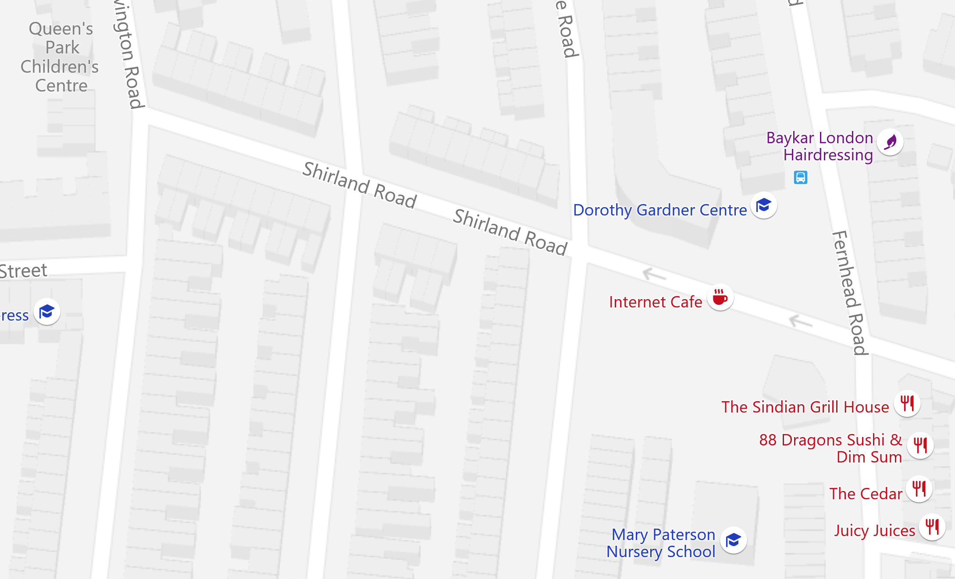

Dorothy Gardner School  - 293 Shirland Road, London  - W9 3JY  020 8969 5835  - head@queensparkschool.co.uk | Mary Paterson Nursery School  13 Riverton Close, London W9 3DS  020 8969 9683  head@queensparkschool.co.uk | Queen's Park Children's Centre  88 Bravington Road  London  W9 3AL  020 7641 5838  head@queensparkschool.co.uk
Buses: 6,18,28,31,36,187, 228,316,328,414.
Tube: Queen's Park Underground Station, Kilburn Park Underground Station, Westbourne Park Underground Station, Maida Vale Underground Station.
Overground: Queen's Park Overground Station, Kensal Rise Overground Station.

Westminster – The place to live and work
Westminster is a vibrant city which offers a wealth of opportunities for its residents, its businesses and more than 28.5 million tourists who visit each year.
The City of Westminster stretches from Pimlico and Victoria in the south through the West End, Marylebone and Bayswater to Paddington and Queen's Park in the north-west. It includes the capital's principal areas of government, shopping, entertainment and tourism and the headquarters of innumerable commercial and professional organisations together with extensive residential areas of all types.
The resident population now stands at approximately 234,000 but it is estimated that about 1 million people set foot in Westminster at some time during the day. There are also tens of thousands of people who live in the City for short-periods or on a part-time basis who are not included in the resident population.
Stretching just over eight square miles, Westminster is one of only two London boroughs to hold city status. As home to the UK government, the monarchy and some of the world’s most iconic landmarks, it is a city of great economic, historic and cultural significance.
The ‘City Plan 2019-2040’ sets out an ambitious strategy to make Westminster one of the best places to live, work and play.
So why not come and join us!

