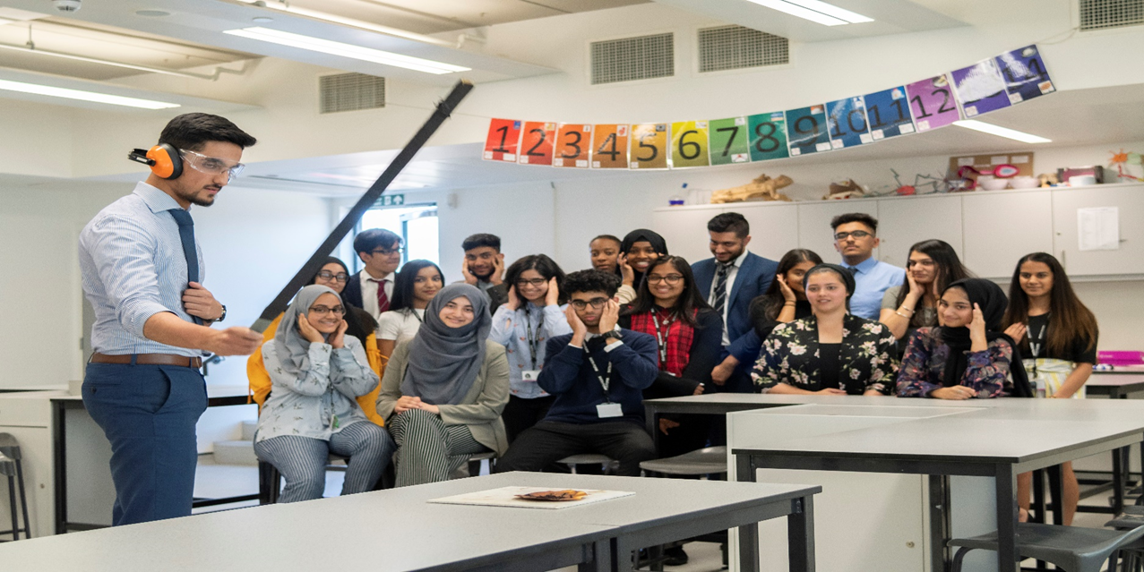

Isaac Newton Academy

Head of Science

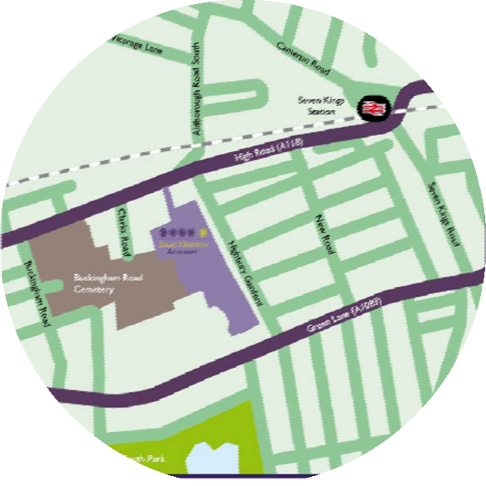

About Isaac Newton Academy

INA is based in new buildings between Ilford High Road and Green Lane in Ilford. The school’s learning community is based upon the core values of mutual respect, personal discipline, and an unwavering commitment
on the part of all community members to do whatever it takes
to excel.

Isaac Newton Academy Secondary is a non-denominational, non-selective school, welcoming girls and boys from all backgrounds from the local community. The school opened with just 180 Year 7 students in September 2012. The secondary school has grown year on year and we now have 1200 11-18 year olds (including 250 students in the Sixth Form). In September 2014, Isaac Newton Academy opened a three-form entry primary school in purpose-built accommodation right next to the secondary academy. There are 90 children in each year group and, like the secondary school, it has grown a year group at a time. From September 2020, we now have children in Reception through to Year 6.

The London Borough of Redbridge forecasts a significant deficit in secondary school places over the coming years. The new Academy will thus serve a critical, long term need for the community. Although the local area encompasses considerable economic disadvantage, its young people achieve some of the best results in London schools. Ark was chosen to sponsor the academy because of the success of our educational model and the alignment of our educational vision with the Redbridge context.

Dear Candidate,

I am delighted to introduce you to Isaac Newton Academy, a brand new, purpose-built, all-through school for students aged 4-18 in Ilford.

Our staff work tirelessly to ensure that each and every student is supported and stretched to reach their full potential. We focus on working towards achieving our vision to ‘equip every student with the knowledge, learning power and character necessary for success at university and beyond’. Commitment to our vision has already delivered a series of great successes highlighted in October 2018 when the academy was judged by Ofsted to be outstanding in all areas.

Joining Isaac Newton Academy in September 2020, I have spent more than a decade as a senior leader, a large portion of this within an all-through school. There is something incredibly special about working in an all-through school, which makes me committed to delivering the highest quality education to all the students at Isaac Newton Academy and will build on the successes already enjoyed by the school.

My vision for the community is to strive to ensure that the students and families we serve continue to receive excellent levels of care and academic support, whilst pushing new boundaries in pursuit of the ambitions I have for the academy and community. These ambitions will be fulfilled by each person in our community committing to our BRIDGES values, displaying a growth mindset and believing that our aspirational vision can achieved by all. Ultimately, I want to help lead a legacy of pioneers who will positively change the world around them.

I wish you the best with your application.
Morgan Haines
Principal
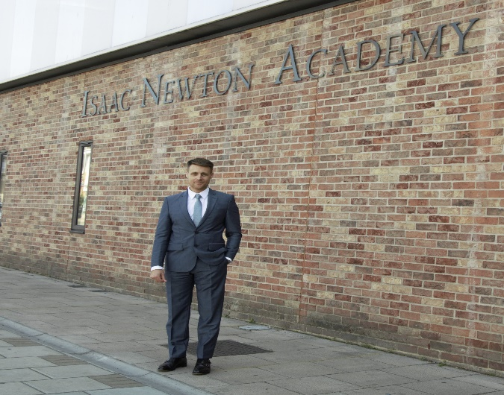

Our Vision, Our Mission and Core Purpose
At Isaac Newton Academy our core purpose (mission) is to equip students with the knowledge, learning power and character necessary for success at university and beyond.

We:
- Set clear, ambitious goals, and rigorously monitor our progress in achieving them
- Offer a curriculum emphasising core academic subjects, while providing the facilities and the specialist staff to meet and stimulate a wider range of interests
- Employ an approach to teaching that instils knowledge, understanding and a desire to learn
- Ensure that all students, teachers, staff and parents commit fully to making Isaac Newton Academy a vibrant learning community.

We expect all staff to be aligned to the mission, core purpose, vision and ethos of the Academy.

Our Ethos
We strive to create a stimulating, challenging and rewarding environment in which to support learning, teaching, development and progress. We share a collective duty of care for resources, facilities and accommodation.

At Isaac Newton Academy everyone is a learner with needs and entitlements. We all have a responsibility to support everyone else in the school community with their learning and a role to play in encouraging ambition, hope and optimism in our fellow learners.

We model good learning habits and we discuss and reflect on our learning journeys. Everyone is expected to work hard and with a common sense of purpose and direction.

The ethos of Isaac Newton Academy is one of mutual respect and consideration. Interactions between members of staff, between students and between staff and students are based on trust and the highest regard for each other. The language we use and the way in which we communicate with each other reflect this. The authority of staff is acknowledged and respected.

The differing backgrounds, views and outlooks of members of the school community are honoured. The particular needs, talents, interests and contributions of students are nurtured and developed.

Core Purpose
- To demonstrate belief in the potential of all students to develop the skills and character necessary for a place at a top university and success in life.
- To embrace shared accountability for the achievements of the students and the performance of the Academy. This will require hard work.
- To uphold all school policies and follow all agreed procedures with consistency and care.
- To maintain zero tolerance of any form of student behaviour that runs counter to the Academy’s stated aims and objectives: for example, disrespect, rudeness, bullying, dangerous/anti-social/loud behaviour, failure to bring basic equipment or complete independent learning tasks, possession of banned items, lateness.

BRIDGES at Isaac Newton Academy

At INA, we know that developing our students’ character crucial to them living happy, fulfilling and successful lives. Our Bridges programme develops the following learning dispositions and characteristics:

“We build too many walls and not enough bridges”
Isaac Newton

CHARACTERISTIC SHOWN THROUGH

BRAVERY courage, creativity, leadership, experimentation, risk-taking,
optimism

RESOURCEFULNESS remembering, making connections, transferring, gathering,
recycling,

scavenging, questioning, reasoning, imagining, imitating

INTEGRITY fairness, humanity, justice, citizenship, honesty, humility

DISCOVERY curiosity, open-mindedness, enthusiasm, energy, noticing

GRIT patience, persistence, resilience, determination, managing distractions, perseverance, concentration

EMOTIONAL INTELLIGENCE listening, empathy, collaboration, sociability,
reflectiveness, imagining, understanding, openness

SELF-DISCIPLINE organisation, hard-work, patience, absorption, practicing, focus, prioritising, planning, prudence, revising, self-regulation, independence, motivation

About Ark
Ark is an education charity set up in 2004 to create a network of high achieving, non-selective, inner city schools where all pupils, regardless of their background or prior attainment, achieve highly enough by age 18 to have real choices: to go on to university or the career of their choice. Ark has no faith affiliations.
All ARK schools are situated in areas of high deprivation or educational need and our pupil profile reflects this: over half of our pupils are eligible for free school meals compared to 18% nationally.
The ARK network operates 38 schools in the UK across London, Portsmouth, Birmingham and Hastings. Each of our schools has its own distinctive character, reflecting its local community.

A Commitment to Encourage Diversity
Ark is committed to eliminating discrimination and encouraging diversity amongst our employees. Our aim is that our workforce will be truly representative of all sections of society and that each employee feels respected and able to give their best. To that end we are committed to provide equality and fairness for all in our recruitment and employment practices and not to discriminate on grounds of age, disability, gender reassignment, marriage/civil partnership status, pregnancy and maternity, race, religion or belief, sex, or sexual orientation. We oppose all forms of unlawful and unfair discrimination.

About the department

At Isaac Newton Academy, we believe that there is a unique opportunity to ensure that Science is taught correctly from the beginning. It is our aim to ensure that the scientific knowledge and understanding required at A-level has its roots in the material taught right from the beginning of the student’s secondary school experience. By embracing the concept of depth-before-breadth and teaching extended Science topics, we aim to provide every student with the foundations for success in Science during and beyond secondary school. Our curriculum has practical science at its heart and we strive to ensure that Science is taught in a hands-on manner where students are taught to think critically and highlight the importance of experimental evidence. We are fortunate to have 12 Science laboratories, 4 preparation rooms and a generous supply of modern apparatus to support with this ethos. We take every opportunity to inspire and engage our students, providing opportunities for investigation and discovery and are committed to enriching the curriculum with out of class learning opportunities.

We have a significant number of Key Stage 5 Science groups in 2020-2021 including a growing Applied Science BTEC provision where many students choose a science related destination for university and this is an exciting opportunity to contribute to the continuing development of the A-Level Science curriculum as we grow and develop our sixth form Science provision.

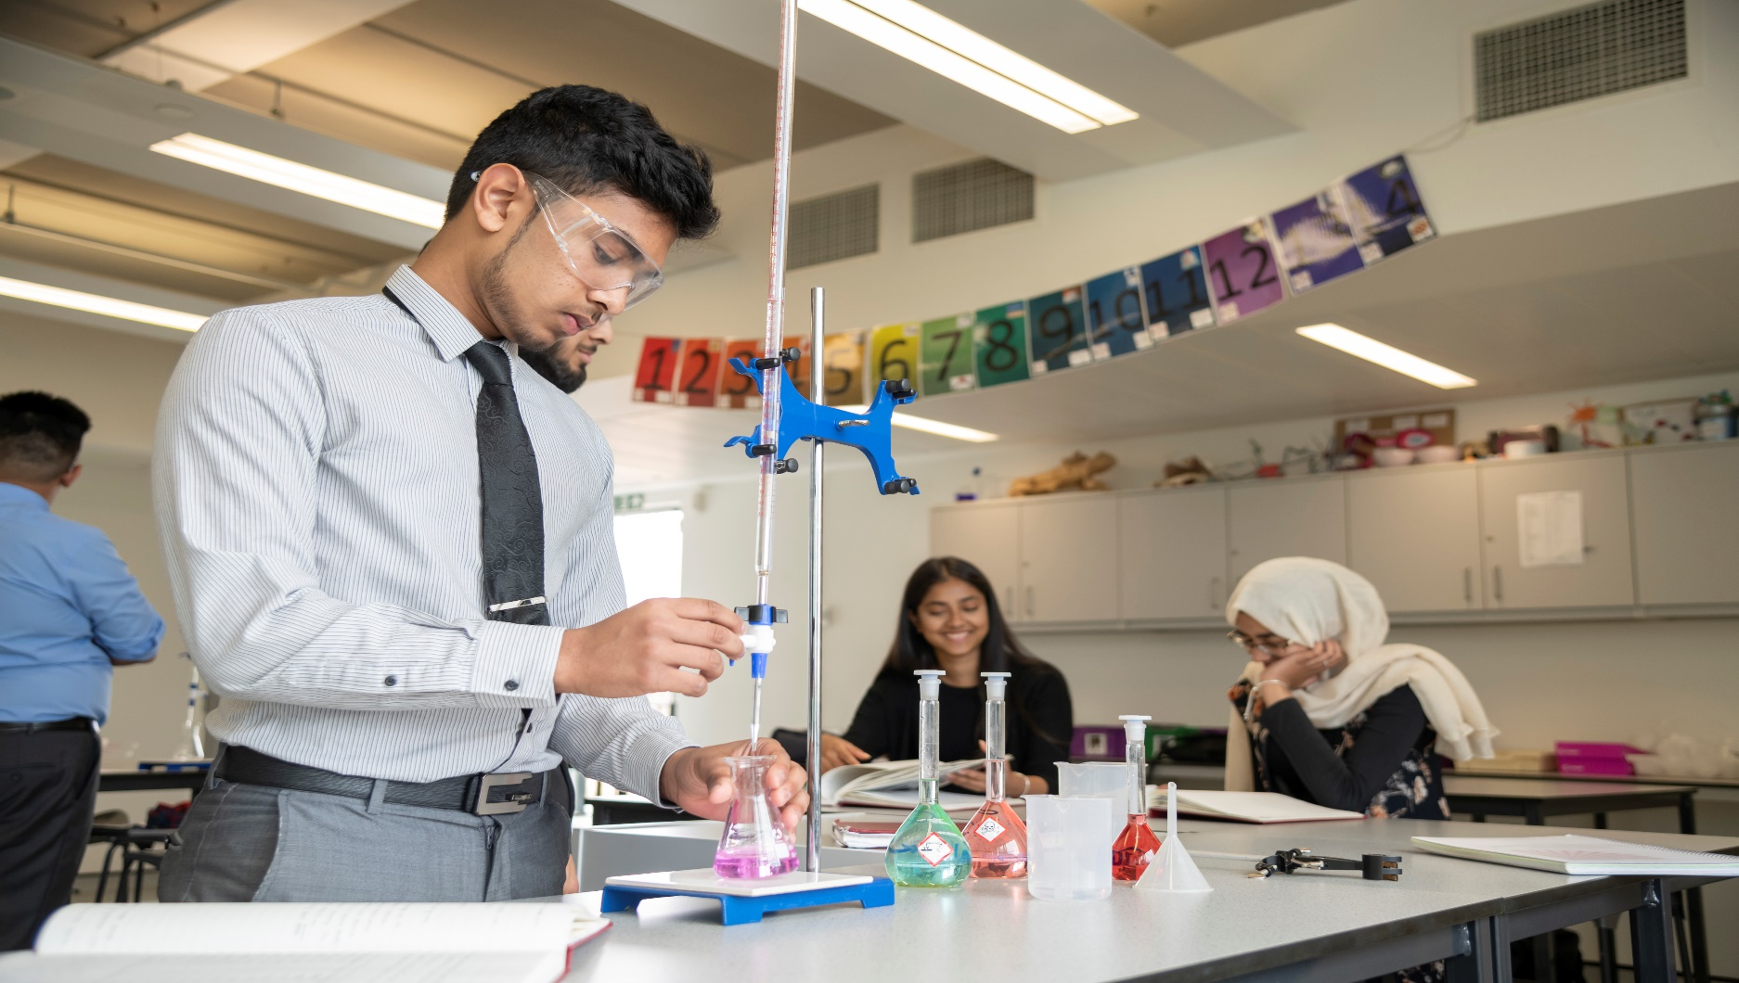
Job Description – Head of Science

Reports to: Assistant/Vice Principal
Start date: Summer term 2022 or September 2022
Location: Isaac Newton Academy, 1 Cricklefield Pl, Ilford IG1 1FY
Salary: L1-10 on Ark scale, dependent on experience
Closing Date: 9am, Monday 7th February 2022
Interviews: Wednesday 9th February 2022

The Role - Key responsibilities

- To lead and manage the subject area
- To be accountable for student progress and attainment levels within the subject area
- To ensure that strategies are in place to maximise levels of attainment in Science for all students
- To take responsibility for Science development across the Academy
- To develop and enhance the practice of other members of staff in the subject area
- To contribute to the strategic leadership of the Academy, developing, implementing and evaluating systems, policies and procedures
- To actively promote the academy and liaise with outside agencies as necessary, representing the Academy or ARK as appropriate
- To maintain a presence around the school to ensure that the highest standards of behaviour and site-usage are upheld
- To contribute to discussions and decisions at Extended Leadership Team meetings
- To communicate and liaise with staff, students, parents, governors and members of the local community as appropriate
- To be active in issues of staff and student welfare and support
- To maintain a teaching timetable, modelling outstanding practice in terms of classroom teaching, preparation, marking and assessment
- To demonstrate a commitment to Equality of Opportunity for all members of the Academy’s community

Curriculum and Assessment

- To design an engaging and challenging Science curriculum that enables all students to enjoy the subject and achieve at the highest level, supported by detailed schemes of work which ensure consistency and coherence across Science teaching
- To teach and model the delivery of outstanding lessons that motivate and inspire students, equipping them with the knowledge and skills needed to achieve at the highest levels
- To review and develop the curriculum, involving subject staff and students
- To keep up to date with national developments in the subject area at each key stage and teaching practice and pedagogy
- To liaise with partner schools, feeder schools, universities and HE institutions, sharing and gleaning best practice and using it to inform the practice of the subject team
- To actively monitor and respond to curriculum developments and initiatives at national, regional and local levels and to disseminate this knowledge to staff
- To set, oversee and evaluate regular, relevant and diagnostic assessments for students ensuring that they are carried out consistently by all subject staff and standardised /moderated thoroughly
- To ensure that all student data is understood, interpreted and utilised by all subject staff to modify planning and personalise support
- To ensure that a comprehensive and rich programme of enrichment and extension activities and trips and visits are offered to and taken up by students
- To play an active role in Science teacher networks, e.g. in Redbridge and at ARK
- To ensure that statutory requirements are met
- To ensure that all subject staff are marking, assessing and providing feedback in line with best practice and Academy policy at all times
- To be a teacher of reading (along with all Academy staff) and to promote and encourage reading through the Science curriculum

Monitoring and Evaluation

- To monitor the effectiveness of teaching and learning within the subject area, through regular lesson observations, book looks and other data collection methods
- To ensure that all staff have short, medium and long term plans to deliver highly effective lessons and schemes of work
- To regularly and forensically review the attainment and progress of all students, groups and subgroups with subject staff and plan, implement and oversee support and interventions
- To produce reports as required on student attainment and progress
- To liaise with all appropriate personnel regarding support for student progress, including SENCO, LT and parents/carers
- To ensure that all Academy policies are implemented consistently by subject staff

Strategic Leadership

- To lead colleagues in the subject area in formulating aims, objectives and strategic plans for the team which support and complement those of the Academy
- To produce an annual Subject Improvement Plan and monitor and evaluate its delivery and impact
- To plan the deployment and development of staff expertise to achieve Subject Improvement Plan objectives

Staff Development

- To support the development and training of subject staff (teaching and operational), ensuring that their CPD needs are met
- To establish a structure for mentoring, coaching and line managing staff in the subject area, including NQTs and BTs as appropriate
- To act as Performance Manager for members of the subject area, carrying out PM reviews in line with the Academy’s policy and setting challenging and appropriate targets
- To support other members of the team in discharging their PM duties and to monitor the effectiveness of PM arrangements within the subject team
- To participate in the recruitment process for members of the subject team
- To ensure effective induction of new staff in line with Academy procedures
- To promote teamwork and to motivate staff to ensure effective relations
- To be responsible for the deployment of staff and the day to day management of subject colleagues, acting as a positive role model
- To provide advice to colleagues on threshold progression, career development etc.
- To support and challenge team members, including in circumstances when they are underperforming
- To organise effective team meetings with relevant agendas centred on teaching and learning and raising attainment

Resources

- To effectively manage and deploy teaching and operational staff in the subject area
- To effectively manage the subject area’s budget in order to progress agreed team and Academy priorities, maximise attainment and ensure value for money
- To effectively manage physical resources, stock and subject accommodation in order to maximise attainment levels and maintain an environment conducive to learning
- To ensure that risk assessments and health and safety checks are carried out in line with Academy policy

Other

- To be a co- tutor and BRIDGES mentor
- To undertake any other professional duties as set down in the ARK Schools pay and conditions of service document, and as directed by the Principal.
- To undertake the main professional duties of a teacher as set out in the ARK Schools pay and conditions of service document
- To meet the expectations of all INA staff as laid out in the Staff Expectations Policy
- To uphold all Academy polices with consistency and diligence.

Person Specification: Head of Science

Qualification Criteria
- Qualified to degree level and above
- Qualified to teach (and work) in the UK.

Knowledge

- In-depth knowledge of the Science National Curriculum at both GCSE and at least one subject at A level (We follow the AQA specification at GCSE & A-Level).
- Up to date knowledge of Science curriculum developments

Experience

- Experience of having worked successfully in at least one school in an urban, multi-cultural setting, teaching students from backgrounds of socio-economic disadvantage
- Experience of delivering consistently outstanding lessons to students of all ages and abilities
- Experience of implementing behaviour management strategies consistently and effectively
- Experience of supporting students of all ages and abilities to make excellent progress and achieve impressive examination outcomes
- Experience of having designed, implemented and evaluated effective, imaginative and stimulating Schemes of Work
- Experience of having contributed to policy formulation, implementation, evaluation and review Excellent subject knowledge
- Understanding of the strategies needed to establish consistently high aspirations and standards of results and behaviour.
- Experience of raising attainment in a challenging classroom environment
- Evidence of continually improving the teaching and learning of their subject through schemes of work and extra-curricular activities.
Behaviours
- Passion for the subject
- High expectations for accountability and consistency
- Vision aligned with ARK’s high aspirations, high expectations of self and others
- A firm and constant belief in the unlimited potential of every student and a commitment to inclusive educational provision
- Motivation to continually improve standards and achieve excellence
- Commitment to the safeguarding and welfare of all students and providing equality of opportunity
- The ability to enthuse and inspire others
- The ability to consistently deliver outstanding lessons
- Effective and systematic behaviour management, with clear boundaries, sanctions, praise and recognition
- Excellent communication, planning and organisational skills
- Demonstrates resilience, motivation and commitment to driving up standards of achievement
- Acts as a role model to staff and students
- Commitment to regular and on-going professional development and training to establish outstanding classroom practice
- The ability to develop positive relations with students and adults
- The ability to work effectively alone and as a part of a team
- Excellent listening skills
- Strong interpersonal, written and oral communication skills and ICT skills
- Strong organisational and time management skills
- The ability to take personal responsibility, a readiness to reflect and self-evaluate, and the ability to change, develop and improve
- Confidence and self-motivation
- The ability to work well under pressure
- High levels of honesty and integrity
- A sense of humour and desire to have fun.

Other
- This post is subject to an enhanced Disclosure & Barring Service check
- The post holder must be committed to safeguarding the welfare of children and to providing equality of opportunity.

Ark is committed to safeguarding and promoting the welfare of children and young people in our academies. In order to meet this responsibility, we follow a rigorous selection process. This process is outlined here, but can be provided in more detail if requested. All successful candidates will be subject to an enhanced Disclosure and Barring Service check.

