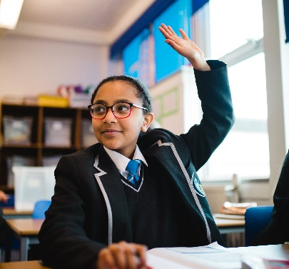
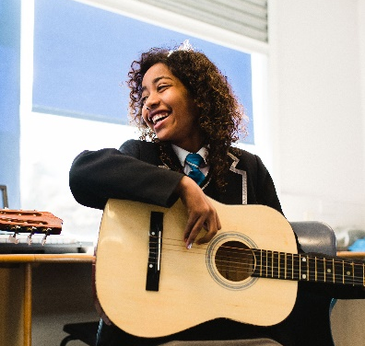

BIRCHES HEAD ACADEMY
Birches Head Road
Stoke-on-Trent
Staffordshire
ST2 8DD
Tel: 01782 233595
Web: www.bircheshead.org.uk

Principal: Ms K Dixon

HEAD OF SCIENCE

Required for January 2022
Permanent, Full Time
MPR / UPR + TLR1B (£10,861)

Birches Head Academy has recently become part of the Frank Field Education Trust and we work collaboratively with others in our FFET family, allowing our students and staff many opportunities to develop. This is embodied in the FFET vision: ‘Social Justice through Excellence in Education’ and in the Academy motto: ‘Aspire to be More’.
Birches Head Academy is looking to appoint a suitably qualified and experienced Head of Science who will play a vital role in helping us to ensure our students receive a world-class education, thereby enabling each child to reach their full potential.

The Head of Science will be an exemplar of implementation and aspiration in the classroom, who will work closely with the Senior Leadership Team and colleagues throughout the department, to drive continuing improvement in students’ progress, as well as the quality of Teaching and Learning within the science department.

The successful candidate should be an outstanding practitioner who is looking for the next step in their career, experienced in teaching both Key Stage 3 and Key Stage 4. You should have a proven track record of successful outcomes and delivering on your plans.

An innovative teacher, you should be passionate about Teaching and Learning and developing pedagogical approaches that inspire learners. The ability to be a highly successful team player in a very busy and fast-paced environment is essential. You will have the capacity and energy to drive improvement, to lead by example and to develop collaboration within the department.

This is an exciting opportunity for an ambitious individual to demonstrate their ability to champion the Academy’s development and to be part of our exciting journey.
We welcome applications from all parts of our community as we aspire to have a staff body that matches the social and cultural diversity of our student intake.

Closing date for applications: Wednesday 22 September 2021, 9:00am

Interviews to be held: week commencing Monday 27 September 2021

For further information, including the recruitment pack and application form, please visit our website at: www.bircheshead.org.uk. Alternatively, you can contact the school for an information pack.

Completed application forms should be emailed to jbracegirdle@bircheshead.org.uk

Birches Head Academy requires an application form to be completed in order to be considered for this role. Please note that CVs alone will not be accepted.

Birches Head Academy is committed to safeguarding and promoting the welfare of children and young people. Applicants will, therefore, be subject to stringent vetting and induction processes, including an enhanced DBS disclosure. References will be requested prior to interview.

All applicants will be considered on the basis of suitability for the post regardless of age, sex, race or disability.

Social Justice through Excellence in Education

