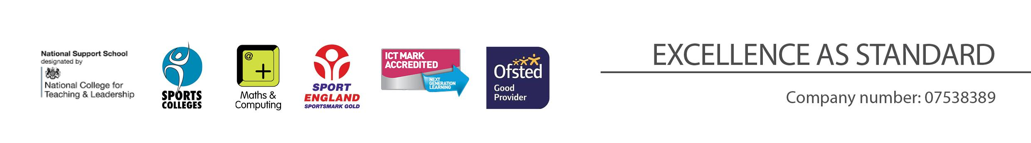
Head of Science (i/c Biology)
Person Specification

REQUIREMENT | ESSENTIAL | DESIRABLE
LEGAL REQUIREMENTS | Enhanced DBS Clearance including children barred lists
QUALIFICATIONS  Principally assessed through letter and application form | Completed DfE recognised teaching qualification (QTS) | NPQML
EXPERIENCE and PROFESSIONAL COMPETENCE  Principally assessed through letter, application form | Currently teaching in a secondary school  Experience of team, project and change leadership  Experience of securing high quality academic student outcomes  Experience of teaching post 16 students in Biology  Wide range of learning and teaching skills  Effective lesson planning to meet the needs of all students  Highly effective classroom management  Ability to engage and motivate all students | Effectively led a subject or department initiatives
KNOWLEDGE  Principally assessed through letter and interview process | Up to date subject knowledge  Monitoring, assessment, target setting, recording and reporting of pupil progress  Use of data to inform appropriate intervention and progression | Current education initiatives  SEND  HP  Use of IT for data analysis
COMMUNICATIONS  Principally assessed through letter and interview process | Have excellent written and verbal communication skills
PERSONAL ATTRIBUTES  Principally assessed through references, letter and interview process | To be committed to safeguarding and promoting the welfare of children and young people  Passion for subject  High student expectations  Determination to succeed  Work effectively as a member of a team: Flexibility  Persistent, consistent and insistent  Be an effective role model through presentation and personal conduct  Committed to teaching and a willingness to continue to learn through professional development  Enthusiasm, energy, vigour, reliability, and integrity | Motivational skills

