# DBS Self Declaration Form (Revised 28.11.2020)

## This form should be completed and returned in a sealed envelope to [ ]

|  |  |
| --- | --- |
| Name: |  |
| Role applied for: |  |
| Academy: |  |

**Question 1:**

If you have never been convicted of a criminal offence or never received a caution, reprimand or warning then please select ‘No’ below.

The amendments to the Rehabilitation of Offenders Act 1974 (Exceptions) Order 1975 (2013 and 2020) provides that when applying for certain jobs and activities, certain convictions and cautions are considered ‘protected’. This means that they do not need to be disclosed to employers, and if they are disclosed, employers cannot take them into account.

Detailed guidance about whether a conviction or caution is protected or should be disclosed can be found on the Ministry of Justice website, which advises:

* All unspent convictions and cautions must be disclosed.
* Spent cautions and convictions must be disclosed if they meet the circumstances described in the table below:

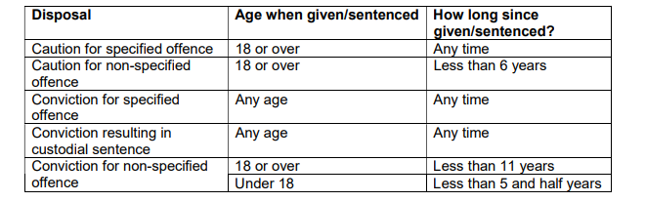

* Any other caution or conviction which does not meet the details set out in the table above, such as spent youth reprimands, warnings and cautions, is considered **‘protected’. This means that they do not need to be disclosed to employers, and if they are disclosed, employers cannot take them into account.**

A “specified offence” is one which is serious and which relates to sexual offending, violent offending and/or are relevant to safeguarding children and vulnerable adults.

Do you have any convictions or cautions (excluding youth cautions, reprimands or warnings) that are not ‘protected’ as defined by the Ministry of Justice?

Yes No (please circle)

If yes, please give details including the nature of the offences and the dates. Please give details of the court(s) where your conviction (s) were heard, the type of offence and sentence(s) received. Could you also give details of the reasons and circumstances that led to the offence(s). Continue on a separate sheet if necessary.

_____________________________________________________________________________________________________________________________________________________________________________________________________________________________________________________________________________________________________________________________________________________________________________________________________________________________________________________________________________________________________________________________

**Question 2:** Are you at present the subject of a criminal investigation, have you been Released Under Investigation or is there a pending prosecution against you?

Yes No (please circle)

**Question 3:** Has there ever been any cause for concern regarding your conduct with children, young people, or adults at risk? Please include any disciplinary action taken by an employer in relation to your behaviour with children, young people or adults at risk.

Yes No (please circle)

If yes, please give details

_______________________________________________________________________________________________________________________________________________________________________________________________________________________________________________________________

Signed: ______________________________ Date: ______________________

**Question 4:** Those applying for work with children and/or adults at risk in positions which fall within the scope of regulated activity please confirm that you are not barred from working with children or adults at risk. (please delete which does not relate to the post you are applying for).

I confirm that I am not barred from working with children

I confirm that I am not barred from working with adults at risk

Signed: ______________________________ Date: ______________________