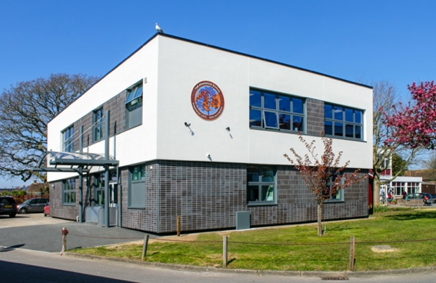
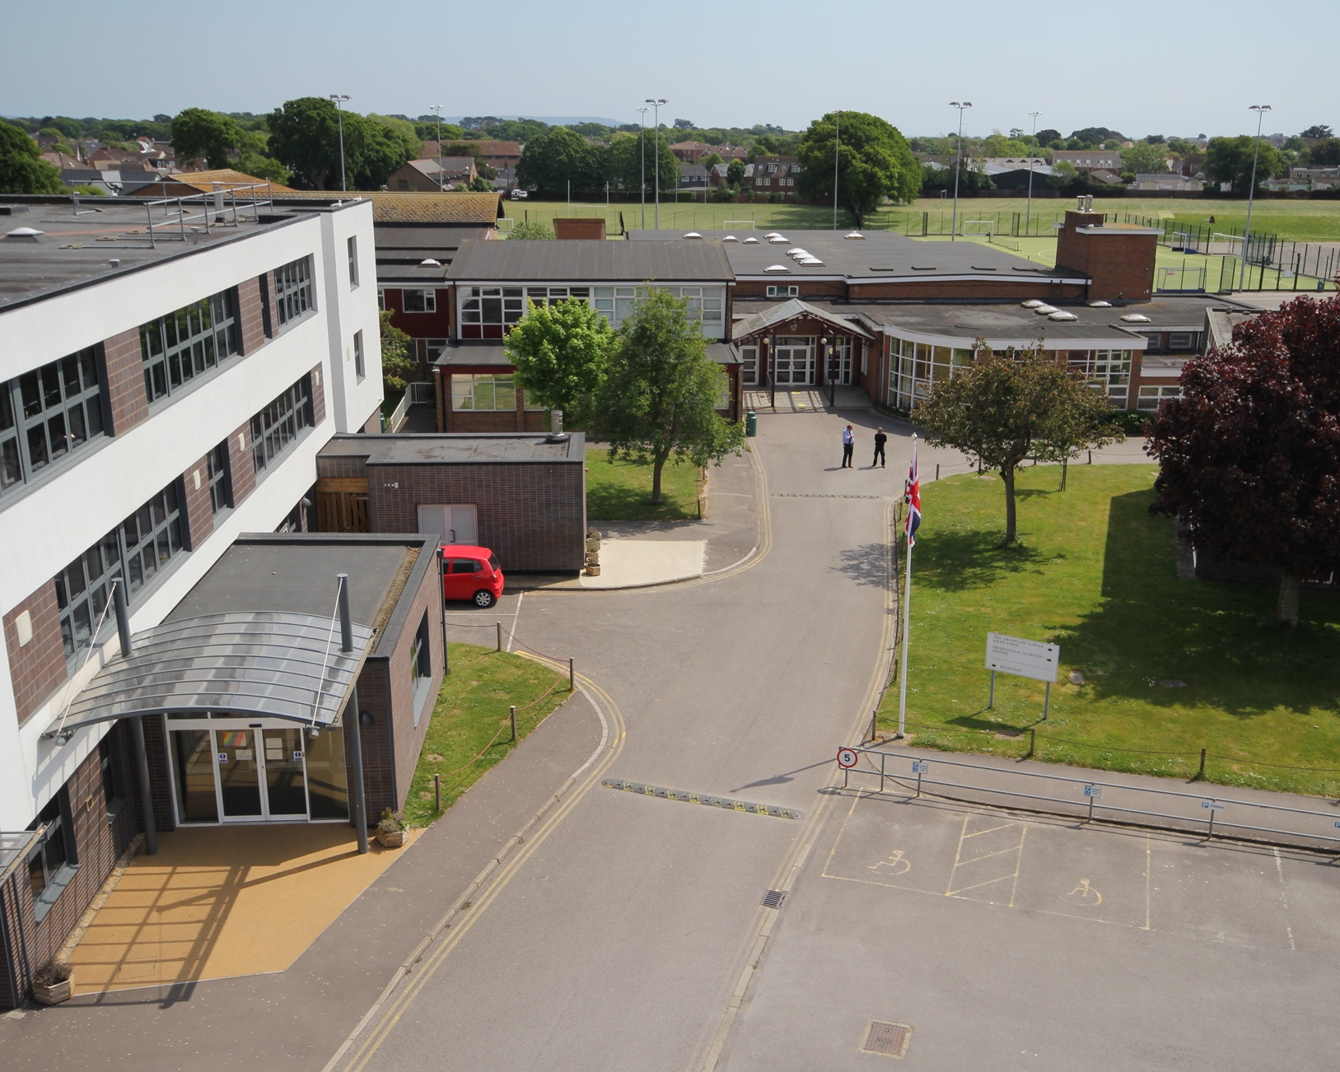
Recruitment Teaching Pack
Information for Applicants

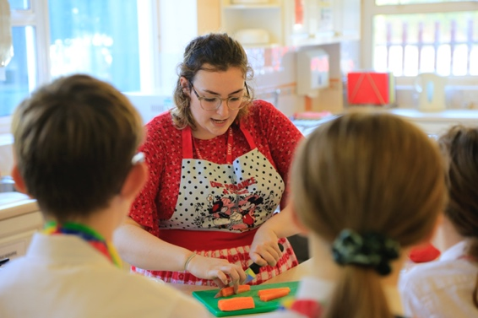
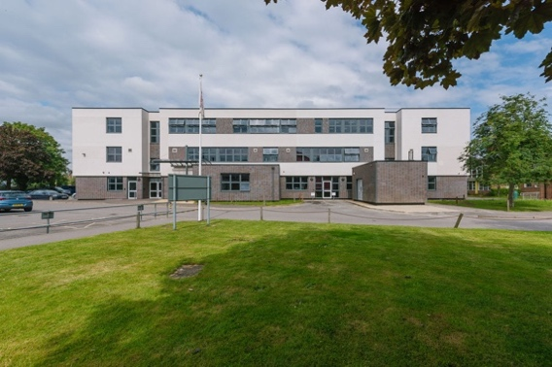
CONTENTS

Page 3 – Job Title
Page 4 – How to Apply
Page 5 – Post Details
Page 6 – Requirement Specification
Page 7 – General Information for Applicants
Welcome to The Arnewood School, an academy that has both a local and national reputation for excellence. We place our children’s needs first so that they are at the core of good decision making as to what is best for our school community. Our academic record over a long period shows us to be a consistently high performing school, with impressive examination results at all key stages including in our vibrant sixth form.

We continue to raise standards in all subject areas; we encourage diversity in teaching and scholarly learning across all subjects. We place great emphasis on a healthy balance between academic work and the all-round development of children. Ours is an academy with a strong commitment to very good pastoral care and a wide variety of curricular opportunities both cultural and sporting. The school is in part characterised by the wide range of trips and visits that create memorable learning experiences for students.

We recognise that words, pictures and statistics will only give you a hint of the warmth, ambition and commitment of our innovative learning community and we invite you to see us in action. I am very confident that a visit to The Arnewood School will justify your interest in the school as we continue to develop as a centre of excellence in The New Forest and beyond. At Arnewood we pride ourselves on our great international links to help develop a global mindset.

Job Title: Head of Science
Salary | MPS TLR 1b: £10,201 – Depending on progression and experience.  UPS – Continuity.
Employment | Full time.  Permanent.
Commencing | Required for January 2023.
Benefits | The Gryphon Trust awards national Teachers’ Pay Awards in full.  Contributions are made to the Teachers’ Pension Scheme (TPS).  Extensive CPD programme based on mastery of skills.  Post 16 teaching career development.
Key Roles | To lead the Science team in delivering and continuing to develop a high-quality Science curriculum to students throughout Key Stage 3, 4 and 5.  To support and develop the Science teaching team to be as effective as possible in delivering strong outcomes.  To facilitate and support students to be as successful in science as possible so they can progress with core skills.  To continue to develop strategies to engender a love of science and STEM across the school.
Contractual | All post holders are expected to carry out the duties of a school teacher compliant with the Teachers’ Pay and Conditions document, Teachers’ Standards, and Academies Handbook.

How to Apply
Thank you for your interest in joining the team at The Arnewood School. We are part of The Gryphon Trust, a small trust with big ambitions serving the local community around New Milton and The New Forest in Hampshire.

The Arnewood School is a brilliant place to work. We are a staff who are committed to providing the best outcomes we can for children. We believe we make a difference to the lives of young people. We are also mutually supportive and have a lot of fun – working with children is a fantastic occupation. Our philosophy is underpinned by personal growth for students and staff alike.

The information contained in this pack is designed to provide you with the key information you will require in applying for the post. However, if you have any questions or would like to arrange an informal visit, please telephone Lindsey Harper on 01425 625405 or email her at l.harper@arnewood.hants.sch.uk .

Please complete an application form. This can be downloaded online from the school website (www.arnewood.hants.sch.uk/vacancies). Emailed applications are welcome but for compliance purposes must be followed in the post by a hand signed hard copy.

The closing date for applications is 9am on 14th October. Please note we reserve the right to interview and appoint ahead of the closing date albeit this is unlikely.

I look forward to receiving your application and reading about how your skills and ambitions can be dovetailed with the role description provided.

Yours sincerely
Mr Nigel Pressnell
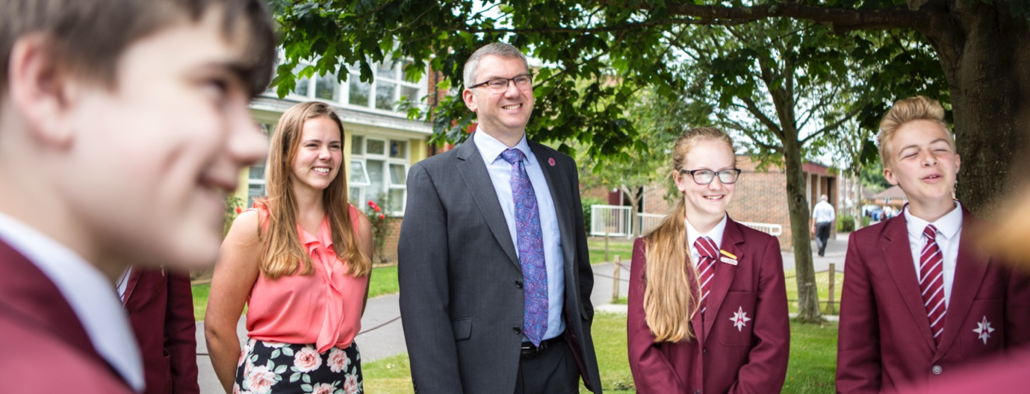
Headteacher
BACKGROUND: Post Details

The Science Department is an established scholarly community, where teachers develop students’ talent in a calm learning environment. Teachers place an emphasis on success through high-quality thinking and explanations and robust practice. For the successful candidate this is a unique opportunity to shape the department's future success. In achieving this you will be supported by an able and dedicated team of teachers all of whom are committed to developing children’s passion for science.

The successful candidate will have a strong and secure knowledge of the GCSE curriculum, in addition they will have a strong understanding of the KS5 curriculum content. They will be able to maintain and build on a culture of success where all feel valued and proud of their achievements. They will be able to lead from the front, motivate members of the team to be the best practitioners they can be and ensuring excellent outcomes for all of our students.

We are seeking an outstanding and inspiring Head of Science to join our team as we continue our journey to providing an outstanding education for all in our care. This is a very important appointment for us, we are looking for someone with character, who has the highest standards and ambitions, and the drive and determination to ensure the department and our students flourish beyond what they thought possible.

We are dedicated in ensuring all lessons are engaging so that our students can thrive. We are committed to all students developing a love of Science and a desire to achieve the very best they can.

The successful candidate will demonstrate: -

- a love of science and teaching and have excellent subject knowledge and pedagogical understanding
- they are an excellent classroom practitioner, who is experienced in teaching science at key Stages 3, 4 and 5
- the ability to lead change, develop, motivate, challenge, support and inspire colleagues and students alike
- outstanding success at achieving consistently good results in science, at least, at key stage 3 and key stage 4
- the ability to create and facilitate highly challenging and engaging lessons
- highest aspirations and expectations for all students and the science team and lead this by personal example
- a desire to provide opportunities for students to broaden their curriculum through STEM activities.
- aspiration to progress their career in the future
- they are optimistic, positive, cheerful and develop others to flourish.
We offer: -

- excellent accommodation (recently renovated), resources, and funding
- the opportunity to be integral to school improvement both within Science and beyond, at a time that suits personal career progression
- well-considered professional development and a wide range of professional opportunities, including significant leadership development opportunities
- excellent career progression opportunities given our strength in partnership working
- a supportive, committed, and experienced team of Science specialists all specialist trained
- sound mentoring for all new staff from a stable and experienced senior team
- a challenging and collegiate workplace with a high level of professional autonomy in which people matter
- a work life balance that values individual happiness and fulfilment.

Requirement Specification
 | Essential | Desirable
Qualifications | UK Qualified Teacher Status (QTS)  or DfE approved equivalence if qualified overseas. | NPQML or equivalent.
Professional Characteristics | Recent training associated with teaching and learning and/or curriculum impact. | Leadership mastery.
Experience | Experience of a leadership position.  Ability to teach KS3/4/5. | A proven track record of improvement in the leadership role, ideally around student outcomes.
Skills & Abilities | An excellent classroom teacher with a clear understanding of what makes for effective teaching and learning and the capacity to share it with others. | Coaching skills and experience of developing members of your team in the past.
Personal Attributes | Cheerful, optimistic and hardworking disposition.  An approachable leader who is able to work well with colleagues, form effect and positive relationships.  Leads by example and selflessly promotes others.  A strategic as well as operational thinker. | Ambitious for future career enhancement.  Contributes to the community and/or engages in voluntary work.
Other Requirements | Willingness to take part in extracurricular activities.  Committed to your own continuing professional development | Willingness to contribute to improvement in wider areas of the school.
General Information for Applicants
The Arnewood School provides a high-quality education for students aged 11 to 19 years of age. The school was formally grant-maintained, then a foundation school and most recently an academy. School leaders established The Gryphon Trust which has two schools. Eaglewood School, The Arnewood School’s partner, is an alternate provision school, recently built following our successful submission to establish a free-school. Despite our autonomy we are by instinct outward facing and always willing to work with others with similar values.

The school currently has just over 1000 students including approximately 150 in the thriving sixth form. The school has an excellent record of academic success albeit this is obscured in performance table as we are truly inclusive. We do not off-roll vulnerable children just to look good for OfSTED. Students, parents, staff and members of the wider community are justifiably proud of the school’s success.

Parents are overwhelmingly supportive of the school and its staff.
The school has excellent IT services and we offer all children the opportunity to participate in a low-cost tablet scheme to which many subscribe. Our embedded use of virtual learning meant that we found ourselves better placed than many to switch to remote schooling during the 2020/21 pandemic.
Our Aim
The school's aim is: -

To allow each student to fulfil their unique potential and make the world a better place through their informed choices and actions.

We aim to inspire the next generation by equipping them with the skill, knowledge and attributes to be successful in their chosen future in work and leisure. We seek to build the aspirations of our so they can become the best versions of themselves and view the world with excitement and opportunity.

This is captured in our mission statement: -

Working together; Shaping Tomorrow
Location
We serve a diverse catchment in New Milton. Children mostly join us from link primary schools but some travel from further afield. New Milton is a thriving town. Its high street has weathered the economy better than many. We have a mainline link to London and Weymouth. Geographically we enjoy the benefits of being equally close to The New Forest National Park and seaside. The town has excellent sporting and cultural amenities including many clubs and an arts centre. Housing, including rental property, is available it the town but many staff live Southampton or Bournemouth which are easily commutable.

The School Curriculum

The school’s curriculum is organised around key curriculum areas each led by a head of curriculum or subject leader. Students follow a broad curriculum in key stage 3 (Y7 and Y8) before selecting options in key stage 4 (Y9 – Y11). We encourage students to think of their time in school as a 7-year journey culminating in sixth form study at Arnewood Sixth.

Our principle curriculum areas are: -

English | Expressive Arts
Science | Information Technology
Science | Design Technology
Humanities | PE
Modern Foreign Languages | Vocational Studies
We offer over 20 different subjects at key stage 5.

Our curriculum is rich and we provide a wide range of learning opportunities in a variety of ways to meet the context of the school and the locality it serves. Both the formal curriculum and informal curriculum are import to us. The school’s extra-curricular programme provides excellent sporting and cultural enrichment.

At all key stages learning is based around five key pillars which we believe to be essential in facilitating the delivery of the school’s aims for its students. These are that learners should be: -

Pastoral Care & SEN
Ours is an inclusive school. We are non-selective and see our roll as giving all students, irrespective of their starting point, the best opportunity in life. All teachers play their part in the pastoral care of our students ably supported by specialist non-teachers with pastoral responsibility including pastoral assistance, medical welfare, attendance, safeguarding and inclusion. Tutors are allocated to tutor groups and in general progress with the same class as they mature through the school. Each year has a head of year.

Our SEND team is led by the school’s SENDCO and the Learning Support Manager. We have a large team of learning support assistants work in classrooms to support teaching staff. Other staff lead small group work in learning support including language and numeracy intervention.
The Arnewood School Professional Culture

Our professional culture sets the tone for the way we interact with others.

- We are here for the children first – the “litmus test” for our decision-making is what is in the best interests of students, their families, and our community.
- We model the behaviour we expect from others including students.
- We praise and share the success of others above ourselves.
- We define problems and design possible solutions - we don't grumble and moan.
- In the face of adversity, we remember we are team players and colleagues will support us through good and bad.
- We are honest - we don't say one thing and think another.
- We only make commitments we intend to and are able to keep.
- We presume honourable motives.
- In conflict we talk directly and privately to the person with whom we share a problem - we don't gossip.
- We forgive and we move on.
- We give ourselves time to listen and think - we work hard and do not feel guilty if we take time for ourselves and friends and family.
- We teach with an “open door”.
- Our core business is teaching and learning – this is the priority.

Safeguarding and Child Protection Statement

In safeguarding children, we aim to: -

- provide an environment in which students feel safe, valued and respected
- allow students to feel confident, and know how to approach adults if they are in difficulties believing they will be heard
- inform all teaching and non-teaching staff of the need to safeguard all young people and of their responsibilities in identifying and reporting possible neglect or abuse
- provide a systematic means of monitoring students known, or thought to be at risk of harm and ensure we, as professionals, contribute to assessments of needs and support for those students
- develop and promote effective working relationships with other agencies, including children’s social services and the police
- maintain a structured procedure within the school including visits and trips which will be followed by staff and the community when child protection is necessary.
All staff working within our school, who have substantial access to children, will be checked as to their suitability to work with young people. This will include, to give some examples, verification of their identity, qualifications, and a satisfactory DBS check. Details will be maintained in a single central record for audit purposes.

Equal Opportunities Statement

The Gryphon Trust and The Arnewood School values the diversity of our workforce and welcomes applications from the whole community irrespective of race, religion, sexual orientation or disability. Together we are stronger.

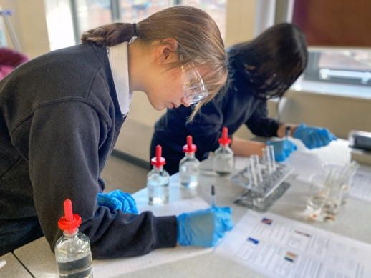
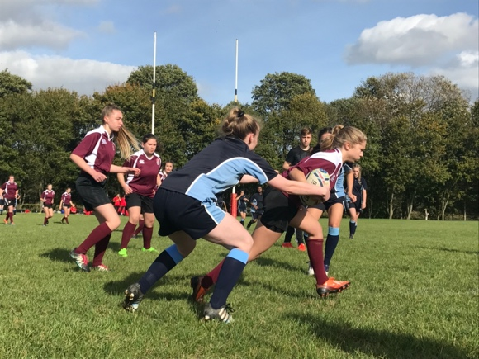

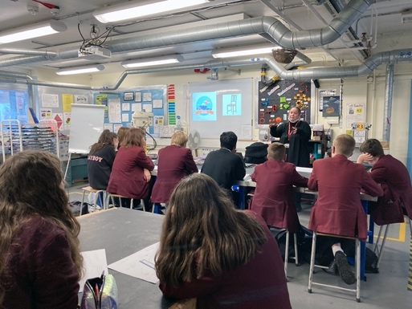
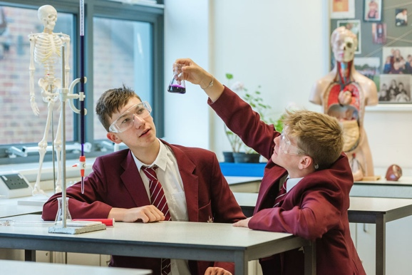

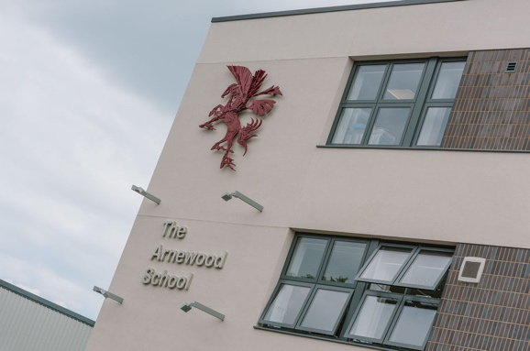
Working Together - Shaping Tomorrow
