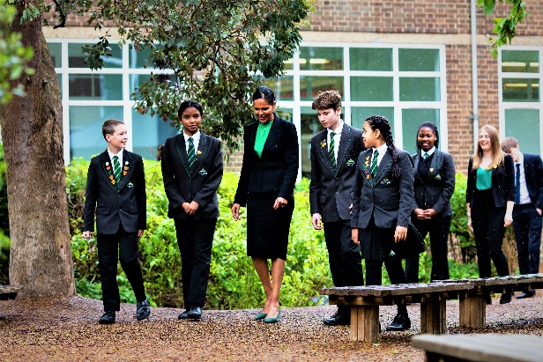

**Head of Sixth Form**

**Information Pack for Candidates**

**January 2022**



Welcome

January 2022

Dear Candidate,

Thank you for your interest in the role of Head of Sixth Form at Stanborough School. We are delighted that you see Stanborough as a school where you can make an impact. This position will offer an exciting opportunity for the successful applicant to work with us as we continue to develop our thriving and dynamic school.

It has been a privilege to lead Stanborough School from September 2018. My team share an educational philosophy which promotes the highest expectations and consistent pastoral care. Our core aim is to nurture enquiring minds and to inspire our youngsters to pursue their dreams, leaving our school ready to excel in a future which has limitless possibilities.

Our aim is simple, we want to be a truly outstanding school in every sense of the word and we want to be confident that our students get the best possible education that is ambitious, varied and stimulating. At the heart of everything we do is a desire to ensure that our students receive the highest standards of teaching and learning. Our curriculum is broad and academically challenging in order to prepare students for the rigours of further study or work.

At Stanborough, we care passionately about the development of each student’s character, their personality and social skills, the way they treat others and the contribution they make to society. We place strong emphasis on outstanding behaviour. Excellent learning is underpinned by excellent behaviour. We expect our students to show respect when interacting with other members of our school community and to uphold the reputation of the school in the local area.

From September 2019 we became an 8 form entry school. Raising our intake number is a reflection of the success and popularity of Stanborough School in the local area.

If you are passionate about education and really feel you can make a positive difference to the school then we look forward to receiving your application to join us at Stanborough.

|  |  |
| --- | --- |
| Mrs M John  Headteacher | C:\Users\sdelaney\AppData\Local\Microsoft\Windows\INetCache\Content.Outlook\LL80MD3L\stanborough_school-335 (2).jpg |

|  |  |  |
| --- | --- | --- |
| Stanborough School  Stanborough School is an 11-18 co-educational Academy that sits on the southern fringe of Welwyn Garden City. The school currently has 1099 students. Due to parental demand for places at the school, from September 2019 the school expanded to 8 form entry. This has required a substantial amount of new premises work to be completed which includes a new teaching block as well as a drama and music block.  We pride ourselves in being a fully inclusive school that serves our local community and on being a school that does its best for each individual student so they can achieve their potential during their time at Stanborough.  Stanborough is proud of its community involvement. We work closely with the four other local Secondary Schools as part of the Welwyn-Hatfield 16-19 Consortium. We also take a leading role in hosting and developing a number of other key community developments such as the Handside Schools Partnership with a local special school and primary school.  The school boasts excellent facilities including our first-rate IT resources, a legacy of our Specialist Computing Status. With a dedicated Art and Technology block, Sports Hall, Sixth Form Centre and recently constructed new teaching block and Music and Drama block the students enjoy some outstanding facilities. Our excellent resources in all curriculum areas also show our commitment to giving students a wide variety of curricular opportunities including technology, the performing arts and computing.  Our greatest asset at the school is our staff. We want the best educators for our students and through exceptional retention we have a stable staff with very low turn-over. A number of staff who started at the school as NQTs now find themselves in senior positions at the school. We have a strong support team and many staff have remained with the school for several years.  With the appointment of a new Headteacher from September 2018, this is an exciting time to join the school and become part of an ambitious and hard-working team dedicated to moving the school forward. We are looking for support staff and teachers who will embody our four principles of High Expectations; Mutual Respect; Quality Learning and Success for All. | | Stanborough Prospectus091  Stanborough Prospectus114  Stanborough Prospectus094  Stanborough Prospectus060 |
| Welwyn Garden City  Welwyn Garden City is a town in Hertfordshire with a population of just under 50,000 people. Welwyn Garden City was the second Garden City to be built, founded in 1920 and it exemplifies the physical, cultural, social and planning ideals of the time it was built.  **Location and Transport Links**  Welwyn Garden City enjoys superb communication links. Stanborough School sits five minutes from the A1(M) and approximately 10 minutes from the M25. The M1 is only a 30 minute drive away. The train station in Welwyn Garden City is on the main East Coast Line linking Scotland to London and Kings Cross station is a 30 minutes train journey.  Luton Airport is less than 30 minutes away and both Heathrow and Stansted Airports are less than an hour’s drive away. The town is also a central hub for local bus services which link it to the rest of Hertfordshire.  **Facilities and Amenities**  Stanborough School is a two minute walk from the Gosling Sports Park and is only a short car/bus journey to the University of Hertfordshire Sports Village in Hatfield. A range of shops, bars, restaurants and cafes can be found in the Town Centre as well as in the local Galleria shopping centre. St Albans, Hitchin and Hertford are all around 30 minutes away and all offer a range of retail and leisure experiences.  The town also has the QEII Hospital, a theatre, cinema and numerous other cultural and leisure facilities. Stanborough School lies at the southern edge of the town and the school grounds back onto the Stanborough Lakes Country Park.  **Housing and Accommodation**  A range of accommodation options are available in the local area and there is a thriving rental market. The excellent transport links allow many staff at the school to live in other parts of Hertfordshire as well as North London.  Help and advice can be given by the school if accommodation is required. | | Welwyn-Garden-CityHowardsgate-Welwyn-Garden-[1]image[1]40008799967TXSM[1]welwyn_houses_29306[1] | | |

Stanborough School Sixth Form

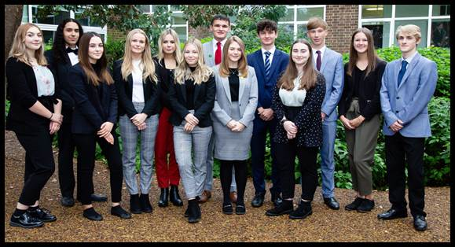

Stanborough School 6th form is part of the Welwyn Hatfield Consortium. The Consortium is comprised of the five secondary schools in Welwyn & Hatfield, Bishop’s Hatfield Girls’ School, Monk’s Walk, Onslow St Audrey’s, Ridgeway Academy and Stanborough.  We work collectively to provide an enviable programme of Sixth Form education throughout the area. Students have access to, and benefit from, academic and pastoral support, an integrated enrichment programme and a wide range of extra-curricular activities. Being part of a Stanborough Sixth Form is more than studying for qualifications. There are significant contributions students can make as a sixth former in a whole variety of ways e.g. mentoring younger students or taking part in our ambassador programme. The Consortium has existed for many years and we constantly review what we offer and seek ways of improving still further the opportunities for post-16 students. By working closely and creatively together we are able to continue to expand our offer of a wide range of over 30 courses with A level, L3 BTEC and L3 Technical qualifications.

Our broad and inclusive curriculum meets the needs of every child, whether they are heading to college, university or the world of work. We are committed to guiding young people every step of the way.

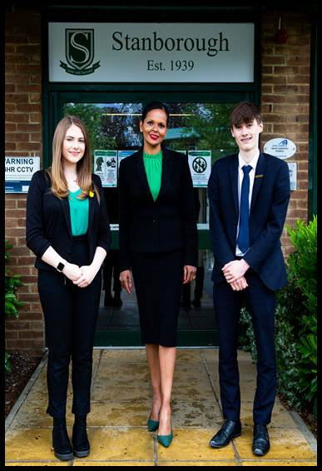

What can we offer you at Stanborough?

* The chance to work in a thriving, developing and expanding school that puts the student at the heart of everything it does.
* The chance to work with amazing staff who are passionate about developing the young people in their care.
* A well-developed and personally tailored staff development offer that meets the needs of individual staff members.
* An expanding school with great facilities including a new teaching block with 17 classrooms as well as a new Music and Drama block.
* An opportunity to be involved in the 16 – 19 Welwyn Hatfield Consortium, one of the oldest and well-established of its kind in the UK. This involves close links and collaboration with four local schools.
* Great resources for staff, including free parking on site, good rail and road links to the school and an attractive edge of town location next to Stanborough Lakes and Gosling Sports Park.



|  |  |
| --- | --- |
|  |  |

|  |  |
| --- | --- |
| **HEAD OF SIXTH FORM**  **JOB DESCRIPTION** | C:\Users\sdelaney\AppData\Local\Microsoft\Windows\INetCache\Content.Outlook\LL80MD3L\A76980_STANBOROUGH_Logo Design FV.jpg |

Grade: TLR 1c

Responsible to: Deputy Headteacher

Responsibility for: Year Groups – 12 and 13

**Main Responsibilities:**

* To lead both the team of tutors and cohort of students. This involves giving a clear vision and direction to work, identifying key areas for improvement and planning appropriate actions to meet them.
* To manage both the people and resources associated with each year group.
* To monitor the quality of learning experienced by the year group, liaising with heads of departments and offering support and guidance where necessary.

**Job Context:**

The Head of Sixth Form is the “figurehead” for the Sixth Form, the most prestigious year groups in the School. The Head of Sixth Form sets the tone for these year groups and oversees the pastoral and academic wellbeing of the Sixth Form. The Head of Sixth Form is responsible for overseeing the day to day running of the Sixth Form Centre with support from the Deputy Head of Sixth Form and Sixth Form Tutor Team. In doing so the Head of Sixth Form ensures that there is an excellent work ethic which will enable the students to achieve their full potential whilst ensuring that the whole school aims are met and that the Stanborough sixth form experience is valued and appreciated by the students. The Head of Sixth Form is mindful of the health and wellness of all Sixth Form students and has an overview of each individual’s needs.

**Academic Progress**

1. To monitor the academic progress of the year group in order to secure and sustain effective learning.
2. To use assessment data, such as GCSE points score and target grades, to inform an analysis of individual student progress, collective progress across each tutor group, year group as a whole.
3. To have an overview of the range of barriers to learning that impact on student progress.
4. To use all of the above to identify underachievement with a view to establishing and coordinating improvement strategies in conjunction with teachers and Heads of Department through KS5 Raising Standards Leader meetings.
5. To liaise with key staff, including the SENDCO, regarding all groups of students’ achievement in the year group
6. To monitor the standards of teaching and learning across the consortium through regular Heads of Sixth meetings and Consortium Review weeks.

**Leadership and Management**

1. To act as a role model for tutors by demonstrating high quality pastoral care and academic monitoring of students, continuous professional development and professional presence in the year team.
2. To lead and manage a team of tutors and maintain regular formal and informal contact with tutors.
3. To ensure all tutors understand, and are actively implementing the key aspects of the school’s policies including those for behaviour, attendance, uniform and safeguarding.
4. To set the agenda for tutor meetings which should include a development item.
5. To make a significant contribution to the induction of tutors referring any individual training needs to the member of SLT with responsibility for staff INSET.
6. To have an overview coordinate interventions, where appropriate, using internal referrals and work with outside agencies.
7. To initiate and respond to communications with parents ensuring that they are kept fully informed and involved in the progress of their children.
8. To contribute to the organisation of any parent information evenings
9. To monitor student attendance and punctuality on a weekly basis and to take all the appropriate steps to ensure that attendance and punctuality of students in the year group are at the highest levels.
10. To contribute to the management of key school events; for example induction, transfer arrangements, outings, extra-curricular and social events.

**Administration**

1. To organise and, through a team of tutors, implement a framework for daily tutorial activities. This includes both group mentoring sessions and weekly PSHE sessions.
2. To ensure that all tutors have access to relevant materials in order to deliver high quality tutorial activities.
3. To maintain, alongside the Sixth Form Study Support Co-ordinator, individual student records as necessary and ensure that they are kept up to date.
4. To oversee ‘in year’ admissions for new students. This will include meeting potential students and parents and in conjunction with key staff organising timetables.
5. To monitor the settling in of new students.
6. To oversee the completion of progress checks as appropriate.
7. To have an involvement in school policy development and decision making across the school, through the Post 16 element of the SIP.

**Specific Accountabilities**

1. Oversee and lead on the 6th form enrichment programme
2. To oversee the transition from Year 11
3. To oversee and lead on UCAS preparation and delivery
4. To oversee the transition from Year 12
5. To lead the revision and preparation for Level 3 qualifications

**Knowledge, experience and training:**

Your professional development and training will be met within the context of your needs and those of the school, and supported by your ‘leadership support’ from a Deputy Headteacher.

As a successful Head of Sixth Form you will require excellent interpersonal skills and the ability to lead and manage through clear structures, effective two-way communication and the ability to inspire and motivate them to work as a team for the benefit of the students. You will be able to discuss, analyse, debate and formulate policy with other Middle leaders and with SLT. Your ‘passion for learning’ and team-working skills are central to the success of the role as are your understanding of students’ needs and of pedagogical issues. Above all your ability to work in an ‘emotionally intelligent’ way with staff and students, and to model the four principles of the school, will contribute to the wider success of the school as well as your team.

**Additional information:**

All staff at Stanborough have a comprehensive package of support, training and performance management, giving scope for personal and professional development.

It is a requirement of all staff that they sign the IT Acceptable User Policy, and all staff will be expected to attend Safeguarding and Prevent training.

*Whilst every effort has been made to explain the main responsibilities and duties of the post, each individual task to be undertaken will not be identified. Employees will be expected to comply with any reasonable request from a manager to undertake work of a similar level that is not specified in this job description. The job description is current to the date shown but, in consultation with you, it may be changed by the Headteacher to reflect or anticipate changes in the job commensurate with the grade and job title.* December 2021

|  |
| --- |
| Head of Sixth Form Person Specification |

**Qualifications**

|  |  |
| --- | --- |
| Essential | Desirable |
| * Qualified teacher status * First degree * Understanding of child safeguarding issues and successful measures that promote and ensure the safeguarding of children * Knowledge of current legislation, guidance and developments relating to the subject area * Meets National Standards for NQT | * Continuous on-going Professional Development * Willingness and desire to undertake further professional development and training * Involvement in and organisation of wider school activities, including extra-curricular activities. |
| **Knowledge and skills** | |
| Essential | Desirable |
| * Experience of tracking pupils’ academic progress at GCSE and A Level * Experience of applying successful intervention strategies at GCSE and A Level. * Successful experience in teaching and as a tutor/pastoral role * Employ a range of effective teaching, learning and assessment strategies. * Ability to challenge and support all students to do their best. * Holding positive values and attitudes and adopt high standards of behaviour in a professional role * An understanding of and commitment to equal opportunities for all students in your Year Group. * Genuine commitment to high quality teaching and pastoral care * Commitment to ensuring excellent standards of learning and study at all times. | * Secure knowledge and a good understanding of UCAS * Knowledge of transition to and from Sixth Form * Clear understanding of the Sixth Form curriculum and its assessment. * Able to use assessment data to inform and set targets at A Level   . |
| Professional Attributes: | |
| Essential | Desirable |
| * High expectations of students and colleagues. * Highly motivated and able to motivate and inspire staff and students. * Excellent interpersonal skills with a range of stakeholders. * Enthusiastic and committed to support others beyond the school day. * An understanding of, and commitment to, equal opportunities for all students * Developing, supporting and leading other members of staff | * A willingness to participate actively in the life and work of the school to support its ethos and culture |
|  |  |
| Personal skills: |  |
| Essential | Desirable |
| * Effective time management skills and an ability to meet deadlines and work under sustained pressure. * Commitment to implementing whole school policies relating to the safeguarding of children * Raising standards in conjunction with other members of staff | * Proven track record of successful teamwork |
| The above will be evidence by a variety of means including:  Application Form Letter of application References Interview process | |

How to apply and the Selection Process

|  |  |
| --- | --- |
| **10th – 24th January 2022** | **Application Window**  Visits to the school for a tour and a meeting with the Headteacher before applying are encouraged. |
| **19th January 2022**  **(9 a.m.)** | **Deadline for applications**  Applications should be sent to **jhonourjones@stanborough.herts.sch.uk**  All candidates will be contacted by email, both those shortlisted and those not successful. Details about date and time of final interviews will be given to successful candidates. Candidates will also be given a topic to prepare for their lesson observation prior to interview. |
| **27th January 2022** | **Formal interview at the school** |
|  | |