09 April 2024

Dear Candidate,

RE: Head of Social Science (Psychology, Sociology, Criminology and Health & Social Care)
TLR 2b - £5,347
Required for September 2024

Thank you for your recent enquiry in respect of the above vacancy.

Enclosed/attached is an application form and recruitment pack setting out the duties and responsibilities of the post, which I hope you will find helpful. Please note to be considered for this post you must fully complete the application form and Recruitment and Monitoring form and return them to me by 9.00am, Monday 22nd April 2024.

In addition, write a letter in support of your application which includes a brief description of your educational philosophy and your approach to teaching Social Science within a 13-18 High School. Your letter should be no more than two sides of A4.

If you require any further clarification or information relating to this post please do not hesitate to contact my P.A., Mrs M Barnes on 01785 337400.

Yours sincerely
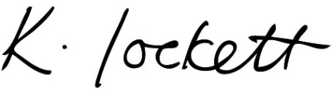

Ms K Lockett
Headteacher

