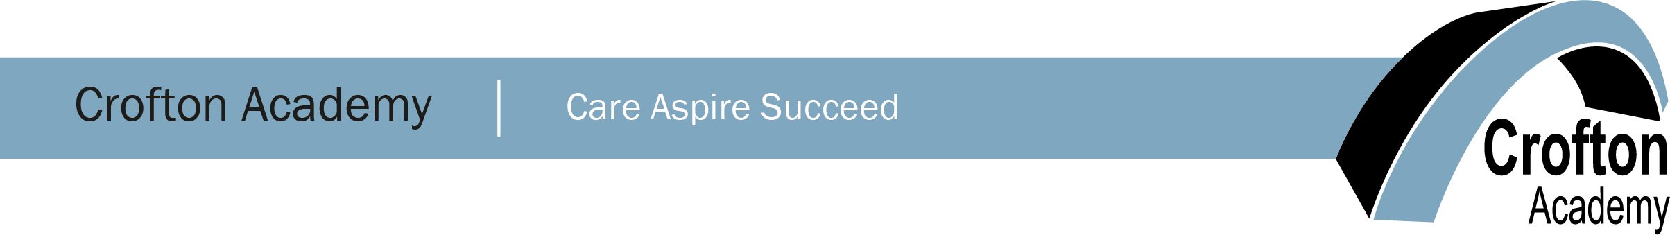

Head of Technology
(TLR 2C – additional R & R allowance available for an exceptional candidate)

An exciting opportunity has arisen for an enthusiastic, dynamic, motivated and able Head of Technology to lead our Technology department. We are looking for an excellent practitioner to work collaboratively with other Department Leaders to develop colleagues in delivering outstanding lessons and develop the wider Technology curriculum, raising academic achievement and ensuring all pupils make outstanding progress in all technology areas including: design technology, construction, engineering, graphics, food technology and textiles across Key Stage 3 and 4.

Applications are welcome from all technology specialisms, however the candidate must be willing to teach some timetabled periods outside of their specific field.

The successful candidate will be:
- Able to inspire pupils of all abilities within Technology to achieve their highest potential across Key Stage 3/4.
- Able to lead/develop a team of specialists ensuring outstanding practice across the department through coaching and mentoring.
- Committed to delivering consistently outstanding teaching and ability to share your practice with others in a constructive and collaborative manner.
- Contribute to the strategic development of the department by implementing new initiatives, monitoring and reporting on key outcomes, to ensure the department meets academic targets.
- Responsible and be accountable for pupil attainment and achievement, by tracking pupil progress and supporting individual pupils’ learning needs.

You will be:
- An outstanding practitioner.
- Inspirational, dedicated and motivated.
- Dedicated to being the best you can be.
- Passionate about Technology and the education of young people.
- Committed to Crofton Academy values.
- Be creative, enthusiastic and engaging and able to challenge pupils.
- Committed to achieving the best for every pupil.
- Supportive of the Academy’s ethos and values at all times both within the Academy and the wider community.
- Committed to inspiring pupils and staff in the development of teaching initiatives and strategies, and promoting Technology as a subject.
- Able to provide an active contribution to the wider part of Academy life.

We would welcome applications from experienced teachers and leaders who wish to take advantage of a new challenge. This is an exciting time to shape the curriculum and develop the department further. We are able to offer staff a secure, supportive environment with continuous professional development. If you have the vision and drive for excellence and want to join an Academy where relationships for learning are fundamental to our continued success we would be delighted to hear from you.

This school is committed to safeguarding and promoting the welfare of children and young people and expects all staff to share this commitment. You will be required to undertake an enhanced DBS disclosure.

Relevant information and application forms are available on the school website at www.croftonacademy.org.uk. For any enquiries, please contact Kim Hinchcliffe at recruitment@croftonacademy.org.uk. The closing date for fully completed applications is 12 noon on Wednesday 14th April 2021. All applications forms should be directed to recruitment@croftonacademy.org.uk or submitted through the TES portal.

