March 2024

Dear Applicant

Thank you for your interest in this post as Head of Year 13 at Archbishop Tenison’s.

This is a great opportunity for a teacher with significant experience of working in a secondary school to take on a pastoral leadership role. The school has a strong team of 8 pastoral leaders – Heads of each year from years 7 to 13 and a Head of Pupil Welfare – and a new team of 3 Senior Pastoral Leaders to work closely with the Deputy Headteacher (Policy and Practice) to help develop our pupil discipline and pastoral care even further. This has been a priority for some time; the new roles grew out of our reflections after our recent OFSTED inspection.

For this post we are looking for a person with a genuine heart for working with young people in an educational context, as well as the skills, expertise and experience to help them progress academically. As in all schools, there are some students who do not have an easy life at home or who arrive here without the academic confidence they need to succeed. This gives us a challenge, but also an opportunity to work and make a difference with motivated students with a high level of ambition. In this role you will be managed by one of our Deputy Headteachers (Christian Character and Learning Culture). The Head of Year 13 will work closely with the Deputy Headteacher and Head of Sixth Form to implement the vision for recruitment and retention. We would like to fill the role with a suitably qualified teacher who has experience in one or more of the following subjects; German, Latin, Geography, Psychology or Computing. The role will be combined with teaching a particular subject alongside another comparable responsibility within the school.

Archbishop Tenison’s is a friendly, aspirational and high achieving Secondary school, with a ever growing Sixth Form, where students take their studies seriously. As a Church of England school, we are always pleased to receive applications from those keen to help develop our Christian ethos.

We look forward to receiving your application and discussing the role further to those called for interview. In your letter, please include the following points:

- why you would like to take up this post at this time.
- which experience and qualities make you particularly suitable for the post.

Please see our website for further details.

Yours sincerely
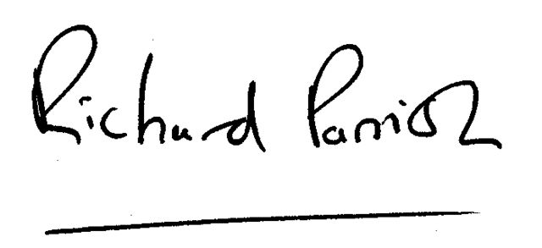
Richard Parrish
Headteacher

