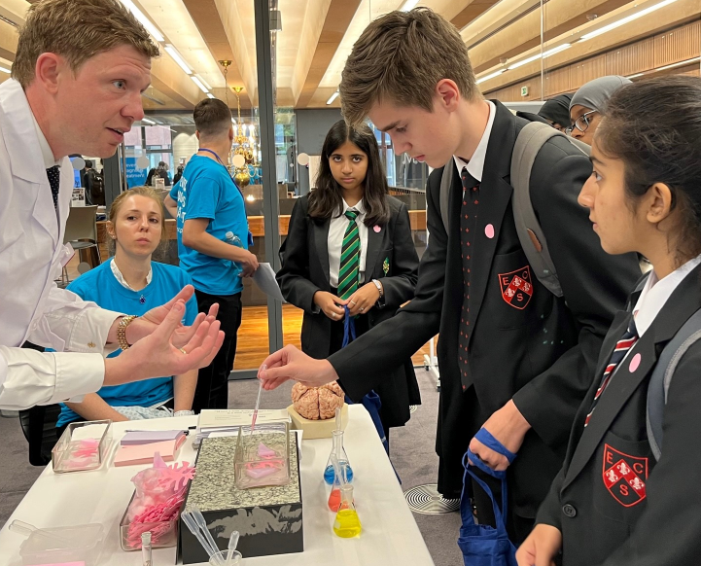

Contents
Headteacher’s Welcome. 4
The Recruitment Process. 5
Advertisement. 6
Job Description. 8
Person Specification. 11
Our Ethos and Strategic Direction. 12

Headteacher’s Welcome
Welcome to Eastbury Community School, and thank you for expressing an interest in applying for the position of Head of Year.
For me, our school is where our young people are given the opportunities to allow them to realise their potential, and that potential can and does manifest itself in a range of ways.
Our young people need to see that success comes in a range of different forms, and ECS is where they can explore where and how they can and will be successful. Our pupils get some of the best progress results in GCSEs in the local area, our 6th Form- judged outstanding (March 2024) achieves some of the best results in the Barking and Dagenham, and over half of these young people go on to attend Russell Group universities.
Our young people need to have a voice in the school, the local community and the wider world. As part of our commitment to this belief we are a Rights Respecting School – Silver award at the moment, but we are confident that within the next year we will achieve Gold – one of the only 3-19 schools in London to do so.
Sir Tim Brighouse said “If a teacher makes the weather the school creates the climate.” and I firmly believe this. It is our role as a leadership team to create the best possible learning environment for our teachers to teach in. In return we expect the best possible teaching from them and our results show this over time. We have created systems and structures that support high quality learning, whilst minimising workload and maximising impact.
Our recent Ofsted report – March 2024 stated:
“Pupils are proud to be part of this inclusive community where people respect and care for each other. They appreciate the support they receive from staff if they have a concern” .
“Leaders are ambitious for all pupils to achieve well”
“The school takes effective steps to address behaviour that does not meet its high expectations. Pupils conduct themselves well and enjoy their time at school. Low level disruption in lessons is rare”
“Staff, including early career teachers, said that leaders have carefully considered their workload and well-being. They value the many opportunities to improve their professional practice.”
If you share our ethos and values and absolutely believe in the potential of all young people then we can offer you the chance to make a difference and change our community for the better, and look forward to receiving your application form and welcoming you to our school.
Sharon Gladman – Executive Headteacher

The Recruitment Process
We are proud of our school, the staff and pupils and in normal times we would warmly welcome prospective applicants to visit us prior to application to learn more about the role and view the school in action.

The interview process will be organised to provide a range of assessment tasks and opportunities for candidates to find out more about the school and demonstrate their ability to fulfil the role.

Key Dates
Visit with the Heads of Secondary Tuesday 2nd July 2024
Closing Date for Applications Monday 8th July 2024 – 9am
Interviews commencing Wednesday 10th July
Please note all dates are subject to change.
To arrange your visit please email: kdu@eastbury.bardaglea.org.uk

Completed applications should be sent to: kdu@eastbury.bardaglea.org.uk

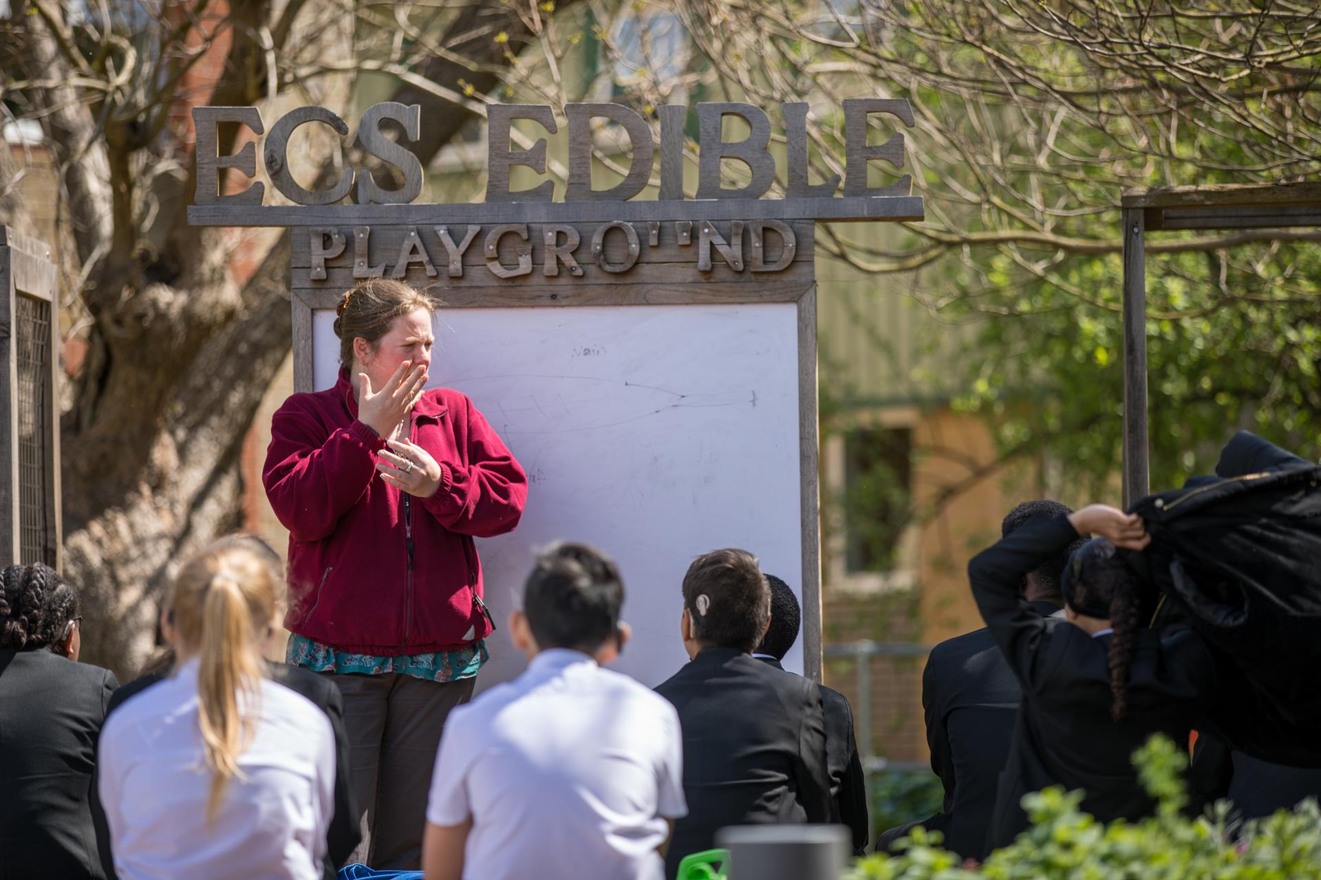

Advertisement

Head of Year

Commencing: September 2024/January 2025
Salary Scale: MPS / UPS + TLR 2C moving to 1A

Do you want to join a highly successful, committed, pupil centred pastoral team?
Are you prepared to work hard with exceptional young people and staff committed to going the extra mile?

We are seeking to appoint an outstanding, innovative and committed leader who will play a significant part in the pastoral development of the school. The successful candidate will be an outstanding teacher with excellent knowledge and understanding of implementing and embedding pastoral systems. The pastoral system is at the heart of Eastbury Community School, and we would welcome applications from individuals with passion for developing and implementing pastoral strategies and who can demonstrate excellent leadership experience and/or qualities
The successful candidate will have:

- Teaching experience across all key stages.
- High standards of pupil behaviour, conduct and attitudes to enhance learning.
- An awareness and understanding of the importance of character education/Rights Respecting School
- The ability to develop and support pupils’ academic progress and achievement, as well as their social and emotional development.
- The ability to lead a team of form tutors and pastoral staff to ensure high standards of care, guidance and support.
- The willingness to go above and beyond for our pupils.
- Experience of implementing positive behaviour strategies and attitudes to learning.
The hours may be long, but the reward will be the chance to work with and help shape our amazing pupils. They are overwhelmingly polite, respectful, considerate and have a fantastic thirst for learning and personify Excellence, Success and Collaboration.
ECS celebrates its diversity, and we positively welcome applications from all sections of the
community. If you are interested in making a difference in young people’s lives, whatever your background or history please apply.
In return we can offer:
- A pupil centred, progress focused ethos.
- A welcoming and supportive community.
- The opportunity to work with a passionate, hardworking and supportive staff.
- A commitment to develop your skills through continued professional development.
- A supportive and committed Leadership Team and Governing Body.
- A cohort of pupils with high aspirations and a willingness to learn.
- A school which understands the importance of staff well-being and workload management

“Pupils value the opportunities that they have to work with leaders to further improve the
school, for example through the school council. Older pupils, and students in the sixth
form, help pupils in the primary phase with their reading. Pupils benefit from a range of
extra-curricular clubs, both at lunchtime and after school.” (Ofsted March 2024)
Please click here to find out more information about what it is like to work at ECS:
https://www.eastbury.bardaglea.org.uk/
The school is located less than 10 minutes’ walk from Upney tube and 15 minutes from Barking mainline station.
To find out more about how teachers can secure rented accommodation at a discounted rate of 20% please contact: info@bdsip.co.uk
ECS is committed to safeguarding and promoting the welfare of children and is an Equal Opportunities Employer.
This post is exempt from the Rehabilitation of Offenders Act 1974 and a comprehensive screening process, including Disclosure check, will be undertaken on all successful applicants.

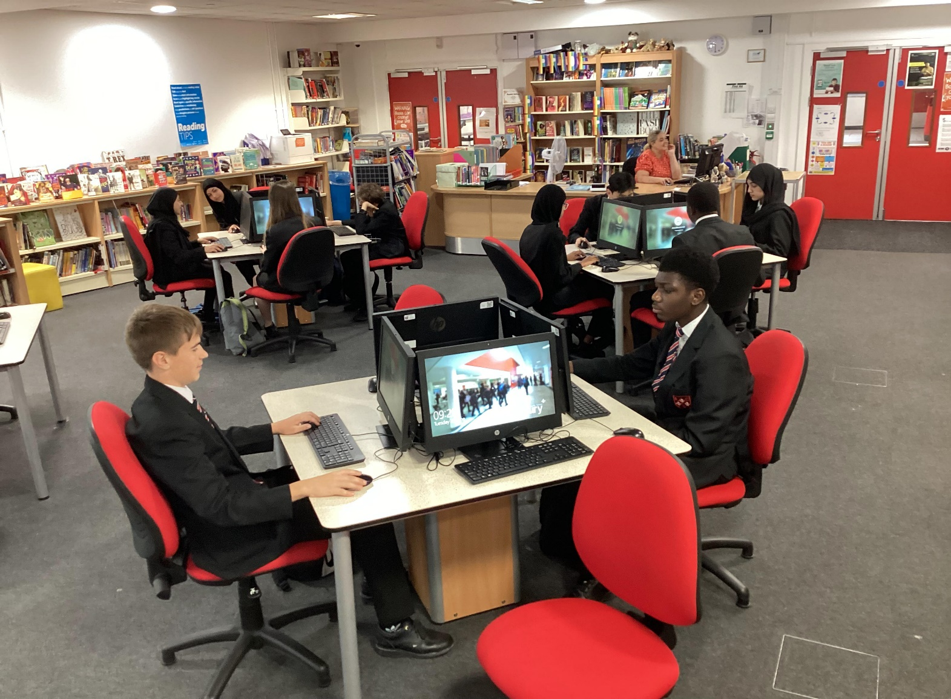

Job Description

Core responsibilities
- To lead on developing and supporting pupils’ academic progress and achievement as well as their social and emotional development across a cohort.
- To lead a team consisting a team of Form Tutors and other pastoral staff to ensure high standards of care, guidance and support.
- To promote and develop the highest standards of pupil behaviour, conduct and attitude to enhance learning.
- To be responsible for ensuring that the highest quality of planned support is available to all pupils in order that every pupil is given the opportunities to fulfil their potential
- To promote the Eastbury 8 learning habits and expectations.
- To model the highest standards of classroom practice
The following indicate some of the principal tasks and responsibilities:

Leadership and Management
- To lead on the identification of underachieving cohorts of pupils within the pastoral group ensuring effective intervention strategies are in place and the impact of these is regularly monitored and evaluated.
- To lead the pastoral team ensuring there are clear expectations and clear lines of delegation.
- To lead, manage, motivate and develop a team of form tutors providing support and communicating information to ensure the care and guidance pupils receive impacts positively on their progress and achievement.
- To lead on the development of effective tutor programmes to support academic tutors and to monitor and evaluate the impact of these programmes – this will be based on the Personal Development Curriculum.
- To lead pastoral academic teams in formulating aims and objectives and action plans, which are both strategic and short-term, which will have coherence and relevance to the identified needs of the pupils.
- To have an overview of all the different care and guidance for pupils’ e.g. SENCO, teaching assistants, external agencies etc.
- To provide a link for parents, tutors, SENCO, teachers, Heads of Department, SLT and external agencies.
- To initiate and respond to communications with parents ensuring that they are kept fully informed and involved in the progress of their children.
- To contribute to the organisation of any parent information evenings by encouraging and monitoring parent attendance to such events.
- To play a key role in promoting and attending events that celebrate the successes of your year group
- To monitor pupil attendance and punctuality on a weekly basis and to take all the appropriate steps to ensure that attendance and punctuality of pupils in the group are at the highest levels, and Persistent Absences continue to fall.

Strategic Planning
- To take a lead on developing pupils’ personal, social and academic progress and to develop and implement effective interventions to address lack of progress and underachievement within the relevant cohort.
- To take a lead, together with the SLT members responsible for achievement, in tracking and monitoring the progress, of individual pupils and targeted groups, producing relevant and accurate data, setting appropriate and achievable targets for cohorts, targeted groups and individual pupils, and ensuring that follow up procedures are adhered to with appropriate interventions when required.
- To take a lead on developing relevant and coherent strategies to ensure all pupils in the cohort are aware of their targets/expectations and are given support and guidance to ensure they make excellent progress.
- To plan, co-ordinate and deliver regular high-quality assemblies which are linked to the SMSC themes/Rights Respecting School/Character Education and the Eastbury 8.
- To take a lead on developing and maintaining robust structures and processes where the views of pupils are sought and acted upon in a planned and coherent way and that this is communicated to staff and pupils.
- To take a lead on developing processes by which we foster close links with parents, especially our harder to reach parents, gathering and acting upon their views.
- To develop effective interventions to address attendance and punctuality issues both for individuals or identified groups of parents causing concern.

To Support Pupils in the Pastoral Group
- To be responsible for meeting the standards for safeguarding and promoting the welfare of the young people within the group. To ensure staff know the current legal requirements, national policies and guidance on the safeguarding and promotion of the well-being of children and young people.
- To have a drive and focus on development of the whole child through a bespoke character education programme.
- To support the emotional wellbeing of pupils, through the delivery of programmes that promote wellbeing.
- To ensure staff know the local arrangements concerning the safeguarding of children and young people and know how to identify potential child abuse or neglect and follow safeguarding procedures, alongside the DSL
- To ensure staff know how to identify and support children and young people whose progress, development or well-being is affected by changes or difficulties in their personal circumstances, and when to refer them to colleagues for specialist support.
- To foster positive relationships with all members of the group whereby each pupil can be confident of receiving support and guidance from the pastoral team when needed.
- To set and maintain high standards of behaviour from pupils in the group by effective role modelling, supporting tutors and liaising with subject staff/leaders to intervene when issues and incidents arise including taking the lead with pupils causing concern across the curriculum and liaising with parents, staff, governors and external agencies as appropriate.
- To support form tutors in the implementation of whole school policies, rules and procedures.
- To induct new tutors and give guidance and support to all form tutors in the effective development of pupils in their care.
- To carry out regular self-evaluation activities as agreed by SLT presenting findings and acting upon them, to maximise pupil support and ensure the efficiency of the form tutor team.
- To implement the mid-term pupil admission procedure to ensure smooth induction to the group, identifying the needs of students and ensuring any necessary support is provided.
- To promote and co-ordinate enrichment activities.
- To review the quality of pupils’ work through regular checks of books and folders with Heads of Department
- To review the quality of pupils’ reports on a termly basis to ensure the quality and accuracy of information being communicated to parents and carers.
- To actively promote and maintain high standards of pupil behaviour and conduct across the school adhering to the high expectations of the school.
- To liaise with members of the SLT, SENCO, pupils support agencies, heads of department, teaching and core staff, relevant internal and external agencies, parents, families.
- To ensure the implementation of school policies and procedures relevant to post i.e. behaviour management rewards and sanctions.
- To liaise closely with the SENCO to identify and implement effective strategies to support pupils with SEND.
- To ensure students respect the community of the school and are outstanding ambassadors for the school.
- To support the implementation of the School Leadership Programme.
- To be part of the team of staff supporting and managing the Internal Inclusion Room and/or The Learning Support Unit

Organisational
- To communicate with and liaise with the pastoral team of form tutors and relevant support staff to main- tain records and information in line with school policy.

Policy Development
- To keep up to date on national developments in pastoral care.
- To actively monitor and respond to developments and initiatives at national, regional and local levels.

Staff and Staff Development
- To promote teamwork within the year group and to motivate staff to ensure effective and positive working relationships.

Quality Assurance
- To ensure the effective operation of quality assurance systems within the group and ensure that they meet the expectations for progress and attainment

Management Information
- To ensure the maintenance of accurate and up-to-date information concerning the group using the school’s Management Information System. (BromCom)
- To apply behaviour management systems to enable effective learning to take place.
- To make regular use and evaluate performance data provided to track and monitor progress and behaviour.
- To identify and take appropriate action on issues arising from data provided – tracking and monitoring attendance, attainment and behaviour.
- To assist in the production of reports with the quality assurance cycle for the pastoral area.
- To provide SLT and the Governing body with relevant information relating to the groups performance and development.

Health and Well Being and Communications
- To ensure that all members of their pastoral team are familiar with its ethos, strategic direction and SDP
- To ensure effective communication/consultation as appropriate with the parents of pupils and to co-ordinate all pupil information received externally.
- To represent the pastoral group’s views and interests through regular meetings.
- To keep parents informed of pupils’ progress and make contact and arrange meetings as necessary.
- To co-ordinate arrangements for parent’s progress meetings/evenings for their group.

Management of Resources
- To manage the available pastoral resources efficiently within the limits, guidelines and procedures laid down, including and keeping appropriate records.
Whilst every effort has been made to explain the main duties and responsibility of the role, each individual task undertaken may not be identified.
Under the reasonable direction of the Executive Head Teacher, teachers are asked to carry out the professional duties of a school teacher as set out in the current School Teachers’ Pay and Conditions Document (STPCD).
The above mentioned duties are neither exclusive nor exhaustive and the post holder may be called upon to carry out such other appropriate duties as may be required by the Executive Head Teacher within the grading level of the post and the competence of the post holder.
The school will endeavour to make any necessary reasonable adjustments to the job and the working environment to enable access to employment opportunities for disabled job applicants or continued employment for any employee who develops a disabling condition.
This job description is current at the date below but will be reviewed on an annual basis and, following consultation with you, may be changed to reflect or anticipate changes in the job requirements which are commensurate with the job title and grade.

Employees Signature |  | Date
Head Teacher Signature |  | Date

Person Specification

Knowledge & Skills | Criteria | Essential | Desirable | Assessment Method  Application A Interview I Task T
 |  |  |  | A | I | T
 | Good classroom management skills and rapport with pupils. | ✓ |  |  | ✓ | ✓
 | A strong, dynamic character. | ✓ |  |  | ✓
 | Good communication, inter-personal skills and organisational skills. | ✓ |  | ✓ | ✓
 | Experience within pastoral care. | ✓ |  | ✓ | ✓ | ✓
 | Good leadership and motivational skills. | ✓ |  |  | ✓ | ✓
Qualifications | A good standard of general education. | ✓ |  | ✓
 | Good Honours Degree. | ✓ |  | ✓
 | A recognised teaching qualification, such as a PGCE. | ✓ |  | ✓
 | Further professional study. |  | ✓ | ✓
Experience | Work well leading a team. | ✓ |  |  | ✓ | ✓
 | Have high personal and professional standards and well-developed pastoral skills. | ✓ |  |  | ✓ | ✓
 | Knowledge to effectively support the needs of pupils. | ✓ |  |  | ✓ | ✓
 | Demonstrate the ability to enthuse and encourage others. | ✓ |  |  | ✓ | ✓
Attitude & Personal Qualities | Flexible, motivated, able to work unsupervised and an ability to deal with unpredictable situations. | ✓ |  |  | ✓
 | Tact, discretion and listens whilst maintaining confidentiality. | ✓ |  | ✓ | ✓
 | Willingness to take part in the wider life of the school. | ✓ |  | ✓ | ✓
 | Honesty and Integrity. | ✓ |  |  | ✓
 | Understanding the need to use discretion and respect confidentiality. | ✓ |  |  | ✓
 | Commitment to safeguarding and promoting the welfare of children and young people. | ✓ |  | ✓ | ✓
 | Motivation to work with children and young people. | ✓ |  | ✓ | ✓
 | Ability to form and maintain appropriate relationships and personal boundaries with children and young people. | ✓ |  |  | ✓ | ✓
 | Emotional resilience in working with challenging behaviours and attitudes to use of authority and maintaining discipline. | ✓ |  |  | ✓ | ✓
 | Understanding of the requirements of data protection and disclosure of information. | ✓ |  | ✓ | ✓ | ✓
 | Ability to demonstrate an awareness of equality and diversity and to promote these through working practices. | ✓ |  | ✓ | ✓
 | Ability to work flexibly and outside of normal school hours, when required | ✓ |  |  | ✓

Our Ethos and Strategic Direction

