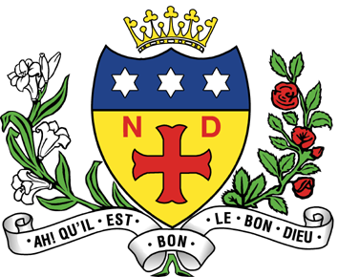
NOTRE DAME HIGH SCHOOL
11-18 Mixed Catholic Comprehensive School
FULWOOD ROAD, SHEFFIELD, S10 3BT

Tel: 0114 2302536

Head of Year (Full time /Permanent)
Teachers’ pay scales +TLR – 2C (currently £7,017 p.a.) with progression onto the Leadership spine (L8 - L12) after one-three years depending on experience and professional development

Applications are invited for the above role and it would be an advantage if you could teach Religious Education (R.E), Maths, or Social Science or but this is not essential.

Start date would be after the Easter holidays, however, the ability to start earlier, would be an advantage.

We are looking to appoint a Head of Year who will be responsible for a specific year group throughout their transition from Year 7 to Year 11. The successful candidate will be managing a tutor team of eight form groups and tutors, and be responsible for the spiritual, moral and academic development of students in their year group. This will include responsibility for the attendance, behaviour, welfare and safety of the year group.

Progression of Leadership role
The Head of Year job at Notre Dame carries as part of the role whole school leadership responsibilities. In addition to responsibility for leading a year group and form tutor team, the Head of Year takes a share in other senior responsibilities in maintaining an excellent climate for learning and formation. These responsibilities are outlined on the job description.

Successful applicants will take on the full set of responsibilities from appointment, but will follow a structured mentoring programme supported by an existing Head of Year during the first two years in post. Following successful completion of this programme, the mentoring support will be withdrawn and the Head of Year will progress onto the Leadership Spine (L8 - L12) in recognition that they are taking full and sole responsibility for the whole school leadership aspects of the role.

Further progress through that leadership scale will be through appraisal and performance management.

Notre Dame is a Catholic school with a strong ethos at its heart. All staff are expected to uphold and contribute to the ethos of the school, which is what makes it a special place to work.

For further details and an application pack please visit our website: www.notredame-high.co.uk or telephone the school.

You are warmly invited to visit the school prior to submitting an application.

Closing date for receipt of completed applications: 9 am on 17th January 2022

Notre Dame High School is committed to safeguarding and promoting the welfare of children & young people and expects all staff to share this commitment. The successful applicant will be required to complete an Enhanced DBS Disclosure. In addition, this post is exempt from the Rehabilitation of Offenders Act and a self-disclosure is required for applicants shortlisted for interview.

