**St John Henry Newman Catholic School**

**Headteacher:** Mr John McAuley BA (Hons) MEd

**Address:** Scalegate Road, Carlisle, CA2 4NL

**Telephone:** 01228 404942 **Email:** office@newman.cumbria.sch.uk

**Website:** www.newman.cumbria.sch.uk

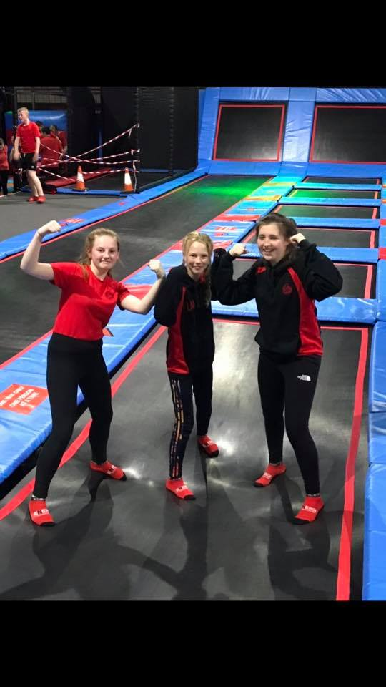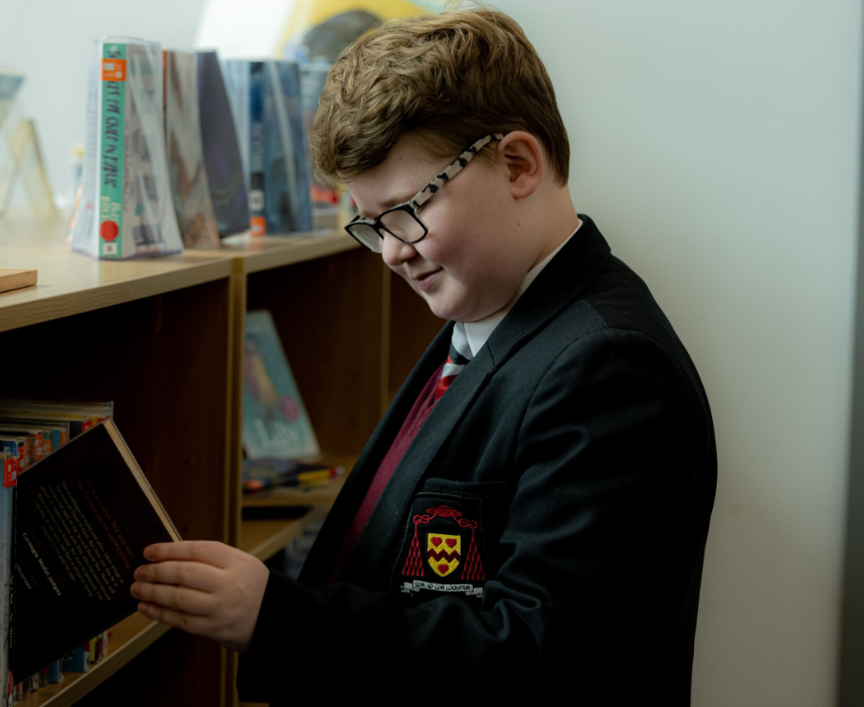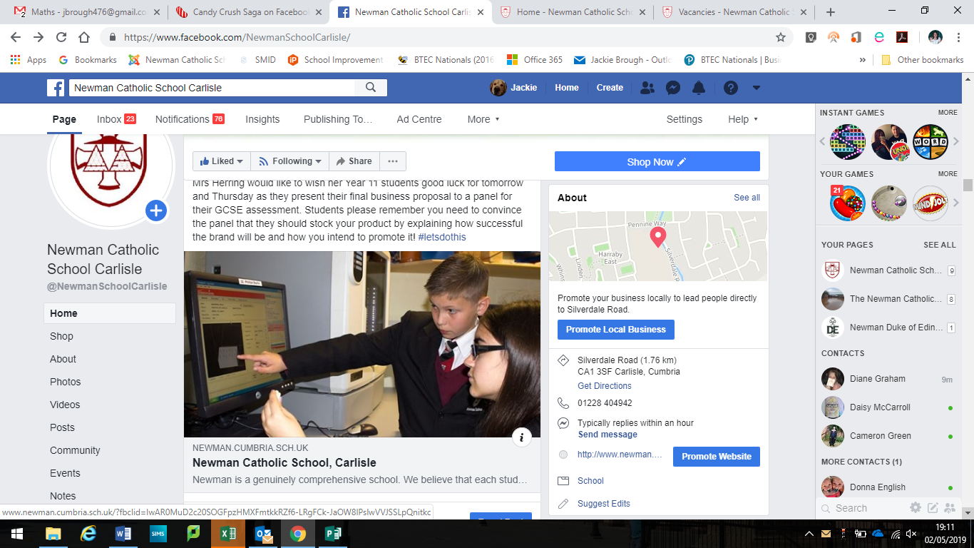

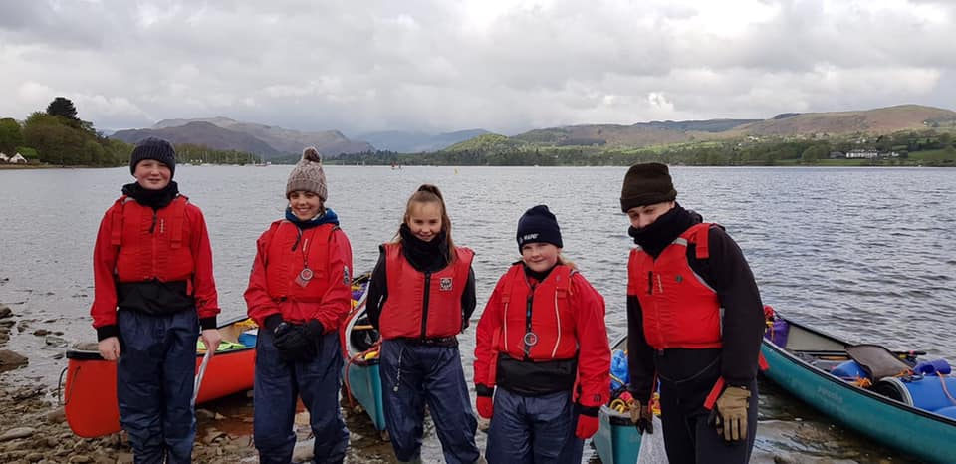

**St John Henry Newman Catholic School**

**Contents**

|  |  |
| --- | --- |
| Page 3 | Letter of welcome from the Headteacher |
| Page 4 | Our Location |
| Page 5 | New School Building |
| Page 6 | Advert |
| Page 7 - 9 | Job Description & Person Specification |
| Page 10 -11 | Mission Statement |

Also included with this application pack:

* Attachments - Notes to Applicant
* Application Form
* Rehabilitation of Offenders Form – issued at shortlisting stage
* Self-Disclosure Form – issued at shortlisting stage
* Recruitment Monitoring Form
* Consent to Obtain Reference Form
* School Privacy Notice - Staff
* Staff Code of Conduct Policy
* Child Protection Statement
* Equality Act Reasonable Adjustment Statement



**St John Henry Newman Catholic School**

Welcome to St John Henry Newman Catholic School. We are a genuinely comprehensive school and believe that our mission is to nurture each child by placing Christ and the teaching of the Catholic Church at the centre of their lives.

We integrate Gospel values and the teachings of the Catholic Church into every aspect of learning, teaching and the totality of school life.

In the words of our patron St John Henry Newman, “To live is to change and to be perfect is to have changed often”; and so we have high expectations of our pupils; we expect them to work hard, to play hard and to take a full part in the life of the school. In return, we strive to provide the best teaching and guidance in a caring and supportive environment, where pupils are challenged and give of their best.

Strong pastoral care is vital to our success and creates a happy and caring atmosphere. As a smaller school, we get to know our pupils well; their well-being is our foundation. This strong pastoral care enables us to support our pupils, not only with their academic work, but also in the varied extra-curricular activities, which are hugely important as they develop into young adults.

It is an exciting time to join Newman. Following the flooding of our site in Carlisle we have now moved to a purpose-built modern school in a developing area of Carlisle, the garden village. After a turbulent time following the flood, the school is rapidly improving and was recently commended by Ofsted for the improvements being made in the quality of teaching, the progress of pupils, and for the highly effective pastoral support. Inspectors’ findings confirmed that a journey of school improvement is underway.

We want our pupils to enjoy their education – to be happy, safe and secure and to grow in God’s love so that when they leave the school, they are equipped to change the world and make it a better place.

John McAuley

Headteacher

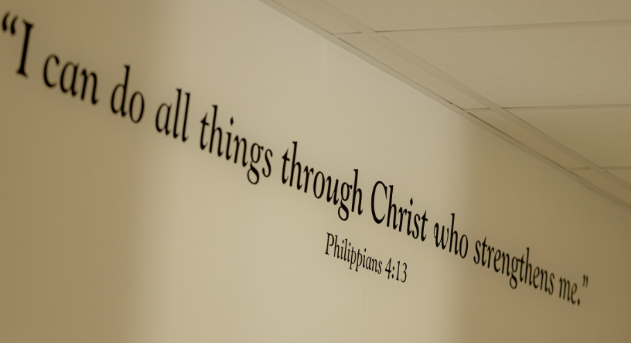

**St John Henry Newman Catholic School**



**Why choose this location**

St John Henry Newman Catholic School is located in Carlisle - the Border City - which is the main shopping, commercial and industrial centre in the north Cumbria. The city sits on the doorstep of both the Lake District and Hadrian’s Wall and blends 2000 years of history with a vibrant 21st century city.

The school has moved to a brand new build, located in the south of the city in a developing area known as the garden village.

The district of Carlisle, with a population of over 100,000, lies 10 miles south of the Scottish borders at the confluence of three rivers.

Originally established as a Roman settlement to serve the forts on nearby Hadrian’s Wall, it is the main commercial centre for north Cumbria. It has a long and interesting history, with Cumbria’s only cathedral and Carlisle Castle, a mediaeval fortress.

Easily accessed from the M6 motorway and A69 east-west route, Carlisle is also a major railway junction, with routes to London, Scotland, Newcastle, west Cumbria and the famous Settle-Carlisle railway.

Cumbria is a predominantly a rural county, considered one of the most beautiful regions of the UK, and includes the whole of the Lake District National Park, the Eden Valley, the North Pennines, the Furness Peninsula, and part of the Yorkshire Dales. The area has provided inspiration for generations of artists, writers and musicians. The county has some beautiful coastlines, vibrant towns and idyllic rural villages.

The quality of life is hard to beat and it is easy to see why so many people are drawn to Cumbria to live and work.



**St John Henry Newman Catholic School**

**Our New School**

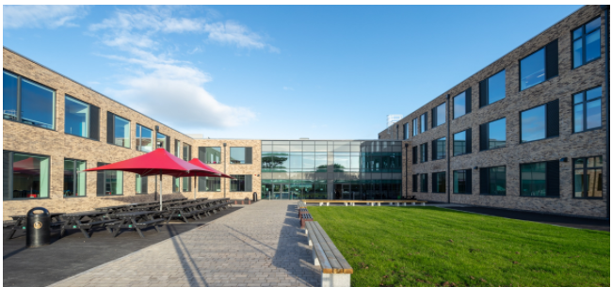

It is an exciting time for Newman, as we have moved to a new build school in the “garden village” area of Carlisle. Our school is a £15million new build in a rural location on the edge of the city. The school has been designed to provide the highest standards of education for our pupils and areas have been purpose built to allow staff to teach effectively in their subject areas.

 **St John Henry Newman Catholic School**

**Head of Year**

Full time (37 hours per week), term time only (39 weeks per year) on a permanent basis

£25,560 per annum pro rata (FTE £29,777) Rising to £26,006 per annum pro rata (FTE £30,296) after a successful 6 month probation period

**Required as Soon as Possible**

The successful candidate will be:

* passionate about supporting pupils to gain an inspirational education
* highly organised and able to prioritise workload
* an outstanding practitioner with high expectations of pupils achievement and behaviour who is committed to providing high quality pastoral support
* an excellent communicator who is able to work inclusively with pupils, staff parents and external professionals as the need arises

Current working hours are 37 hours per week:

Monday to Thursday 8.30am – 4.30pm

Friday 8.30am – 4.00pm

Our school has a distinctive caring and Christian ethos with the emphasis on the individual and supporting staff and pupils in fulfilling their full potential. St John Henry Newman Catholic School is committed to safeguarding and promoting the welfare of young people. This post will be subject to an enhanced DBS, health checks and a six month probation period.

This is a non-teaching post, you will join our pastoral team. Initially you will be working with primary schools to get to know the incoming Year 7 for September: You will be Head of Year for this cohort from September 2024.

You will support school improvement by working as part of a vital team to contribute to an effective pastoral and learning mentor system by providing support to teachers, pupils and families whilst also assisting with daily break and lunch supervision of pupils.

For an informal chat about the post or to request to visit our school please contact Mrs Mooney, Assistant Headteacher Pastoral by email: [kmooney@newman.cumbria.sch.uk](mailto:kmooney@newman.cumbria.sch.uk).

Application packs can be requested by emailing vacancies@newman.cumbria.sch.uk or downloaded from our website at <http://newman.cumbria.sch.uk/Vacancies/>

The closing date for applications is12.00pm on Friday 10 May 2024.Completed application forms can either be emailed to the address above or by post addressed to HR and Finance Department.

Short listed candidates will be contacted by telephone or email.

 **St John Henry Newman Catholic School**

**Job Description**

**Post Title:** Pastoral Support Officer

**Responsible To:** Senior Assistant Headteacher

**Grade:** PCD8i/ii

37 hours per week. Term time only plus 1 week to include inset and assisting with out of school events.

**Main Purpose:** To support school improvement by working as part of a team to contribute to an effective pastoral and learning mentor system by providing support to teachers, pupils and families whilst also assisting with daily break and lunch supervision of pupils.

**Principal Accountabilities**

To integrate learning support and processes with other provisions within school and elsewhere in order to provide support and guidance to pupils by removing barriers to learning in order to promote effective participation, enhance individual learning, raise aspirations and help pupils reach their full potential.

**Key Tasks**

* Provide a service to enhance existing provisions in order to support learning, participation and encourage social inclusion
* Create, maintain and develop effective and supportive mentoring relationships with parents/ carers, other professionals and pupils
* On occasion be the first point of contact within school for parents/carers of pupils in school
* To support and supervise at break and lunchtime, to ensure an orderly atmosphere in the school
* To liaise directly with school to achieve the best outcomes for pupils by promoting learning and raising standards
* To attend meetings with parents/ carers and professionals as directed by school
* To investigate, mediate and resolve pastoral issues for individuals and small groups of pupils
* To ensure that incidents are dealt with and recorded in line with school systems
* To report findings of incidents to the Senior Assistant Headteacher
* Support and assist the organisation of school detentions
* Assist pupils to make a successful transfer between school and transition at key stages in their learning
* Contribute to the comprehensive assessment of pupils entering school and the review of their progress and achievements
* Contribute to the identification of barriers to learning for pupils and provide them with a range of strategies for overcoming barriers
* Establish and develop effective one-to-one mentoring and other supportive relationships with pupils
* Develop, agree and implement a time bound action plan with those involved in supporting the pupil to asses a pupils strengths and needs
* Facilitate access to specialist support services for pupils with barriers to learning
* To coordinate Early Help Assessments and hold regular |Team Around the Family meetings

**Other Duties**

* Be aware and comply with policies and procedures relating to data protection, child protection, health & safety, security and confidentiality reporting all concerns to an appropriate person in accordance with school policies
* Contribute to the development of policies and practices which will promote social inclusion, engagement and educational achievement
* Be aware of and support differences and ensure all pupils have equal access to opportunities to learn and develop
* Contribute to the overall ethos, work and aims of school
* Participate in training and other learning opportunities in performance management as required
* Any other duties the Headteacher may direct within the conditions of service and workforce reform policy

**Review**

This job description may be reviewed from time to time with the Headteacher. Whilst every effort has been made to explain the main duties and responsibilities of the post, each individual task will not necessarily be identified

**John McAuley**

**Headteacher**

**January 2024**

**PERSON SPECIFICATION**

|  |  |  |  |
| --- | --- | --- | --- |
| **1**. |  | **ESSENTIAL** | **DESIRABLE** |
| **Qualifications/**  **Training**  **Competences** | * Relevant NVQ 3 or equivalent, or experience in relevant disciple * 5 GCSEs at C or above including English and Mathematics or equivalent | Child Protection and Safeguarding Level 1 |
| **2.** | **Knowledge** | * Understanding of working with children or a relevant age in a learning environment * Up to date knowledge and understanding of practices and procedures within education relating to the welfare, safety and education of pupils |  |
| **3.** | **Relevant Experience** | * Working with young people in an educational settings | * Experience of mentoring young people * An understanding of the protocols of professionals from other disciplines and services |
| **4.** | **Skills** | * To be well organised and capable of working on their own initiative to a high level of accuracy and presentation * ICT skills as required for the post * Professional telephone manner * Effective written communication skills to suit a variety of purpose and audible * To have a forward looking approach to pupil support with drive and initiative and an ability to respond to situations quickly * Ability to remain calm and negotiate in difficult situations * To work both independently and as part of a team * To have access to confidential and sensitive information and must be able to demonstrate tact, sensitivity and absolute respect for the confidentiality of information | * Working knowledge of SIMS |

 **St John Henry Newman Catholic School**

**Mission Statement**

*Our mission is to educate our pupils in the wholeness of mind, body and spirit through the teachings of Jesus Christ as proclaimed by the Catholic Church by placing Him at the centre of pupils' lives.*

*Our school commits itself to the principles of Catholic education and academic excellence, leading our pupils from shadows and images to the fullness of the Truth, as envisioned by the St John Henry Newman. The school community recognises that excellence in education can best be achieved, and future leaders nurtured, within a living tradition rooted in the Love and Truth of Christ.*

*We encourage pupils to cultivate Christian virtue and an appropriate sense of social responsibility.*

*We inspire an enthusiasm for life-long learning and are committed to success for all.*

**St John Henry Newman Catholic School**

**Governors’ Strategic Vision 2018-2023**

This text sets out our aspirations for St John Henry Newman Catholic School and provides a description of the school the governors would like to see evolve as the manifestation of their ambitions.

Each year’s School Improvement Plan will take us closer to achieving these goals and will represent the practical steps required to deliver this vision.

**We will develop a school which is characterised by:**

* Christian values, where Catholic teaching is at the centre of every aspect of school life, and kindness and compassion are qualities which are shared by the whole school community
* equal respect for all members of the school community in which diversity is welcomed and celebrated
* dedicated, highly professional and committed staff who fulfil their various roles to the highest of standards and work effectively as a team
* fostering high aspirations and determination in our pupils, and driving them to be high achievers in all aspects of their learning and development
* a safe, nurturing and inclusive outlook

**As a result of our collective efforts, we expect our pupils to be:**

* well rounded young people, independent, confident and articulate, outward facing and ready to make a positive difference in the world as responsible citizens in a tolerant and democratic society
* happy and able to fulfil all dimensions of their human potential: spiritual, academic, personal and social
* shaped by Christian values, and willing to contribute actively in their faith and secular communities, providing a positive example to others
* confident in their abilities and equipped to achieve excellence in their studies leading to success in continuing education or training and future careers
* both leaders and good team players with a strong sense of self-esteem as well as respect for others
* the best that they can be, behaving in such a way that all can be proud of them
* self-disciplined and courteous, setting an example to others

**The school will provide an environment which is:**

* an inspirational place in which to learn: spacious, light, attractive and stimulating
* suitable to meet all needs – physical, academic, personal, social and spiritual
* furnished with a distinctive and prominent working chapel open to all, at all times, with regular Masses
* supportive of learning in all domains, flexible and responsive to the changing curricular requirements of the 21st Century
* responsive to the progression routes of all pupils, including the provision of high quality post-16 programs within its own distinctive sixth form.
* an environment which brings pupils together, with communal and recreational spaces conducive to a civilised experience
* safe, secure and appropriate to the diverse needs of the pupil’s community
* well-resourced with the equipment and materials required to provide the best contemporary education possible