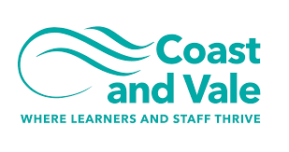

Being the best we can be

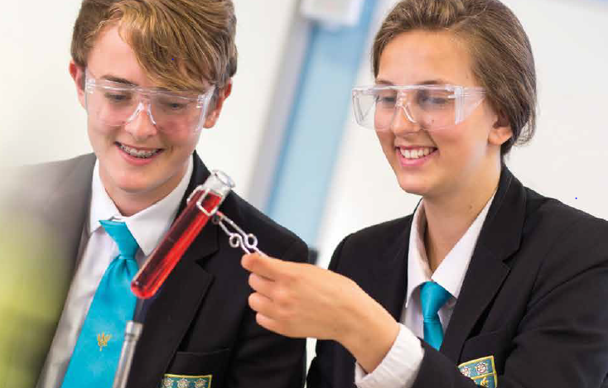

Head of Year
Closing Date Monday 6th June 2022, 9am
Recruitment Information Pack
Scalby School
Fieldstead Crescent, Scarborough, YO12 6TH

Contents

Welcome from the Headteacher 3
Our results 4
Our schools 5-6
Application process and how to apply 7
Job Description/Person Specification 8-13

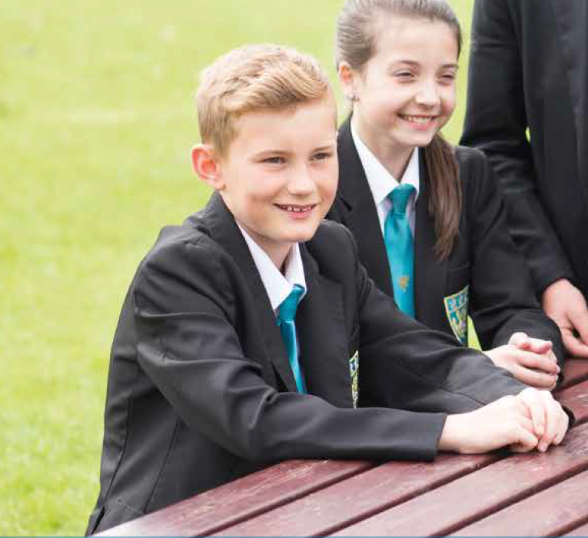

Dear applicant,

Allow me to extend a warm welcome from all governors, staff and students of Scalby School.

I was delighted to be appointed Head of School and while any Head will say their school is special – I truly believe Scalby is.

It is hard to encapsulate in words the full dynamism and vibrancy of our school. We are hugely proud of our students and privileged to serve them and this community. We see it as our professional and moral duty to prepare them as individuals to play their part as active citizens – rounded and centred and aware of all they might contribute to the world. In practical terms, this commitment is manifested in the lessons we deliver, the extra-curricular opportunities we offer and in the wider opportunities we promote.
Scalby is a school with a strong academic tradition but we are equally committed to the Arts, to sport and to collective and individual achievement beyond the classroom. Our annual productions held at the Stephen Joseph theatre are testament to this, and over the years we have seen productions of Macbeth, Romeo and Juliet, Our House to name but a few.
We have developed and benefited from our partnerships within Coast and Vale Learning Trust, Scarborough Teaching Alliance and local secondary and primaries – a few reasons to join us!

In recent years enormous strides have been made to further increase learning standards. This hard work has seen results improve consistently and led to Ofsted rating our school as ‘Good’ in 2012 and in 2019. I truly believe we are a school with highly effective teachers and support staff producing outstanding outcomes for our students.

I hope you can see that this is an excellent time to join Scalby. If successful you will join a staff team of wonderful professionals who have ambition for our students and for themselves. I take pride in ensuring colleagues receive opportunities to develop their skills and experiences – and we have an enviable reputation for delivering high quality professional development.

I hope that you will take the time to come and see and experience for yourself the warm and welcoming atmosphere which makes our vision a reality.

Good luck with your application.

Chris Robertson
Head of School

Our results
Scalby School’s last set of externally examined GCSE results in 2019 were characterised by high levels of achievement. We have worked hard during COVID to ensure students have also achieved in line with these results in 2020 and 2021 when TAGs were awarded.

Our students consistently make significantly better progress than their peers did nationally. Results in English, Maths and Science are above the national averages at Grade 4 and Grade 5, with 36% of students achieving a Grade 7 or better in English, 28% achieving Grade 7 or better in Maths and 21% achieving Grade 7 or better in two sciences.

Recent results are particularly pleasing because of the high number of students who achieved Grade 8 and 9 across a number of subjects.

None of these fantastic results would have been possible were it not for the professionalism and dedication of our teachers and learning support teams. These results mean that our students leave us now being able to access a wide range of post-16 courses at college and they have the skills and knowledge valued by employers.”

Our success in our GCSE results follows our positive Ofsted inspection in February 2019. We are delighted that the high quality of education on offer has been doubly validated at a national level.

Our schools

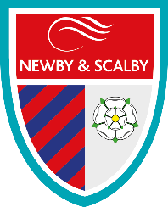
Newby and Scalby Primary School

We are one of the schools of choice in our community and we are within commutable distance of Whitby, Teeside, York and surrounding areas. Ofsted in 2018 judged us to be ‘good’ in all areas and as a school we are very much outward facing both in terms of teaching and learning and in constantly thinking about how we can improve.
Since our “good” Ofsted, we continue to build on our successes and we are a family and a team, where everyone is given the challenge and support to be the best they can possible be in a safe, welcoming and positive environment. Children and staff will work and play together developing skills so that we all become ambitious and reflective lifelong learners as well as being respectful and respected members of the community.
To learn more about us please visit us at:
Newby and Scalby Primary School - Home (coastandvale.academy)

Friarage Primary School
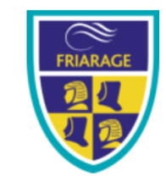
We are proud to serve the communities around the Castle Ward area of Scarborough as ‘Together we can’ make a real difference to the life chances of children and young people in Scarborough.

Children and staff will work and play together developing skills so that we all become ambitious and reflective lifelong learners as well as being respectful and respected members of the community.
We are committed to Restorative Practice Principles to nurture respect for all in our school community.

To learn more about us please visit us at: Friarage Community Primary School - Home (coastandvale.academy)

Scalby School
Scalby School is a successful and popular 11-16 community school and in recent years we have become the school of choice in our local community. We were judged ‘good’ by Ofsted in 2019 and in 2019 we celebrated sustained results. Our provisional P8 score has placed us in the top 20% of schools nationally. We are proud of our broad and balanced GCSE based curriculum.
To learn more about us please visit us at: Scalby School - Home (coastandvale.academy)

Lady Lumley’s School
Lady Lumley’s School (11-18) in Pickering is on a transformational journey. We are a school that is popular with parents and is easily accessible across North Yorkshire, East Riding and Wolds and Vale. The communities we serve around the Pickering, Ryedale and wider Coastal area deserve and need our school to play a leading role in terms of teaching, learning, progress and outcomes.

In April 2020 we welcomed our new Headteacher Clair Foden who joined us at the same time we joined our Trust - Coast and Vale Learning Trust. Lady Lumley’s is on an ambitious journey of school improvement.

To learn more about us please visit us at Lady Lumley's School - Home (coastandvale.academy)

Scarborough University Technical College

Scarborough UTC is a growing University Technical College (year 9 to year 13) based in a new building, with fantastic technical facilities in the centre of Scarborough. As a University Technical College, we offer a high quality academic and technical education for our students through the specialisms of engineering, health and cyber security. Our unique approach provides students with an excellent range of opportunities including Combined Cadet Force (CCF Navy), strong links to our industrial partners, project-based learning and our flagship Career Development Programme for our Sixth Form students.

Our work with employers and universities ensure we are able to deliver an innovative blend of technical, practical and academic learning which ensures our students make good progress and go on to outstanding destinations.

Our staff are our greatest resource and we have invested in both our teaching and support staff teams which has ensured that educational standards have improved significantly. We have built a staff team of key support and teaching practitioners who are proud to work at our University Technical College.

To learn more about us please visit us at: https://www.scarboroughutc.co.uk

Application Process
The closing date for all applications is Monday 6th June 2022, 9am

Interviews will be held week as soon as possible after the closing date

Completed applications must be returned to Garry Morrison at garry.morrison@northyorks.gov.uk

If you think you’re the person for the job, please complete the enclosed application form and send to the email address above by the closing date.

An email will be sent to shortlisted candidates with details of the interview process. If you have not heard from us within a week of the closing date please assume your application has been unsuccessful.

Queries
Please contact Garry Morrison at garry.morrison@northyorks.gov.uk or on 07814935700

Job Description

POST: Head of Year
GRADE: G (scp 13-18)
RESPONSIBLE TO: Senior Leader for Engagement & Safety
STAFF MANAGED: None
JOB PURPOSE: | To support learning through the use of data, strategic intervention and monitoring in order to maximise student attainment. To provide pastoral support and guidance to students in order to ensure they attend school regularly, behave appropriately and achieve their academic potential.
JOB CONTEXT: | Works within the school’s pastoral team, working with SLT, students, parents and external agencies to promote good attendance and behaviour of students.  An ability to fulfil all spoken aspects of the role with confidence through the medium of English  Enhanced DBS clearance required
ACCOUNTABILITIES / MAIN RESPONSIBILITIES
Operational Issues | - Liaise with the Senior Leader for Engagement and Safety in all matters pertaining to the attendance, behaviour and welfare of students.  - Liaise and meet with parents and agencies in promoting the attendance, good behaviour, welfare, development and attainment of students. On occasions, this will involve acting as ‘case manager’ for the student in partnership with outside agencies and the writing of reports.  - Conduct investigations, take statements and report results to a senior leader for action.  - Apply sanctions consistent with the school’s behaviour policy.  - The data collection system, plan, intervention strategies as directed by the Pastoral Protocol.  - Analyse data weekly to improve the engagement and learning of vulnerable students.  - Advise, guide and support students with general learning, welfare and behavioural issues.  - Contribute to the Culture and Character Programme through assemblies.  - Perform daily supervisory duties during mentor periods and lunch times.  - Develop individual student learning plans and monitor their effectiveness. This may involve the production of a formal education plan that is disseminated to relevant staff.  - Supervise detentions after school.  - Contribute to the secure and confidential recording of incidents.  - Lead a Year team meeting once per half term.  - Cover for an absent Head of Year or the Consequences’ Gatekeeper when required.  - Contribute to enrichment or intervention sessions as required after school.  - Supervise students prior to examinations, during the Pre-Public exams and GCSE exam season.  - Contribute to specified events dictated by curricular needs (e.g. Options process).  - Participate in Parents’ Evenings giving key guidance to individuals in need of specific support.  - Work closely with the Access to Learning Manager, the SENDCo and the Senior Leader for Engagement and Safety on the development intervention strategies.  - Track and intervene with serial internal truants or students who are consistently late to lessons.  - Liaise with parents and the attendance officers regarding attendance issues.  - Ensure strict confidentiality in all areas of work.  - Undertake any other duties, relevant to the post, which may from time to time be required as instructed by the Senior Leader for Engagement and Safety, any other member of the Senior Leadership Team and the Headteacher.
Communications | - Establish good working relationships and communicate effectively with all staff, students, parents and external partners  - Communicate effectively with the Schools SLT  - Contribute to weekly Head of Year meetings.  - Attend weekly staff briefing.
Resource management | - Participate in the schools performance management scheme.  - Participate in training and other learning activities and performance development as required  - Highlight additional training and supervision needed to build on your skills and knowledge.
Safeguarding | - Identify and record any child protection and safeguarding concerns. This could include processing referrals, auctioning initial assessments and organizing meetings with parents.  - Prepare and contribute information as required for Early Help or Multi-Agency meetings.  - Action relevant aspects of Child Protection plans under the direction of the Designated Senior Leader.  - Act at all times in line with the school’s Child Protection procedures.  - Know about data protection issues in the context of your role.  - Maintain confidentiality as appropriate  - Be responsible for promoting and safeguarding the welfare of children and young people that you are responsible for and come into contact with.
Systems and Information | - Maintain and update all necessary records using manual and computerised systems and check entries.  - Be aware that different types of information exist (for example, confidential information, personal data and sensitive personal data), and appreciate the implications of those differences.  - Share information appropriately – in writing, by telephone, electronically and in person.
Data Protection | - To comply with the Trust’s policies and supporting documentation in relation to Information Governance this includes Data Protection, Information Security and Confidentiality.
Health and Safety | - Be aware of and implement your health & safety responsibilities as an employee and where appropriate any additional specialist or managerial health & safety responsibilities as defined in the Health & Safety policy and procedure.
Equalities | - We aim to make sure that services are provided fairly to all sections of our community, and that all our existing and future employees have equal opportunities.  - Ensure services are delivered in accordance with the aims of the equality Policy Statement.  - Develop own understanding of equality issues.
Flexibility | Coast and Vale Trust provides front line services, which recognises the need to respond flexibly to changing demands and circumstances. Whilst this job outline provides a summary of the post, this may need to be adapted or adjusted to meet changing circumstances. Such changes would be commensurate with the grading of the post and would be subject to consultation. All staff are required to comply with Trust Policies and Procedures.
Customer Service | The Trust requires a commitment to equity of access and outcomes, this will include due regard to equality, diversity, dignity, respect and human rights and working with others to keep vulnerable people safe from abuse and mistreatment.  - The Trust requires that staff offer the best level of service to their customers and behave in a way that gives them confidence. Customers will be treated as individuals, with respect for their diversity, culture and values.  - Understand your own role and its limits, and the importance of providing care or support.
Date of Issue: | 10 May 2022

Scalby School
Person Specification – Head of Year

Essential upon appointment | Desirable on appointment (if not attained, development may be provided for successful candidate)
Knowledge  - An understanding of issues that may affect student’s abilities at school / to attend school. | - Knowledge of school procedures  - Knowledge of child protection legislation and procedures
Experience  - Experience of working with SIMS or a similar data management system  - Experience of working with children and young people and their parents / carers  - Administrative experience | - Experience of working in a school environment
 | - Experience of implementing policies
Occupational Skills
- Excellent communication skills, including advisory and persuasive skills  - Ability to establish positive and effective relationships with children and young people  - Organisational skills  - Excellent ICT skills  - Analytical skills  - Ability to keep accurate records  - Ability to work successfully as a team  - Ability to work on own initiative  - Confidentiality  - Report writing skills | - Experience of Microsoft Office  - SIMS (School’s Management System)  - Experience of Telephone Systems
Qualifications
- Good GCSEs including Maths & English or equivalent | - Level 3 qualification in business / administration or equivalent
Personal Qualities
- Organisational skills
- Ability to work successfully in a team
- Able to work under pressure
- Ability to form and maintain appropriate relationships and personal boundaries with children and young people
- Emotional resilience in working with challenging behaviours and attitudes.
- The ability to converse at ease with customers and provide advice in accurate spoken English is essential for the post.
- Confidentiality
Other Requirements
- To be committed to the school’s policy and ethos.
- Commitment to Continuing Professional Development
- Motivation to work with children and young people
- Enhanced DBS clearance required
- Flexibility
Equal Opportunities
- To assist in ensuring that Trust’s equalities policies are considered within the school’s working practices in terms of both employment and service delivery.

