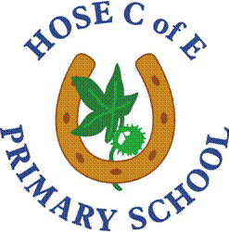

Please contact the School Office on 01949 860312 or email manager@hose.leics.sch.uk for an application pack. Please note that only applications submitted on the application form in the pack will be considered.

