

**Kempston Rural Primary School**

Head Teacher

Application Pack

Dear Applicant,

Thank you for applying for the for the position of Head Teacher at Kempston Rural Primary School. This is a full time, permanent post beginning in January 2025 or Easter 2025 for the right person.

Kempston Rural Primary School is a well-established two-form entry maintained school sitting on the outskirts of Kempston, Bedford. We enjoy a vibrant community of approximately 420 students, from Early Years Foundation Stage (EYFS) through to Year 6. We also operate a nurturing 24-place Pre-School for three-year-olds, contributing to our commitment to providing a strong foundation for lifelong learning. Our school is known for its happy and successful environment, dedicated to fostering the personal, social, and academic development of all our pupils. The successful candidate will take over from our current Head Teacher, who has dedicated 20 years to successfully leading the school and establishing a culture of exceptional behaviour and motivated learners; this was recognised in our latest Ofsted report, November 2023;

“Pupils behave exceptionally well, in and out of lessons. They are motivated and enthusiastic learners. Staff are ambitious for pupils’ academic achievement.”

We are rightly proud of all we have achieved to date and we look forward to continuing our journey with a new Head Teacher. Whether you are an aspiring or current Head Teacher, what matters to us is that you are a leader who is passionate about education, and that you have the capacity to inspire those around you. You must also be driven by a moral purpose to strive for outstanding outcomes for all students and wholly dedicated to the values, ethos and mission statement of our school.

Visits to our wonderful school are essential and appointments to be shown around by the current Head Teacher can be made by calling the school office, 01234 854286. Appointments can also be made via email, office@kempstonrural.co.uk. We look forward to meeting you and should you require any further information please do not hesitate to contact the school.

Yours sincerely

Mr. Neil Dodson

Chair of Governors

**Vacancy**

**Head Teacher – Full Time Permanent Position**

Starting date: January 2025 or Easter 2025

We are committed to safeguarding children and adopt safer recruitment procedures.

Posts are subject to enhanced DBS clearance.

Closing Date: Friday 11th October at 9.00am

Interview Date: Friday 18th October

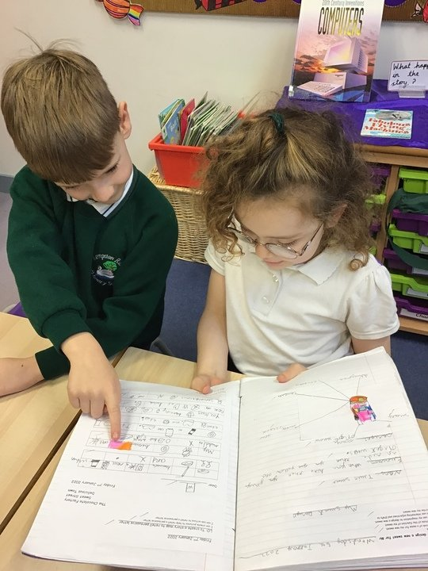

Included within this application pack:

* Background Information about our school
* Job description and personnel specification
* Selection Criteria

Full details and an application form, Declaration of criminal Record are on our website at [www.kempstonrural.co.uk](http://www.kempstonrural.co.uk) .

Please go to the ‘more’ tab along the top bar of the home webpage to access the ‘vacancies’ information.

**Contextual Information**

**School Site**

Kempston Rural School has a rich history that dates back to its establishment in 1844 at Church End, Kempston. In 2014, the school made a significant move to its current site, which was purpose-built to meet the evolving needs of its students. This modern facility not only reflects the commitment to providing high-quality education but also creates a vibrant and inviting atmosphere for learning. The building, now a decade old, has been exceptionally well cared for, showcasing the dedication of both staff and the community towards maintaining an inspiring environment.

Designed with the needs of its pupils in mind, the layout of the school promotes a dynamic learning experience. The bright interiors and thoughtfully planned spaces foster creativity and engagement, allowing students to thrive academically and socially. Beyond the classrooms, the outdoor facilities greatly enhance the educational experience. A large playground provides ample opportunities for physical activity and play, while the expansive playing field serves as a venue for various sports and outdoor events. The inclusion of a Multi-Use Games Area (MUGA) ensures that students can engage in diverse sporting activities. Furthermore, the small forest school area offers unique opportunities for exploration and connection with nature, enriching the curriculum and supporting holistic development. Overall, Kempston Rural School stands out as a vibrant hub of learning and growth, dedicated to nurturing every pupil's potential.

**Finances**

The school is financially secure. Last academic year we enhanced the Pre-School environment with a new outdoor covered learning space; there are interactive whiteboards in every classroom; in 2023 an extension to the building was completed providing a conference room, SEND breakout room, an office for our two SENDCo’s and an office for the Assistant Head Teachers alongside a music area. We are currently looking at replacing some of our pupil IT equipment and will be purchasing 30 Chromebooks to support the computing curriculum. The school is well equipped and teachers lack for nothing.

**The Staff**

Our staff of over 60 includes 5 senior leaders, (one DHT and three AST’s, one of whom is part time) teachers, teaching assistants, two-part time SENDCo’s, mid-day supervisors and site management team. We also have a dedicated office team of 3 who happily support the whole school environment.

There is currently a vacancy for a lower KS2 teacher and SEND TA’s, other than these vacancies, all posts are filled. We are rightly proud of our staff, they are excellent practitioners who work hard to ensure our pupils are provided with the best possible education and cultural experiences.

**Governance**

We are extremely fortunate to have a strong governing body of nine. Our Governors are totally committed to supporting the strategic direction of the school, to supporting the HT in their role and to ensuring that both financially and educationally the children have the best chances to achieve and be happy.

**The children**

We are extraordinarily proud of all the children that attend our school. Alongside the National Curriculum, we strive to provide additional opportunities for our children to prepare them not only for their next stage of learning, but also for life. We offer opportunities for leadership, participation in after school clubs, economy leader scheme ‘Kempston Coins’ and supporting the local community.

**Academic Achievement**

Kempston Rural data is consistently above national and LA data in all areas. The school website gives current information on achievement.

**Job Description**

Job Title: Head Teacher

Grade: Group 3 L11 - L18

Contract Type: Full time, permanent

Responsible to: Kempston Rural Primary School - Governing Body

Responsible for: All staff and pupils

**Main Purpose**

The Head Teacher will:

* Establish and sustain the school’s ethos and strategic direction together with the governing board and through consultation with the school community
* Establish and oversee systems, processes and policies so the school can operate effectively
* Identify problems and barriers to school effectiveness, and develop strategies for school improvement that are realistic, timely and suited to the school’s context
* Make sure these school improvement strategies are effectively implemented
* Monitor progress towards achieving the school’s aims and objectives
* Allocate financial resources appropriately, efficiently and effectively

**Qualities**

The Head Teacher will:

* Uphold public trust in school leadership and maintain high standards of ethics, behaviour and professional conduct
* Build positive and respectful relationships across the school community
* Serve in the best interests of the school’s pupils

**Duties and responsibilities**

**School culture and behaviour**

The Head Teacher will:

* Create a culture where pupils experience a positive and enriching school life
* Uphold ambitious educational standards in order to prepare pupils from all backgrounds for their next phase of education and life
* Ensure a culture of staff professionalism
* Encourage high standards of behaviour from pupils, built on rules and routines that are understood by staff and pupils, and clearly demonstrated by all adults in school
* Use consistent and fair approaches to managing behaviour, in line with the school’s behaviour policy

Teaching, curriculum and assessment

The Head Teacher will:

* Establish and sustain high-quality teaching across all subjects and phases, based on evidence
* Ensure teaching is underpinned by subject expertise
* Effectively use formative assessment to inform strategy and decisions
* Ensure the teaching of a broad, structured and coherent curriculum
* Establish curriculum leadership, including subject leaders with relevant expertise and access to professional networks and communities
* Use valid, reliable and proportionate approaches to assessing pupils’ knowledge and understanding of the curriculum
* Ensure the use of evidence-informed approaches to reading so that all pupils are taught to read

Additional and special educational needs (SEN) and disabilities

The Head Teacher will:

* Promote a culture and practices that enables all pupils to access the curriculum
* Have ambitious expectations for all pupils with SEN and disabilities
* Make sure the school works effectively with parents, carers and professionals to identify additional needs and provide support and adaptation where appropriate
* Make sure the school fulfils statutory duties regarding the [SEND Code of Practice](https://www.gov.uk/government/publications/send-code-of-practice-0-to-25).

Managing the school

The Head Teacher will:

* Ensure staff and pupils’ safety and welfare through effective approaches to safeguarding, as part of a duty of care
* Manage staff well with due attention to workload
* Be kind and considerate and be an advocate for staff wellbeing
* Ensure rigorous approaches to identifying, managing and mitigating risk

Professional development

The Head Teacher will:

* Ensure staff have access to appropriate, high standard professional development opportunities
* Keep up to date with developments in education
* Ensure training and continuing professional development is effectively planned, delivered and evaluated
* Make sure professional development opportunities draw on experts both within, and beyond the school
* Seek training and continuing professional development to meet the needs of all staff members

Governance, accountability and working in partnership

The Head Teacher will:

* Understand and welcome the role of effective governance, including accepting responsibility
* Ensure that staff understand their professional responsibilities and are held to account
* Ensure the school effectively and efficiently operates within the required regulatory frameworks and meets all statutory duties
* Work successfully with other schools and organisations
* Maintain working relationships with fellow professionals and colleagues to improve educational outcomes for all pupils

Please note that this is illustrative of the general nature and level of responsibility of the role. It is not a comprehensive list of all tasks that the Head Teacher will carry out. The post holder may be required to do other duties appropriate to the level of the role.

**Personal Specification**

|  |  |  |
| --- | --- | --- |
| Criteria | Qualities | Desirable |
| **Qualifications  and training** | * Qualified teacher status * Degree | NPQH – gained or in the process of gaining |
| **Experience** | * Successful leadership and management experience at senior level in a school * Teaching experience in KS1 and KS2 * Understanding of high-quality teaching based on evidence, and the ability to model this for others and support others to improve * Experience at having led at senior level * Evidence of developing effective strategies for school improvement |  |
| **Strategic Leadership** | * Ability to provide clear educational vision and direction * Ability to inspire and motivate all stakeholders * Evidence of developing effective strategies for school improvement | Working at a senior level in school improvement planning |
| **Leading Teaching and Learning** | * Successful experience of monitoring, evaluating and improving the quality of teaching and learning * Understanding the role and impact of assessment * Secure knowledge of statutory requirements relating to curriculum and assessment * Experience of leading curriculum innovation | NPQH in Teaching and Learning |
| **Leading and Managing Staff** | * Ability to lead, manage and motivate across the school community * Ability to establish positive working relationships * Ability to plan, allocate, delegate, support and evaluate work undertaken by individuals and teams * Successful experience of identifying the need for, and leading, in-service training | Significant experience of taking a lead role in performance management of staff including leading lesson observations |
| **Managing Resources** | * Ability to manage, monitor and review available resources, ensuring value for money | Successful experience of managing budgets |
| **Skills and knowledge** | * Data analysis skills, and the ability to use data to set targets and identify weaknesses * Understanding of school finances and financial management * Effective communication and interpersonal skills * Ability to communicate a vision and inspire others * Ability to build effective working relationships |  |
| **Personal qualities** | * Commitment to uphold the 7 principles of public life (the [Nolan principles](https://www.gov.uk/government/publications/the-7-principles-of-public-life)) at all times * High expectations of self and others * A commitment to getting the best outcomes for all pupils and promoting the ethos and values of the school * Ability to work under pressure and prioritise effectively * Ability to establish and maintain positive relationships, including with parents * Commitment to maintaining confidentiality at all times * Commitment to safeguarding and equality, ensuring that personal beliefs are not expressed in ways that exploit the position * Effective computing skills for both teaching and management * Ability to remain positive and enthusiastic, including when under pressure |  |