BLEAK HILL PRIMARY SCHOOL

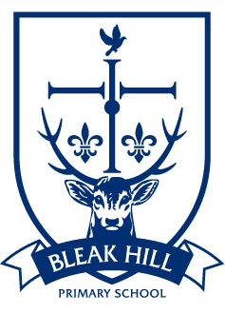
Head Teacher: Mr I Wellens B.Ed Hons, NPQH
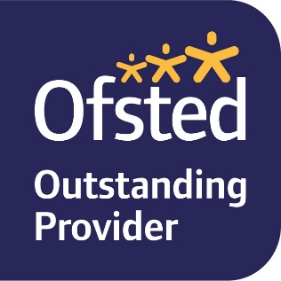
Email: bleakhill@sthelens.org.uk
Telephone: 01744 678190
Website: www.bleakhill.st-helens.sch.uk

Hamilton Road
Windle
St. Helens
WA10 6HG

February 2021

Letter to applicants for the post of Head Teacher

Dear Applicant
Thank you for your interest in the position of Head Teacher at our outstanding and growing school. As governors, we are incredibly proud of our school with its excellent team of committed leaders, teachers, support staff and its enthusiastic and caring children. This is a really exciting time in the history of the school as it was permanently changed to a three-form entry primary school, effective from September 2020. Consequently, our school population will continue to grow year on year for a further five years. To accommodate these increased numbers a two-phase building project commenced in 2019. Phase 1 has provided increased the hall/dining space, completed in summer 2020 and Phase 2 comprises a new extension of four classrooms which will house our EYFS provision and is due for completion at Easter 2021.
We are seeking to appoint a dynamic, inspirational and committed leader to work in partnership with our experienced and dedicated staff, to build on the school’s significant successes and drive the school forward. This will be a challenging and rewarding role for the successful candidate and governors are fully committed to providing the new Headteacher with all the support that he/she will need in taking up the post. We also encourage and support the take-up of opportunities for continuing professional development.
Due to the restrictions of Covid-19 we are unable to facilitate visits to the school at this time. However, our current Head Teacher, Mr Ian Wellens, is very happy to have a telephone conversation with potential candidates. If you would like to arrange a telephone conversation, please contact Mrs June Thow, School Business Manager, on 01744 678190 to book a mutually convenient time between Friday 26th February and Wednesday 3rd March 2021.
You can also learn more about our school from our website at www.bleakhill.st-helens.sch.uk
Our shortlisting will be based on the online application form and your accompanying written statement of no more than 1,300 words. The closing date for applications is Friday 5th March 2021 at 1pm. Interviews are scheduled for Tuesday 16th and Wednesday 17th March 2021. Further shortlisting of candidates may take place at the end of the 16th March.
On behalf of Governors, thank you again for your interest in this position. We look forward to receiving your application.
Yours faithfully
Diane Ross
Mrs Diane Ross
Chair of Governors

