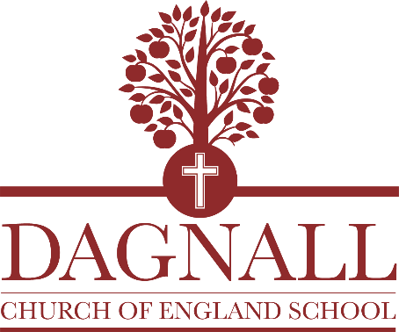

Dagnall VA Church of England School

JOB DESCRIPTION FOR HEADTEACHER

The School Teachers’ Pay and Conditions Document defines the role and professional responsibilities of the Headteacher. Within that framework, the Governing Body, the LEA and the Diocese are seeking to emphasise the following:

JOB PURPOSE

- to develop and manage the school effectively and efficiently, providing clear vision and positive, incisive and purposeful leadership and educational direction to the school

- to ensure the highest quality of education, range of educational opportunities and standards of attainment for all pupils

JOB SPECIFICATION

- to have commitment to upholding the Christian vision and values of the school

- to provide clear leadership, educational direction and professional guidance when working with Governors to develop and implement the agreed aims and policies

- to act as Designated Safeguarding Lead, to take lead responsibility in school for all Safeguarding & Child Protection issues as the highest priority and to ensure comprehensive records are maintained

- to lead and manage the school’s annual planning, monitoring, budgeting and evaluation procedures in partnership with the Governors

- to promote and champion inclusion and have a sound understanding of the barriers children face in their learning

- to be prepared to teach regularly in the classroom, according to the needs of the school

- to foster excellent practice and high standards across the full age and ability range

- to establish a positive ethos that reflects a commitment to high achievement, an effective learning environment, good relationships and equality of opportunity for all pupils; including the Rights of the Child

- to ensure the successful implementation of the National Curriculum, Foundation Stage and wider curriculum and local management of schools for the direct benefit of pupils and their learning

- to facilitate and initiate new ideas and encourage creative development of the curriculum and methodology

- to lead, co-ordinate and motivate the full school staff team, including volunteers, ensuring effective staff development and training, with opportunities for each individual’s personal and professional growth within the wider staff team

- to ensure the care, well-being and fulfillment of staff and pupils

- to promote the use of ICT to benefit pupils’ learning and support management systems

- to forge and develop supportive relationships and positive liaison with parents, church, the Diocese, the community, other schools, the Local Authority and the various services and agencies which support the school

- to ensure a safe, well maintained and attractive school environment

- to develop and maintain programmes of extra-curricular activities

- to ensure the school provides value for money in terms of educational standards achieved and the quality of education provided

September 2022

PERSON SPECIFICATION

 | Essential Attributes | Desirable Attributes
Professional Standards | First degree  Qualified Teacher Status  Evidence of further professional development  Clear DBS | Safer Recruitment Training  NPQH (for those new to Headship)
Philosophy & Commitment | Ability to uphold the Christian vision and values of the school  Clear and appropriate vision for the continued development of the school. | Personal commitment to the Christian faith  Growth Mindset
 | Ability to articulate a clear philosophy of Early Years and primary education and its development within the school. | Involvement in successful school improvement work.
 | Commitment to promoting equal opportunities and meeting the educational needs of all pupils. | Rights of the Child  Pupil Premium
 | Understanding of and experience with children with special educational needs and disabilities.  Commitment to ensuring the safeguarding of pupils | SENDCO training
 | Understanding of and commitment to: developing links between home, school, the church, the Diocese and the community. | Experiences of promoting home-school and other partnerships
 | Commitment to leading teams to ensure the highest standards of pupil achievement.
 | Commitment to publicising the development and achievements of the school.
 | Commitment to the highest standards, continuous improvement and quality assurance.
 | Commitment to putting pupil outcomes at the core of all aspects of leadership and management.
 | Demonstrate a full understanding of the EYFS and primary curriculum that provides a rich, balanced and coherent experience for all pupils.

PERSON SPECIFICATION (Continued)

 | Essential Attributes | Desirable Attributes
Personal Qualities | The ability to show inspirational leadership and excellent interpersonal skills  Demonstrate a sense of perspective and the ability to be reflective and identify areas for personal and professional development  Creativity combined with attention to detail  The ability to establish positive and productive working relationships with a wide range of people including pupils, parents, colleagues, governors, pre-school providers and people outside school  The ability to accept support from others and to ask for help | Evidence of  enthusiasm; flexibility; coolness under pressure; effective networking; being able to hold the wider perspective  and sense of humour
Professional Skills | Ability to establish, develop and promote a positive school ethos with an emphasis on high achievement for all  Ability to communicate the aims, objectives and values of the school to people within the community  Ability to communicate effectively, both orally and in writing, with a wide variety of people both inside and outside the school  Ability to empathise with children across the age range and wide ethnic background and to be firm, fair and consistent  Ability to set up effective teams and develop team approaches  Ability to be enhance existing strengths of the school while offering challenge to establish meaningful positive change  An understanding of the patterns of children’s learning  A competent user of ICT with a clear understanding of its use to aid and promote the quality of teaching and learning. | Experience of promoting the school with the community.

