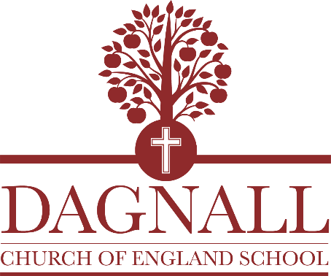

Head Teacher

Dagnall VA Church of England School
'Like trees, we grow and keep on bearing fruit.' Jeremiah 17:8
Overview
Our school is located in a Buckinghamshire village at the foot of the Chiltern Hills. We are a small Church of England primary school for 3-11 years with four mixed year classes.
The governors are eager to hear from candidates for the role of Headteacher to start from January 2023.
This is a permanent, full time post that includes a teaching commitment. Job-share would be considered.
Salary: Range L6-L11
Visits to the school are actively encouraged. Please contact Mrs Godbold on 01442 842473 to arrange a visit.

Applications: to be received by email to office@dagnall.bucks.sch.uk before 12pm, Monday 17th October

Interviews: will take place on Thursday 20th October.
About Us
Dagnall CofE School is a welcoming, friendly school which caters for girls and boys of primary age; we also offer nursery provision for children aged 3 by September of each year.

School numbers are currently 57 plus 3 in the Nursery. Our pupil admission number in each year group is 15.

The school has recently completed expansion to full primary school status having admitted Year 6 pupils for the first time this September. Our school serves Dagnall village but we have children from nearby towns and villages, families who want to take advantage of our small classes and our nurturing environment.
As a Church of England school, our Christian vision informs all that we do and we are looking for a leader who can promote our vision and help children grow spiritually and morally, as well as provide an excellent all-round education.
We received a ‘Good’ in our last Ofsted inspection in 2018 with ‘Outstanding’ for our Early Years provision. Our SIAMS inspection in the same year also found us to be ‘Good’.

We have a very experienced, hard-working staff team and a dedicated governing body. We are supported well by parents and the community and we have strong links with the church and village pre-school.

Contact details
Dagnall VA Church of England School
Main Road South
Dagnall
Berkhamsted
HP4 1QX
01442 842473
office@dagnall.bucks.sch.uk

Website: https://www.dagnall.bucks.sch.uk

