



Head Teacher Application Pack

for September 2024

|  |  |  |  |
| --- | --- | --- | --- |
| School visits | Closing Date | Shortlisting | Assessment and Interviews |
| Tue 13/2, Wed 14/2 (PM), Thur 15/2 (AM) Fri 16/2 | Friday 23rd February (Noon) | Wednesday 28th February 2024 | Wednesday 20th March 2024 Thursday 21st March 2024 |



**Contents**

**Letter from the Chairman of Governors Page 3**

**About our school Page 4**

**School values Page 5**

**School vision Page 6**

**Key facts and statistics Page 7**

**What our pupils say about the school Page 8**

**What our parents say about the school Page 9**

**What our staff say about the school Page 9**

**Job description/key responsibilities Pages 10 - 16**

**Person specification Pages 17 - 19**

**Completing your application Page 20**



**Welcome from the Chairman of Governors**Dear Colleague  
  
On behalf of the Board of Governors may I thank you for your interest in the role of headteacher at Gearies Primary School.  
  
Gearies Primary emerged from the amalgamation of the Infant and Junior Schools in 2013, and was awarded National Teaching School status the following year. In 2016 the School agreed to expand to four forms of entry, and this involved the on-site construction of a completely new classroom block, which accommodated its pupils for the first time in September 2019. There’s been a lot going on, but notwithstanding, Gearies was judged by Ofsted as being outstanding on each of its last two visits.  
  
Gearies recognizes the need to adapt its educational provision in order to meet the needs of children living in an international community. Our vision documents the key purpose of education for children in the modern world, expanding beyond our traditional focus on taught lessons, to include a wider range of essential functions such as safety, wellbeing and social justice, and which reflect our diverse community’s global heritage. We are committed to ensuring every child achieves their full potential in an inclusive, caring environment which embraces the individual needs of all our learners.  
  
On the retirement of our headteacher, we are seeking to appoint a leader who will lead by example and build on the excellent practice already existing at Gearies in shaping and promoting our vision and ethos. The Governors are fully committed to providing the new headteacher with the support they will need in taking us forward.   
  
Should you wish to visit the school, we would be delighted to see you and show you around, when you would be able to meet with our community.  
  
Again, many thanks for your interest!  
  
Yours sincerely  
John Pettifer  
Chairman of Governors

    



**About our school**  
"Gearies Primary is located close to Gants Hill roundabout in the outer London Borough of Redbridge.  It is a large, 4fe Primary school in an affluent neighbourhood, serving children with family roots in Asia, Europe and Africa.  Our diversity is a strength and the school is proud to serve this global majority community.

The school has a long tradition of high standards. Our pupils are noted for their good behaviour and academic success, which has been achieved through a close partnership between home and school. Our diverse community is reflected in the school’s curriculum, staffing and governance. It is important to us that each child is treated with equality and respect.

The school’s primary purpose is to meet the educational needs of the children who attend it. These are many and varied.  Educational research informs our teaching, for which we have an international reputation.  The experience of living through a global pandemic has sharpened the focus of the school to embrace clearer aims and priorities.  These are:

* The school is an agent of social change
* Our curriculum is exciting, relevant and challenging for all children, and reflects the global perspective of our local community
* All teaching is inspired, passionate and personalised to meet the needs of all children
* School leaders are well-informed, effective and passionate about their areas of responsibility

The children at Gearies are a credit to the community and are dear to us all.  We invest in their futures and relish the opportunity to serve a just society."

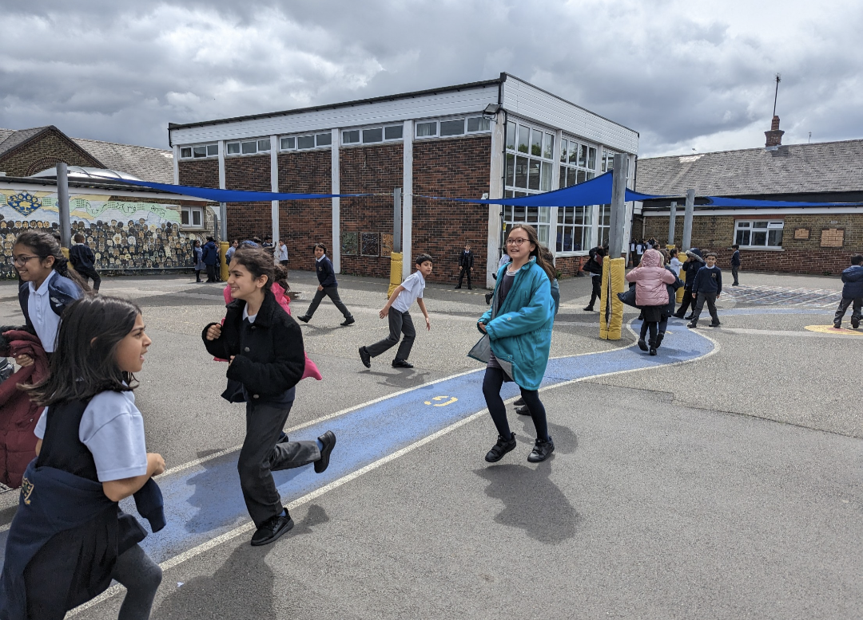



**Our School Values  
  
School Values:**

The following values are the focus in children’s learning each month:

1. Good manners: I say please and thank you

2. Co-operation: I get along well with others, share and take turns

3. Honesty: I tell the truth

4. Tolerance and respect for others: other people are just as important as me

5. Respect for property: I look after things in school

6. Friendship: I am a good friend

7. Self-control: I behave myself in school

8. Kindness: I say and do kind things

9. Courage and Independence: I try and persevere with new things and do things for myself

10. Being healthy: I look after and respect myself





**Our School Vision**

1. We intend our School will provide a happy, secure and stimulating learning environment where everyone will be inspired to do their best to achieve their potential. We will have high expectations for all.

2. We are committed to achieving the highest standards of teaching required for outstanding achievement and progress. We will support our staff in delivering this through continuous professional development, outstanding leadership, appropriate initiatives and the effective deployment of resources.

3. We are committed to safeguarding and well-being underpinning the processes of teaching and learning at our School.

4. We intend our School will provide a broad and balanced yet challenging curriculum for each subject and year group that is relevant to children’s interests and responsive to their learning needs. We recognise all pupils should access the content and make progress through the curriculum, and that they should understand the concepts and underlying principles on which the curriculum approach is based.

5.  We will encourage each child to be a confident, independent and well- rounded citizen who will be able to make a positive contribution to their own educational experiences at our School, to the community, and to the world around them.

6. We are committed to ensuring that every child achieves their full potential in an inclusive, caring environment, which respects our diverse, multi-ethnic community and the individual needs of all learners.

We intend that through processes of proper enquiry and feedback, we will monitor the impact of our strategic role.



**Key facts and statistics**

Type of School: Mixed community

Address: Waremead Road, Ilford Essex IG2 6TF

Telephone Number: 020 8550 1803

Email: [admin@geariesprimaryschool.co.uk](mailto:admin@geariesprimaryschool.co.uk)

Age Range: 3-11

Number on Roll: 905

Children with SEND: 88

Children on FSM: 93

Current Attendance (across the school): 94%



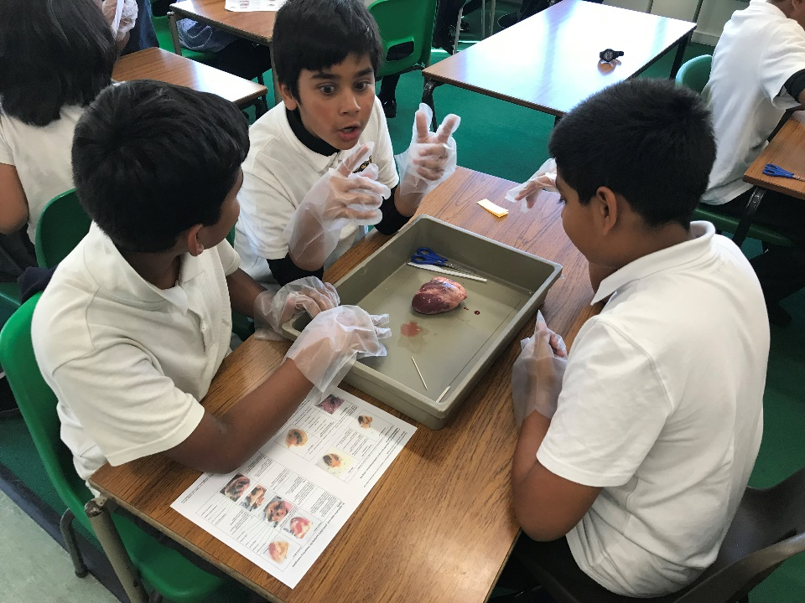



**What our pupils say about the school**  
  
“I love Gearies because it has many diverse backgrounds that children are able to interact with and learn from”. -Patrick 6D

“I really admire how Gearies puts a lot of effort in school trips, swimming lessons and competitions- Gearies is amazing!” -Alexandra 4B

“I think Gearies is a wonderful school because all the teachers are nice”- Inara 1D

“I like the fun lessons in school”- Issac 1B

“My favourite thing about Gearies Primary School is that the work my teacher gives is always challenging. This helps me to learn new things and I think it will help me to be successful when I am older. I have people around me to help me when I am stuck” - 2D child.

“It's a friendly, respectful school with fun learning. They care about us and protect us” - Zoriaz 3A

“I like Gearies Primary school because every staff are very supportive and they give us the rights to be treated equally” - Ishani 5C



  
**What our parents say about the school**

|  |
| --- |
| “The school supports my child well and helps to develop her, the SEND support is excellent”. |
|  |
| “Excellent school! The teachers are very helpful”. |
| “This is an amazing school with extraordinary staff. I am so happy that my child got admission in this school”. |
|  |
| “The support has been tremendous. They want EVERYONE to succeed”. |
| “I believe that school is best and handling each child with proper and personal attention. I am totally satisfied with the school” |
| “One of the best and outstanding schools in Redbridge”. |
| “No words to describe how amazing this school is. Cannot thank you all enough on behalf of child and us as parents. Thank you” |

**What our staff say about the school**

“I enjoy having fun with the children and seeing good progress”

“The school’s strengths include strong leadership, support for the Early Years and a very inclusive provision.  We have a reputation for very high standards of teaching, learning and behaviour”.

“I really enjoy working with children building relationships with them, making sure they are happy in school and making sure I am there for them. I enjoy supporting and working with children and teaching them new things”.

“I enjoy planning fun lessons and creating resources”.

“I enjoy seeing the children happy, learning, applying themselves, and developing relationship with colleagues”.

“The children always motivate me they are the reason I come into work and the reason I enjoy my job”.

“I am motivated here knowing that what I do makes a difference to the school, working as a team to achieve success together and ultimately for the children here”.



**Job description/Key responsibilities  
  
Main purpose of the role of Head Teacher  
  
Introduction**

Headteachers are leading professionals and role models for the communities they serve. Their leadership is a significant factor in ensuring high quality teaching and achievement in schools and a positive and enriching experience of education for pupils. Together with those responsible for governance, they are custodians of the nation’s schools.

Parents and the wider public rightly hold high expectations of headteachers, given their influential position leading the teaching profession and on the young people who are their responsibility. The headteachers’ standards set out how headteachers meet these high expectations. The standards are an important benchmark not only for headteachers and those who hold headteachers to account, but also for those who train and develop school leaders.

These standards replace the national standards of excellence for headteachers 2015. They are non-statutory and intended as guidance to be interpreted in the context of each individual headteacher and school. They are designed to be relevant to all headteachers.

**Duties and responsibilities**The Governors of Gearies Primary have used the domains and characteristics expected of all Head Teachers in the National Standards of Excellence for Head Teachers but adjusted them where required to reflect the context of our school.  
  
The standards can be used to:

* shape headteachers’ own practice and professional development, within and beyond the school
* support the recruitment and appointment of headteachers, including the development of job descriptions and person specifications
* underpin frameworks for the training of school leaders, including current and aspiring headteachers
* inform the performance management of headteachers

**Relationship to the teachers’ standards**The [teachers’ standards](https://www.gov.uk/government/publications/teachers-standards) (2011, as amended), including the personal and professional code of conduct which applies to teachers, provide a foundation upon which the standards for headteachers are built.  
  
Headteachers, like other teachers, are expected to meet the teachers’ standards. The headteachers’ standards articulate how headteachers can meet both the additional responsibilities of headship and the requirements of the teachers’ standards.

The first section of the headteachers’ standards outlines the ethics and professional conduct expected of headteachers. This is developed from part 2 of the teachers’ standards. As such, they consist of statements that define the behaviour and attitudes which should be expected of headteachers.  
  
  
The second section sets out 10 headteachers’ standards. The first 6 standards build on the teachers’ standards, whereas the other 4 standards focus on leadership responsibilities specific to headteachers. There is no hierarchy to the standards; the numbering below is only to aid identification.

1. School culture (builds on teachers’ standard 1)
2. Teaching (builds on teachers’ standards 2 and 4)
3. Curriculum and assessment (build on teachers’ standards 3 and 6)
4. Behaviour (builds on teachers’ standard 7)
5. Additional and special educational needs (builds on teachers’ standard 5)
6. Professional development (some match to teachers’ standard 4)
7. Organisational management
8. School improvement
9. Working in partnership
10. Governance and accountability

**Domains**The ethics and professional conduct section is at the core of the standards. This outlines the ethics and professional conduct expected of headteachers. It consists of statements that define the behaviour and attitudes which should be expected of headteachers.

The standards in section 2 cover interlinked domains of the headteacher’s role all underpinned by the governance and accountability domain.  
  
**Culture and ethos**

* teaching
* curriculum and assessment
* additional and special educational needs

**Curriculum and teaching**

* school culture
* behaviour
* professional development

**Organisational effectiveness**• organisational management

* school improvement
* working in partnership

**Section 1: Ethics and professional conduct**Headteachers are expected to demonstrate consistently high standards of principled and professional conduct. They are expected to meet the teachers’ standards and be responsible for providing the conditions in which teachers can fulfil them.

Headteachers uphold and demonstrate the [Seven Principles of Public Life](https://www.gov.uk/government/publications/the-7-principles-of-public-life) at all times. Known as the Nolan principles, these form the basis of the ethical standards expected of public office holders:

* selflessness
* integrity
* objectivity
* accountability
* openness
* honesty
* leadership

Headteachers uphold public trust in school leadership and maintain high standards of ethics and behaviour. Both within and outside school, headteachers:

* build relationships rooted in mutual respect, and at all times observe proper boundaries appropriate to their professional position
* show tolerance of and respect for the rights of others, recognising differences and respecting cultural diversity within contemporary Britain
* uphold fundamental British values, including democracy, the rule of law, individual liberty and mutual respect, and tolerance of those with different faiths and beliefs
* ensure that personal beliefs are not expressed in ways which exploit their position, pupils’ vulnerability or might lead pupils to break the law

As leaders of their school community and profession, headteachers:

* serve in the best interests of the school’s pupils
* conduct themselves in a manner compatible with their influential position in society by behaving ethically, fulfilling their professional responsibilities and modelling the behaviour of a good citizen
* uphold their obligation to give account and accept responsibility
* know, understand, and act within the statutory frameworks which set out their professional duties and responsibilities
* take responsibility for their own continued professional development, engaging critically with educational research
* make a positive contribution to the wider education system

**Section 2: Headteachers’ standards  
  
1. School culture**Headteachers:  
  
• establish and sustain the school’s ethos and strategic direction in   
 partnership with those responsible for governance and through   
 consultation with the school community

* create a culture where pupils experience a positive and enriching   
   school life
* uphold ambitious educational standards which prepare pupils for all   
   backgrounds for their next phase of education and life
* promote positive and respectful relationships across the school   
   community and a safe, orderly and inclusive environment

• ensure a culture of high staff professionalism  
  
**2. Teaching**Headteachers:  
  
• establish and sustain high quality, expert teaching across all subjects   
 and phases, built on and evidence informed understanding of effective teaching and   
 how pupils learn

* ensure teaching is underpinned by high levels of subject expertise and approaches   
   which respect the distinct nature of subject disciplines or specialist domains
* ensure effective use is made of formative assessment

**3. Curriculum and assessment**Headteachers:  
  
• ensure a broad, structured and coherent curriculum entitlement which   
 sets out the knowledge, skills and values that will be taught

* establish effective curricular leadership, developing subject leaders   
   with high levels of relevant expertise with access to professional   
   networks and communities
* ensure that all pupils are taught to read through the provision of   
   evidence-informed approaches to reading, particularly the use of   
   systematic synthetic phonics in schools that teach early reading
* ensure valid, reliable and proportionate approaches are used when   
   assessing pupils’ knowledge and understanding of the curriculum

**4. Behaviour**Headteachers:  
  
• establish and sustain high expectations of behaviour for all pupils, built   
 upon relationships, rules and routines, which are understood clearly by   
 all staff and pupils

* ensure high standards of pupil behaviour and courteous conduct in   
   accordance with the school’s behaviour policy
* implement consistent, fair and respectful approaches to managing   
   behaviour
* ensure that adults within the school model and teach the behaviour of   
   a good citizen  
    
  **5. Additional and special educational needs and disabilities**Headteachers:  
    
  • ensure the school holds ambitious expectations for all pupils with additional special educational needs and disabilities
* establish and sustain cultural and practices that enable pupils to access the   
   curriculum and learn effectively
* ensure the school works effectively in partnership with parents, carers and   
   professionals, to identify the additional needs and special educational needs and   
   disabilities of pupils, providing support and adaptation where appropriate
* ensure the school fulfils its statutory duties with regard to the SEND code of practice

**6. Professional development**Headteachers:  
  
• ensure staff have access to high-quality, sustained professional development   
 opportunities, aligned to balance the priorities of whole-school improvement, team   
 and individual needs

* prioritise the professional development of staff, ensuring effective planning, delivery and evaluation which is consistent with the approaches laid out in the standard for   
   teachers’ professional development
* ensure that professional development opportunities draw on expert provision from beyond the school, as well as within it, including nationally recognised career and professional frameworks and programmes to build capacity and support succession planning

**7. Organisational management**Headteachers:  
  
• ensure the protection and safety of pupils and staff through effective approaches to   
 safeguarding, as part of the duty of care

* prioritise and allocate financial resources appropriately, ensuring efficiency,   
   effectiveness and probity in the use of public funds
* ensure staff are deployed and managed well with due attention paid to workload
* establish and oversee systems, processes and policies that enable the school to   
   operate effectively and efficiently
* ensure rigorous approaches to identifying, managing and mitigating risk

**8. Continuous school improvement**Headteachers:  
  
• make use of effective and proportional processes of evaluation to identify and   
 analyse complex or persistent problems and barriers which limit school   
 effectiveness, and identify priority areas for improvement

* develop appropriate evidence-informed strategies for improvement as part of well-  
   targeted plans which are realistic, timely, appropriately sequenced and suited to the   
   school’s context
* ensure careful and effective implementation of improvement strategies, which lead   
   to sustained school improvement over time

**9. Working in partnership**Headteachers:

• forge constructive relationships beyond the school, working in partnership with   
 parents, carers and the local community

* Commit their school to work successfully with other schools and organisations in a   
   climate of mutual challenge and support
* establish and maintain working relationships with fellow professionals and   
   colleagues across other public services to improve educational outcomes for all   
   pupils

**10. Governance and accountability**

Headteachers:  
  
• Understand and welcome the role of effective governance, upholding their   
 obligation to give account and accept responsibility

* establish and sustain professional working relationship with those responsible for   
   governance
* ensure that staff know and understand their professional responsibilities and are held to account
* ensure the school effectively and efficiently operates within the required regulatory frameworks and meets all statutory duties

**How the standards apply to different leadership roles**The headteacher’s standards cover the full breadth of leadership responsibilities within a single school. For most headteachers in maintained schools or academies in single academy trusts this means that all of the standards should be relevant to them, though it is anticipated that they will meet some standards through the successful leadership and management of teams and individuals within their schools.

There can be a range of job roles and titles for those leading individual schools, particularly where a school is working within a group, such as in a multi-academy trust. Job roles and titles are various, including Head of School, and Associate Head, as are the governance arrangements to which headteachers are accountable. In some settings headteachers are responsible for leading more than one school. There are also instances of shared headship through co-headship or job-shares. Employers, in such instances, will therefore want to decide which standards are applicable to roles in these contexts.



**Person specification  
Criteria  
  
Key  
E = Essential  
D = Desirable  
A = Application  
I = Interview  
T= Task (on Assessment day)  
  
Education and Qualifications**

|  |  |  |
| --- | --- | --- |
| 1. Qualified Teacher Status and a minimum of 5 years’ experience as a Head teacher, Deputy Head teacher or Assistant Head teacher. 2. Evidence of recent continuous development including safeguarding. 3. Higher qualification in education and/or management. 4. National Professional Qualification for Headship (NPQH) (or working towards) or other evidence of postgraduate study relevant to the post. | E  E  D  D | A  A/I  A/I  A |

**Experience**

|  |  |  |
| --- | --- | --- |
| 1. Track record of effective leadership in senior roles, preferably Head  teacher, Deputy Head teacher or Assistant Head teacher in a primary school.  2. Experience of working in a school with a multi-ethnic, multi-faith community and socio-economic disadvantage.  3. Demonstrate success in building and leading teams.  4. Proven track record of improving outcomes for pupils and diminishing differences in attainment, including for SEND and disadvantaged Pupils.  5. A proven track record of improving quality of teaching.  6. Leadership of an area of the curriculum and knowledge of current curriculum initiatives and priorities.  7. Evidence of accurate school self-evaluation based on data analysis.  8. Evidence of effective and research-based school improvement strategies.  9. Use of performance management to secure accountability and improve performance.  10. The effective management of people and resources. | E  E  E  E  E  E  E  E  E  D | A/I  A/I  A/I  A/I  A/I  A/I  A/I/T  A/I  A/I  A/I |

**Leadership qualities**

|  |  |  |
| --- | --- | --- |
| 1. Vision, ambition and the ability to think and work strategically.  2. The ability to inspire, challenge, motivate and empower others.  3. The ability to delegate responsibility with accountability.  4. The ability to produce and implement school improvement planning and to evaluate their impact.  5. Demonstrate constantly adapting leadership styles in order to reshape resources so that an excellent education for children is maintained. | E  E  E  E  E | A/I  A/I  A/I  A/I  A/I |

**Skills and knowledge**

|  |  |  |
| --- | --- | --- |
| 1. Lead by example in promoting the school vision and ethos.  2. A belief in the importance of professional collaboration with others   within and beyond the school.  3. The statutory requirements and framework that should underpin the   leadership and management of a school, linked to the national policy in   a local context.  4. Knowledge of national trends that could impact in the school and an   understanding of the broader educational landscape.   5. Detailed knowledge of safeguarding practice and policy implementation.   6. Financial awareness and the ability to understand, plan and manage the   budget in the context of financial benchmarking and best value   principles.  7. Familiarity with disciplinary and capability HR procedures. | E  E  E  E  E  E  E | I  A/I  A/I  A/I  A/I  A/I/T  A/I |

**Communication and working with people**

|  |  |  |
| --- | --- | --- |
| 1. Developing and sustaining strong relationships, respect and credibility   with the governing board, pupil staff, parents, the wider community and   other stakeholders. | E | A/I |

**Personal leadership qualities**

|  |  |  |
| --- | --- | --- |
| 1. A commitment to inclusion and achievement for all.  2. Excellent interpersonal and communication skill.  3. Receptive to the support and challenge provided by governors and   colleagues.  4. A commitment to ongoing personal and professional development.  5. A commitment to ensuring a culture of work life balance and wellbeing   creating a collegiate atmosphere where all members of the school   community feel valued.  6. A passion for education and a commitment to equal opportunities. | E  E  E  E  E  E | A/I  A/I/T  A/I  A/I  A/I  A/I |



**Completing your application  
  
Application form**Using the standard application form provided (CVs are not accepted) please complete all aspects of the form fully. Include your full work history with no unexplained gaps since leaving school education. Include all the training you have completed, particularly those courses in recent years which have helped you for headship.

**Person specification and personal statement**When writing your response, it is really important that you address each of the requirements in the person specification. Ensure that you evidence additional aspects such as training; and qualifications; together with your background and experience, within the personal statement. You are to use no more than three pages of A4.  
  
**References**Please make sure your referees are aware of your application and that they are able to provide a swift turn round. Preferred referees are your last two employers and you should provide their official organisation email address for us to contact. One referee is likely to be your last Head Teacher or Chair of Governors.   
  
**Important dates and information  
Pay range Group 5 L25 (£88,890) – L31 (£101,349)** **(Outer   
 London Rate)**  
**Visit the school Tues 13/2, Wed 14/2 (PM), Thurs 15/2 (AM),   
 Fri 16/2**   
**Closing date Friday 23rd February 2024 (noon)**  
**Completed applications Karen Mount (KJM Governor Services)  
to be returned to** [**kmount4.317@lgflmail.org**](mailto:kmount4.317@lgflmail.org)  
  
**Shortlisting date Wednesday 28th February 2024  
  
Assessment & Interview Wednesday 20th March and Thursday 21st March   
 2024**   
**Start date September 2024**