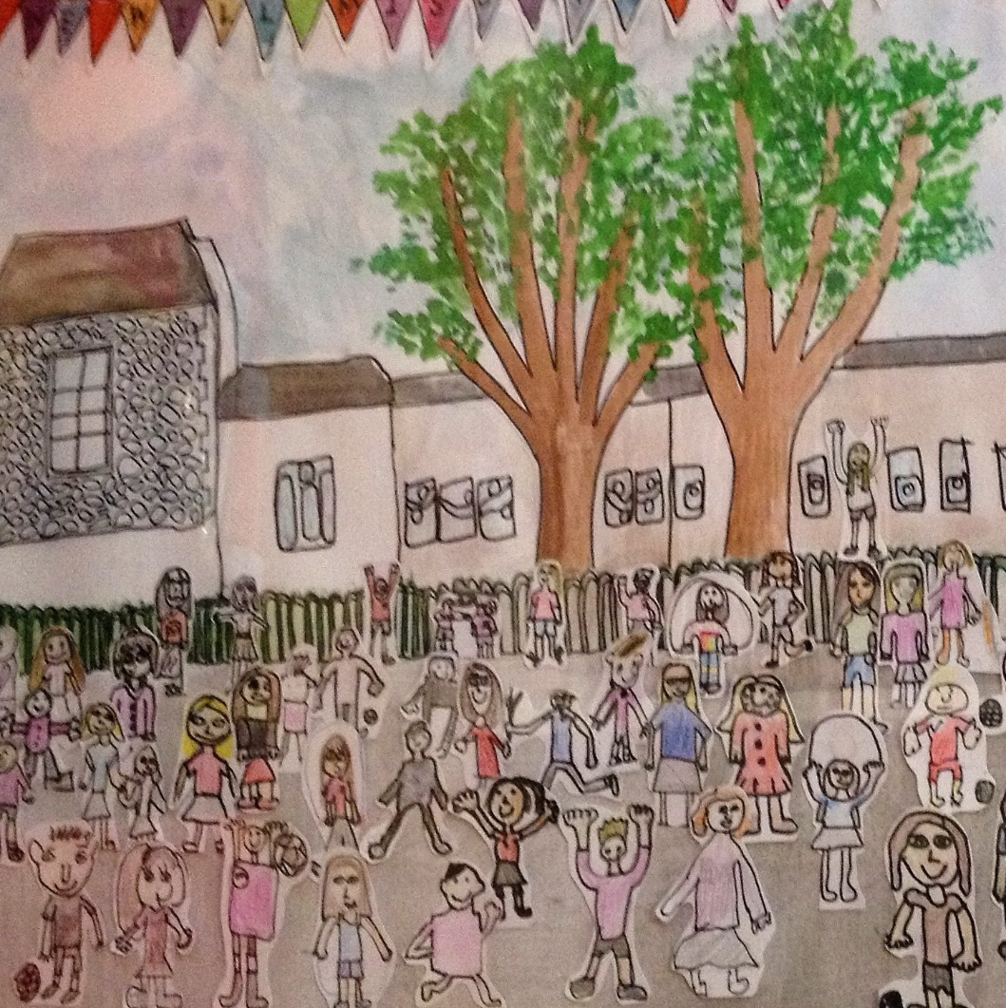

HEAD TEACHER APPLICATION PACK

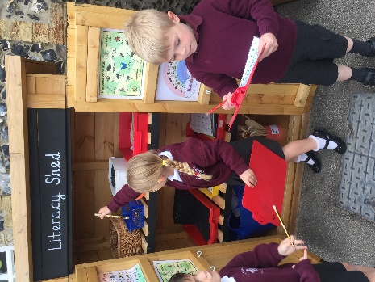
CONTENTS

Welcome from the Chair of Governors 3
Advertisement 4
The Diocese of Ely 5
Cambridgeshire Local Authority 6
Job description 7
Person specification 9
Head Teacher Qualities 12
Local area information 13
School information 14
The wider community 17
The Governing Body 18
School achievements 19
Employment Application Form 21

Welcome from the Chair of Governors

Thank you for your interest in the position of Head Teacher at Isleham Primary School.

The village of Isleham is on the Cambridgeshire/Suffolk border and the school serves a catchment area based on the village of Isleham and the neighbouring village of
Chippenham. We are a Voluntary Controlled Church of England school with a distinctive Christian ethos. We currently have 209 pupils on roll and are committed to ensuring that all our children enjoy learning within a caring and stimulating environment, where each individual is valued.

Having led us since 2016 our present Head Teacher will be leaving us to take on a new role in July. We are looking for an inspiring leader who will build on the work carried out by our present Head Teacher and teaching staff and bring a new perspective to our school. We wish to appoint a Head Teacher who will create an environment where both pupils and staff, can achieve their full potential. Your letter of application should address how you will endeavour to achieve this.

Our senior leadership team works alongside a talented group of colleagues and happy, enthusiastic, motivated children. They have established high expectations of staff and pupils alike, with a secure focus on raising standards and achieving their respective full potential in a safe, nurturing, and inspiring environment. They are supported in this by an informed and knowledgeable governing body who are actively involved in the school.

Isleham is a thriving and dynamic community, 7 and 24 miles respectively, from the historic and beautiful cities of Ely and Cambridge. The village has excellent amenities, including a Co-op supermarket and a new community centre. In addition to many local societies and clubs, we have three active Churches, a Post Office, several small shops and three public houses.

For more information about the school, and villages of Isleham and Chippenham please visit these websites:
http://www.isleham.cambs.sch.uk/website https://www.isleham-village.co.uk/

We plan to appoint our new Head Teacher for the autumn term 2022. The closing date for applications is 9.00 am on Wednesday 22 June 2022. Short-listing will take place on Monday 27 June 2022 and candidates will be contacted shortly afterwards. Interviews are scheduled for Monday 4 July and Tuesday 5 July.

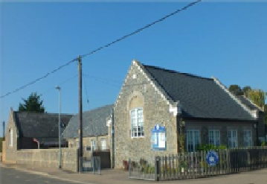
We hope the information in this pack encourages you to apply for this role. We are here to help you; if you need any more details, please feel free to contact Mrs Gill Dunbavin or Mrs Lisa Dennis in the school office for further information or to arrange a visit. We look forward to receiving your application.

All at Isleham Church of England primary school are committed to equality of opportunity and to safeguarding and promoting the welfare of our children.

Advertisement

Isleham Church of England Primary school is seeking to appoint an outstanding Head Teacher to lead our thriving village school from September 2022.
We are looking for someone who is passionate about children's learning and welfare, with proven leadership and management skills, and the ability to coach others and lead by example.
We are a friendly one form entry school set in the attractive village of Isleham, on the Cambridgeshire/Suffolk border, approximately 30 minutes away from Cambridge. We pride ourselves on providing our children with a broad curriculum with exciting challenges and opportunities for learning, both in and out of the classroom. The school has high expectations of itself and of the children and benefits from being at the heart of the village community, with supportive parents, staff, and governors.
We are seeking an individual who will support our vision for the school and enhance the already strong relationships with the local community. The successful candidate will be energetic and ambitious and will lead the school in its continuing improvement journey.
Visits warmly welcomed, please contact Mrs Gill Dunbavin or Mrs Lisa Dennis to arrange a mutually convenient time.
Application packs are available from EPM Ltd, email: headship@epm.co.uk or download from www.epm.co.uk. A completed application form and a covering letter should be sent directly to: headship@epm.co.uk.
The Closing date for applications is 9.00 am on Wednesday 22 June 2022
Interviews to be held on for Monday 4 July and Tuesday 5 July 2022
Salary Range: L12 to L18
We are committed to safeguarding and promoting the welfare of our children and expect all staff to share this. The successful candidate will be subject to an enhanced DBS disclosure.
ISLEHAM CHURCH OF ENGLAND PRIMARY SCHOOL
Malting Lane, Isleham, Cambridgeshire, CB7 5RZ.
Tel: 01638 780336
Email: office@isleham.cambs.sch.uk Website:
http:// www.isleham.cambs.sch.uk/website

The Diocese of Ely

The Diocese of Ely, centred on its magnificent cathedral, covers a diverse area of some 1,500 square miles. Its growing total population is more than 650,000 and there are over 300 parishes and 325 churches. The Diocese includes the Cambridgeshire fens, the western part of Norfolk, the southern part of Peterborough City, the communities either side of the A1 down to St Neots as well as the city of Cambridge and its surrounding villages.
Universal free education in England began when the Church of England introduced schools in every parish - more than 50 years before the provision of state education. Two hundred years later, church schools continue to serve their communities, are popular with parents and they provide an inclusive education with a strong Christian ethos. Both legally and historically, church schools, whatever their category, are bound to their diocese more fundamentally than to the political authority that ‘maintains’ them. The significance of this is increasing in present times as the school landscape changes rapidly. Church schools are committed to being distinctive and inclusive and rooted in the local communities they serve. They are community schools with Christian character serving those of all faiths or none according to the Church of England Vision for Education of ‘deeply Christian, serving the common good’.

There are more than 80 Church Schools in our diocesan family serving 15,000 pupils in Cambridgeshire, Norfolk and Peterborough, all but one in the primary sector. About one third currently are Voluntary Aided (VA), two thirds Voluntary Controlled (VC); half are academies (both stand alone and members of the Diocese of Ely MAT).
The Diocese of Ely offers support, training and resources including an annual conference, as well as a website presence www.elyeducation.org. A particular feature of our direct schools support is our team of experienced Ely Diocese Regional Advisers (EDRAs) who visit maintained schools on a termly basis, offering support and guidance for Headteachers. Additional bespoke support is offered for governors and staff for Section 48 inspection (SIAMS) and Religious Education. The Diocese of Ely does not operate a Service Level Agreement (SLA) system with its schools and therefore most services are provided at no cost to schools.
All church schools have a church presence on the governing body and are underpinned by the common Ethos Statement written into their constitution (‘Instrument of Government’).
Recognising its historic foundation, the school will preserve and develop its religious character in accordance with the principles of the Church of England and in partnership with the Church at parish and diocesan level. The school aims to serve its community by providing an education of the highest quality within the context of Christian belief and practice. It encourages an understanding of the meaning and significance of faith and promotes Christian values through the experience it offers to all its pupils.
The Diocese of Ely Education Team promotes close collaboration between local parishes and their church school to support with Christian character, collective worship, spirituality and governance.
We are delighted that you are interested in working with us in one of our Church schools and look forward to welcoming you to the Diocese of Ely family of schools.

Cambridgeshire Local Authority

Cambridgeshire is the fastest growing county in the country and one of the main economic drivers for the UK.
The 0-19 population of Cambridgeshire is expected to increase by 18.5% between 2016 and 2036, although not evenly across the county. Cambridge City is expected to grow by 12.3% over this period, while South Cambridgeshire is facing an increase of 29.4%.
There are around 137,800 children and young people under the age of 18 years living in the county, which represents 21% of the total population. The levels of free school meals is lower than the national averages. Nationally 14.5% of primary pupils and 13.2% of secondary pupils are eligible; across Cambridgeshire the levels are 9.8% and 8.3% respectively.
Children and young people of school age from minority ethnic groups account for 12.2% of primary pupils and 9.4% of secondary pupils - compared with 31.4% and 27.9% respectively for the country as a whole. Locally the largest minority ethnic group is Asian (3.8% of school-aged children). Travellers of Gypsy Roma and Irish heritage account for 0.7% of the school age population compared with a national average of 0.4%.
Cambridgeshire is a relatively prosperous county. Our children generally have above average health, educational attainment, and life chances. However, there are pockets within the county where deprivation levels exceed or equal the national average, particularly in parts of Wisbech, Huntingdon North and the northeast of Cambridge City. A particular feature of Cambridgeshire is that deprivation is spread widely across the county. 65% of children living in low-income families live in our more affluent areas.
Cambridgeshire County Council’s Equality Pledge
“We believe in the dignity of all people and their right to respect and equality of opportunity. We value the strength that comes with difference and the positive contribution that diversity brings to our community. Our aspiration is for Cambridge and the wider region to be safe, welcoming, and inclusive.”
Cambridgeshire County Council’s Equality Objectives
Promote equality and inclusion with our workforce
- Support employee and Member support networks
- Improve the diversity of our workforce to reflect the communities we serve
Promote and celebrate diversity across the Council
- Raise the profile of equality and diversity through communications campaigns

Job description

The Governing Body, the Local Authority and the Diocese of Ely believe that the Head Teacher of a Church of England School is fundamental to the happiness and spiritual growth of the children and the success of the school.
The Governing Body, Local Authority and the Diocese actively offer their support and encouragement to the Head Teacher, providing positive challenge as well as a committed partnership.
Details of the role and professional responsibilities of the Head Teacher are given in the DfE’s National Standards of Excellence for Head Teachers. While the Head Teacher is expected to meet those requirements the Governing Body and Diocese are looking for a Head Teacher who will regard the following as priorities in all their dealings with the school.

Leadership and Strategic Direction
Ensure that the school continues to reflect on and develop its vision and that this is clearly articulated. Ensure that the vision is accessible to all stakeholders, including children, parents and all staff and the wider village community, and that all actions by the school reinforce the central values identified in the vision.
Engage Governors and staff in development of the School’s Improvement Plan and ensure its implementation through continuing engagement, monitoring, and oversight of the staff. Be responsible for the School Improvement Plan becoming embedded in the ethos of the school and is reflected in all we do.
Develop, lead and work closely with a well-motivated, collaborative, and supportive staff team, whose talents are valued, shared, utilised, and celebrated for the benefit of the school as a whole. Lead by example in prioritising continual improvement in the standards of teaching offered to our children.
Lead the School in providing an excellent education, based on a strong Christian Ethos.

Learning and Teaching
Work with others to provide a safe, happy, and non-judgmental environment in which all learners may reach their potential.
Foster excellent practice and high expectations across the full range of ages and abilities.
Champion the recognition of additional needs and the timely involvement of external partners and the implementation of internal additional help, to ensure all children are helped to access the curriculum and reach their potential.
Make effective use of collection and monitoring of strategic data in a consistent format to inform development of the Improvement Plan, and to share with governors to enable consistent monitoring.
Ensure the successful implementation of the developing curriculum requirements through support of staff for the benefit of all learners. Encourage staff to be creative and innovative in their interpretation of the curriculum to inspire and enthuse children.

Job description cont.

Lead collective worship and, where appropriate, teach classes to support the learning of pupils and demonstrate your commitment to both the teaching and learning of the school. Teaching classes as a means of sharing best practice and modelling expected behaviours from colleagues.
Develop and maintain a strong programme of extra-curricular activities, making connections with local providers and helping the school benefit from the outreach activities offered locally.

Management and Accountability
Accurately and consistently evaluate the school’s performance, identify priorities, and means of improvement. Communicate the data obtained effectively and in a timely manner to Governors and the Diocese as appropriate.
Share the data with all staff as a means of identifying areas requiring improvement and to celebrate positive results. Use data as an opportunity to share good practice and explore ideas for improvement.
Lead and manage the annual planning, monitoring budgeting and evaluation procedures in partnership with Governors and Staff.
Ensure efficient day to day management of the school in conjunction with others.
Ensure that clear suitable and effective accountability procedures are in place. Use accountability procedures as appropriate to support the effective performance of the school.
Through robust performance management lead the school in improvement in the teaching and interventions offered.

Development
Encourage, support, and ensure effective staff development and training. Provide opportunities for the professional and personal growth of staff and facilitate the sharing of development and training for the overall benefit of the school.
Demonstrate commitment to your own development, both personal and professional. Share the development undertaken and the results achieved in order to inspire and lead by example.
Using the current development of and changes to the curriculum to encourage new ideas about the exploration and delivery of subject matter. Encourage the use of the curriculum as a starting point for continuous development of teaching and learning.
Use Information and Communications Technologies actively to support the school’s management systems, information sharing and communications both internally and externally.

Working with others
Nurture and further develop the strong relationships which exist with parents, Governors, the Diocese, the Local Authority, the wider community, and the agencies which support the school.
Actively engage with other schools to build effective learning communities, capitalising on the extensive networks already developed.
Represent the school positively at external events and meetings.

Person specification

This Governing Body, the Local Authority & Diocese are committed to safeguarding and promoting the welfare of children and young persons and Head Teachers must ensure that the highest priority is given to following the guidance and regulations to safeguard children and young people. The successful candidate will be required to undergo an Enhanced Disclosure from the Disclosure and Barring Service (DBS) and complete a Disqualification Declaration.

 | COMPETENCIES, KNOWLEDGE, QUALIFICATIONS
QUALIFICATIONS AND CPD RECORD | Essential:  - Qualified Teacher status and first degree (or equivalent, e.g., Cert Ed)  - Record of relevant CPD
EMPLOYMENT RECORD | Essential:  ▪ Successful recent track record of leadership in the primary sector
PERSONAL EFFECTIVENESS | - Ambitious for all our children  - Belief in the value of supporting all staff  - Stamina and energy to lead a busy school  - A drive to continue your own personal development  - Ability to identify and grapple with priority issues and be adaptable and responsive to circumstances.  - Consistency of judgement and inner integrity  - Outstanding interpersonal and communication skills (written and verbal)  - Resilience and determination  - The ability to innovate and implement new initiatives through to completion  - Strong problem-solving skills including evidence of having dealt successfully with a range of challenges  - Be committed to inspiring constant improvement of quality first teaching
LEADING AND MANAGING STAFF | - Proven leadership and impact at SLT, with experience of managing teams in differing circumstances.  - Ability to inspire high teaching standards and professional behaviour  - Experience of maintaining morale, addressing problems, and resolving conflict.  - Evidence of strong performance management of staff with robust leadership to ensure the highest standards become embedded in teaching  - Positive and approachable with a strong commitment to equal opportunities and high achievement by staff  - High-level understanding and implementation of management structures and systems, with appropriate delegation, monitoring, and enforcement of accountability
Person specification cont.
LEADER AND MANAGEMENT OF STUDENT/PUPIL ACHIEVEMENT, PROGRESS AND SAFETY | - Concerned about individual pupil needs; regards personal safety and achievement for each individual as the highest priorities  - Ability to inspire high levels of performance in pupils  - Understanding the needs of pupils with additional needs and a commitment to ensuring the best outcomes for all pupils  - Experience of identifying and applying for additional help for those children who need it  - The ability to analyse the complex issues relating to pupils’ attainment and progress and develop effective and creative responses  - Successful track record in managing and deep appreciation of monitoring and evaluation techniques of pupil progress, translating into detailed plans with specific measurable targets  - A commitment to supportive behaviour management and a positive attitude to modelling the behaviour we expect from our children  - Knowledge and experience of safeguarding pupils with current DSL qualification
LEADERSHIP AND MANAGEMENT OF THE CURRICULUM | - In depth of knowledge of the National Curriculum and sound experience of curriculum delivery, monitoring, and assessment  - The ability to analyse complex curriculum issues and develop effective and creative responses  - In-depth knowledge and understanding of current national and international curriculum thinking which informs school priorities and developments and against which the school’s progress can be mapped  - A vision for building on curriculum development work already in place with ambition to improve and extend it
MANAGING RESOURSES | - An understanding of the needs of the school against a backdrop of financial constraint  - The ability to solve resourcing problems creatively when necessary  - Evidence of the ability to analyse complex issues relating to finance and resources and a record of developing effective and creative responses  - Ability to plan strategically for future expenditure to ensure the best outcomes for all pupils
Person specification cont.
STAKEHOLDERS AND THE LOCAL COMMUNITY | - Effective communication with staff, parents, pupils, and governors  - Sensitivity to the school’s role within the community  - Knowledge and practice of effective governance, including recent experience of reporting to a governing body  - Willingness to engage with community and school groups and maintain existing relationships  - Evidence of the ability to establish a “standing” within the community and engagement with a wide variety of stakeholders  - Be sensitive of the need to value and further develop links with the parish church and the diocese
ACCOUNTABILITY AND GOVERNANCE | - Evidence of successful school self-evaluation and development planning, and a strong track record of implementing and managing the delivery of sustained improvement  - Willingness to engage in dialogue with governors and openness to challenge  - Understanding of the need for evidence-based reporting of results
TEACHING | - Substantial successful teaching experience in the age range
ETHOS | - Embrace and build upon the Christian ethos of our school

Head Teacher Qualities

Our Children would like a Head that:
- Is kind and caring
- Firm but fair
- A book lover
- Likes all subjects
- Funny with a good sense of humour
- Is a good teacher.
Our teachers would like our new Head Teacher to:
- Be approachable, fair, and understanding to all members of the school community
- Lead initiatives by example, with conviction, giving time and support for staff to embed properly
- Want the very best in every single child, giving everyone a chance to turn things around, holding no grudges
- Involve senior leaders in research and decision-making stages of any new direction to allow the SLT to promote it successfully with a united front
- Be organised with strong communication, including giving realistic time frames and as much notice as possible
- Prioritise the absolute best use of directed time and staff meeting time for maximum impact
- Have a good understanding of the SEN processes and want the best for children with SEN, promoting the best support in school for SEN children
- To be visible in the school and community, develop trust and create a sense of transparency and shared purpose with parents, staff, community members and pupils.
- To listen to the staff/child voice and make meaningful change to improve based on the perspectives of staff/children
- Give acknowledgement and recognition to staff and children when appropriate.
Our Support Staff are looking for a Head Teacher who:
- Is a good communicator
- Leads by example, occasionally teaching in the classroom
- Is consistent with discipline
- Is a people person
- Provides practical support to the TA team
- Has the confidence and conviction to stand up to scrutiny of their vision and strategy.

Local area information

The village of Isleham is on the Cambridgeshire/Suffolk border and the school serves a catchment area based on the village of Isleham and the neighbouring village of Chippenham. The majority of our Year 6 pupils progress to the catchment secondary school of Soham Village College.
Situated 30 minutes from Cambridge and 7 and 24 miles respectively from the historic and beautiful cities of Ely and Cambridge, Isleham is popular for commuters to Cambridge, London, and Norwich. The size of the village, however, means that there are a large number of local people who remain resident in the village; we are definitely not a ‘dormitory’ village and there is a lot going on during every weekday.
We have a population of approximately 2,500 in Isleham and 550 in Chippenham, and these support a large number of societies, clubs, and social events, as well as a wide choice of exercise classes and sporting opportunities. The Beeches, a multi-purpose sustainable community centre was opened in 2013, which is used daily by the local community for a wide range of events such as family fun days, farmers markets, exercise classes, local group meetings such as Scouts, Cubs and Beavers, tribute band nights and sportsman's dinners. The centre also serves as the sports pavilion for the fixture lists for football and cricket. In addition to the village community centre, football and cricket pitches, the recreation ground also hosts a multi-use games area, a skate park and a children’s play area. The annual village gala is a high point in the year, which starts with a parade of floats through the village streets, followed by displays, a small fun fair and friendly competitions, such as baking, vegetable growing, children’s races and novelty races on the recreation ground. All accompanied by stalls and refreshments provided by various organisations within the local community.
As well as the community centre we have a very busy Co-Op, a Post Office, Chinese take-away, Farm shop and a number of vegetable and fruit stalls. There are three public houses in the village, one of which is also a restaurant drawing diners from a wide area. As well as three public houses we also have three very active churches; the school’s link to St Andrews is important to every member of the school, and the children visit the church at regular points through the school year.
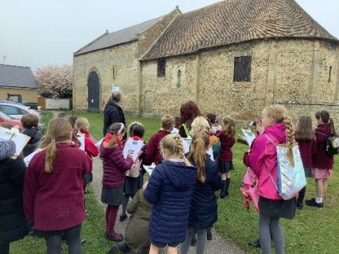
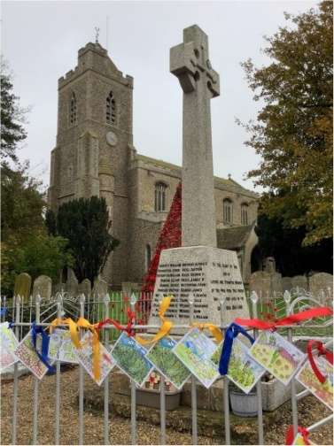
The school is at the heart of Isleham, and many pupils have parents and grandparents who attended when they were children. Every child is part of the wider community, and the community as a whole supports the school.

School information

Our school motto

“Let your Light Shine” (Matthew 5:16)
Here at Isleham Church of England Primary School we are committed to providing the highest quality education possible for all our pupils, regardless of race, class, gender, creed, ability, or disability. We aim to ensure that our children enjoy learning within a rigorous but caring environment where each individual is valued. Personal achievement and happiness are nurtured through a wide range of opportunities. We take pride in all we do and will do everything in our power to make your child’s time with us as successful as possible.

As a Church of England primary school, we:
- Value and respect every individual
- Challenge and support our learners
- Reward effort
- Enjoy learning
- Promote health, happiness, and wellbeing
- Share
- Provide a safe and caring environment
- Uphold Christian values

General Information
We are a one form entry primary school with approximately 209 pupils. We have a large site for a village school that includes a swimming pool, sports field, school hall, nature pond and vegetable patches. The school has access to a local wooded area which supports our Forest Schools programme. Reception Class have their own enclosed play area; in the main play area there are a range of activities to stimulate the children such as a climbing wall. The school offers a Breakfast Club to families from 07:45. There is an after-school club which is run by a not-for-profit independent provider JLR Play CIC.
Staff Structure Overview
Head Teacher Mrs Skillern | Deputy Head Teacher Mrs Deacon
Reception Class Miss Diplock & Ms Barnes-Weston
Year 1 Miss Simmons
Year 2 Miss Stanley
Year 3 Mr Walker
Year 4 Ms Bottomley & Ms Sassoli
Year 5 Mrs Stevens-Ward & Ms Eatock (Mrs Gibbs – maternity leave to July 2022)
Year 6 Mr Tull
SENCo Ms Sikyta & Mrs Deacon
School Administrator Mrs Dunbavin |  | Finance Manager Mrs Dennis
Senior Leadership Team: Mrs Gibbs, Ms Sassoli, Ms Sikyta, Mrs Skillern, Mrs Deacon, Mrs Dennis

School Council

We have a very active school council who meet every two weeks to come up with ideas to help improve our school and make sure everybody has a voice.

There are two elected representatives in each class.

Recent Projects: The school council have been helping to plan the charity events for the year ahead and produce artwork for the Church display board. The children have created a book all about our school to share with new pupils.

Clubs & Activities

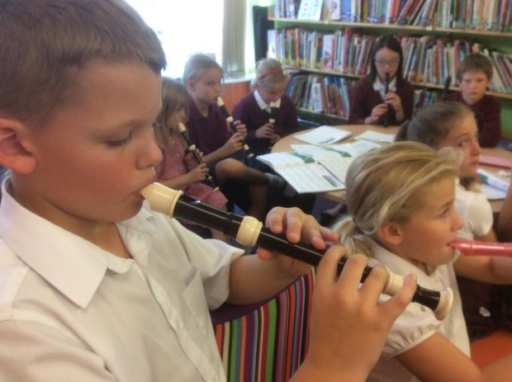
We offer a wealth of clubs and extra-curricular activities each term for the children to choose to attend free of charge from ICT to Chess, Cookery & Music Clubs.

All after-school clubs run until 4.15pm. Children can be collected from the playground at the end of their club/activity.

In addition to all of the above, children are able to sign up for brass, guitar or piano tuition with visiting specialist music teacher Mr Wright.

School Games & Sport at Isleham Primary

The children at Isleham C of E Primary School enjoy a wide variety of sporting activities. We offer at least 2 hours high quality physical education each week in addition to lunchtime and playtime or extra-curricular club opportunities. We promote a healthy and active lifestyle for all of our children.

We are fortunate to have a heated school pool on site, so that all of our children can enjoy weekly swimming lessons from April through to October each year.

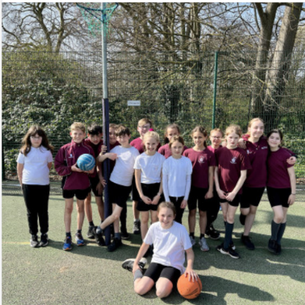
In addition, each class enjoys P.E. lessons in gymnastics and dance in the school hall each term, and games and ball skill lessons outdoors on the playing field, or in the playground on a weekly basis. We ensure children enjoy all elements of the P.E. curriculum, and benefit from specialist sports staff leading lessons at Key Stage 2, as well as offering some exciting after-school clubs and lunchtimes.

Children compete in local tournaments, matches and sporting events with neighbouring schools, including in football, multi-skills, cross country, and cricket. Many are run by the Witchford Schools Sports Partnership.

Our playground and field are well equipped for active playtimes too with a climbing wall and playframe, and plenty of space to run; there are organised activities at lunchtimes by our sports specialist coach and our trained group of pupil play leaders.

The School Games are inclusive to all young people and provides opportunities for everyone to get involved, either within school, against other local schools, or at county or regional level. Some events also act as pathway events to further competition in the future.

See our Sport Premium web page for details of how the Sport Premium grant is used at Isleham Primary School to support school sport and promote physical activity and healthy lifestyles: http://www.isleham.cambs.sch.uk/website/sport_premium/74657

School Dinners

School meals are provided by Cambridge-based specialist schools caterer; The Lunchtime Company (www.lunchtime.co.uk). The Lunchtime Company provides delicious, nutritious, healthy meals to the pupils at Isleham C of E Primary School. Their aim is to help children gain a real appreciation for good quality food, where it comes from, how it is produced and why healthy food is important.

We believe that Lunchtime should be the highlight of the day for everyone at Isleham Church of England Primary School. We want to help children gain a real appreciation for good quality food, where it comes from, how it’s produced and why healthy food is important.

Together we offer children a wonderful choice of hot food, fresh vegetables, freshly baked bread, fresh fruit, yogurt, jacket potatoes… there really is something for everyone.

All meals are cooked from fresh ingredients every day, sourced locally (where possible within a 60-mile radius of the school), and prepared on-site.

Over the course of the academic year, we provide an array of theme days, activities, cookery classes and charity events.

School Website
Our School Website is regularly updated, where you can see what each class is learning this term, find out more about the school council, about the wider community and a wealth of information.
http://www.isleham.cambs.sch.uk/website

The wider community
Volunteers
We welcome the involvement of volunteers in school, and we value the many skills that they bring with them. Volunteers support school trips and visits, help with specific events such as visits to the local woodlands for 'forest schools' experiences or offer help in the classroom.
PTA
One of our school’s key strengths is the well supported Parent & Teacher Association. The committee is made up of parents and carers & staff members whose primary aim is to raise money for the school, and offer additional events, resources, and experiences for both children, staff, and parents. The PTA raise funds for the running of the general upkeep and running costs of school swimming pool, and through these funds help to open the school pool in term-time and the school holidays for families at a minimal cost per family. In the 2020-21 academic year, despite the pandemic, the PTA provided over £6,000, and within the past 5 years have helped to fund significant projects such as the purchase of new playground markings, PA equipment, benches, and smartboards alongside the Co-op community fund, and Isleham charities partnership (see below).
Isleham Charities partnership
As the sole school in Isleham, the primary school has been generously supported by the local Isleham Charities partnership each year, which ensures that funds are available for exciting opportunities such as brass & ukulele lessons for whole classes and the purchase of instruments, and that all children can be supported to attend residential visits and school trips in cases of financial hardship. Rugs have also been purchased for classrooms and structures for the development of the outside reflections area at the school.
Community Groups
There are a variety of wider community groups that we are involved with, such as:- the Soham Cluster of schools (including Fordham, St Andrew's, Kennett, The Shade and The Weatherall’s), Circle Schools, Isleham 'Under Fives' Pre-School (which is located on site but run by separate management), Locality parenting classes, Witchford Sports Partnership, St Andrew’s Church, The Ark Church and Pound Lane Free Church & The Beeches social centre. The Head Teacher is also included in all Cambridgeshire local authority Head Teacher meetings and correspondence, and as a Church of England (VC) school, in all updates and support from the Ely Diocese Education board. The school has a dedicated school improvement advisor provided by the local authority and Ely Diocesan Regional Advisor who provide support and guidance to the Head Teacher, governors and staff team.

The Governing Body

As Head Teacher of Isleham Church of England Primary School you will be fully supported by an experienced, involved, and cooperative governing body. Our full governing body is 14 strong comprising:
- 2 Parent Governors
- 1 Local Authority Governor
- 1 Staff Governor
- 3 Foundation Governors
- The Head Teacher
- 6 co-opted governors

The full governing body form the sub-committees that enable us to focus on the key areas of pupil welfare and improving educational standards. A number of these committees meet termly; Health and Safety, Performance and Standards, and the Resources Committee, with the remainder being convened as required; Appeals, Complaints, Pupil Discipline, Staff Dismissal, Staff Grievance, Salary Review, Salary Appeals, and Head Teacher Performance Management. Representatives of the Governing body also attend the Local Authority termly briefings summarising and reporting back to the full governing body. Governors undertake regular training and play an active role in visiting the school to carry out learning walks and meet with staff and children
Our Governors bring experience to the school from the education, legal, training, medical pharmaceutical, construction, and finance fields.
More information about our governors can be found on the school website at
https://www.isleham.cambs.sch.uk/web/governors/74693

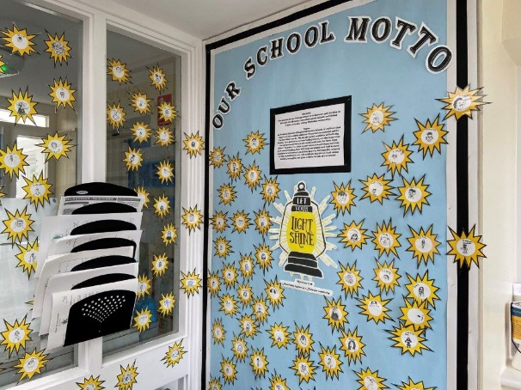

School achievements

The school is proud of the achievements of all its pupils who 'work hard in their lessons' as identified by OFSTED in their January 2022 inspection of the school.

The first paragraphs of the OFSTED report from the 12th and 13th January really sums up our school and its pupils, staff, and parents - there is a strong family focus.

Pupils enjoy attending this happy and welcoming school. They say, ‘Everyone makes friends easily here.’ Pupils enjoy positive and warm relationships with adults. This helps to create a caring environment where pupils feel safe. Pupils respond well to the school’s Christian values. They are confident and get on well together.

Leaders have high expectations, ensuring that pupils do well at school. Nurturing pupils’ talents and developing their interests are important. Pupils take part in a range of activities, such as learning to play the recorder or a brass instrument. Pupils have every opportunity to live the school motto ‘Let your light shine’.
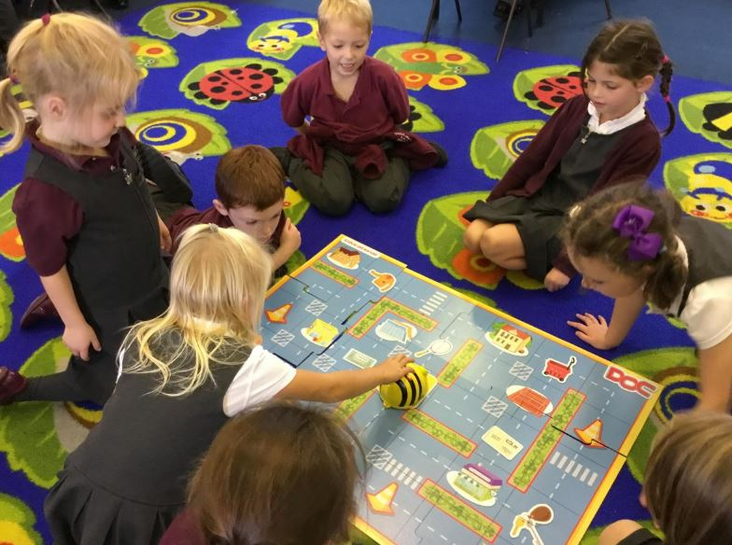
Pupils work hard in their lessons. They enjoy learning because teachers make it fun. They listen to what adults tell them and take pride in their work. Pupils understand the different forms bullying can take. They say that it is rare in their school. Pupils are reflective about their behaviour. They look for ways to make things better by being kind and considerate to everyone. Parents are happy. One parent, echoing the views of others, simply said, ‘Just an amazing school.’

Performance Data Commentary
As a one-form entry school, performance data differs from year to year based on the individuals in each cohort. The chart overleaf shows that some year groups have significant numbers of pupils with recognised special educational needs (SEN) or an Educational Health & Care Plan (EHCP) in place for whom performance and progress is not always shown well in national tests. However, these children are well catered for through careful planning by the school's class teachers and SENCo, as well as an experienced and dedicated team of learning support assistants providing cover for each class across the school day and working week.

Despite higher than national average SEN figures, progress data remains high across all ability levels, and in each cohort, able pupils are stretched and challenge to achieve mastery and greater depth levels in their learning, as shown in the 2022 predictions below.

SEN figures (April 2022)

 | R | 1 | 2 | 3 | 4 | 5 | 6 | Totals
Statements/EHCP | 1 |  |  | 1 | 3 | 2 | 2 | 9
Additional needs support | 4 | 4 | 7 | 8 | 5 | 5 | 7 | 40
Total | 5 | 4 | 7 | 9 | 8 | 7 | 9 | 49

School Data Summary- April 2022
Year Group | No. of Pupils | Boys | Girls | Pupil Premium | Free School Meals
R | 31 | 14 (45.2%) | 17 (54.8%) | 3 (9.7%) | 3 (9.7%)
Y1 | 26 | 13 (50.0%) | 13 (50.0%) | 5 (19.2%) | 4 (15.4%)
Y2 | 30 | 16 (53.3%) | 14 (46.7%) | 1 (3.3%) | 1 (3.3%)
Y3 | 31 | 18 (58.1%) | 13 (41.9%) | 6 (19.4%) | 4 (12.9%)
Y4 | 32 | 15 (46.9% | 17 (53.1%) | 7 (21.9%) | 4 (12.5%)
Y5 | 29 | 8 (27.6%) | 21 (72.4%) | 10 (34.5%) | 9 (31.0%)
Y6 | 30 | 13 (43.4%) | 17 (56.7%) | 9 (30.0%) | 7 (23.3%)
ALL | 209 | 97 (46.4%) | 112 (53.6%) | 41 (19.6%) | 32 (15.3%)

Performance data predictions 2022

Year 2- Key Stage 1 Summer 2022 (30 pupils)
 | Number of SEN children | Number of pupils consistently working at Greater Depth | Predicted %  National Standard+
Reading | 7 | 3 | 70
Writing | 7 | 2 | 63
Maths | 7 | 2 | 67

Year 6- Key Stage 2 Summer 2022 (30 pupils)
 | Number of  SEN children | Number of pupils consistently  working at Greater Depth | Predicted %  National Standard+
Reading | 9 | 9 | 67
Writing | 9 | 4 | 60
Maths | 9 | 5 | 70
SPAG | 9 | 6 | 63
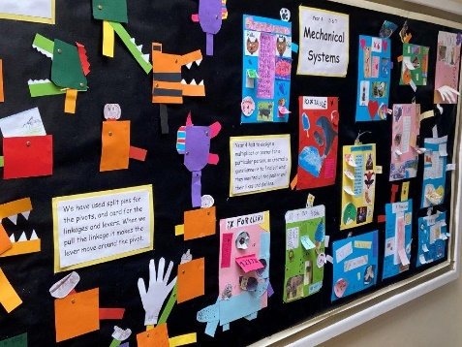
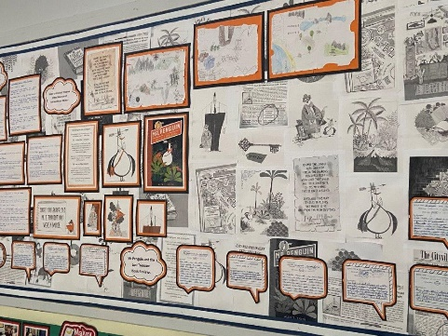

Internal use only
Reference no:
Date received:

Employment Application Form: Head Teacher
We are committed to safeguarding and promoting the welfare of children and young people and expect all staff and volunteers to share this commitment.
Please ensure that you complete all sections of Part 1 and Part 2 of the application. Please note that providing false information will result in the application being rejected, withdrawal of any offer of employment, summary dismissal if you are in post and possible referral to the police. Please note that checks may be carried out to verify the contents of your application form. Please complete the form in black ink or type. CVs are not accepted.
Vacancy Job Title | a

Part 1: Information for Shortlisting and Interviewing

Initials: Surname or Family Name:
- Letter of Application
Please enclose a letter of application. Please refer to the applicant information pack which may include instructions on how to complete the letter of application.
- Current/Most Recent Employment: If Teaching
Name, address and telephone number of school:
Type of school: | Boys: ☐ Girls: ☐ Mixed: ☐  Age range: Number on Roll:
Type of school:
(E.g. Community, Aided, Academy, Foundation, Free School, Independent, etc.)
Job title:
Please enclose a copy of the job description
Subjects/age groups taught:
Date appointed to this post:
Salary:
Date available to begin new job:
- Current/Most Recent Employment: If Non-Teaching
Name, address and telephone number of employer:
Job title:
Please enclose a copy of your current job description
Date appointed to this post:
Salary:
Date available to begin new job:
- Full Chronological History
Please provide a full history in date order, most recent first, since leaving secondary education, including periods of any post-secondary education/training, and part-time and voluntary work as well as full-time employment, with start and end dates, explanations for periods not in employment or education/training, and reasons for leaving employment.
Job title or position | Name and address of school, other employer, or description of activity | Number on roll and type of school, if applicable | Full or part-time | Dates (DD/MM/YYYY) |  | Reason for  leaving
 |  |  |  | From | To

Please enclose a continuation sheet if necessary.
- Secondary Education and Qualifications
Examinations passed | From | To | Examination passed (i.e. A-Level, GCSE), subject and grade
‘A’ level or equivalent
Other (please specify)
- Higher Education
Name and address of university, college and/or university education department | Dates |  | Full or part-time | Courses/subjects taken and passed | Date of examination and qualifications obtained | Age groups for which trained
 | From | To

- Professional Courses Attended and/or Delivered
Please list relevant courses attended/delivered in the past 3 years.
Subject and organising body | Trainer or trainee | Date(s) | Duration

- National Professional Qualification for Headship (Please give details)
From 8th February 2012 the NPQH became optional for an appointment as a Head Teacher in a school. Nevertheless, prospective employers are entitled to prefer candidates with NPQH.

- Other Relevant Experience, Interests and Skills

- Referees
Please provide details of two people to whom reference may be made. The first referee should normally be your present or most recent Head Teacher or equivalent person. In the case of serving Head Teachers this may be the Director of Children’s Services, Chair of Governors, or Trustees. If you are not currently working with children, please provide a referee from your most recent employment involving children. Referees will be asked about all disciplinary offences which may include those where the penalty is “time expired” if related to children. Referees will also be asked whether you have been the subject of any child protection concerns, and if so, the outcome of any enquiry. References will not be accepted from relatives or people writing solely in the capacity of friends.
It is normal practice to take up references on shortlisted candidates prior to interview. This is in line with the most recent version of Keeping Children Safe in Education statutory guidance.
First Referee
Title and name:
Address and postcode:
Telephone number:
Email address:
Job title:
Relationship to applicant:

I consent to this reference being requested before interview.
Yes: ☐ No: ☐

Second Referee
Title and name:
Address and postcode:
Telephone number:
Email address:
Job title:
Relationship to applicant:

I consent to this reference being requested before interview.
Yes: ☐ No: ☐

- Reference Declaration
In compliance with the General Data Protection Regulation (GDPR), we would like to ensure that you are aware of the data we will collect and process when requesting your references.
Reference requests sent to your referees will ask the referee to confirm as a minimum:
- The referee’s relationship with the candidate
- Details of the applicant’s current post and salary
- Performance history
- All formal time-limited capability warnings which have not passed the expiration date
- All formal time-limited disciplinary warnings where not relating to safeguarding concerns which have not passed the expiration date
- All disciplinary action where the penalty is “time expired” and relate to safeguarding concerns
- Details of any child protection concerns, and if so, the outcome of any enquiry
- Whether the referee has any reservations as to the candidate’s suitability to work with children. If so, the school will ask for specific details of the concerns and the reasons why the referee believes the candidate may be unsuitable to work with children
By signing the below, I consent to my named referees being contacted in accordance with the above.
Sign:
Print:
Date:
You have the right to withdraw your consent at any time and can do so by informing our organisation’s Data Protection Officer that you wish to withdraw your consent.

THIS PAGE IS INTENTIONALLY BLANK

Part 2 Internal Ref. No.

This section will be separated from Part 1 on receipt. Relevant responses may be verified prior to shortlisting and/or used for administration purposes but will not then be used for selection purposes.
- Personal Information
Surname or family name:
Previous surname(s)
Forenames:
Title:
Current address:

Postcode:
Home telephone number:
Mobile telephone number:
National insurance number
Email address:
DfE reference number:
Do you have a current full clean driving licence?  Only applicable for posts that require driving | Yes: ☐ No: ☐ N/A: ☐
Do you require sponsorship (previously a work permit)? | Yes: ☐ No: ☐  If YES please provide details under separate cover.
- Compulsory Declaration of any Convictions, Cautions or Reprimands, Warnings or Bind-overs
It is the school’s policy to require all applicants for employment to disclose convictions or cautions (excluding youth cautions, reprimands or warnings) that are not ‘protected’ as defined by the Ministry of Justice.
In addition, the job you are applying for is exempt from the provisions of the Rehabilitation of Offenders Act 1974 (Exceptions) Order 1975 (2013 and 2020) which requires you to disclose all spent convictions and cautions except those which are ‘protected’ under Police Act 1997 – Part V and the amendments to the Exceptions Order 1975 (2013 and 2020) and are not subject to disclosure to employers on DBS certificates and cannot be taken into account.
If you are invited to interview you will be required to complete a “Disclosure of Criminal Record” form and bring the completed form to interview.
In accordance with the provisions of The Childcare Act 2006 and The Childcare (Disqualification) Regulations 2009 and Childcare (Early Years Provision Free of Charge) (Extended Entitlement) (Amendment) Regulations

2018, there is a requirement on some staff in educational settings to disclose relevant information. This requirement will apply to your application if the post you are applying for is in an Early Years setting with children (from birth until 1 September following a child’s fifth birthday) or Later Years childcare (children above reception age but who have not attained the age of 8) in nursery, primary or secondary school settings, or if you are directly concerned with the management of such childcare.
The information you give will be treated as strictly confidential. Disclosure of a conviction, caution, bind-over order, warning, or reprimand will not automatically disqualify you from consideration. Any offence will only be taken into consideration if it is one which would make you unsuitable for the type of work you are applying for. However, offences relating to children may make you unsuitable since this is a “regulated position” under the Criminal Justice & Courts Services Act 2000.
- Prohibition from Teaching
In accordance with the requirements of The School Staffing (England) (Amendment) Regulations 2013, any future appointment is subject to a check with the Department for Education to ensure that you are not subject to a prohibition order or an interim prohibition order.
- Data Protection – Data Protection Act 2018 and General Data Protection Regulation 2018 (GDPR)
In compliance with the Data Protection Act 2018 and GDPR, we would like to inform you of the purpose for which we are processing the data we have asked you to provide on this application form. Further information is available in our Privacy Notice and Data Retention Policy which can be found on our website.
The person responsible for Data Protection in our organisation is Mrs Lisa Dennis and you can contact them with any questions relating to our handling of your data. You can contact them via email at: finance@isleham.cambs.sch.uk
The information you have provided on this form will be retained in accordance with our data retention policy.
To read about your individual rights and/or to complain about how we have collected and processed the information you have provided on this form, you can contact our Data Protection Officer. If you are unhappy with how your query has been handled, you can contact the Information Commissioners Office via their website.
This form will be kept strictly confidential but may be photocopied and may be transmitted electronically for use by those entitled to see the information as part of the recruitment process.
- Notes
(a) Under the Criminal Justice & Courts Services Act 2000 it is an offence for an individual who has been disqualified from working with children to knowingly apply for, offer to do, accept, or do any work in a ‘regulated position’. The position you are applying for is a “regulated position”.
(b) Canvassing, directly or indirectly, an employee or governor will disqualify the application.
(c) Candidates recommended for appointment will be required to provide a satisfactory Enhanced DBS certificate and complete a pre-employment medical questionnaire and may be required to undergo a medical examination.
(d) This organisation is under a duty to protect the public funds it administers, and to this end may use the information you may provide as part of the recruitment process for the prevention and detection of fraud. It may also share this information with statutory bodies responsible for auditing or administering public funds for these purposes.

- Declaration
I certify that, to the best of my knowledge and belief, all particulars included in my application are correct. I understand and accept that providing false information will result in my application being rejected or withdrawal of any offer of employment, or summary dismissal if I am in the post, and possible referral to the police. I understand and accept that the information I have provided may be used in accordance with paragraph 14 above, and in particular that checks may be carried out to verify the contents of my application form.

Signature of applicant:
Print name:
Date:

THIS PAGE IS INTENTIONALLY BLANK

Part 3: Equality and Diversity Monitoring
This section will be separated from Part 1 and Part 2. Collection of equality information is solely for monitoring purposes to ensure that our policies and procedures are effective. We also collect this data in accordance with the general and specific public sector equality duties under the Equality Act 2010. Any data you enter onto this monitoring form will only be used for monitoring purposes and will not be used in assessing and or scoring your application or during the interview process. This information is kept confidentially, and access is strictly limited in accordance with the General Data Protection Regulation 2018 (GDPR), as outlined in section 15.
Ethnicity | Workforce census code |  | Please tick
White | WBRI | British English Welsh Northern Irish Scottish
 | WIRI | Irish
 | WIRT | Traveller of Irish Heritage
 | WROM | Gypsy / Roma
 | WOTH | Any other White background
Mixed | MWBC | White and Black Caribbean
 | MWBA | White and Black African
 | MWAS | White and Asian
 | MOTH | Any other Mixed background
Asian or Asian British | AIND | Indian
 | APKN | Pakistani
 | ABAN | Bangladeshi
 | CHNE | Chinese
 | AOTH | Any other Asian background
Black or Black British | BCRB | Black – Caribbean
 | BAFR | Black – African
 | BOTH | Any other Black background
Other ethnic group | ARAB | Arab
 | CHNE | Chinese
 | REFU | Refused/Prefer Not to Say
 | OOTH | Any other ethnic group
Sexual orientation | Please tick
Bi-sexual
Gay Man
Gay Woman
Heterosexual
Other
Prefer not to say

Gender | Please tick
Female
Male
Transgender
Prefer not to say

Personal relationship | Please tick
Single
Living together
Married
Civil Partnership
Prefer not to say

Religion or belief | Please tick
No religion
Christian (including Church of England, Catholic, Protestant and all other Christian denominations)
Buddhist
Hindu
Jewish
Muslim
Sikh
Any other religion (Write this in the box)
Prefer not to say
Disability  Do you consider that you have a disability? | Please tick
Yes - Please complete the grid below
No
Prefer not to say
My disability is:
Physical Impairment
Sensory Impairment
Mental Health Condition
Learning Disability/ Difficulty
Long-standing illness
Other
Prefer not to say

