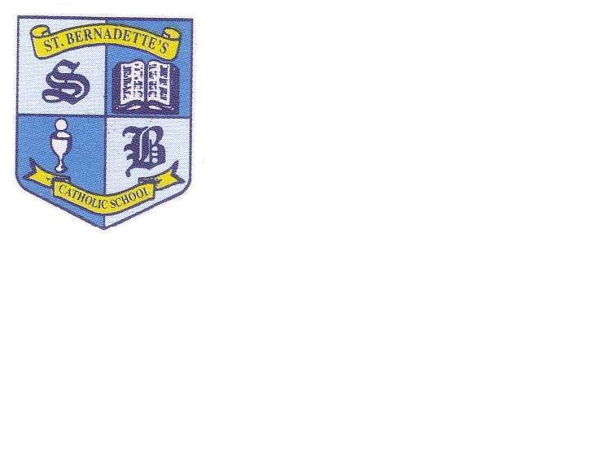

**St Bernadette’s Catholic Primary School,**

**Hob Moor Road, Yardley, Birmingham B25 8QL,**

**TEL: 0121 783 7232**

**Email: m.smallwood@stberns.bham.sch.uk**

**Head Teacher: Miss Angela Cowings**

**Head Teacher**

**Salary: Band 4**

**ISR 21 – 27**

**£81,441 - £94,332**

**Contract type: Permanent**

**Closing date: Wednesday 26 March 2025 at 9.00 am**

**Interview date: w/c 7 April 2025**

**Date to be confirmed**

How to apply

The application pack including the required Catholic Education Service application form and supplementary forms are available by emailing [m.smallwood@stberns.bham.sch.uk](mailto:m.smallwood@stberns.bham.sch.uk)

Your completed application form should be accompanied by a letter addressed to Mr John Lenihan, Chair of Governors outlining your suitability for the role and emailed to the above email address. Please note only the Catholic Education Service application forms will be accepted. You will also be required to complete and return the recruitment and monitoring form.

Visits to the school are encouraged please contact Maria Smallwood on 0121 783 7232 to book a suitable date and time.

*St Bernadette’s is committed to safeguarding and promoting the welfare of children and young people and expects all staff to share this commitment.*