

**Welcome from the**

**Chair of Governors**

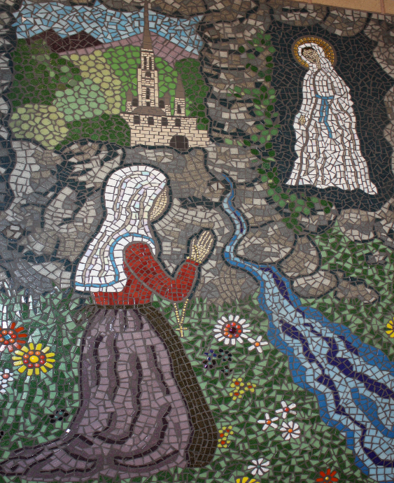

Dear applicant,

We are delighted to welcome you as a prospective candidate for the position of Head Teacher at St Bernadette’s Catholic Primary School. As the Governing Board, we are committed to ensuring the continued success and growth of our school, and we are seeking a leader who will uphold and further our mission of providing an outstanding Catholic education for all our pupils.

**Our Mission Statement**

At St Bernadette’s Catholic Primary School, you will find us caring, hard-working and co-operative. We follow the ways of Jesus using our talents and gifts to make our school special. We show respect to all and welcome you.

**Our Ofsted Report**

We are pleased to share our latest Ofsted report of January 2023 which reflects the dedication and hard work of our staff and pupils. The report highlights the fact that staff and pupils “do not rest on their laurels. Instead they work together to improve things further.”

“Staff and pupils are proud to be part of this forward-looking and hard-working school community. Pupils talk excitedly about their school and look forward to attending each day.”

We are also aware of areas for continued development, and we welcome a leader who will build upon these strengths while addressing the challenges ahead.

N:\INSPECTION\OFSTED - Jan 2023.pdf

**Our Recent Catholic Schools Inspectorate**

We are pleased to share our latest Catholic Schools Inspectorate report of June 2024 which reflects the welcoming and inclusive community where there is a strong sense of family deep rooted in Gospel teaching. Pupils’ behaviour in lessons and around school is exemplary because they have a secure understanding of how to enact Christian values.

Please take the time to read the report

N:\INSPECTION\Catholic Schools Inspectorate - 2024.pdf

**The Role of Head Teacher**

As Head Teacher, you will play a pivotal role in leading our school forward with vision, compassion, and dedication. You will have the opportunity to shape the future of our children by fostering an inspiring learning environment, supporting staff development, and strengthening our links with the parish and wider community. We seek a leader who is not only passionate about education but also deeply committed to the Catholic ethos that underpins all that we do.

We hope this letter provides insight into our school community, and we would be delighted to discuss this exciting opportunity with you further. If you have any questions or would like to arrange a visit to the school, please do not hesitate to Mrs Smallwood on [m.smallwood@stberns.bham.sch.uk](mailto:m.smallwood@stberns.bham.sch.uk).

T:\MEDIASHARE\Shared Video\Catholic Life 2024.mp4

Thank you for your interest in St Bernadette’s Catholic Primary School. We look forward to learning more about how your experience and vision align with our aspirations for the future.

Yours sincerely,

John

**John Lenihan**

**Chair of Governors**

**Learn to Love, Love to Learn**