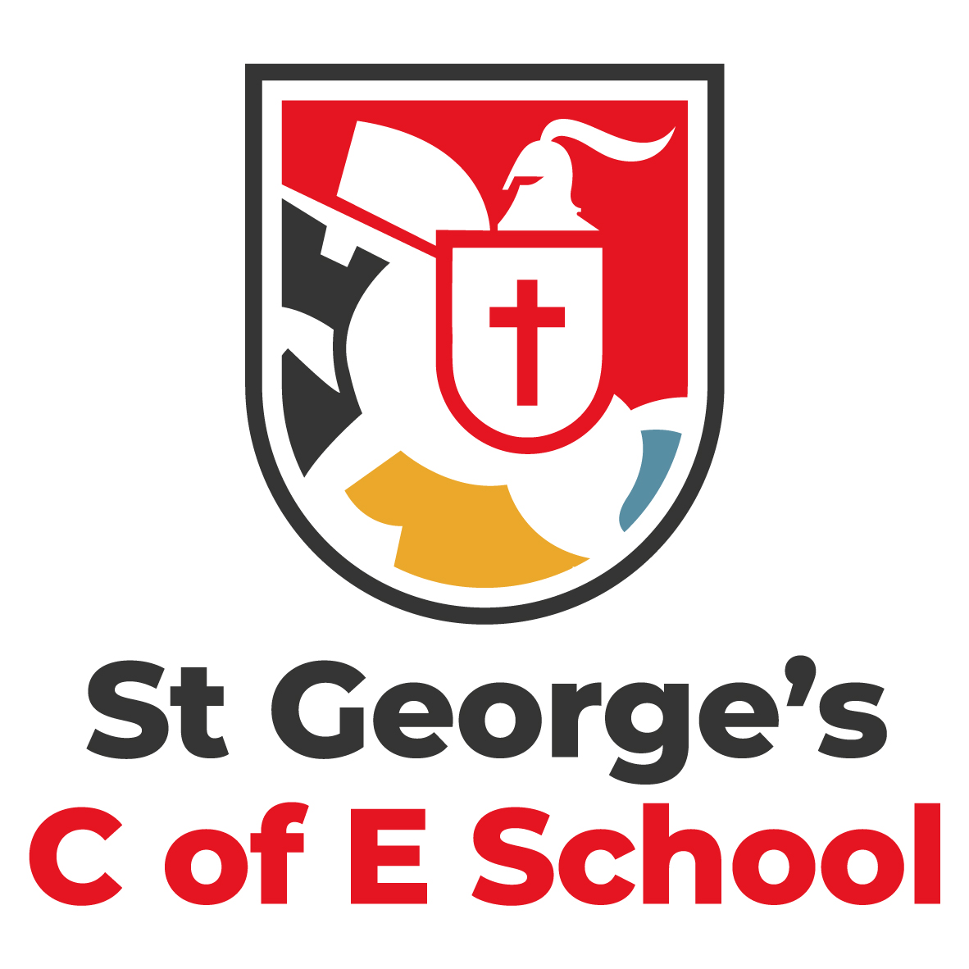
St George’s C of E School
A Voluntary Aided Church of England Primary School
The Hoskers, Westhoughton, Bolton
BL5 2FB
Telephone: (01942) 813069
email: office@st-georges.bolton.sch.uk

On behalf of the Board of Governors, thank you for expressing an interest in the position of Head Teacher at St. George’s primary school. I hope this information pack will answer your questions and inspire you to apply for this exciting role.
The Governing Board are seeking to appoint an exceptional leader who will share our values and ambition for the school. A Head Teacher who can build on our strengths and provide strong, trusted, and resilient leadership. A headteacher that can take our ‘Good’ school to ‘Outstanding’.
At St George’s CE Primary school our vision is that every child upholds the Christian values within their daily lives. Our children strive to be confident, kind, thoughtful and selfless. You can see our vision come to life when walking through our school and in our classrooms. Our school motto is ‘Jesus colours our love, our life, our learning’. We strive to live out this vision in everything we do in school to allow children to enjoy the fullness of life and enable them to flourish in the world in which they live both during their time at St. George’s and beyond.
Rooted in the Gospel of John and in particular chapter 10 ‘I have come that they may have life and have it to the full.’, our school vision encompasses our six gospel values compassion, love, truthfulness, thankfulness, forgiveness and hope.
I believe in the unique potential of each and every child. The school’s primary objective is to create a nurturing environment that is uncompromising in ensuring that pupils benefit from the care and support needed to thrive. In addition, our staff are unwavering in their commitment to provide the highest quality education, delivered through a broad and ambitious curriculum that is designed to give all our pupils, particularly those that are disadvantaged and pupils with SEND, the knowledge and cultural capital they need to succeed in life.
Our community is characterised by its diversity and inclusivity, and all members of the St. George’s Church of England Primary School team work hard to promote a sense of belonging and mutual respect. As a Church of England Primary School deeply rooted in Christian values, we take immense pride in fostering an environment that embodies these principles.
I acknowledge the position of Headteacher can be demanding and challenging and I am committed to ensuring that the Board of Governors provide the necessary support and resources for the successful candidate to thrive in their role.
I hope to meet you in the very near future. Visits to school are strongly recommended and warmly welcomed.
Georgina James
Chair of Governors

