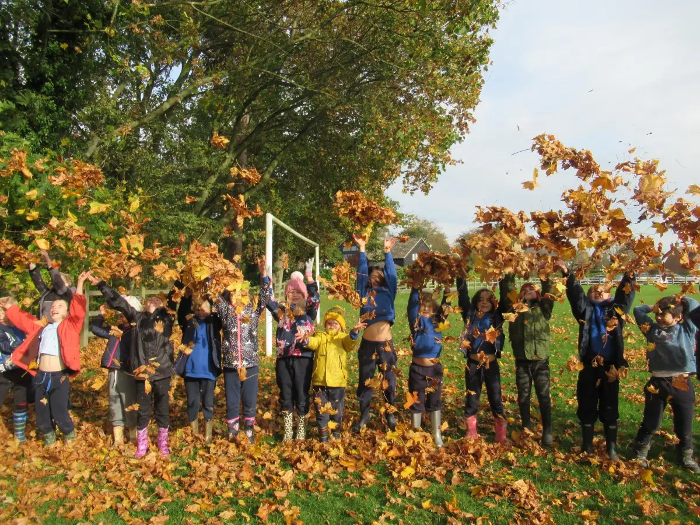



**URCHFONT CE**

**PRIMARY SCHOOL**

**HEADTEACHER RECRUITMENT PACK**



# **WELCOME FROM THE CHAIR OF GOVERNORS**

Welcome to Urchfont CE Primary School and thank you for your interest in leading our wonderful team and children. After nearly 14 happy years with us, our Headteacher, approaching retirement, is moving on. They leave an experienced and well-established workforce who look forward to welcoming some fresh thinking and enthusiasm for change.

Change is very much the watchword as we are in process of joining EQUA-Mead Learning Trust, a geographically-based Multi Academy Trust; it is intended that we will have transferred by September 2025. The Governing Body have driven these changes and are excited, seeing real opportunities for a new Headteacher to make an impact and grow both the school and themselves.

In May 2023, OFSTED confirmed the school as Good stating that "Pupils love learning at Urchfont, follow an ambitious curriculum, staff are proud to work at the school". We have a young Governing Body who agree with this and have strategic ambitions to grow the school and increase community engagement. Our vision is that each child is valued and encouraged, and we want children to leave Urchfont having achieved their best and with an embedded life-long love of learning.

Our small school is an integral part of the beautiful village of Urchfont, an active community offering plenty of opportunities for engagement and interaction. Last year, among other actions, the staff arranged an art display as part of the annual 3-day Scarecrow Festival (and produced a Scarecrow), supported the Summer Fete and sang carols around the village. As a CofE school, we maintain active links with the church and foster lots of opportunities for interaction and support for our pupils throughout the year. The school has excellent facilities with a newly equipped playground, large playing field and Oakfrith Wood on the doorstep used for forest school. We also have a well-subscribed pre-school on the grounds with good links for smooth transition.

The Governing Body is looking to appoint a Headteacher with vision, enthusiasm and leadership to take an active part of shaping the next stage in our journey of a being a successful village school. We welcome applications from individuals who are at the beginning of their Headship career, or indeed where this might be their first step - a significant advantage of becoming part of EQUA Mead is that the successful applicant will benefit from substantial mentoring and support in their new role. The Governing Board, staff and children are all looking forward to hearing from you. Yours sincerely,

Ian Walker

# **WELCOME FROM THE CEO OF EQUA MEAD LEARNING TRUST**

Thank you for the interest in this post.

EQUA Mead Learning Trust is a family of like-minded schools, that collaborate to provide mutual support, share best practice and learn from each other, whilst retaining and developing each school’s individual and distinctive character. We believe every child has the right to an inspiring and fulfilling education and we seek to improve the life chances of all those we serve; therefore, we make it our mission to give **Every Child, Every Chance** of success. ​

At EQUA Mead, we are an inclusive, passionate and forward-looking educational organisation. We are a Trust of seventeen primary schools, two secondary schools and eight nurseries, all based in Wiltshire. In addition, we have three additional schools joining us in September 2025, of which Urchfont CE Primary School is one. Across our schools, we also have four Resource Bases that provide specialist education to children and young people with complex needs. ​

We believe in the power of education to transform lives and shape a brighter future. We are dedicated to fostering a strong sense of community where everyone works together to achieve their very best. At all of our schools, we do all we can to enable each child and young person to realise their full potential and to develop positive social and moral values.

​

We understand that successful schools are rooted in their local community. We respect and value the individual nature and ethos of each school while knowing we are more effective when we work together and support each other. We are a mixed Trust that benefits from both church and non-church-based schools and we actively celebrate this diversity. We are highly inclusive and collaborate closely to promote a culture of openness and integrity. ​

We thrive on providing a wealth of support to schools and seek to empower school leaders. Our CPD, NPQs, ITT, networks, training, research programmes and range of courses underpin a comprehensive development programme for all staff, whilst ensuring wellbeing is at the centre of all decision making. ​

We have lots more information about EQUA Mead on our website ([www.equamead.org](http://www.equamead.org)), however, if at any stage, you would like to find out more, please do feel free to get in touch. ​

​

​​

​

Paul Skipp​

CEO, EQUA Mead Learning Trust​

# **ABOUT OUR SCHOOL**

# Vision Picture

# Our school is part of Urchfont, a thriving community village 5 miles Southwest of the town of Devizes. We are a Church of England school based within the Salisbury Diocese with 87 children across four classes; we have the capacity for 112 children.

# Our team of enthusiastic teachers and assistants have a wide range of experience and create a quiet, caring environment where all are respected equally. The ethos of our school reflects our belief that the behaviour, relationship and self-esteem of everyone is vitally important. Through our vision we encourage everyone to work together. Each child is valued and encouraged, and we offer a welcoming, safe, nurturing and inspiring environment to all.

# Our values provide a strong foundation and are embedded throughout the school day. Our children persevere to flourish and fulfill their potential engaging in learning that is exciting, dynamic and challenging. Through courage, children take supported risks and learn from them. We prepare children to become responsible, informed and creative citizens who will contribute with their wisdom and compassion to the rapidly changing world they live in.

Urchfont is a C of E Voluntary Controlled Primary School, which is supported and served by the Salisbury Diocesan Board of Education (SDBE). The SDBE works with school and EQUA Mead leaders to build confident, effective church schools and academies, that belong at the heart of the church and community, serving society’s greater good.

Church Schools within the EQUA Mead Trust are supported through the Church Schools Flourishing Programme to ensure that their unique vision and that of the Trust is lived out in every aspect of school life. More details about Church Schools can be found on the EQUA Mead website in the Church Schools section.

There are strong links between our school and the local church, and the school is subject to a Statutory Inspection of Anglican and Methodist Schools (SIAMS) approximately every five years. Visitors and parents comment positively on how the Christian ethos of the school permeates everyday life in a natural and sympathetic way. Pupils and staff are also inclusive of people of other faiths and beliefs.

The school has a wide range of rooms and facilities, some of which were installed only a few years ago; they include four classrooms, a library, ICT room, music room, and ELSA room. There is a substantial playground with hard-standing, a recently installed artificial turfed area with climbing and balancing equipment, and a large playing field which is used for football and other sports; it also hosts our annual sports day.

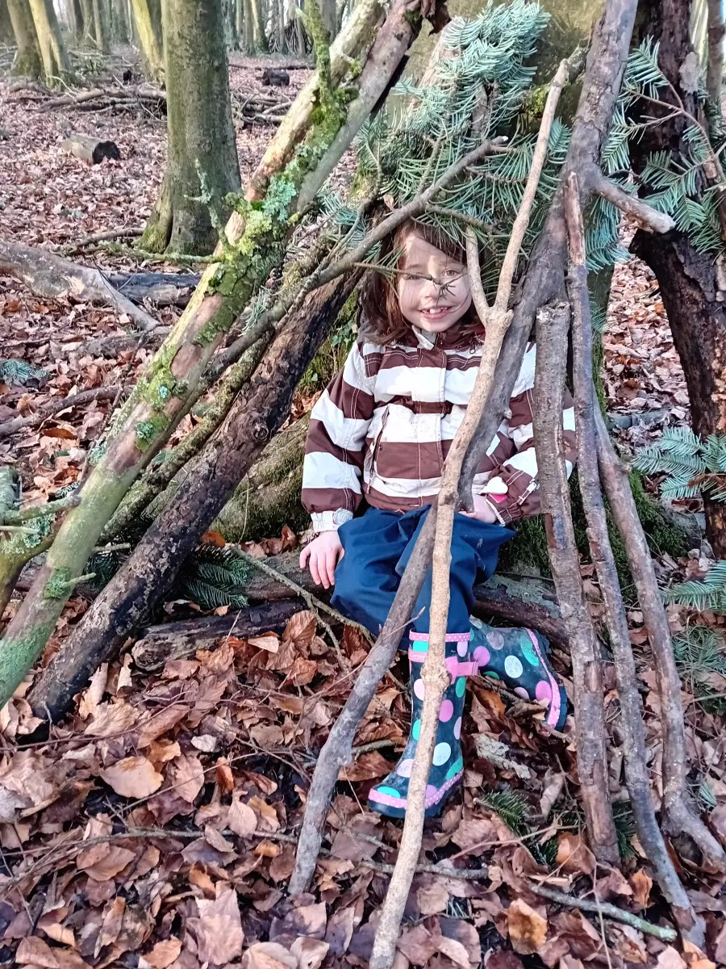There is an independent pre-school on-site with which the school has close ties, providing wrap around cover and a smooth transition into the Reception Year.

The children enjoy a wide range of outdoor activities with active participation in sports with other schools. On our doorstep is Oakfrith Woods which is used for nature walks and a regular Forest School.

There is a supportive community of parents and an active Parent Teachers Association that raises funds to support Forest School, social trips and additional equipment; they also organise fun events for the children such as discos and easter egg hunts.

Above all, our school is loved by the children and their parents and carers. As Ofsted reported: “*Pupils love learning at Urchfont”*

More information and a copy of this pack can be found at [Urchfont C Of E Primary School](https://urchfont.mystrikingly.com/) This site is being added to as information becomes available. Please also visit the school website [www.urchfontprimary.co.uk](http://www.urchfontprimary.co.uk)

# **HEADTEACHER- THE ROLE AND THE PERSON**

The children, staff, parents and Governors of Urchfont CE Primary School and EQUA Mead Learning Trust are looking for a new Headteacher with vision, enthusiasm and leadership to take an active part in shaping the next stage in our journey of being a growing, successful village school within the wider community of EQUA Mead. We are keen to welcome:

* A passionate Headteacher who will be an active part of the school, engaging and communicating with all members of the school community. They will provide interactive leadership to the staff, taking advantage of their experience and knowledge and enthusiasm for change.
* A visionary Headteacher who will be an active member of the wider EQUA-Mead Learning Trust community, who can see the opportunities for the school and staff through shared resources, shared experiences and shared expertise.
* An enthusiastic Headteacher who is seeking to develop themselves in the role, bringing new ideas and fresh thinking and encouraging others to share their vision. Someone who will create a culture of inclusive continuous development and improvement within the school.
* A Headteacher who is also an exceptional teacher, who wants to continue to teach as part of the role (there is a teaching commitment as well as curriculum leadership of a specific subject area), but they should also see it as a way of supporting staff by freeing time for their development.
* A Headteacher who enjoys the challenges and rewards of working in a small school and working with the church, supporting the values and ethos of the Diocese.
* An individual who can communicate effectively the with wider community, to foster relationships and to take mutual advantage of the goodwill and support that the Village offers.

# **THE SUCCESSFUL CANDIDATE**

The successful candidate will be able to demonstrate that they have experience of senior leadership, either as a Headteacher, a Deputy/Assistant Headteacher or as a member of the Senior Leadership Team. Ideally, they will have some experience of working in a small school.

To fulfill the post of Headteacher they will have:

* the expertise and capacity to provide the leadership and improvement support required
* the ability and organisational skills to provide any day-to-day support with staffing
* the ability to lead and shape the vision of the school and the Trust
* excellent communication skills and the ability to celebrate and promote high-quality teaching and learning
* the ability to support, challenge and inspire our children, encouraging them to achieve the best they can
* a positive and optimistic approach; be proactive and confident. Be able to build relationships quickly
* a thirst for educational issues, approaches and alternatives from around the world
* the ability to be a team player and leader who will go the extra mile to support children and families; and
* be able to use resources, intellect, creativity and innovation to be successful; and
* be committed to partnership, collaboration and sharing.

This is an excellent opportunity to work within a high performing Multi Academy Trust at an exciting stage of its development.

We welcome visits to the school from interested candidates. We have allocated two days for this, 2nd and 3rd April.

*To arrange this please email the school on* [admin@urchfont.wilts.sch.uk](mailto:admin@urchfont.wilts.sch.uk) or call 01380 840793

Contract Type: Full Time, Permanent, Salary Scale: L9 to L15 £60,644 -£70,293 (24/25)

Urchfont CE Primary School and EQUA Mead Learning Trust are committed to safer recruitment and promoting the safeguarding and welfare of our children and families. This post is subject to an Enhanced Disclosure and Barring Service check.

# **HEADTEACHER JOB DESCRIPTION**

*The following Headteacher Job Description is provided for completeness and as a guide for the post. It is not expected that any applicant would fulfill all the elements on day one!*

The post holder will be responsible for the leadership, internal organisation, management and control of the school, in consultation, where necessary and appropriate, with the LA, Governing Body, staff and parents (subject to any overriding requirements and the professional duties specified in the Condition of Employment of Headteachers referred to in the School Teachers’ Pay and Conditions Document).

**School culture**

* Establish and sustain the school’s ethos and strategic direction, in partnership with those responsible for governance and through consultation with the school community.
* Ensure the school’s ethos and strategic direction is in line with the values and vision of EMLT Multi Academy Trust.
* Create a culture where pupils experience a positive and enriching school life.
* Uphold ambitious educational standards which prepare pupils from all backgrounds for their next phase of education and life.
* Promote positive and respectful relationships across the school community and a safe, orderly and inclusive environment.
* Ensure a culture of high staff professionalism.

**Whole-school organisation, strategy and development**

* Provide overall strategic leadership and, alongside others, lead, develop and support the strategic direction, vision, values and priorities of the school.
* Ensure that EMLT’s strategic direction, vision and values are reflected in the school.
* Establish, oversee and evaluate systems, processes and policies that enable the school to operate effectively and efficiently.
* Produce and implement improvement plans and policies that benefit the development of the school and EMLT.
* Make use of effective and proportional processes of evaluation: to identify and analyse complex or persistent problems; barriers which limit school effectiveness; identify priority areas for improvement.
* Develop appropriate evidence-informed strategies for improvement as part of well-targeted plans which are realistic, timely, appropriately sequenced and suited to the school’s context.
* Ensure careful and effective implementation of improvement strategies which lead to sustained school improvement over time.

**Teaching**

* Establish and sustain high-quality, expert teaching across all subjects and phases, built on an evidence-informed understanding of teaching practices.
* Ensure teaching is underpinned by high levels of subject expertise and approaches which respect the distinct nature of subject disciplines or specialist domains.
* Ensure effective use is made of formative assessment.
* Lead and manage teaching and learning throughout the school, including ensuring that a teacher is assigned in the school timetable to every class or group of pupils.
* Teach, as required.
* Liaise with other leaders within EMLT to secure creative, responsive and effective approaches to teaching and learning.

**Curriculum and assessment**

* Ensure a broad, structured and coherent curriculum entitlement which sets out the knowledge, skills and values that will be taught.
* Establish effective curricular leadership, developing subject leaders with high levels of relevant expertise with access to professional networks and communities.
* Ensure that all pupils are taught to read through the provision of evidence-informed approaches to reading.
* Ensure valid, reliable and proportionate approaches are used when assessing pupils’ knowledge and understanding of the curriculum.

**Health, safety and behaviour**

* Promote the safety and wellbeing of pupils and staff.
* Ensure rigorous approaches to identifying, managing and mitigating risk.
* Ensure the protection and safety of pupils and staff through effective approaches to safeguarding, as part of the duty of care.
* Ensure good order and discipline amongst pupils and staff.
* Establish and sustain high expectations of behaviour for all pupils, built upon relationships, rules and routines, which are understood clearly by all staff and pupils.
* Ensure high standards of pupil behaviour and courteous conduct, in accordance with the school’s Behaviour Policy.
* Implement consistent, fair and respectful approaches to managing behaviour.
* Ensure that adults within the school model and teach the behaviour of a good citizen.

**SEND and additional needs**

* Ensure the school holds ambitious expectations for all pupils with SEND and additional needs.
* Establish and sustain culture and practices that enable pupils with SEND and additional needs to access the curriculum and learn effectively.
* Ensure the school collaborates effectively in partnership with parents and professionals to identify the additional needs and SEND of pupils, and ensure support and adaptation are provided where appropriate.
* Ensure the school fulfils its statutory duties with regard to the SEND code of practice.

**Management of staff and resources**

* Lead, manage and develop staff members, including appraising and managing their performance.
* Develop clear arrangements for linking appraisal to progression and advise the Local Governing Body on pay recommendations for teachers.
* Organise and deploy resources within the school.
* Prioritise and allocate financial resources appropriately, ensuring efficiency, effectiveness and probity in the use of public funds.
* Promote harmonious working relationships within the school.
* Maintain relationships with organisations representing staff members, e.g. unions.
* Ensure staff are deployed and managed well, with due attention paid to workload.
* Ensure resources are managed in line with EMLT’s policies and procedures.

**Professional development**

* Promote the participation of staff in relevant CPD.
* Ensure staff have access to high-quality, sustained professional development opportunities, aligned to balance the priorities of whole- school improvement, team and individual needs.
* Prioritise the professional development of staff, ensuring effective planning, delivery and evaluation which is consistent with the approaches laid out in the ‘Standards for teachers’ professional development’.
* Ensure that professional development opportunities draw on expert provision from beyond the school, as well as within it, including nationally recognised career and professional frameworks and programmes to build capacity and support succession planning.
* Participate in arrangements for the appraisal and review of their own performance and, where appropriate, that of other staff members.
* Participate in arrangements for their own further training and professional development and, where appropriate, that of other teachers and support staff, including induction.
* Take responsibility for their own CPD, engaging critically with education research.

**Communication and working with others**

* Consult and communicate with the Local Governing Body, staff, pupils and parents.
* Collaborate and work with colleagues and other relevant professionals within and beyond the school, including relevant external agencies and bodies.
* Forge constructive relationships beyond the school, working in partnership with parents, carers and the local community.
* Commit to ensuring the school collaborates successfully with other schools and organisations in a climate of mutual challenge and support.
* Establish and maintain working relationships with fellow professionals and colleagues across other public services, to improve educational outcomes for all pupils.
* Build and maintain excellent relationships with other schools in EMLT, the LGB and the Board of Trustees.

**Governance and accountability**

* Understand and welcome the role of effective governance, upholding obligations to give account and accept responsibility.
* Establish and sustain professional working relationships with those responsible for governance.
* Ensure that staff know and understand their professional responsibilities and are held to account.
* Ensure the school effectively and efficiently operates within the required regulatory frameworks and meets all statutory duties.

**Ethics and professional conduct**

* Uphold and demonstrate the Seven Principles of Public Life at all times – selflessness, integrity, objectivity, accountability, openness, honesty and leadership.
* Uphold public trust in school leadership and maintain high standards of ethics and behaviour.
* Build relationships rooted in mutual respect and observe proper boundaries appropriate to the position.
* Show tolerance of, and respect for, the rights of others, recognising differences and respecting cultural diversity.
* Uphold fundamental British values, including democracy, the rule of law, individual liberty and mutual respect, and tolerance of those with different faiths and beliefs.
* Ensure that personal beliefs are not expressed in ways which exploit the position or pupils’ vulnerability, or which might lead pupils to break the law. Serve in the best interests of the school’s pupils.
* Demonstrate conduct compatible with this influential position in society by acting ethically.
* Know, understand and act in line with the relevant statutory frameworks which set out professional duties and responsibilities.
* Make a positive contribution to the wider education system.

# **HOW TO APPLY**

Applicants are welcome to visit the school which we would strongly recommend. We have set aside two days for this on the 2nd and 3rd of April. Please contact our School Admin Manager, 01380 840793, [admin@urchfont.wilts.sch.uk](mailto:admin@urchfont.wilts.sch.uk) to arrange a visit.

In addition, if you would like to discuss the role further or have any questions please contact the Chair of Governors Ian Walker, [iwalker@urchfont.wilts.sch.uk](mailto:iwalker@urchfont.wilts.sch.uk)

If you need any help with your application, i.e. due to technical difficulties, or if you require an adjustment to the application process, for example due to disability or a medical condition, please email us at [admin@urchfont.wilts.sch.uk](mailto:admin@urchfont.wilts.sch.uk) and we'll support you as best as we can.

The application form can be accessed at [Jobs at Wiltshire](https://jobs.wiltshire.gov.uk/) (type Urchfont into job location) please include a supporting statement with your completed Application Form

**Key Dates:**

**Closing date (and time): Wednesday 23rd April (Noon)**

**Interview date: Thursday 8th and Friday 9th May 2025**

**Commencement date: Monday 1st September 2025**

*This school is committed to safeguarding and promoting the welfare of children and young people and expects all staff and volunteers to share this commitment.*

*All applicants will be subject to an Enhanced Disclosure and Barring Service check before appointment is confirmed.*