Victoria Community School, Victoria Road,
Burton upon Trent, Staffordshire. DE14 2LU
01283 247432
Victoria Orchard Site, Belvoir Road,
Burton upon Trent, Staffordshire. DE13 0RA
01283 247420

Head Teacher: Mrs Elizabeth Laughlin
E-mail: headteacher@victoria.staffs.sch.uk

Victoria Community School @VictoriaCommun1

September 2021

Dear Applicant,

Thank you for your interest in our school and the key post of Headteacher at Victoria Community School.

The Governing Body are keen to appoint a Headteacher who will continue and build on the good progress made by the current head to take the school beyond the Recovery Curriculum and maintain and develop its Good Oftsted rating.

We are looking to employ somebody who is a strong approachable leader and is passionate and knowledgeable about teaching and learning in schools and has a love of working with children and making a difference.

We enclose a job description and personal specification which provide more details about the post.

Our school is situated in the heart of the community and is a key part of the local area.

More information about our school is available on the school website.

We look forward to hearing from you.

Yours sincerely

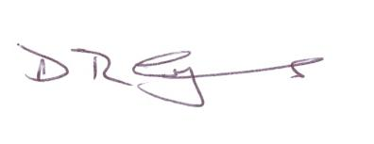

Mr Dave Symons
Chair of Governors

