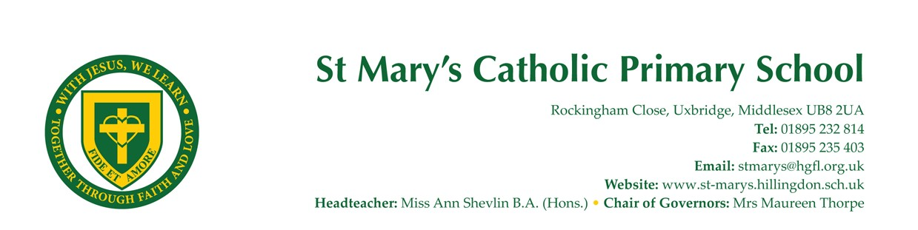

Headteacher at St. Mary’s Catholic Primary School

Rockingham Close, Uxbridge, Middlesex UB8 2UA

Required from September 2026
Contract: Full Time Permanent | School Group: Group 2 | Salary: Leadership scale 15-21 £77,209-£87,932

Lead Our Thriving School Community
Are you an inspiring leader with a passion for nurturing both academic excellence and a caring, faith-filled environment? St. Mary’s Catholic Primary School is seeking a dedicated and forward-thinking Headteacher to guide our successful school into its next exciting chapter. This is a wonderful opportunity to join a high-achieving, supportive community where every child and staff member is truly valued.

About St. Mary’s Catholic Primary School
St. Mary’s is a small, welcoming Catholic primary school with a strong academic record and a vibrant, inclusive ethos. Rooted in Gospel values, we celebrate the uniqueness of every child and are proud of our caring, family atmosphere. Our dedicated staff, engaged governors, and supportive families work together to create a nurturing environment where children flourish academically, spiritually, and socially. We are proud of our achievements and are now looking for a Headteacher who will help us build on our strengths and support and guide our school as we move forward. Situated just outside Uxbridge town centre, our school has excellent transport links as well as tube and bus services and a number of mainline stations nearby.

The Role
As Headteacher, you will play a central role in shaping the future of our school, leading with integrity, compassion, and vision. You will work collaboratively with staff, governors and families to ensure our Catholic values and high standards continue to shine through in all we do. This is your chance to make a meaningful impact, supporting our school’s ongoing success and fostering a culture where everyone can thrive.
Key Responsibilities:
- Inspire and nurture the Catholic life of the school, ensuring faith is at the heart of our daily practice
- Build on our strong academic foundations, leading the school confidently into its next phase of development
- Lead Religious Education and the Catholic life of the school
- Lead the development of the curriculum and teaching and learning across the school
- Work in partnership with our committed governors, fostering open and effective governance
- Lead, motivate and support staff, promoting teamwork, professional growth and wellbeing
- Manage school finances and resources wisely, ensuring the best outcomes for all pupils
- Develop strong, positive relationships with parents and carers, valuing their partnership in every child’s journey
- Safeguard and promote the welfare of all children, embedding a culture of safety and care
- Celebrate children’s achievements and support every pupil to reach their full potential

Qualities of the new Headteacher
We are seeking an enthusiastic and empathetic leader who is passionate about making a difference in a thriving, community-focused school. A leader who will continue to develop the Catholic ethos of the school.
If you value collaboration, are committed to the wellbeing and success of every child and adult, and are ready to support a school that is already doing well academically, we would love to hear from you.
We’re Looking For:
- A motivated and passionate leader with experience in a Catholic school setting, ready to guide our community with faith and vision
- Is a practising Catholic, with a clear vision and strong commitment to Catholic Education
- A team player who works collaboratively with staff, governors, and families to achieve shared goals
- Someone with a strong commitment to nurturing the Catholic ethos and leading Religious Education
- A leader who can build on the curriculum and support the development of teaching and learning
- Have experience leading and continue developing further the prayer life in a Catholic school
- An effective communicator who builds trust and positive relationships with all stakeholders
- A skilled manager, confident in overseeing school finances and resources
- Someone who prioritises the wellbeing and safeguarding of every child
- An individual who values and encourages the vital role of parents and carers in school life
- A reflective practitioner committed to continuous improvement and the progress of all pupils

What We Offer
At St. Mary’s, we believe our staff are our greatest asset. We are committed to providing a supportive and caring environment, where you can thrive both personally and professionally.
Benefits of Joining Our Team:
- A welcoming, family-like atmosphere where you are truly valued and supported
- The opportunity to lead a high-achieving school with a strong sense of community and shared purpose
- Supportive and engaged governors who work alongside you and champion your vision
- Excellent opportunities for professional development and personal growth
- The chance to make a real difference in the lives of our children, families and the wider community

Commitment to Safeguarding

Our organisation is committed to safeguarding and promoting the welfare of children, young people and vulnerable adults. We expect all staff, volunteers and trustees to share this commitment.
Our recruitment process follows the Keeping Children Safe in Education Guidance.

Offers of employment may be subject to the following checks (where relevant):
Childcare disqualification
Disclosure and Barring Service (DBS)
Medical
Online and social media
Prohibition from teaching
Right to work
Satisfactory employment and priest references (requested and received prior to interview)
Suitability to work with children
You must tell us about any unspent conditional cautions or convitions under the Rehabilitation of Offenders Act 1974.
Please see the link below to our safeguarding statement
· https://www.st-marys.hillingdon.sch.uk/page/?title=Safeguarding&pid=29

As well as a link to the following statutory document that all appointed staff are asked to read, understand and sign a declaration

https://assets.publishing.service.gov.uk/media/68add931969253904d155860/Keeping_children_safe_in_education_from_1_September_2025.pdf

An enhanced DBS check will be carried out before any appointments. We follow the guidance on safer recruitment from Schools HR Co-operative as well as London Borough of Hillingdon Governance.

How to Apply
Interested candidates are warmly invited to submit their application before the closing date of mid-day on the 20th February 2026. For further information or to arrange an informal visit, please contact the School Business Manager, Kayleigh Taberer via ktaberer@stmarysuxbridge.org.uk or 01895 232814 option 2. Application forms can also be returned in an envelope marked ‘confidential’ for the attention of Kayleigh Taberer, School Business Manager by hand to the school. If using Royal Mail please ensure the large letter stamps are used and envelope is weighed and correct postage ascertained.
We look forward to welcoming a new Headteacher who will help us continue our journey of success and care.
This appointment is formed with the collaboration of the Diocese of Westminster in partnership with the London Borough of Hillingdon.

Closing Date: Midday, Friday 20th February 2026
Interviews and Assessment: Shortlisting: Wednesday 25th February 2025
Interviews to be held Wednesday 11th March 2026

