St Joseph Catholic Primary School Hunslet, Leeds

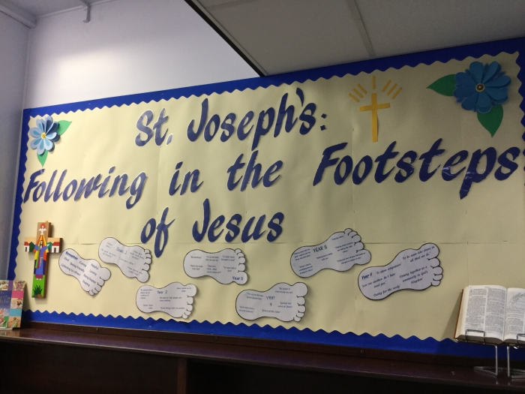

Mission Statement
St Joseph’s: following in the footsteps of Jesus,
having fun learning, achieving & loving together.

Headteacher Recruitment
Information for Applicants
April 2021

Vicariate for Education
Diocese of Leeds
SAINT JOSEPH CATHOLIC PRIMARY SCHOOL
Joseph Street
Hunslet
Leeds
LS10 2AD
Tel 0113 2712093
Fax 0113 2773938
Headteacher – Miss C M^{c}Hale
www.hunslet-st-josephs.leeds.sch.uk
email: office@stjosephscatholicprimary.org

Dear Applicant,
Thank you for taking the time to find out more about the vacancy for a Headteacher at St Joseph’s Catholic Primary School, Hunslet in the Diocese of Leeds. We hope that the information in this pack will be useful to you and please do look at the school’s website should you wish to find out more.
The governors of St Joseph’s are extremely proud of our school and wish to thank Miss M^{c}Hale for her substantial contribution to the school and to Catholic education as she retires from headship. The school is a vital part of the Parish of St Margaret Clitherow in Leeds. We recognise that this appointment provides an opportunity to work alongside a new Headteacher as we begin the next stage of our school’s journey, which will include working with the new Headteacher to appoint a Deputy Headteacher.
We work in partnership with a group of local Catholic schools to provide a variety of opportunities for the children and staff, as well as working with schools across Leeds and the Diocese. It is Bishop Marcus’ vision that all Catholic schools in the Diocese join a Catholic Multi Academy Trust. As yet we have not made a decision to join the St Gregory the Great Catholic Academy Trust so at some stage in the future you may be asked to guide us towards this.
Where possible, coronavirus guidance permitting, we will facilitate visits to the school and you are welcome to contact Miss M^{c}Hale for further information or with any queries you may have.
Thank you for your interest and we look forward to receiving an application form from you by 12 noon on 7 May 2021. Interviews will be held on Wednesday 26 May 2021.
Yours sincerely,
Andrew Machin
Chair of Governors
ST JOSEPH CATHOLIC PRIMARY SCHOOL
Joseph Street, Hunslet, Leeds, LS10 2AD
Tel: (0113) 271 2093

Headteacher

Salary Range L15-21
Required for January 2022
www.hunslet-st-josephs.leeds.sch.uk
Number on roll: 205  Closing date: 7 May 2021 at noon  Shortlisting: 11 May 2021  Interviews: 26 May 2021 | Following the retirement of the current Headteacher the Governors are seeking to appoint a caring, motivated and dedicated Headteacher. St Joseph’s is a welcoming, caring community where children develop spiritually, morally and academically. Children enjoy coming to school and are proud of their community. Our children and families appreciate the importance of education and have the drive to succeed in life. They have the support of hard working and caring staff and benefit from excellent links with the parish.  The successful candidate will;  - Be a committed and practising Catholic with a clear vision of Catholic Education.  - Be passionate about education and the difference it makes to children’s lives.  - Be committed to promoting the holistic wellbeing of children and their families  - Be an outstanding leader with high expectations of pupils  - Have the ability to develop staff as excellent teachers and future leaders.  - Have the drive and commitment to raise standards.  - Have proven Senior Leadership experience.  In return St Joseph’s can offer you;  - Enthusiastic, happy, well-behaved children and supportive families.  - Hard working and dedicated staff.  - Excellent links with the Parish  - Professional and supportive links with local Catholic Schools  - Ongoing professional development opportunities  - A supportive Governing Body  Visits to the school are welcome; we have a strict Covid-19 Health & Safety plan in place. Please contact Miss C. M^{c}Hale, Headteacher on (0113) 2712093 to arrange a visit.  To request an application pack, please email: educ.headteacher@leeds.gov.uk  St Joseph’s Catholic Primary School is committed to safeguarding and promoting the welfare of our pupils and expects all staff and volunteers to share this commitment. Appointments are made subject to an enhanced Disclosure and Barring Service check and registration with the update service.
Mission Statement
St. Joseph’s: following in the footsteps of Jesus,
having fun learning, achieving & loving together.

Our Vision
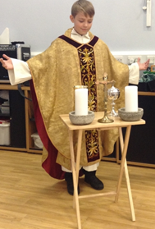
We at St Joseph’s, as a Catholic School, aspire to inspire all in our school to grow and learn together in their love of God by building a teaching and learning community where we offer the best opportunities we can to help each child recognise and value their unique dignity as a child of God based on the Gospel values of love, justice, mutual respect, acceptance and forgiveness.

We will inspire each other to be the best we can be by:
- Recognising and realising our full potential as unique children of God.
- Celebrating diversity and respecting different beliefs, cultures and ways of life.
- Listening to and valuing each other’s contributions.
- Encouraging independence and resilience.
- Sharing our gifts and talents with all in our school family and society.

We will achieve this by:
- Making sure our school is safe, friendly and welcomes all
- Setting high expectations for our spiritual, moral, intellectual, social, emotional and physical development.
- Ensuring that the Catholic ethos of the school is fostered at all times.
- Teaching our children to respect and help each other, embracing differences and to follow the principles of Catholic social teaching so that they recognise that people are more important than things and that we must support the poor and vulnerable in society.
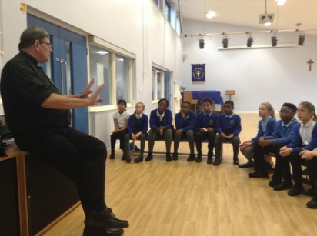
- Providing a curriculum that will be innovative, stimulating, challenging and well resourced. It will fit our children’s needs and be supported by visits and visitors to develop pupils into independent lifelong learners.
- Promoting the highest standard of teaching which engages all learners.
- Leading each child towards self-discipline, self-esteem and a positive attitude to learning
- Nurturing a strong partnership between home, school, parish and our wider communities.

Our School
‘Evidence of pupils' general self-esteem, their excellent behaviour and confident sense of belonging confirm that the school's Mission Statement is 'a lived reality'. It determines a common purpose for all members of the school family with Christ at the centre’. Section 48 Inspection
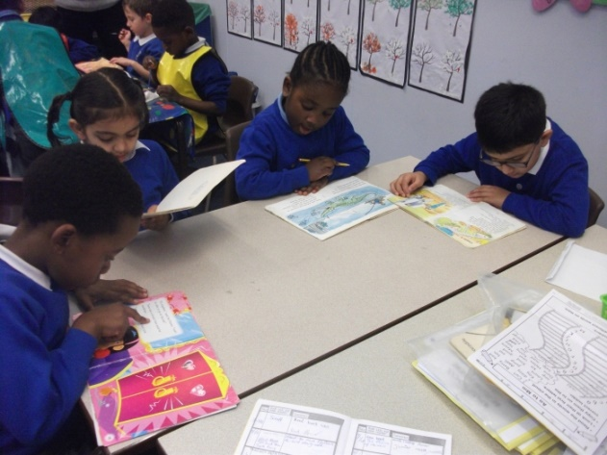
St Joseph’s is a one form entry school for children age 4-11. It is situated in Hunslet, Leeds, in the Parish of St Margaret Clitherow. Saint Joseph's Catholic Primary School has a long history of education in Hunslet. The first “school” dates back to the 1870s. The school building gradually developed, beginning with the classrooms that our youngest children now use. Since then education has seen many changes and despite the old building, Saint Joseph's Catholic Primary School has moved with the times. Our Mission Statement: 'St Joseph's: following in the footsteps of Jesus, having fun learning achieving and loving together' reflects the Gospel values as we encourage every child to achieve their full potential. Staff, parents and children work together at St Joseph’s to create a loving, caring environment in which children feel safe and happy. Our aim is to develop the whole child who will make a truly valuable contribution to the world in which we live.
The very best part of our school is our children. The school is a calm, well ordered and welcoming place to learn. At our last s5, inspectors commented that “you are determined that every child in your care must and will do well. You work imaginatively and carefully to make this happen”. (OFSTED 2018). The main conclusion was that our school: “has maintained the good quality of education in the school” and that “school provides children with a language-rich environment where they are encouraged to talk, as they explore a wide range of interesting activities.”

Pupils enjoy school and especially the broad curriculum and enrichment opportunities provided. As a result of the carefully structured curriculum, pupils are learning much about their world and the values and ethics the school teaches them. Almost all pupils relish the diversity of the school and the community which it serves and point to how much they learn from each other as a result.

Parents, staff and pupils are very positive about the school. Parents value the school and support its caring yet rigorous academic emphasis. Staff are proud to work at the school, feel well supported and in turn go beyond what is expected to support each other and the children and their families.

We have a school of which we are proud and in which we take pride! We strive for the highest possible standards and we achieve what we do because the children are happy and supported in school and because we want the best for the children in their care. We have strong partnerships with our parish of St. Margaret Clitherow, the Diocese of Leeds and our Catholic Teaching Alliance which together enhance our children’s experience of Catholic education as loving, respectful, caring, warm and welcoming.

Our School by Our Children

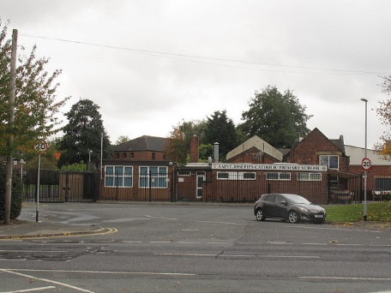
‘The teachers take care of us. They make us feel happy.’
‘We are like a big family.’
‘We are a strong community.’

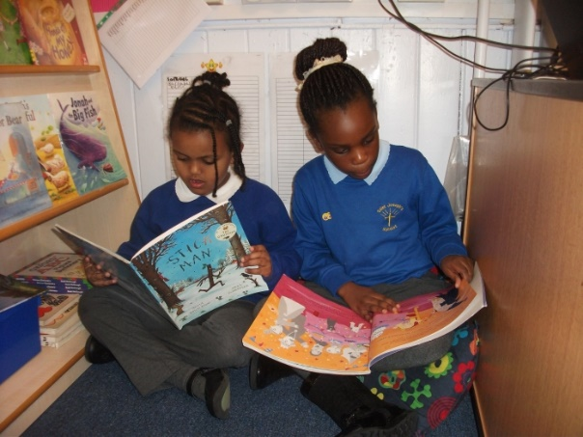
‘We have fun learning and achieving.’
‘We make great friends.’

‘We love Reading!’

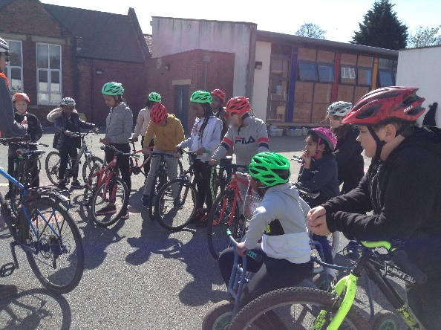
‘We learn something new every day - there is no time to be bored.’

St Joseph’s Catholic Primary School
Headteacher – Job Description based on Headteacher Standards 2020

Section 1: Ethics and professional conduct
Catholic Headteachers are expected to demonstrate consistently high standards of principled and professional conduct inspired by Christ and His beatitudes and exemplified by the self-cultivation of virtues, those qualities of character fundamental to the Catholic tradition: faith, hope, love, justice, solidarity, temperance, fortitude and practical wisdom. Catholic Headteachers are expected to meet the teachers’ standards and be responsible for providing the conditions in which teachers can fulfil them.
In addition, Catholic Headteachers uphold and demonstrate the Seven Principles of Public Life at all times. Known as the Nolan principles, these form the basis of the ethical standards expected of public office holders:
- selflessness
- integrity
- objectivity
- accountability
- openness
- honesty
- leadership
Catholic Headteachers are custodians of diocesan schools and as such embody the abundant hope the Church has placed in education. Catholic Headteachers are entrusted with the task of human formation in conformity with Christ and Church teaching, and so uphold ecclesial and public trust in school leadership and maintain high standards of ethics and behaviour. Both within and outside school, Catholic Headteachers:
- build relationships of mutual respect rooted in the belief that all are made in the image and likeness of God and at all times observe proper boundaries appropriate to their professional position
- show tolerance of and respect for the rights of others, recognising differences and respecting cultural diversity within contemporary Britain enabling each person to play their full part in building and sustaining the Common Good.
- uphold fundamental British values, including democracy, the rule of law, individual liberty and mutual respect, and tolerance of those with different faiths and beliefs understanding that such values are rooted in the Catholic understanding of dialogue and the Church’s Social Teaching.
- ensure that personal beliefs are not expressed in ways which exploit their position, pupils’ vulnerability or might lead pupils to break the law, but are always orientated to the service of others in light of the Gospel.
As leaders of their Catholic school community and profession, Headteachers:
- serve in the best interests of the school’s pupils
- conduct themselves in a manner compatible with their influential position in church and society by behaving ethically, fulfilling their professional responsibilities and modelling the virtues of a good citizen of the Kingdom of God.
- uphold their obligation to give account and accept responsibility
- know, understand, and act within the statutory frameworks which set out their professional duties and responsibilities
- take responsibility for their own continued professional development, engaging critically with educational research to further the Church’s mission in education
- make a positive contribution to the wider education system within and without the Catholic sector

Section 2: Headteachers’ standards

1. School culture
Headteachers:
- establish and sustain a Christ centred vision embodied in the school’s Catholic mission, ethos and strategic direction in partnership with the parish and Trust, those responsible for governance and through consultation with the school community and diocese
- create a Christ inspired culture where pupils experience a positive and enriching school life enabling them to flourish
- uphold ambitious educational standards which reflect the distinctive characteristics of Catholic education and which prepare pupils from all backgrounds for their next phase of education and life
- promote positive and respectful relationships across the school community and a safe, orderly and inclusive environment which recognises an individual’s dignity as made in the image and likeness of God
- ensure a culture of high staff professionalism rooted in mutual respect, subsidiarity and the pursuit of excellence

2. Teaching
Headteachers:
- establish and sustain high-quality, expert teaching across all subjects and phases, built on an evidence-informed understanding of effective teaching and how pupils learn
- ensure teaching is underpinned by high levels of subject expertise and approaches which respect the distinct nature of subject disciplines or specialist domains, and demonstrate how each discipline and domain contributes to the Christian vision of human flourishing to live life to the full.
- ensure effective use is made of formative assessment

3. Curriculum and assessment
Headteachers:
- ensure a broad, structured and coherent curriculum entitlement rooted in the distinctive characteristics of Catholic education which sets out the knowledge, skills, values and virtues that will be taught
- establish effective curricular leadership, developing subject leaders with high levels of relevant expertise with access to professional and diocesan networks and communities
- ensure that all pupils are taught to read through the provision of evidence-informed approaches to reading, particularly the use of systematic synthetic phonics in schools that teach early reading
- ensure valid, reliable and proportionate approaches are used when assessing pupils’ knowledge and understanding of the curriculum

4. Behaviour
Headteachers:
- establish and sustain high expectations of behaviour for all pupils, rooted in love, justice and reconciliation and built upon relationships, rules and routines, which are understood clearly by all staff and pupils
- ensure high standards of pupil behaviour through the promotion of the virtues and courteous conduct in accordance with the school’s behaviour policy
- implement consistent, fair and respectful approaches to managing behaviour
- ensure that adults within the school lead by example and model and teach the virtues characteristic of a good citizen

5. Additional and special educational needs and disabilities
Headteachers:
- ensure the school holds ambitious expectations for all pupils with additional and special educational needs and disabilities in light of the principles of Catholic Social teaching
- establish and sustain ethos, culture and practices rooted in the distinctive characteristics of Catholic education that enable pupils to access the curriculum and learn effectively
- ensure the school works effectively in partnership with parents, carers, parish and professionals, to identify the additional needs and special educational needs and disabilities of pupils, providing support and adaptation where appropriate
- ensure the school fulfils its statutory duties with regard to the SEND code of practice

6. Professional development
Headteachers:
- ensure staff have access to high-quality, sustained professional development opportunities in all key and distinctive aspects, aligned to balance the priorities of whole-school improvement, team and individual needs
- prioritise the professional development of staff, ensuring effective planning, delivery and evaluation which is consistent with the approaches laid out in the standard for teachers’ professional development
- ensure that professional development opportunities draw on expert provision from beyond the school, as well as within it, including diocesan and nationally recognised career and professional frameworks and programmes to build capacity and support succession planning

7. Organisational management
Headteachers:
- ensure the protection and safety of pupils and staff through effective approaches to safeguarding, as part of the duty of care
- prioritise and allocate financial resources appropriately, ensuring efficiency, effectiveness and probity in the use of public funds reflecting the school’s Catholic mission
- ensure staff are deployed and managed well with due attention paid to workload
- establish and oversee systems, processes and policies that enable the school to operate effectively and efficiently and that are rooted in a clear understanding of the Church’s mission in education
- ensure rigorous approaches to identifying, managing and mitigating risk

8. Continuous school improvement
Headteachers:
- make use of effective and proportional processes of evaluation to identify and analyse complex or persistent problems and barriers which limit school effectiveness, and identify priority areas for improvement
- develop appropriate evidence-informed strategies for improvement as part of well-targeted plans which are realistic, timely, appropriately sequenced and suited to the school’s Catholic context
- ensure careful and effective implementation of improvement strategies, which lead to sustained school improvement over time

9. Working in partnership
Headteachers:
- forge constructive relationships beyond the school, working in partnership with parents, carers, the Parish, diocese and the local community
- commit their school to work successfully with other Catholic schools and other schools and organisations in a climate of mutual challenge and support
- establish and maintain working relationships with fellow professionals and colleagues across other public services to improve educational outcomes for all pupils

10. Governance and accountability
Headteachers:
- understand and welcome the role of effective governance, rooted in strategic stewardship of the Catholic mission in education, upholding their obligation to give account and accept responsibility
- establish and sustain a professional working relationship with those responsible for governance which is inspired by a Christ centred vision of human formation
- ensure that staff know and understand their professional responsibilities and are held to account
- ensure the school effectively and efficiently operates within the required regulatory frameworks and meets all statutory duties

Based on the 2020 DfE Headteachers’ Standards published to articulate the additional responsibilities of headship in addition to the requirements of the teachers’ standards but reflecting the ethos of the Catholic school and the vocational role of a Catholic headteacher in upholding the mission of the Church

St Joseph’s Catholic Primary School
Headteacher - Person Specification

Introduction
St Joseph’s Catholic Primary school is a voluntary aided Primary School with a strong religious character. Their Memorandum and Articles state that they are part of the Catholic Church and are to be conducted as Catholic schools in accordance with Canon Law, the teachings of the Roman Catholic Church and the Trust Deed of the Diocese of Leeds. At all times the school is to serve as a witness to the Catholic Faith in Our Lord Jesus Christ.
This person specification is intended to assist both candidates and governors in the appointment process. It highlights the particular qualities for Headteachers of Catholic schools in ensuring that they meet the same expectations of Headteachers of all schools while serving the mission of the Church in education.
The core purpose of the headteacher of any school is to provide professional leadership and management. In our Catholic school, that professional leadership is provided in the context of a community rooted in the Catholic faith. Thus it is an essential requirement that applicants have a deep rooted, strong, personal faith and recognise the opportunities and challenges facing Catholic education as a vibrant part of the mission of the Church in education.
The governing body and the Diocese acknowledge the importance of the role of the Catholic headteacher and will actively offer long term support, encouragement, affirmation and realistic challenge to the successful candidate.
The governing body acknowledges that the criteria reflect the evolving role of headship in the early 21st Century and that they apply as much to experienced Headteachers as they do to aspirant Headteachers. The successful candidate will be encouraged to participate in the diocesan induction programme and will be offered an appropriate and experienced Catholic headteacher as mentor. If the successful applicant has not completed the CCRS course in Catholic Education or equivalent, an undertaking to successfully complete the course may be expected
What is the objective definition of a ‘practising Catholic’ for appointments to key posts in Catholic Schools?
To objectively define what a ‘practising Catholic’ is when assessing applicants for key leadership posts within a Catholic school, it is necessary to understand that there are general obligations as well as essential components that constitute ‘practice’ of the faith in the teaching of the Catholic Church.
The Church’s general obligations for its members require that they strive to live lives of holiness by being faithful to the teaching of the Gospel, by trying to uphold the values proclaimed in the Beatitudes, by assisting in the Church’s mission to make Christ known to all peoples, by upholding privately and publicly the Church’s moral and social teaching, by endeavouring to follow an informed conscience and by making every effort to keep the precepts of the Church. This is the ‘practice’ of the Catholic faith in its widest and all-encompassing sense. At the heart of these general obligations though, there are essential components for “full communion” with the Catholic Church. These are sacramental initiation (Baptism, Confirmation and the Eucharist) and the bonds of profession of faith, the sacraments and ecclesiastical governance. The preservation of this full communion is not limited to purely religious activity but is to be an integral part of the whole pattern of behaviour of a member of the Church. It is what essentially constitutes being a committed and ‘practising Catholic’.
For further information including examples where there may be a reason why somebody is not in a position to take up a key responsibility in a Catholic school, please see ‘Christ at the Centre’ by Mgr. Marcus Stock, CTS Publications ISBN 978-1-86082-843-0

CONFIDENTIAL REFERENCES AND REPORTS | Essential or Desirable | Evidence
A positive and supportive written faith reference from a priest where the applicant regularly worships. | E | R
A positive recommendation from current employer or Headteacher | E | R
A second professional reference | E | R

JOB SPECIFICATION
Please note source of evidence of fulfilled criteria:
Application Form - A Letter – L References – R Interview - I
QUALITIES AND KNOWLEDGE | Essential or  Desirable | Evidence
Practicing Catholic who can show by example and from experience that he or she will ensure that the school is distinctively Catholic in all aspects. | E | I/R
Qualified Teaching Status | E | A
Degree | E | A
NPQH or similar | D | A
CCRS (Catholic Certificate in Religious Studies) | D | A
Teaching and leadership experience in one or more Catholic primary schools | E | A/I/R
Lead by example and be a positive role model with excellent communication skills | E | I/R
Ability to articulate a clear vision and purpose for Catholic education and to share their Catholic Faith with a range of colleagues who may or may not be Catholic themselves. | E | A/I/R
Personal impact and presence | E | I/R
Participation in a Parish Community | E | A/I/R
Ability to lead the spiritual development of staff and pupils | E | I/R
Understanding of current educational provision and the wider school systems | E | A/I
Political and financial astuteness | E | A/I/R
Demonstrate an experience of working alongside clergy and faith leaders | E | A/I/R

PUPILS AND STAFF | Essential or  Desirable | Evidence
Have ambitious standards and high expectations for all pupil’s | E | A/I/R
Excellent understanding of high quality teaching and learning | E | A/I/R
Promote the development of the whole child | E | A/I/R
Use data analysis to effectively drive whole school improvement | E | A/I/R
Encourage all staff and pupils to develop their unique potential, character and virtue | E | A/I/R
Identify emerging talent, develop excellence and clear succession planning | E | A/I/R

SYSTEMS AND PROCESS | Essential or  Desirable | Evidence
Efficient strategic leadership and astute financial planning | E | A/I/R
Ensure the safety of all staff and pupils at all times | E | A/I/R
Promote excellent behaviour and positive attitudes to school life | E | A/I/R
Systems for performance management to hold staff to account | E | A/I/R
Ability to challenge under –performance | E | A/I/R
Understanding of strong governance to hold the school to account | E | A/I/R
Ensure budgets and resources are deployed in the best interests of pupils | E | A/I/R
Promote distributive leadership throughout the school | E | A/I/R

SELF IMPROVING SCHOOL | Essential or  Desirable | Evidence
Knowledge and experience of working with other schools and organisations | E | A/I/R
Effective partnerships with a range of professionals | E | A/I/R
Use well evidenced research to achieve excellence | D | A/I/R
Provide high quality opportunities for staff development | E | A/I/R
Confident, entrepreneurial, and innovative approach to school improvement | E | A/I/R
Source of inspiration and encouragement for all in the school community. | E | A/I/R

CHILD PROTECTION | Essential or  Desirable | Evidence
Ensure that the child protection policies and procedures adopted by the governing body are fully implemented and followed by all staff | E | A/I/R
Ensure that sufficient resources and time are allocated to enable staff to discharge their child protection related responsibilities effectively | E | A/I/R

SECURING ACCOUNTABILITY | Essential or  Desirable | Evidence
Fulfil commitments arising from contractual accountability to the Governing body | E | A/I/R
Develop a Catholic school ethos | E | A/I/R
Ensure individual staff accountabilities are clear, understood, agreed, reviewed and evaluated | E | A/I/R
Work with the Governing Body to enable it to meet its responsibilities | E | A/I/R
Develop an accurate and understandable account of the school’s performance for a range of audiences | E | A/I/R
Personally contribute to school achievements taking account of feedback from others | E | A/I/R

STRENGTHENING THE COMMUNITY | Essential or  Desirable | Evidence
Build a school culture and curriculum which takes account of the richness and diversity of the community’s Catholic Christian faith | E | A/I/R
Create and promote strategies for challenging racial and other prejudices | E | A/I/R
Ensure learning experiences for pupils are linked into and integrated with the wider community | E | A/I/R
Ensure a range of community based learning experiences | E | A/I/R
Collaborate with agencies in providing for the academic, spiritual, moral, social emotional and cultural well-being of pupils and their families | E | A/I/R
Create and maintain an effective partnership with parents and carers | E | A/I/R
Invite local community into school to enhance and enrich the school | E | A/I/R
Share effective practice working in partnership with other schools | E | A/I/R

APPLICATION FORM AND LETTER | Essential or Desirable | Evidence
Application form to be completed in full and legible | E | A
Supporting statement to be clear, concise and related to the specific post and appointment criteria no more than 2 sides of A4 in font size 11 | E | L

Working in Leeds Diocese
Thank you for taking the time to find out more about the position of Headteacher at St Joseph Catholic Primary School, Hunslet, Leeds in the Diocese of Leeds.
The Diocese of Leeds covers a wide geographic area encompassing eight local authorities mainly in West and North Yorkshire well served by a network of rail and motorway links. We have 79 primary schools, 13 high schools, a sixth form college in Leeds and a residential non-maintained school for the deaf. Our smallest school is 70 pupils whilst the largest is 2,300 pupils serving both rural and urban areas. There are good partnerships between schools across the Diocese as well as within local deaneries and further networks with local authority schools. Also within the Diocesan educational provision is our Catholic university of Leeds Trinity. Asset out in the bishop’s vision 2018 (available on the diocesan website) all schools are in the process of converting to one of five multi-academy trusts within the diocese. This process is nearly complete and St Joseph Catholic Primary School will become an academy in the St Gregory the Great Catholic Academy Trust in due course.
The primary headteachers across the diocese meet on a termly basis as part of the Leeds Diocesan Association of Primary Headteachers (LDAPH) to join in the retreats usually as an overnight event at the Bar Convent in York giving opportunities for spiritual refreshment and networking together. Retreats are sometimes held nationally and in Rome in more normal situations than we are currently experiencing.
The Diocese together with its trusts offers a comprehensive programme of continuing professional development every academic year which is available on the website and available free of charge to all schools giving to the Diocesan school contribution scheme.
It is an exciting time to join a Diocesan school so I hope that you will take this opportunity to apply to be the new headteacher at St Joseph’s Catholic Primary School.
Kind regards
Angela Cox OBE
Director of Education
Diocese of Leeds

DIOCESE OF LEEDS
HEADTEACHER WELLBEING SERVICE
What is the Headteacher Wellbeing Service?
The Service:
• Was requested by Headteachers for Headteachers
• Is designed to meet the specific needs of Headteachers in the Leeds Diocese
• Is a confidential service for all Headteachers in Diocesan primary, secondary and special schools
• Offers an opportunity to talk confidentially on a personal and professional basis
• Facilitates links with other professionals
What does the Service Aim to Do?
The Service:
• Promotes the wellbeing of the Catholic Headteachers in the Leeds Diocese
• Provides personal support for individual Headteachers
• Assists Headteachers in resolving issues
• Facilitates support networks
• Enhances relationships between Headteachers, Governors, Diocesan and Local Authority personnel
What is the Role of the Diocese?
• The Diocese is committed to supporting Headteachers in their task and to working in partnership with schools
• The Diocesan Office for Education acts as the agent in the employment of the Co-ordinator for Headteacher Wellbeing
How is the Service Funded?
• The Headteacher Wellbeing Service is funded through the School Contribution Scheme, which is an annual donation whereby schools support the work of the Diocese in relation to education and school property.
A confidential mobile line is available Monday to Friday during term time. There is a voicemail facility and response will be made within 24 hours. CEOs, Headteachers and Acting Headteachers can use this service at any time as require

The Gospel of Matthew 5:3-12
The Book of Genesis 1:26-27
Dialogue and Proclamation, (1991) Pontifical Council for Inter-Religious Dialogue, Vatican.
Compendium of the Social Doctrine of the Church, 2004, Vatican.
The distinctive characteristics of Catholic education are 1. The search for excellence, 2. The uniqueness of the individual, 3. The education of the whole person, 4. The education of all and 5. Moral principles
The Gospel of John 10:10
The relevant principles being: the Dignity of the Human Person, the Call to Community and Participation, Rights and Responsibilities, the Preferential Option for the Poor and Solidarity.

