Welcome
Our current Headteacher, after 19 years at the school and 12 years as Headteacher, is embarking on a change of career, and therefore we are advertising a vacancy for the post of Headteacher, to commence September 2024. We welcome applications from serving Headteachers and experienced Deputy Headteachers. The unique sense of community is very strong within the school and relationships are close-knit and constructive so children can achieve the best possible outcomes. The school has a clear purpose and the contribution of each and every adult is critical to the realisation of the school vision. As a result, we have a collaborative and supportive working environment. If you decide to apply to lead our school, you will be joining a committed team of staff who make it their business to excite and inspire our pupils, providing them with the very best opportunities to be successful.
The school is in a very strong position. We are located in the Parsloes Ward, Barking & Dagenham. There are up to 492 pupils (PAN) including the 3-4 year olds in Nursery. The school admits 60 pupils in Reception each year and approximately 40 Nursery children (mix of FT and AM/PM placements, 26 children per session).

The school hosts and leads an Additional Resourced Provision for Deaf & Complex Needs (N-Y6). There are 20 places, with currently 19 of these places filled. These are included in the pupil numbers above. The proportion of pupils eligible for the Pupil Premium, is higher than that found nationally (37%), as is the proportion of pupils who speak English as an additional language (61%). The school serves a diverse population, with 15 ethnic groups represented. More pupils than average leave or join the school than the usual times throughout the year.

Significant Groups

- The percentage of pupils with SEND support is 16%, the percentage of children with an EHC Plan is 6+%.
- 61% of pupils are learning English as an additional language
- 37% of pupils qualify for Pupil Premium
- The school has a higher level of deprivation (quintile 4 of all schools)

At the last OFSTED Inspection (October 2022), the school was judged to be Good in all areas.
The most recent IDSR highlights that Reading, Writing and Maths progress in KS2 is above average in all areas. Combined attainment at Expected and Greater Depth exceeds national averages. There is an increase in GD attainment in all three subjects. There is a dip in EYFS GLD, attributable to the number of high needs SEND in the cohort. KS1 attainment is broadly at national averages.
The school believes in futures-thinking and innovation, with every classroom being equipped with a smartboard and every child with an iPad, enabling blended learning opportunities where IT is fully integrated as a tool for children to use in their learning.

The school has been accepted to present their ongoing work for inclusion at the International Forum for Inclusive Practitioners/ UNESCO at the Global Pillars of Inclusion exhibition in Paris in March 2024.

I strongly encourage you to take the opportunity to come and visit the school prior to submitting
an application. Visits are offered at the following times:
- Wednesday 1st May 9.30am, 11am, 1:30pm, 3:30pm
- Friday 3rd May 3:30pm
- Tuesday 7th May 9:30am

If you would like to arrange a visit, please contact Robert Helim (School Business Manager) by
email (rhelim@five-elms.bardaglea.org.uk) or telephone (02082704909) to make an appointment.

In addition to this, a wealth of information about our school can be found on our website.
If you would like to apply for the post, please do so at:
Find a job in teaching - Teaching Vacancies - GOV.UK (teaching-vacancies.service.gov.uk)
The deadline for applications is
5pm 10th of May.

Applicants who are shortlisted for interview will be contacted week beginning Monday 13th May 2024, with interviews taking place during the week beginning 20th May 2024.

If you believe that you are the right candidate to lead our school into and through the next
chapter in its exciting journey, I look forward to hearing from you.

Carol Canary
Chair of Governors
Five Elms Primary School

Mission, Vision and Values

A school is defined by its culture and ethos – ‘the way things happen’. At Five Elms we have a very established and embedded ethos, defined by our five values:

- Can-Do
- Resilience
- Expectation
- Aspiration
- Motivation

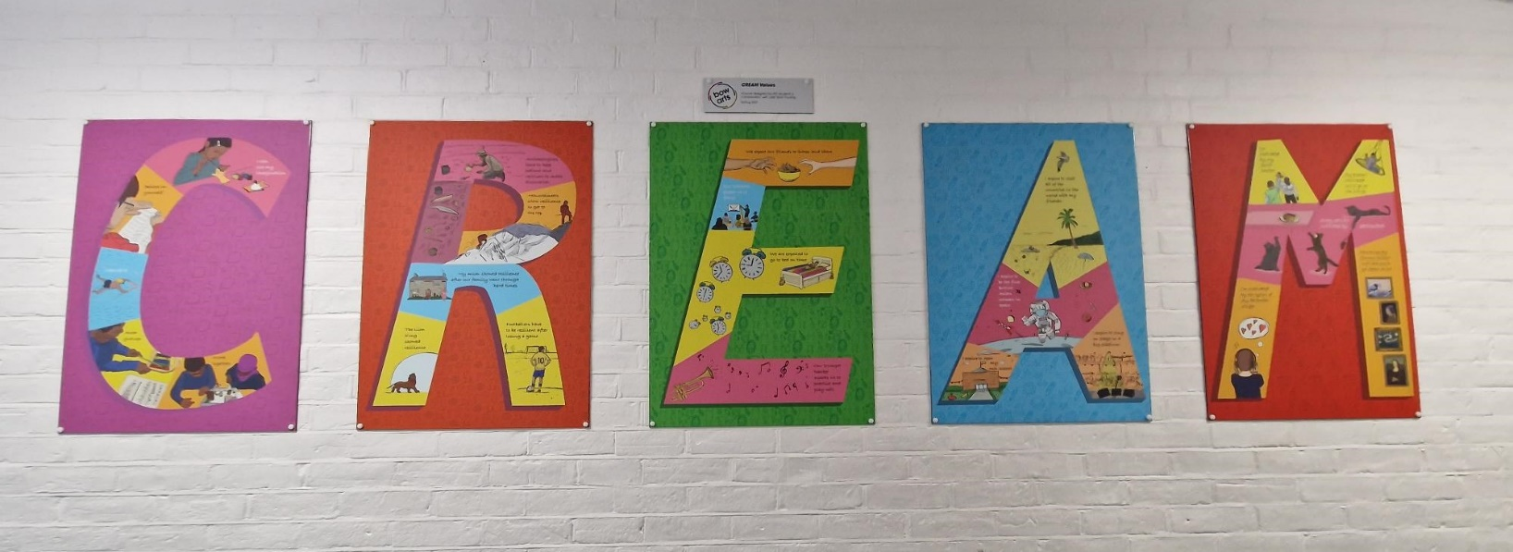
Artwork created in Spring 2023 in partnership with Bow Arts

Our Vision for Our Children

Learn to read, learn to write, learn to express myself, learn to solve problems, learn to think creatively, learn not to give up, learn to collaborate, learn to be independent, learn respect for myself and others, learn empathy, learn to look after my body and mind, learn about joy, learn to admire, aspire and wonder, learn to question, learn to explore, learn new things, learn from mistakes, learn to adapt, learn that we are all different, learn the value of everyone, learn my value in the world, learn who I am, learn who I will become.

