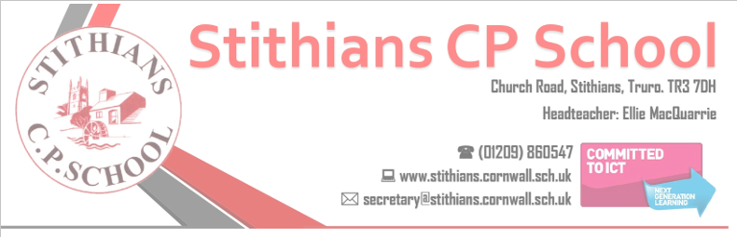

Application Pack

Headteacher
Stithians Community
Primary School
School Group: 2
Salary: L11 – 17 (£66,638 – £76,772)
Full time – Permanent
Start date: Sept 2026 or Jan 2027

Stithians C.P. School is committed to safeguarding and promoting the welfare of children and young people and expects all of our staff and volunteers to share this commitment. Applicants must be willing to undergo child protection screening and employment checks, including enhanced DBS clearance and full reference checks with previous employers.

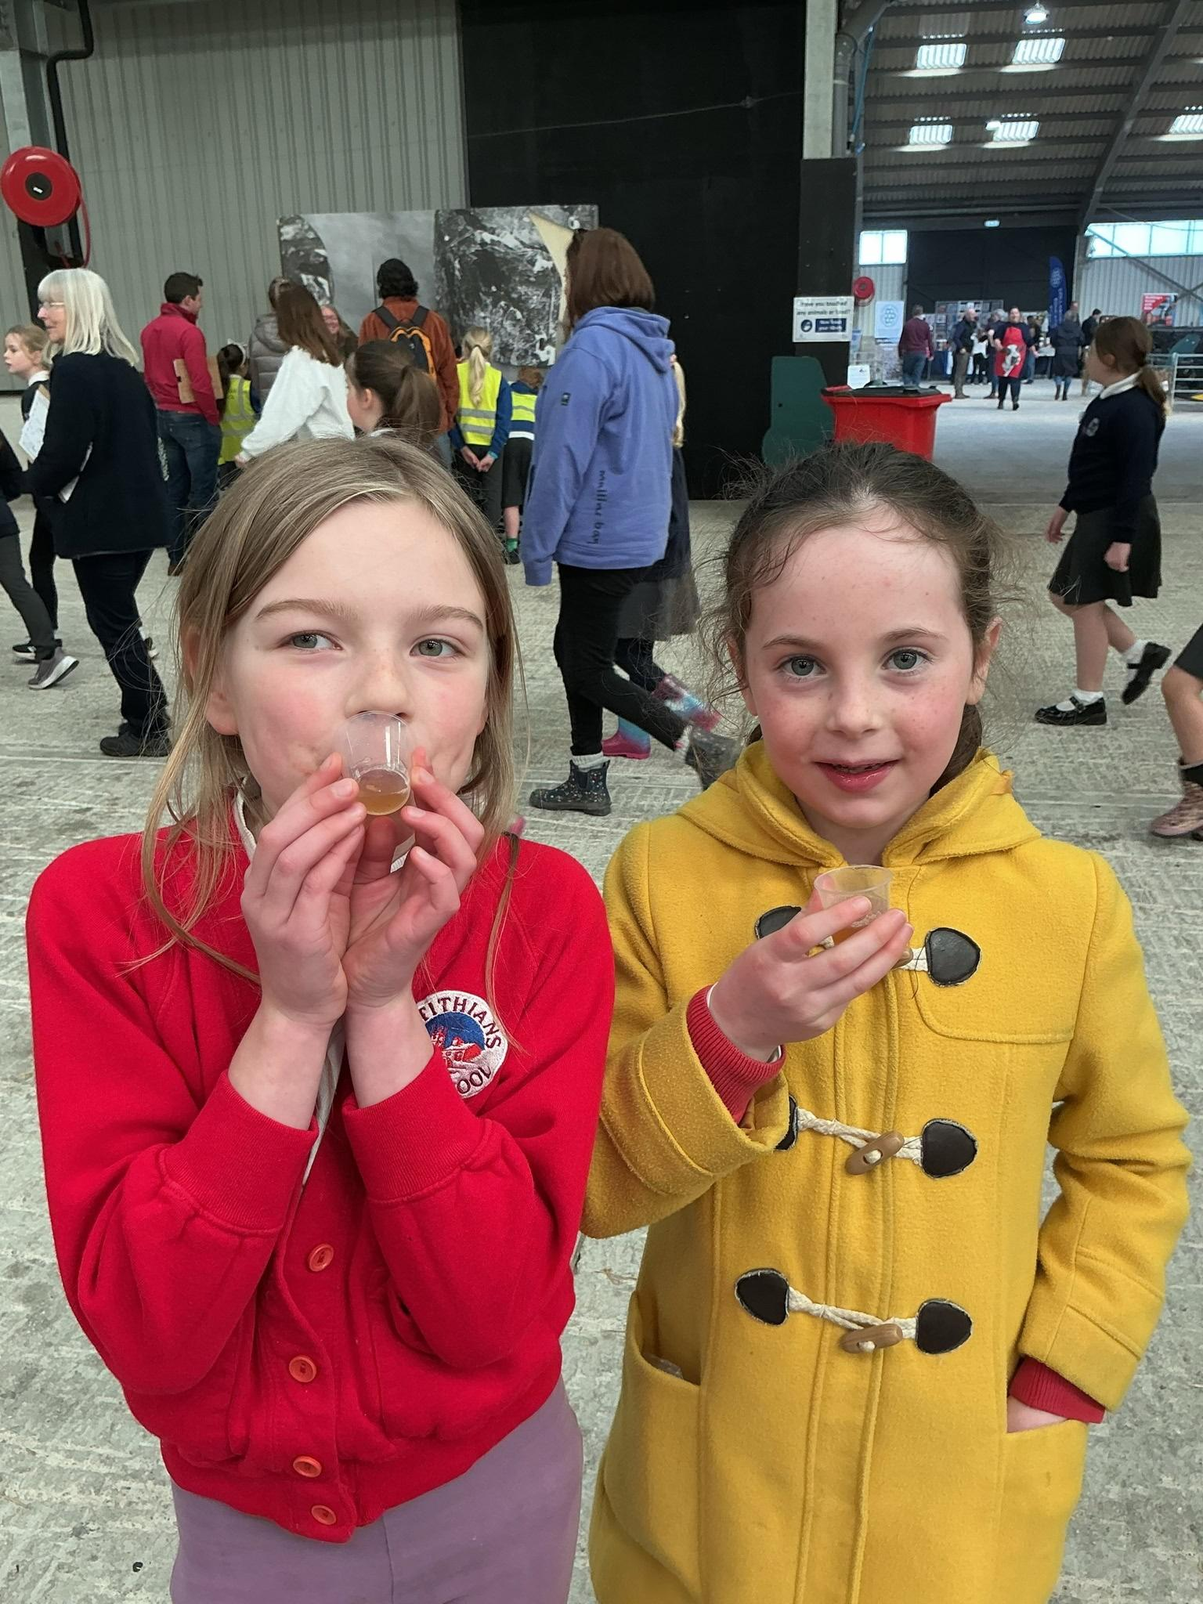

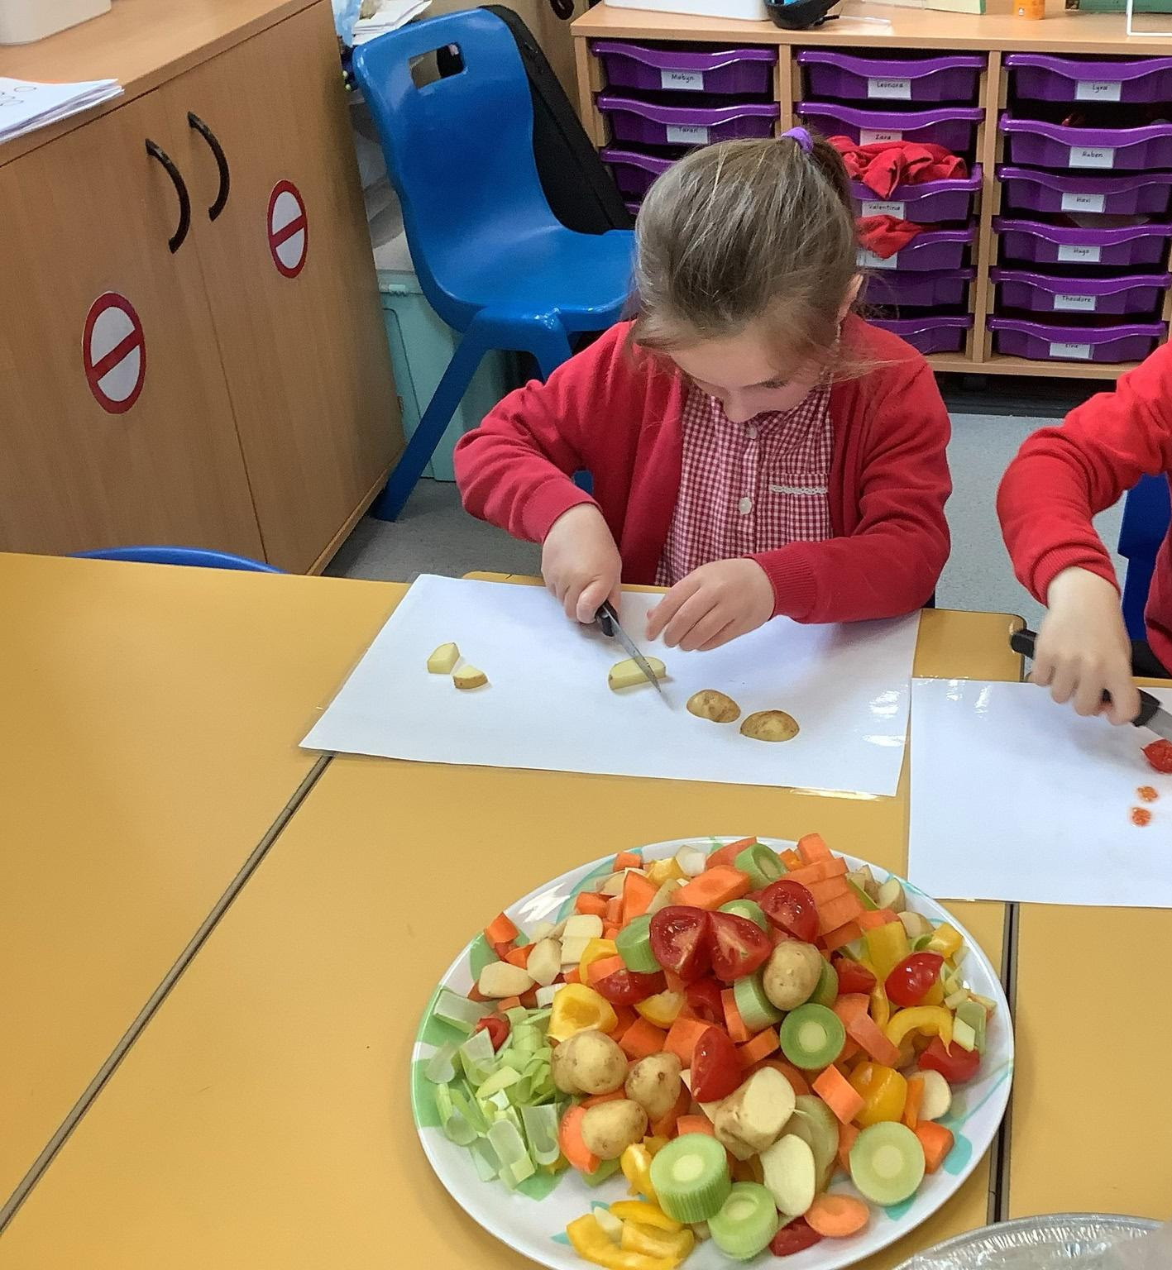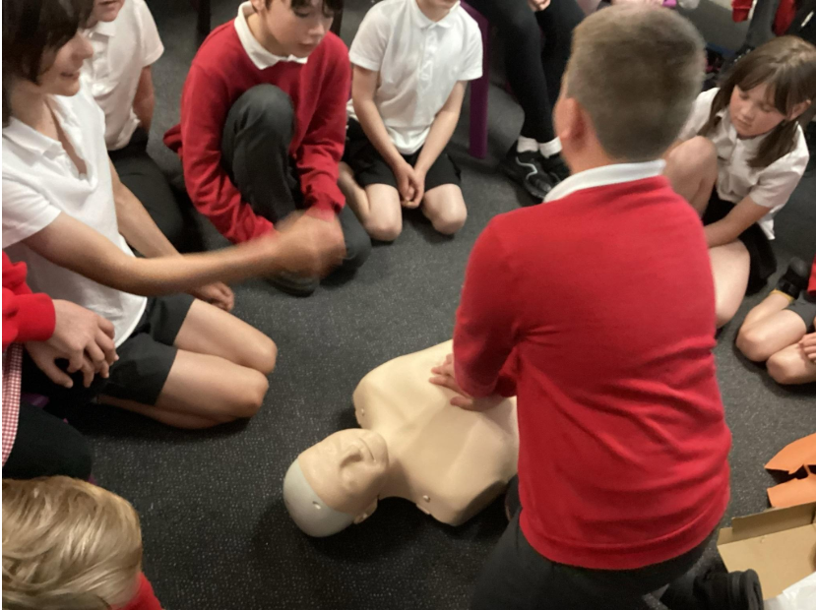
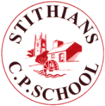

WELCOME

Dear Applicant

I am delighted that you are considering applying for the post of Headteacher of Stithians School.

We’re very proud of our school and the children and we hope that this comes across to you.

Who are we looking for now?
- An inspirational leader who can model excellence in teaching and learning and drive school improvement.
- A strategic, forward-looking leader who is able to cultivate effective partnerships with local schools, stakeholders and agencies to ensure long term sustainability.
- A leader who enjoys teaching and being with the children in class and a Headteacher who enjoys their role within both the immediate school and wider community.
- A leader who will embrace and develop our STREAM (Supportive, Together, Relationships, Engaged, Autonomy, Mindset) culture and build on our inclusive vision for the school, to drive up standards whilst ensuring every child feels valued and experiences a sense of belonging.
- A leader who can sustain and nurture the excellent teamwork that is characteristic of the whole school community.
- A leader who will build on the exciting work already undertaken to develop our curriculum and will invest in and empower the staff.

Stithians is a lovely, happy school at the heart of a vibrant and truly Cornish village. The children really enjoy coming to school. Our visitors often remark on the friendly and positive atmosphere in school. The school was judged to be ‘Good’ in all areas during its most recent OFSTED inspection in September 2022 with the report stating, ‘Stithians School is a warm, nurturing and happy place. Pupils are proud of their school.’

Since then, the school has moved forward at pace with the key developmental strands of Thrive now woven throughout the curriculum and major developments in our outdoor learning provision: a ‘mini-forest’; ‘Wide Tribe’ training and outdoor learning provision; sensory area; climbing / traversing wall; and the development of an energetic OPAL (Outdoor Play and Learning) committee. Autumn 2024 also saw the opening of our new seventh classroom providing capacity for all year groups to have single year teaching in the mornings.

Our staff are a very experienced, dedicated and caring team. They are committed to inclusion, have high aspirations for all the children regardless of their starting point and are determined to provide them with every opportunity to enjoy each day and to encourage in them a love of learning.

We are a maintained school who enjoy support of the Local Authority and have close working relationships with both Primary and Secondary schools in the Redruth and Penryn areas. These continue to provide opportunities for collaboration and partnership. We are also privileged to have great support from our parents and the wider community. Our active Friends of Stithians School (FOSS) PTA raise funds for the school by organising and running a variety of popular events throughout the year valued by students and the community alike.

I hope very much that the information provided, together with our website, will give you all you require to make an application and provide you with a sense why Stithians School is so popular within our community and a fabulous place to work.

Details of how to apply or arrange an informal visit can be found later in this pack. If you would like to arrange a visit you would be warmly welcomed by us all, enabling you to meet the staff and children.

The closing date for applications is midnight on Tuesday 23 June 2026

Shortlisting: Thursday 25 June 2026

The provisional Interview date is Thursday 2 July 2026

If you are an outstanding classroom practitioner with the interpersonal skills to motivate and inspire others and a personal commitment to drive an ethos of continuous improvement, then we want to hear from you. The successful candidate can be assured of our full support with their future professional and career development and a commitment to their well-being and work/life balance.

Thank you for your interest and we look forward to hearing from you.

With very best wishes



Bill Marshall
Chair of Governors

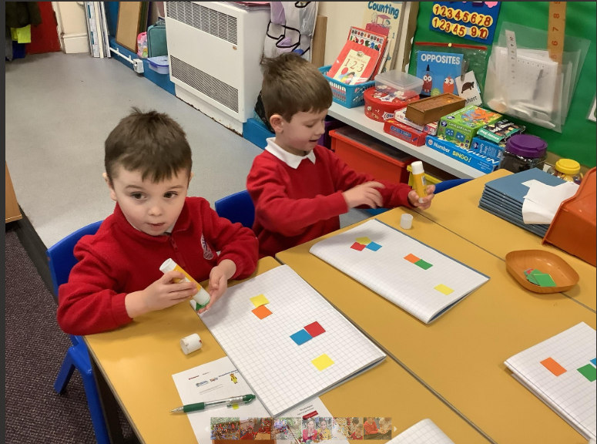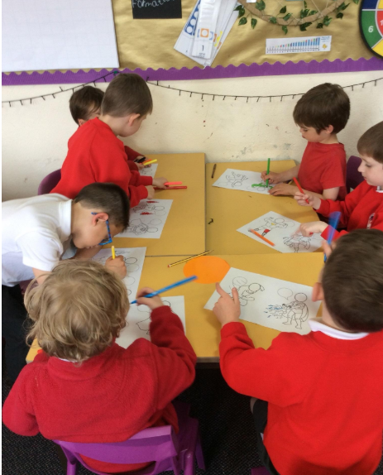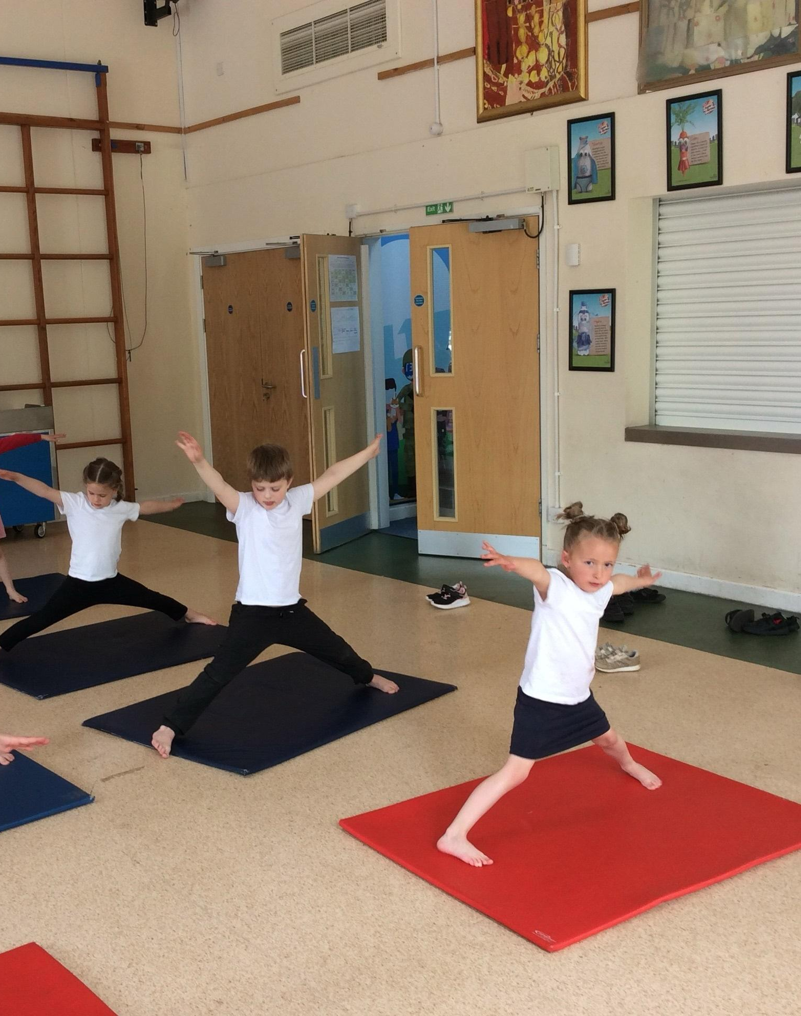

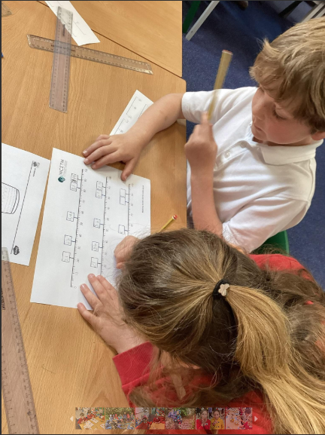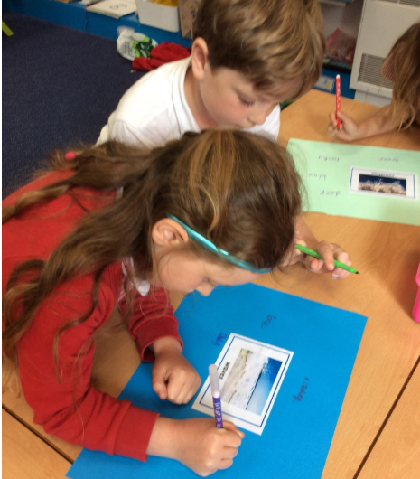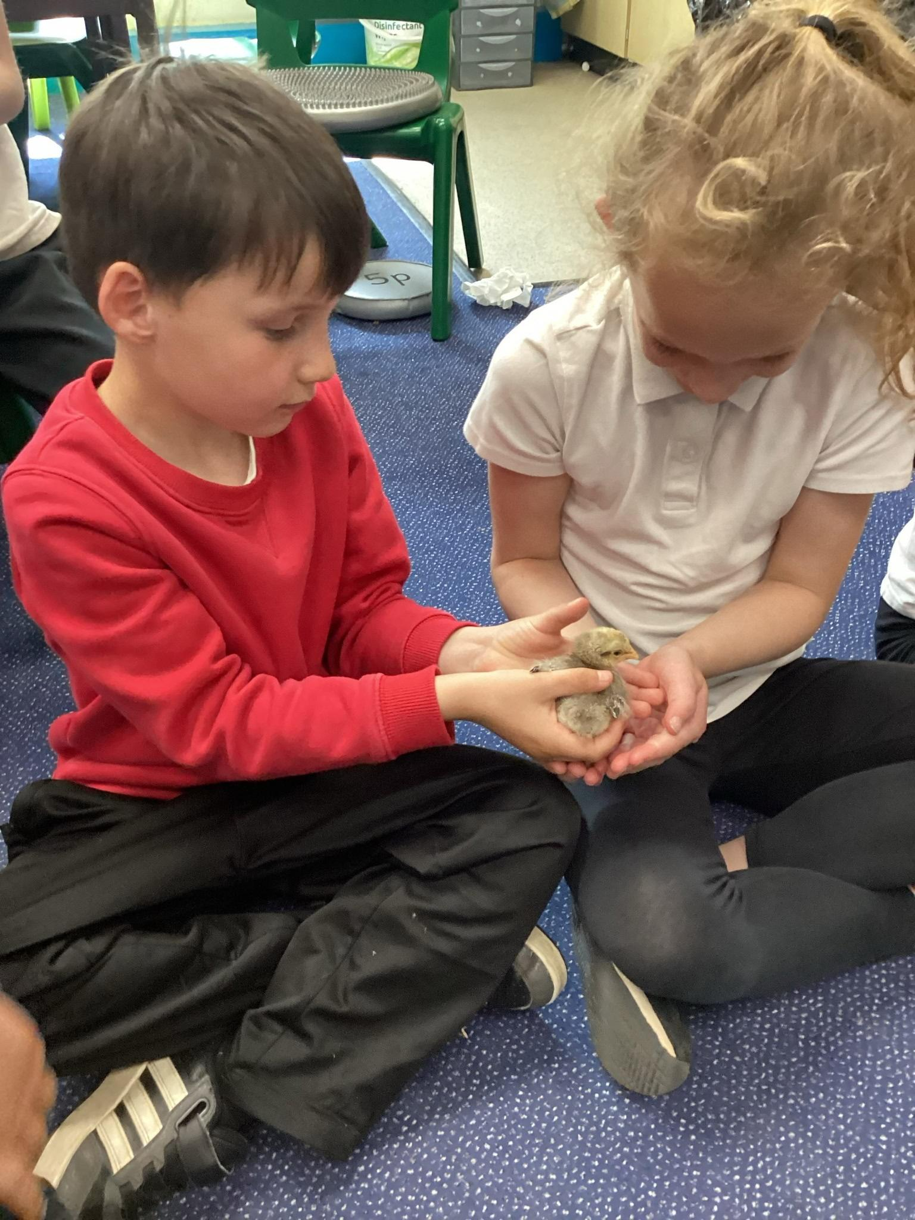

How to Apply - Guidance Notes

Please read these guidance notes before completing your application.

We hope you find this pack and the information available on the School website provides all you need to consider an application for this post.

Please read the job description and person specification thoroughly. The essential criteria are the minimum level of skills, knowledge and experience required for the role and are of equal importance. The desirable criteria are those that will enable the successful candidate to perform the job more effectively and will be used for shortlisting purposes if several candidates have all the essential criteria.

The shortlisting panel will be looking for evidence in your application that shows that you meet the criteria.

In the first instance, please contact Jean White, Governor Services Support Officer at Cornwall Council if you are unclear about any aspect of the application process.
Email: headships@cornwall.gov.uk

- Prior to applying, you may wish to discuss the position informally or arrange an informal visit to the School. Please email bmarshall@stithians.cornwall.sch.uk

- Please contact school reception T: 01209 860547 or E: secretary@stithians.cornwall.sch.uk should you require any additional information specifically about Stithians Community Primary School.

- Application Form. Please ensure you complete all sections of the application form. The school is committed to safeguarding all young people and children and requires candidates to explain all gaps in their career history. Stithians Community Primary School reserves the right to reject incomplete application forms. Any inconsistencies or anomalies will be explored at, or prior to, interview.

- Completed application forms and equal opportunity monitoring forms should be submitted by 23:59 on Tuesday 23 June.
Please note that CVs will not be accepted. Please also note that any applications received after the closing date will not be considered.

- The provisional interview date is Thursday 2 July 2026.
Should you decide to apply, please confirm your availability when submitting your application.

- References will only be taken up for shortlisted candidates who will be notified beforehand. Please contact each of your named referees to inform them that, if you are shortlisted, we will request a reference prior to interview.

- Providing false information as part of your application may lead to a withdrawal of any conditional offer of employment, or disciplinary procedures potentially leading to dismissal without notice if you have already been appointed.

- Stithians Community Primary School is committed to safeguarding and promoting the welfare of children and young people and expect all staff and volunteers to share this commitment. All staff are subject to pre-employment checks which include applying for an enhanced DBS disclosure.
- Background Information

Location: Stithians is a village and parish in Cornwall with a population of over 2000. Its central location makes it a very popular village for people who want to live in a rural location but within easy access to the North and South Coast beaches and harbours, the local towns of Redruth, Helston and Falmouth, and the city of Truro.

The Parish includes the villages of Stithians and Longdowns as well as several local hamlets. The village is well known for hosting the largest single day agricultural show in England (www.stithiansshow.org.uk).

The village is blessed with many facilities and has a large number of active clubs and groups. Local facilities include a village shop, a pub, a doctor’s surgery and community centre – the Stithians Centre - with outreach post office twice a week. The village has a medieval C of E Church near to the school and a Methodist Chapel.

The Stithians Centre is adjacent to the school and is also home to a busy Preschool that provides wrap-around care for Stithians School pupils.

In the fields opposite the school is a large, well-equipped playing field for village use. Adjacent to this field, the various active village sports clubs are located with a football pitch, a cricket pitch and pavilion, a bowls club and pavilion, and a tennis court. There is also a Skateboard Park and BMX racetrack. The village also has a brass band with an active youth/training band.

Also, within the parish, Stithians lake is a hub for water sports hosting Pilot gig rowing clubs, and Greenbank Falmouth rowing club along with dingy sailing, foiling and windsurfing.

School Accommodation and partnerships: The original granite school buildings have been at the heart of this beautiful village since 1869. Refurbishment and extensions have created an excellent learning environment including comfortable classrooms, a large hall, a dedicated library area, on-site kitchen, various other rooms, including IT suite, and Early Years area (incorporating a large reception classroom with a wet weather conservatory extension, two classrooms and exclusive KS1 playground and outside learning areas).

We have a large playground zoned for different activities and team sports and a large school garden area. A ‘mini-forest’ is maturing quickly and two adapted containers provide a boot/changing room for wet weather gear and a sensory area. We are fortunate to have a beautiful school field with a ‘Wild-Tribe’ outdoor learning area, an all-weather track encircling a football pitch and space to engage with nature and endless possibilities to use the imagination.

These are all bounded on one side by the quietly flowing Kennall River, mature trees and fields.
Stithians is very lucky to have beautiful accessible countryside all around including a nearby nature reserve and a rich local history that provides fantastic curriculum opportunities.

The school maintains close community links with the church and chapel and the Stithians Show and the local sports clubs.

Working with other schools in the Redruth Learning Group provides additional enrichment opportunities for children to work together, with the annual dance performance at the Redruth Regal always very popular! The group also provides moderation and staff development opportunities and for the sharing of good practice. Both Redruth Secondary School and Penryn College provide curriculum support in various areas and Stithians School benefits from being part of the Penryn Sports Partnership.

We encourage all children to lead a healthy lifestyle and uptake of the wide range of sporting opportunities and extra-curricular clubs is very high - including children from vulnerable groups who are carefully tracked to ensure they are making the most of these opportunities. Additional sports activities run after school, delivered by staff. The school performs to a high level in many areas of competitive sport (local leagues in football almost every year, rugby, netball, cross country, basketball, hockey, gymnastics and swimming).

Staffing structure

Senior staff:
- Miss Ellie MacQuarrie – Headteacher
- Mr Trevor Manley- Deputy Headteacher
- Mrs Julie Bingham – Office Manager

The SENDCO is Mr Trevor Manley (class teacher, Year 3)

In all there are currently 5 full-time teachers, 3 part-time teachers and 12 teaching assistants supporting children’s learning.

We have a really strong team of support staff with at least one person in each class on each day. We have an experienced part time school secretary, 0.8FTE in the office and assistant secretary 0.6FTE, and an ICT technician. 0.1FTE.

There is a hardworking team of cleaning staff lead by a cleaner-in-charge and several Meal Time Assistants.

Class structure

School PAN 175, pupil numbers currently 171
The proposed delivery model for September 2026 is seven separate classes am and pm.

KS1 |  | KS2
Gunwalloe Class | - Reception (18 pupils) | Zennor Class | - Year 3 (29 Pupils)
Marazion Class | - Year 1 (23 pupils) | Godrevy Class | - Year 4 (26 Pupils)
Sennen Class | - Year 2 (26 pupils) | Porthmeor Class | - Year 5 (21 pupils)
 |  | Kynance Class | - Year 6 (28 pupils)

