## capel st mary (colour)

**HEADTEACHER APPLICATION PACK**

## Capel St. Mary CEVC Primary School

## The Street, Capel St Mary, Ipswich, Suffolk IP9 2EG

**Tel:**  01473 310386

E: mail admin@capel-st-mary, suffolk.sch.uk

Website: [www.capel-st-mary.suffolk.sch.uk](http://www.capel-st-mary.suffolk.sch.uk)





**Contents**

|  |  |
| --- | --- |
|  |  |
| 1. | Welcome from Chair of Governors |
| 2. | About our school |
| 3. | Vision and ethos |
| 4. | Safeguarding |
| 5. | What we want from our Headteacher – children’s views |
| 6. | Our community |
| 7. | Our Church – St Mary’s |
| 8. | Job description |
| 9. | Person specification |
| 10. | Application process |
| 11. | Visits to our school |

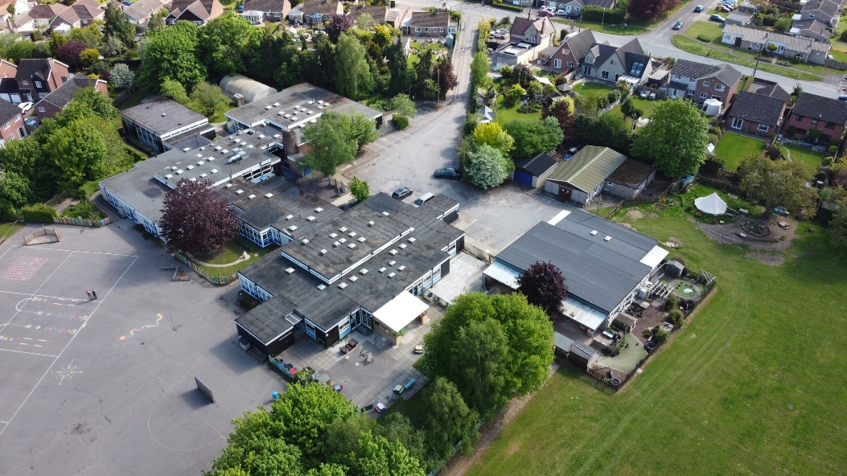

**1. Welcome from the Chair of Governors**

Dear Applicant

Thank you for your interest in the vacancy for the post of Headteacher at Capel St Mary CEVC Primary School.

Due to the retirement, at Easter 2025, of our current Headteacher after 6 successful years, we are looking for an inspirational, dynamic and dedicated person who can continue to drive our school towards excellence, provide an outstanding education to our pupils and uphold the values upon which our community is based.

Capel St Mary CEVC Primary School is a happy, secure and stimulating environment. We believe in providing our pupils with a high standard of well-rounded education and in celebrating all achievements be they academic, sporting or creative. The school has a PAN of 45 with 268 children on roll, and a nursery of 13 children.

We offer a committed team of teaching and support staff; enthusiastic and happy children who are willing to learn and governors and parents who are both active in, and supportive of, the school. Capel St Mary CEVC Primary School has a strong Christian ethos and is an important part of the village community.

The governors are looking for a Headteacher who will be able to:

* Demonstrate a track record of raising standards
* Inspire and motivate pupils and staff to achieve their very best
* Have a clear vision for continuous improvement and build on the school's strengths and successes
* Demonstrate proven leadership and management skills.
* Ensure good financial planning and practice and make sure that the premises and equipment are fit for purpose
* Cultivate a team working approach throughout the school and communicate regularly with children, parents / carers, staff, governors and the local community about the school's activities, performance and progress.
* Collaborate with other schools to ensure best practice, generate opportunities and maximise the benefit of available resources.
* Show commitment to the Christian ethos of the school together with courage, good humour, confidence and resilience.

As you will see from the enclosed information, our closing date will be 9am Thursday 16 January 2025, with interviews taking place on Tuesday 28 and Wednesday 29 January. We welcome visits to the school between Wednesday 8 January and Monday 13 January. Please contact the school office to arrange this. Please also visit our school website for more information and to get a further feel for what we are about.

If you would like an informal conversation about the role and the school, please contact me on 07455 232408.

If you believe you have the ability to take our school forward with the necessary enthusiasm and vision, we very much look forward to receiving your application form. Should you be shortlisted we look forward to meeting you and learning what you can bring to our community, staff, parents and governors, and primarily, our children.

Yours sincerely

Alison Huard

**2. About our school**

Capel St Mary CEVC Primary school has a PAN of 45. The current school roll is 268 plus the nursery of 13. We have nine classes across KS1 and KS2, and two classes in EYFS (reception and nursery). This means that staff work in Units (Y1/Y2, Y3/Y4 and Y5/6), and are experienced in mixed age teaching.

We have12.6 FTE teachers including the Head, 2 HLTA’s whose FTE is 1.25, 1 Cover Supervisor, FTE 0.67, and 9 TA’s whose FTE is 5.36 plus one on maternity leave returning on 0.39 FTE. We are currently recruiting an additional TA with an FTE of 0.73. We have the usual complement of office staff, midday supervisors, a caretaker and a cleaner. We also have an active PFA who raise significant funds for the school.

Capel had a small Victorian school and then the present school was built in the 1960’s. The school is situated on a spacious site, with a large playing field and a tarmac playground to which the children have access. This facilitates our Forest Schools programme.

Capel is a popular local school; we have very high pupil attendance and standards of behaviour are excellent. Visitors often comment on how polite and kind the children are.

The school is fortunate to have a dedicated and enthusiastic teaching body which is supported by a highly efficient Business Manager and Administrative team.

Two years ago, the school adopted the CUSP programme (Curriculum for the Unity Schools Partnership) for most subjects and this is proving successful in developing a broad and balanced curriculum for our children.

The school benefits from an active governing body. This has 13 governors comprising 2 Foundation governors, 5 co-opted, 1 staff, 4 Parent governors and the Headteacher. At the moment we have one vacancy, for which we are actively recruiting. Currently the work of the governing body involves two main committees: Leadership & Management and Learning Standards & Achievement. Other committees convene and meet as necessary.

The Governing Body is committed to the following strategic priorities:

* The quality of teaching and learning is excellent. Learners make strong progress to reach and exceed their potential from their starting points.
* The curriculum provided is broad, balanced and exciting, it engages all learners.
* Leadership is highly effective and is developed at all levels in order to manage change effectively.
* All learners are supported and taught how to be safe at all times. Learners are taught how to keep themselves safe in the future.
* The provision is excellent whilst remaining sustainable within the budget framework.

As with all schools we face budgetary challenges, but our Business Manager together with our governors manage expenditure robustly.

Capel St Mary’s last Ofsted inspection in March 2020 and SIAMS inspection by the local Diocese in January 2017 both judged the school to be “Good”.

Ofsted in 2020 commented:

‘Pupils feel proud to attend this thriving, happy school and they enjoy learning. Staff have high expectations. The school’s mission for every child to come to school to ‘care, achieve, persevere, enjoy and learn’ is understood by everyone’.

The SIAMS inspector in 2017 reported:

“The Christian ethos of the school is deeply embedded and has provided the secure foundation on which improvements in the cohesion and effectiveness of the staff team have been built”.

**3. Vision and Ethos**

Our vision is that Capel will provide an environment where children are nurtured and encouraged to be the best that they can be. The school community will deliver on achievement in learning by:

* having a broad and balanced curriculum with high quality teaching,
* enabling children to feel valued and inspired to learn through perseverance,
* celebrating achievement.

Capel St Mary CEVC Primary is a highly inclusive, happy and thriving School. We are very proud of our children’s caring behaviour and attitudes. The respect and kindness they demonstrate daily to each other and everyone around them is wonderful to see. We are also very proud of the great progress they make with their learning and the enthusiastic way they approach their lessons.

We are a Church of England School and have strong and positive links with St Mary’s Church and other churches in the village. This includes visits to Church for special occasions and visitors from Church for collective worship.

Our attendance figures are high because we know our children enjoy coming to school. Our parents are supportive and very keen for their children to do well.

We use the letters of our School name **CAPEL** to give us our school drivers… our children come to school to **C**are, **A**chieve, **P**ersevere, **E**njoy and **L**earn!

We  believe that every child is a tiny seed with the potential to become a mighty oak. Our biblical foundation comes from the story of the mustard seed in the book of Matthew:

"With faith as small as a mustard seed, you can move mountains"

Matthew 13, verses 31 – 35

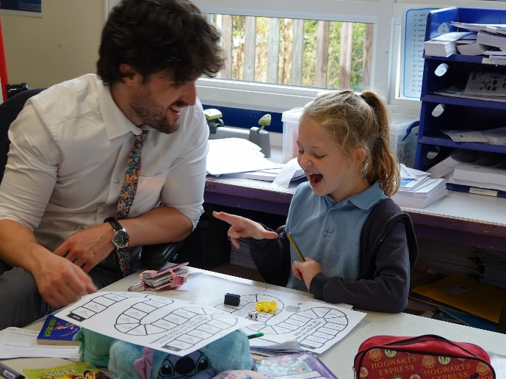 

**4. Safeguarding**

Capel St Mary CEVC Primary School is committed to safeguarding and promoting the welfare of children and young people at all times.

The Headteacher will be responsible for promoting and safeguarding the welfare of all children for whom he/she is responsible, or with whom he/she comes into contact, in accordance with the School Safeguarding policy. The successful candidate will be required to undergo an Enhanced Disclosure from the Disclosure and Barring Service.



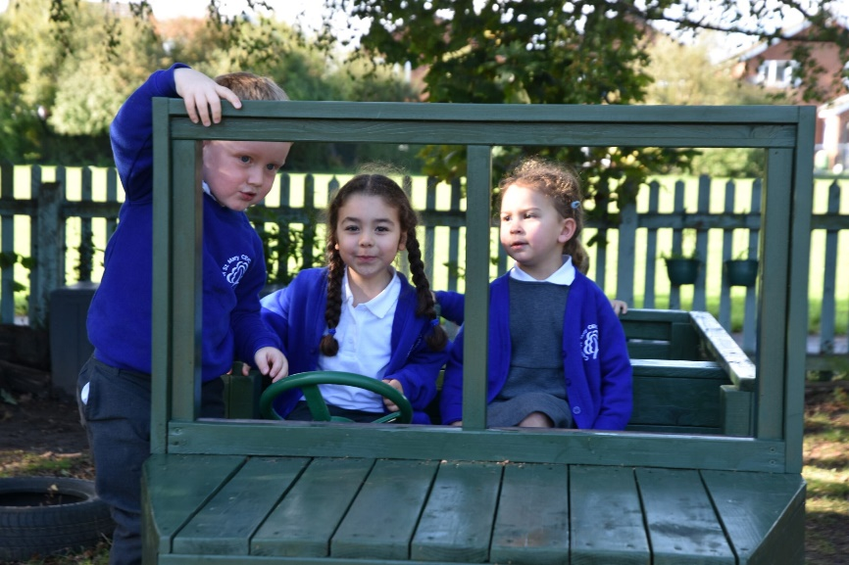

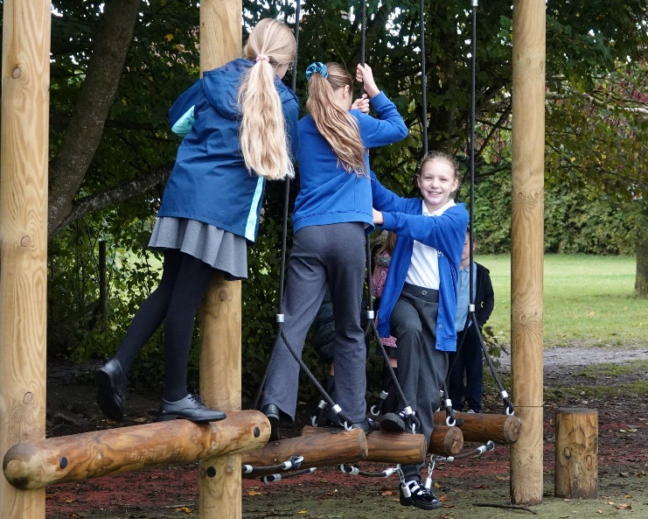

**5. What we want from our Headteacher – Children’s Views**

I would like someone with a good sense of humour, funny and who makes me feel happy. I would want them to do more music shows in the school.  **Eleanor**



I would like them to talk with the teachers and be nice and kind to us. They need to be friendly and want us to do well. **Penelope**

I would like someone who is protective of us children, are fit and healthy and can be a good role model to us. I would like them to be strict if we are naughty, but nice to us. I would like them to put more focus on PE. **Ethan**

I would like someone who is excited to be our headteacher! I would like someone who gets more people to visit the school and talk to us. **Ella**

I would like a new headteacher to make us feel safe and happy and care about our wellbeing. **Freya**

I would like someone who is energetic, supportive and makes us feel safe. I would like a headteacher who wants to do more music clubs for us to do. **Ava**

I would like a new headteacher to be joyful. They need to be quiet at the right times and strict at the right times. **Lily-Rose**

I would like someone who likes science and nature and is honest, calm and funny. I would like them to add more after school options for us to do. **Hunter**

**6. Our Community**

Capel St Mary CEVC Primary school is located in a large village just off A12 between Ipswich and Colchester. Capel St Mary is a friendly and lively village which caters for all age groups. According to the Census 2021 the population of the village is around 3,107.

The village is equipped with several facilities including a selection of shops, garden centre, petrol stations, doctors, dental surgery, library, three churches, sheltered accommodation and allotments. There is also a large community centre with a village bar, two recently refurbished children’s play areas and a large playing field which currently offers bowls, football, running and tennis clubs. In addition, Capel St Mary has an active Community Trust which provides annual events throughout the year.

Capel St Mary village has been developed over the years with two developments having been completed within the last 5 years. The school have been consulted in relation to each development and the school have seen an increase in numbers as a result of those developments completing. There is further developer interest relating to land near the A12 which may result in further development in the future.

The school has strong and positive links with St Marys Church as well as the other churches in the village. The school visits St Mary’s Church on special occasions as well as Rev’d Sally Letman, the Priest-in-Charge of the benefice being a school governor and visiting the school regularly.

There is a private nursery (Robins) within the school grounds, which offers a Breakfast Club and after school provision. In addition, the school does provide its own breakfast and after school clubs which have proven popular with parents.

Capel St Mary CEVC Primary School works closely with East Bergholt CEVC Primary School and some other schools in the local area.

Most Capel pupils transfer to East Bergholt High School in Year 7 and the staff at both schools work closely together.

**7. Our Church - St Mary’s**

I am delighted to introduce myself to you as the Priest in charge St Mary’s Church in Capel St Mary.

The links between the church and our church school continue to be strengthened as we learn together. The children are regularly at church for Harvest, Christmas and Easter, and also have worked on their own Stations of the Cross.

I try be in school every week giving assemblies, sit on the Governing Body and am often in teaching the children about baptism or the Eucharist as they learn about different faiths. My dog Buzz Lightyear will be very pleased to meet you.

There are many of us in the team at St Mary’s who contribute to enabling St Mary’s to be a guiding light to the school, as they grow from small mustard seeds with the values of honesty, integrity and kindness which bodes well for all our futures.

Many Blessings,

Rev Sally





**8. Job Description**

**Duties**

This job description is subject to the general conditions of service for a Headteacher as set out in the current School Teachers Pay and Conditions Document. This job description is based on the National Standards of Excellence for Head Teachers (2020).

**Main Purpose**

The core purpose of the Headteacher is to provide professional leadership and management for the school. The Headteacher is responsible for the internal organization, management and operational control of the school.

In collaboration with the Governing Body, the Headteacher provides vision, leadership and direction for the school. Our Headteacher is expected to uphold the Christian ethos of the school. We are resolutely committed to safeguarding and promoting the welfare of children and expect all staff and volunteers to share this commitment. The Headteacher has overall responsibility for ensuring that the school meets all statutory safeguarding requirements. The Headteacher also seeks to secure the commitment of the wider community to the school by developing and maintaining appropriate networks with stakeholders.

Annual targets will be set by the Governing Body for the Headteacher; successful completion of these will determine any annual pay increments.

**Key Relationships**

The Headteacher establishes and maintains effective working relationships with:

* The school’s children, staff and parents
* The school's Governing Body
* Partner primary schools and high schools
* The Local Authority
* The Diocesan Board of Education
* Community stakeholders

**Strategic Direction and Development**

The Headteacher will:

* Challenge, inspire and empower the school community to carry the vision forward.
* Evaluate school performance, review and implement the school development plan and identify priorities for continuous improvement.
* Support the Governing Body in challenging and supporting the school effectively, ensure statutory responsibilities are met and opportunities identified and acted upon.
* Deploy all resources effectively, including staff and financial resources, to achieve the school’s aims
* Ensure that strategic planning takes account of the diversity, values and culture of the school, paying particular regard to the school’s Christian ethos.

**Leading teaching and learning**

* Develop a supportive and collaborative, safe and inclusive environment in which high quality teaching is the primary objective for all teachers, expecting the best of pupils of staff and inspiring everyone to achieve their full potential.
* Demonstrate personal enthusiasm, high standards and commitment to the learning process, model best practice, and set ambitious and measurable targets.
* Foster creativity, innovation and deploy appropriate new technologies to drive excellence.
* Monitor, evaluate and review classroom practice, the quality of teaching and pupil progress, and promote improvement strategies.
* Pay particular regard to SEND and Pupil Premium children, rigorously using data to implement strategies to promote inclusion, equality, access and improved outcomes.
* Effectively utilise staff resources, building and securing trust and commitment.
* Regularly review own practice, set personal targets and take responsibility for own professional development.

**Community focus and communication**

* Respect, strengthen and foster the school’s relationship with the local churches and foster its Christian ethos.
* Demonstrate outstanding interpersonal skills and communication skills to build, maintain and strengthen relationships with parents, carers, governors and the wider community.
* Seek opportunities to invite parents, community figures, businesses, faith leaders and others into the school to enrich the education of the pupils.
* Collaborate with other schools and educational professionals to share expertise.

**Managing the School**

* Ensure that safeguarding and the welfare of pupils is the priority in every aspect of the role, while ensuring that the school retains its open, friendly atmosphere.
* Establish and sustain a structure that enables the school to be managed in an efficient and effective manner, both on a day-to-day and long-term basis.
* Prioritise, plan and organise the workload of self and others, delegating management tasks and responsibilities as appropriate.
* Ensure that individual staff accountabilities are clearly defined, understood and agreed, and are subject to review and evaluation.
* Budget and prioritise school finances, in partnership with the Governing Body, with the focus firmly on pupil outcomes.
* Manage and organise the school environment to ensure that it fosters positive learning.
* Ensure that the school facilities and buildings are maintained to high standards of cleanliness and repair, conform to health and safety regulations and provide access for all.

**Accountability**

* Present a coherent and accurate account of the school’s performance to a range of audiences, including governors, parents and carers, the Local Authority, Diocese, Ofsted and the Department for Education.
* Maintain and provide all appropriate records, statistical data and returns.
* Work with the Governing Body, providing timely information, objective advice and support, in order to enable it to meet its responsibilities.
* Be the Designated Safeguarding Lead and be accountable for all elements of this role,
* Ensure all legal requirements for health and safety, maintenance and financial management are fulfilled.
* Engage the school community in the systematic, regular and rigorous self-evaluation of the work of the school and work closely with the Governing Body to ensure that effective self-review and external evaluation inform school improvement priorities.

This Job Description may be amended at any time after consultation with the post holder and will be reviewed annually.

**9. Person specification**

|  |  |  |  |
| --- | --- | --- | --- |
|  | **Essential** | **Desirable** | **Where identified?** |
| **Qualifications** | * Qualified Teacher Status * Degree or graduate Level equivalent | * NPQH * Additional Leadership Qualifications * SENCO qualification | Certificates |
| **Experience** | * Experience of a senior leadership role * Experience of the successful management of change which has resulted in raising standards * Experience of developing, leading and managing staff * Experience of identifying and challenging poor performance in a positive and constructive way. * Experience of budget management * Curriculum management – planning, teaching and assessment | * Experience of being a designated safeguarding lead * Experience of each key stage within a primary school * Experience of leadership during Ofsted inspections * Experience of working in good/outstanding primary schools * Experience of SIAMS inspection | Application and Interview |
| **Leadership & Management** | * Ability to motivate staff to build on current achievements and to continue to raise standards and aspirations * Develop strategic direction and clear objectives with the school community to achieve sustained school improvement * Ability to effectively communicate the school’s vision and show how this leads to enhanced outcomes * Ability to lead and maintain the Christian ethos of a Voluntary Controlled School, and to be supportive of other faiths and communities * Ability to use data effectively to identify areas of development * Ability to analyse complex issues relating to finance and resources and develop effective responses * Undertaking school self-evaluation and using the outcomes to improve children’s learning * Commitment to high standards of achievement and equality of opportunity for all pupils * Facilitate exciting learning environments | * Experience in managing buildings * Knowledge of obtaining additional funding opportunities * Experience of developing strategies for an inclusive school * Experience of innovative curriculum strategies including outdoor learning * Use of a range of evidence, including performance data, lesson observation and planning scrutiny | Application, references and interview |
| **Professional Knowledge** | * A deep and secure understanding of how to sustain a safe, secure and healthy school environment in accordance with Keeping Children Safe in Education (2024) * Knowledge of legal issues relating to the management of a school including health and safety, equal opportunities, race relations, disability, human rights and employment legislation * Clear knowledge and understanding of current local and national educational strategies, issues and developments * A working knowledge and understanding of the most recent Ofsted framework * Understanding of managing financial resources appropriately, to ensure efficiency, effectiveness and probity in the use of public funds * An understanding of the importance of effective governance and how it supports a school in setting clear, ambitious direction whilst ensuring compliance and high standards * Understanding of how the school website and information technology can strengthen engagement with parents/carers and the wider community * Evidence of Continual Professional Development |  | Application and interview |
| **Personal   Attributes** | * Demonstrate effective inter-personal skills and an approachable style of leadership * A passion for education with ability to inspire children of all abilities to reach their full potential * Commitment to setting and achieving ambitious performance targets and effectively monitoring and evaluating them * Skilful communicator, able to adapt style appropriate to the circumstance and audience * Demonstrate enthusiasm, positivity, confidence and compassion * Ability to build and sustain effective working relationships with staff, parents/carers, governors, Church and the wider community * Excellent organisation and time management skills * Have the intellectual understanding and emotional intelligence to manage the well-being and development of pupils and staff * Resilience * The ability to create a professional and personal support network for advice and balance |  | Application, references and interview |

**10. Application process**

Please complete the application form provided with this pack and email it, together with your supporting statement, to:  [**headships@suffolk.gov.uk**](mailto:to_headships@suffolk.gov.uk)**.**

**Closing date:** 9am Thursday 16 January 2025

**Interviews**: Tuesday 28 and Wednesday 29 January 2025

**11. Visits to our school**

We encourage visits to the school prior to your application (Wednesday 8 to Friday 10 January or Monday 13 January 2025): please contact the school office on **01473 310386** to arrange a mutually convenient time.

For an informal conversation about the role, please contact our Chair of Governors, Alison Huard, on **07455 232408.**